
Paradise Palms
Visit notes · August 2026 portfolio roadtrip
Lakeland, FL | 50 units | JREF II | Regional manager: Alex Pontes
10 items logged · 2 needs attention now · 2 waiting on a decision
These are our notes from the visit, straight from the walk-through and the conversation on site. Nothing here is a directive yet. If something is already done, wrong, or you disagree with it, say so — that is more useful to us than a clean list. Reference numbers are in brackets so you can quote them back.
CAPITAL & INFRASTRUCTURE
- Fence around the new drainfield? SAFETY NEEDS A DECISION [PF-0424]
CONSTRUCTION QUALITY & VENDORS
- Stair and door configuration is inconsistent across identical models, night and day between two crews. Some homes have stairs oriented to match the door swing, others do not, forcing residents to walk around the landing to enter. Fix is either rehanging doors to match the stairs or reorienting the stairs to match the doors, finished with skirting.
- Most concrete pads and steps in the park are correctly and well executed; the outliers show missing caps, exposed wood where skirting was not applied, and misaligned steps. Full park walk-through needed to log every exception with lot numbers and photos into a punch list.
- Standardize and enforce the install spec at install: door swing dictates stair orientation, stair skirting on all visible wood, concrete step alignment to the approach path. Hold a pre-work briefing with both crews.
- Tree roots were badly damaged during electrical trenching. Inspect the affected areas and propose corrective landscaping or root protection.
- Punch items: paint the office front door, replace the missing post cap (ref 1923), and close out all missing caps against the punch list.
CURB APPEAL & SITE STANDARDS
- Mailbox cover [PF-0425]
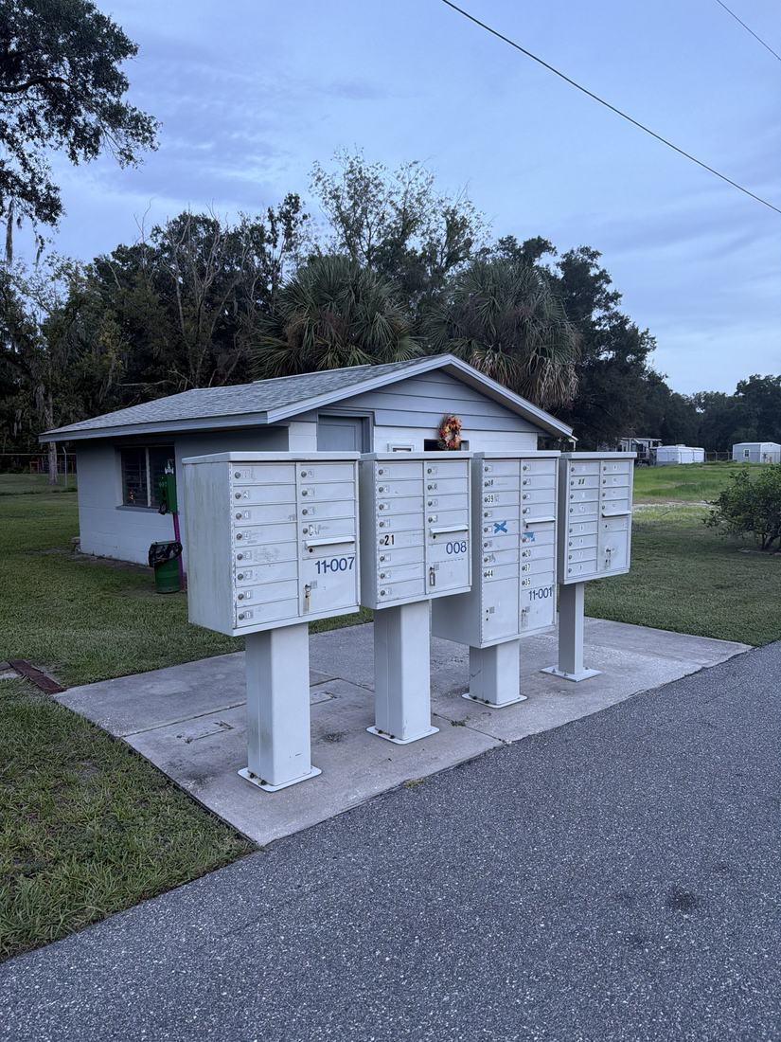
RESIDENT ISSUES & ENFORCEMENT
- 55+ community, so quality, safety and appearance carry more weight and visible defects do more reputational damage. Team likes the park layout.
SITE OPS, STAFFING & EQUIPMENT
- Curbside trash? NEEDS A DECISION [PF-0426]
- Entry codes for the houses and the clubhouse were not working and the team had to follow another vehicle in. Audit and fix the codes, distribute updated ones to authorized personnel, and retire the dead codes. SAFETY
WHAT WE NEED BACK FROM YOU
Send corrections and status to your regional manager, Alex Pontes. Quote the reference number. Three things help most: what is already finished, what is wrong on this list, and what you would put first if you could only pick one.
Source: August 2026 portfolio roadtrip, site punch list and visit notes, Aug 17‑23, 2026. Compiled 2026-09-02.

