
River Oaks
Visit notes · August 2026 portfolio roadtrip
Ruskin, FL | 113 units | JREF I | Regional manager: Alex Pontes
30 items logged · 7 waiting on a decision
These are our notes from the visit, straight from the walk-through and the conversation on site. Nothing here is a directive yet. If something is already done, wrong, or you disagree with it, say so — that is more useful to us than a clean list. Reference numbers are in brackets so you can quote them back.
CAPITAL & INFRASTRUCTURE
- Take out the median with trees to make additional parking on both sides. When paving pave driveways and dedicated parking [PF-0427]
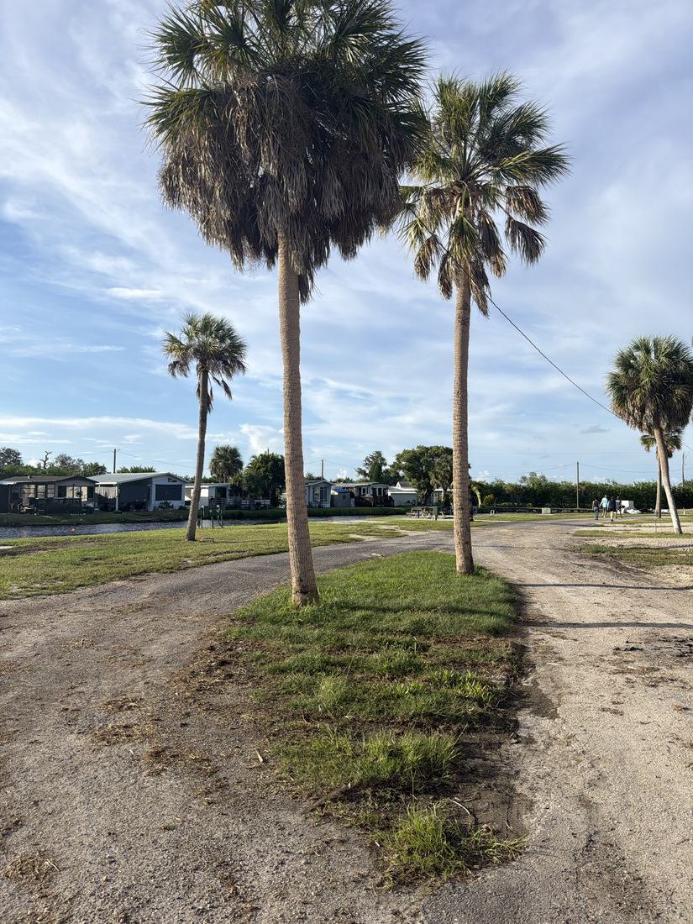
- Seawall around entire lake and boardwalk? NEEDS A DECISION [PF-0428]
- Underground plumbing [PF-0429]
- Electric to the dock [PF-0430]
- Move well somewhere that it can be to not kill the dead lots NEEDS A DECISION [PF-0431]
- Power must be restored to the pier; George started the work and it is not complete. Electric to the dock still outstanding.
- Digging a new well to reclaim 6-8 lots was viewed as cost-effective at that yield; it would require relocating the horseshoes area.
- Broader infrastructure (water lines, seawall, roads) to be phased after a defined time frame.
INFILL, HOMES & SALES
- Look into porches for the homes with steps on the front [PF-0432]
- Vicki should go to other parks and tell the managers for lower priced homes send them to us [PF-0433]
- Billboard ads for River oaks [TD-0152]
- Homes are not currently listed in Rent Manager and the process to list and sell through the platform is unresolved, which is blocking sales. NEEDS A DECISION
- Disagreement on inventory management: a hold on bringing in more homes until current homes sell was suggested to build sales momentum. No decision recorded. NEEDS A DECISION
- Offering a 15% discount to current RV residents to convert them to home buyers was proposed; terms and implementation to be defined.
- Grassroots marketing agreed as a strong strategy: Vicki to visit communities with homes priced over $100,000 and ask managers to refer lower-cost buyers to River Oaks for a referral fee; visit RV parks to learn visitor patterns and distribute flyers to snowbirds with a $50,000 budget; target the Elks Lodge and American Legion, frequented by retired veterans living in mobile home parks.
- Billboard advertising to raise visibility for a tucked-away park, starting with the blank board on Bayshore Road at Route 41 in Ruskin. Referral fees to outside managers raised an ethical question with no resolution on managers who cannot accept payment. NEEDS A DECISION
CURB APPEAL & SITE STANDARDS
- Parakeet street signs [PF-0434]
AMENITIES & COMMON AREAS
- Bathhouse needs fully redone [PF-0435]
- New fish cleaning station [TD-0156]
- Swinging trex swing to left of clubhouse [PF-0436]
- Fix the bingo machine [TD-0155]
- Microwave for the clubhouse [TD-0157]
- Pet wash station outside [PD-14]
- Aerator for fountain [TD-0162]
- Clubhouse: restroom needs upgrading and an inspection report is to be reviewed. Post-hurricane repairs included a new roof but the building is still leaning and leaking, and no owner was assigned to the structural issues. Needs a microwave, new windows, and possibly wall repairs. NEEDS A DECISION
- Agreed to buy a used bingo machine from the marketplace for cash rather than replace new. Outdoor furniture: wooden swing favored over hammocks on safety grounds, with Adirondack chairs considered.
- Fountain is not working; a quote was received for an aerator, recommended as the better lower-maintenance option, and agreement that it needs to be running.
- Amenity ideas pending a resident survey that has not yet been created or distributed: bocce court, horseshoes, dog wash, car wash, Tesla charging. A pickleball court is not feasible at the suggested location because of an underground electrical transformer. NEEDS A DECISION
RESIDENT ISSUES & ENFORCEMENT
- Resident survey - bocce, pickleball, etc [TD-0158]
- Residents are actively engaged, decorating for holidays and organizing activities. Outdoor movie nights by the pier using a projector and Bluetooth speakers were suggested, plus Fourth of July and Halloween events.
WHAT WE NEED BACK FROM YOU
Send corrections and status to your regional manager, Alex Pontes. Quote the reference number. Three things help most: what is already finished, what is wrong on this list, and what you would put first if you could only pick one.
Source: August 2026 portfolio roadtrip, site punch list and visit notes, Aug 17‑23, 2026. Compiled 2026-09-02.

