
Terrace Crossings
Visit notes · August 2026 portfolio roadtrip
Thonotosassa, FL | 65 units | JREF II | Regional manager: Alex Pontes
6 items logged
These are our notes from the visit, straight from the walk-through and the conversation on site. Nothing here is a directive yet. If something is already done, wrong, or you disagree with it, say so — that is more useful to us than a clean list. Reference numbers are in brackets so you can quote them back.
INFILL, HOMES & SALES
- Some recent sales at Terrace Crossings, with showings improving on online scheduling.
CURB APPEAL & SITE STANDARDS
- Mailbox cover [PF-0443]
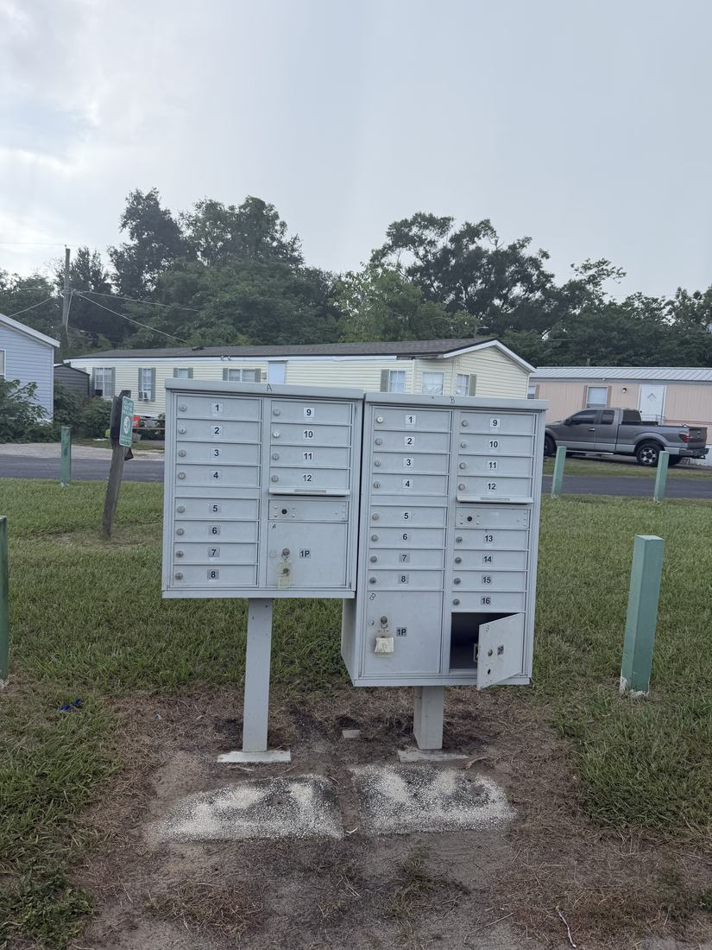
- Paint and straighten the do not park poles on all streets [PF-0444]
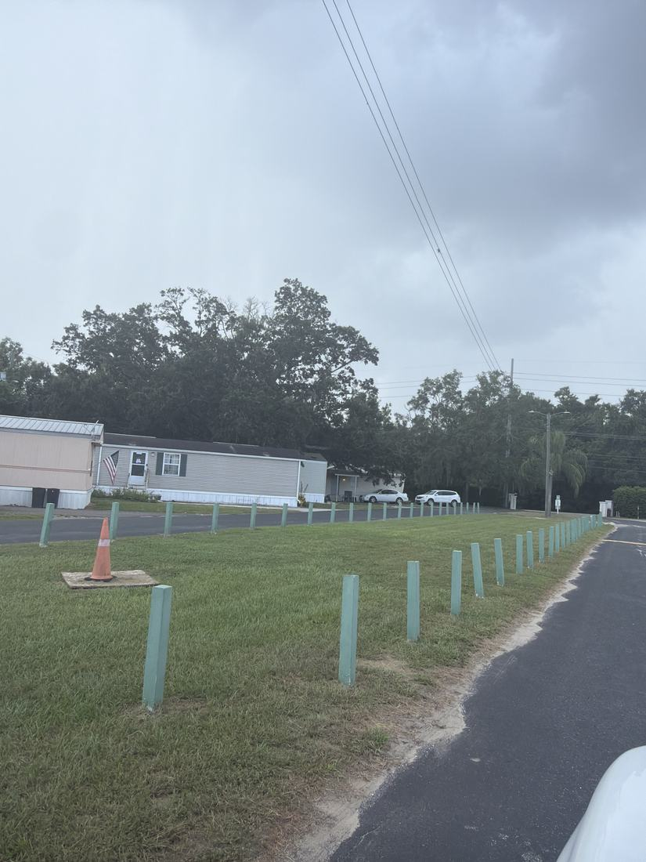
- Individual street signs for TC [PF-0445]
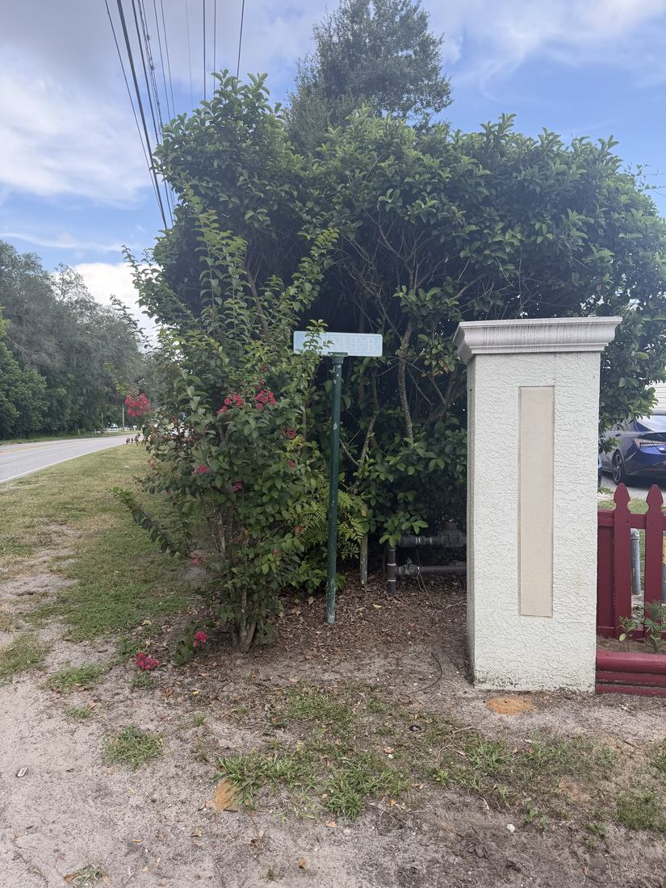
RESIDENT ISSUES & ENFORCEMENT
- Residents use The Oaks pool and occasionally its clubhouse for parties on a $100 deposit applied to rent. Cameras are installed with controlled access; the access system needs to stay secure and authorization controlled.
SITE OPS, STAFFING & EQUIPMENT
- Trash overflow at Terrace Crossings is consuming significant staff time, four days a week of pickup. Individual cans are preferred over a dumpster because they are easier to regulate and cut cleanup. Trucks can access for pickup and waste management already collects yard waste. The $15,000 trash cost is charged in rent and tied to the rent increase timing, July here versus October at The Oaks.
WHAT WE NEED BACK FROM YOU
Send corrections and status to your regional manager, Alex Pontes. Quote the reference number. Three things help most: what is already finished, what is wrong on this list, and what you would put first if you could only pick one.
Source: August 2026 portfolio roadtrip, site punch list and visit notes, Aug 17‑23, 2026. Compiled 2026-09-02.

