
The Oaks
Visit notes · August 2026 portfolio roadtrip
Thonotosassa, FL | 190 units | JREF II | Regional manager: Alex Pontes
20 items logged · 3 needs attention now · 2 waiting on a decision
These are our notes from the visit, straight from the walk-through and the conversation on site. Nothing here is a directive yet. If something is already done, wrong, or you disagree with it, say so — that is more useful to us than a clean list. Reference numbers are in brackets so you can quote them back.
CAPITAL & INFRASTRUCTURE
- High white pvc fence around WWTP SAFETY [PF-0446]
- Consensus to replace the chain link at the wastewater treatment plant with a 12-foot PVC fence, for security against teenagers accessing the area and for appearance as new homes go in nearby. Install before listings to avoid negative buyer impressions. Specs, vendor and schedule still to be set. SAFETY
INFILL, HOMES & SALES
- Three homes need rehab and crews are starting. Policy is no new incoming renters but renewals for existing, with effort to convert renters to owners. Legacy lease options from a prior purchase continue and about six have paid off; buyout options are worth evaluating to accelerate conversions. New homes planned with pricing not yet set.
- On-site familiarity is limited to in-house financing, with less experience of outside lenders. Connect the on-site team with the in-house financing specialist to guide prospects through applications and keep engagement in-house.
CURB APPEAL & SITE STANDARDS
- Mailbox structure, painted etc [PF-0447]
- Take this tree down by office SAFETY [PF-0448]
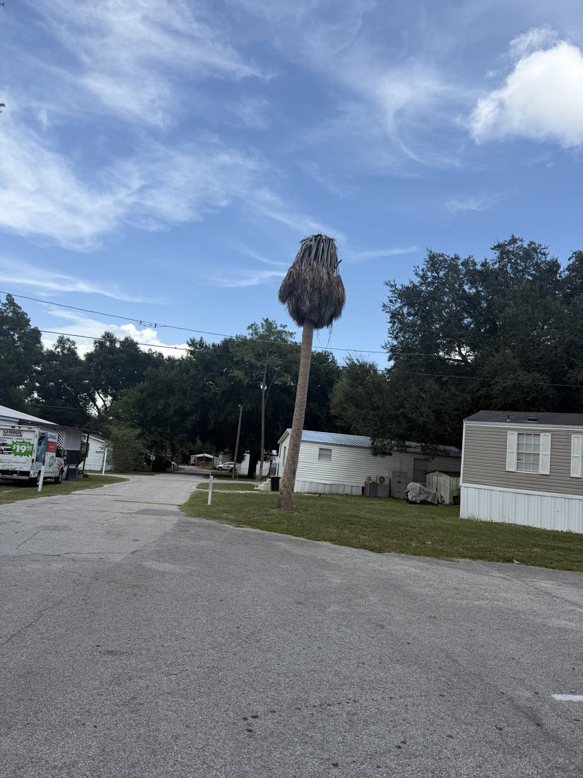
AMENITIES & COMMON AREAS
- New bus stop (in house) [PF-0449]
- Full screened in pavilion [PF-0450]
- Full size basketball court [TD-0177]
- Baby swing on swingset and whatever is on the other wood structure [PF-0451]
- Favor expanding basketball with double hoops and re-striping over pickleball, on the view that pickleball interest is low. Pavilion proposed as half screened, half open like Paradise Lakes, with electrical service, to support events and manage mosquitoes. Site, design, permitting and budget not yet defined.
RESIDENT ISSUES & ENFORCEMENT
- Lot rent credit for the mom managing community Facebook page. Sponsor lunch or tea for the mom’s group. [PF-0452]
- Events include pool movies October to December, cookouts, biweekly bingo, a summer bash with glow sticks, and craft centers for Mother's and Father's Day. A committee of moms coordinates events and should get lunch or tea provided for their meetings.
SITE OPS, STAFFING & EQUIPMENT
- New maintenance shed and restocked tools [PR-0032]
- Cans garbage [TD-0172]
- Replace truck with gator [PF-0453]
- Move toward individual trash cans here and at Riverwalk, aligned with rent increase timing (October here). Costs, rollout dates and resident communication still to be confirmed. NEEDS A DECISION
- Larger durable shed on a concrete slab needed to organize tools and materials, storing spare skirting, siding, PVC and fittings. Tool inventory is sparse since Eric left; compile and price a basic tool package.
- Positive inclination toward buying a UTV/gator for mobility and tasks like trash pickup, but no final decision, cost-benefit or procurement review. NEEDS A DECISION
- Timing is right to start next year's budgets.
WHAT WE NEED BACK FROM YOU
Send corrections and status to your regional manager, Alex Pontes. Quote the reference number. Three things help most: what is already finished, what is wrong on this list, and what you would put first if you could only pick one.
Source: August 2026 portfolio roadtrip, site punch list and visit notes, Aug 17‑23, 2026. Compiled 2026-09-02.

