
Hershey Park
Visit notes · August 2026 portfolio roadtrip
Summerville, SC | 76 units | JREF II | Regional manager: Liz Santiago
7 items logged · 1 needs attention now · 2 waiting on a decision · 1 working well
These are our notes from the visit, straight from the walk-through and the conversation on site. Nothing here is a directive yet. If something is already done, wrong, or you disagree with it, say so — that is more useful to us than a clean list. Reference numbers are in brackets so you can quote them back.
CAPITAL & INFRASTRUCTURE
- Cracked curbs throughout - vendor fix [PF-0378]
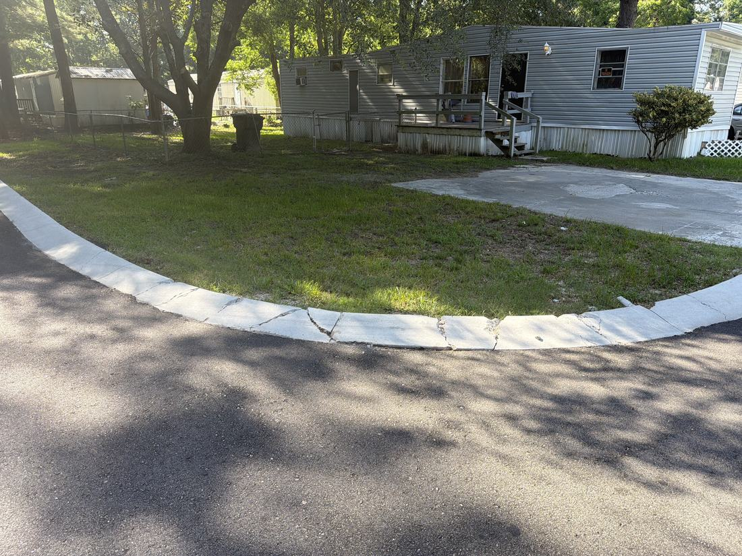
- Fix county electrical box SAFETY [PF-0379]
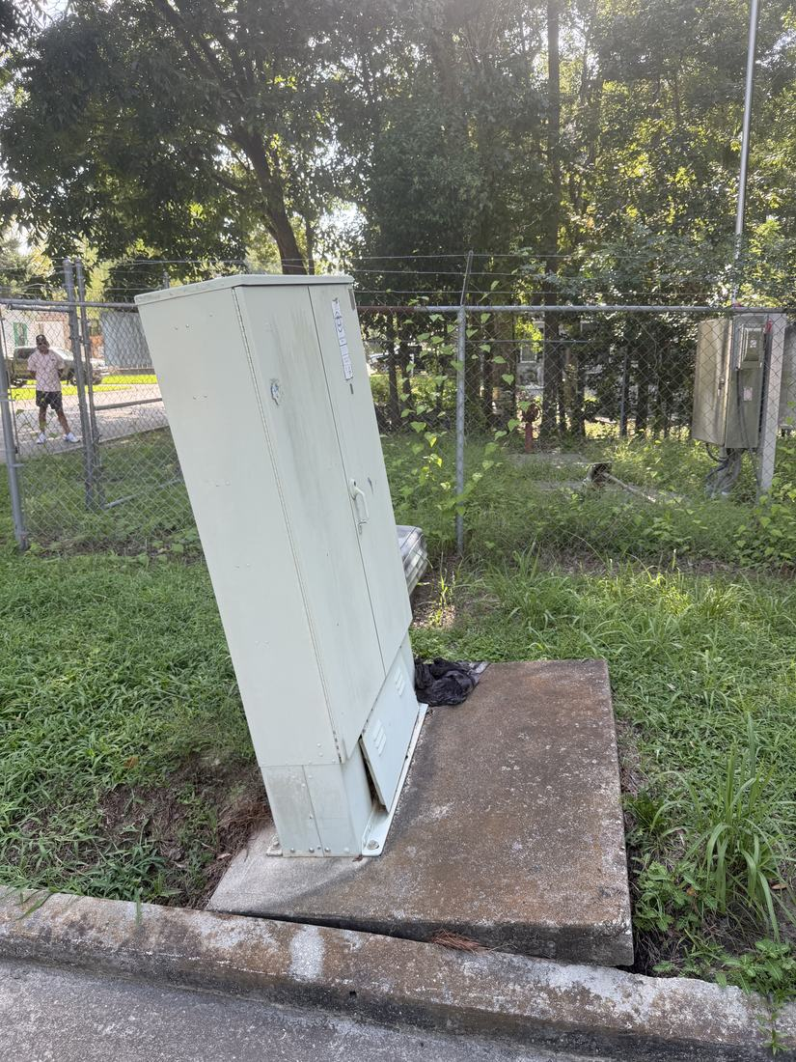
- Look into French drains in the areas that pond [PF-0380]
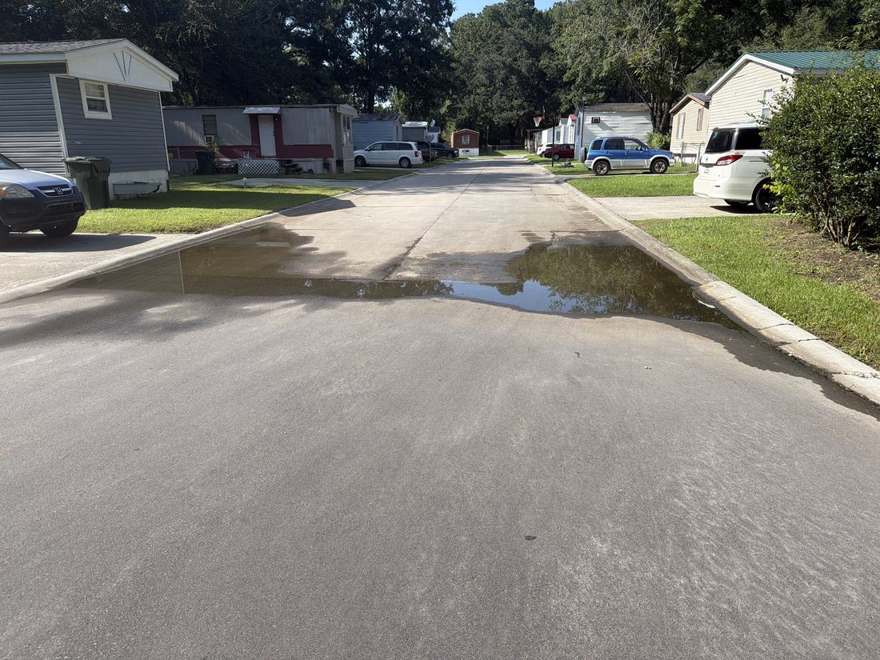
INFILL, HOMES & SALES
- Vacant lot 123 [PF-0381]
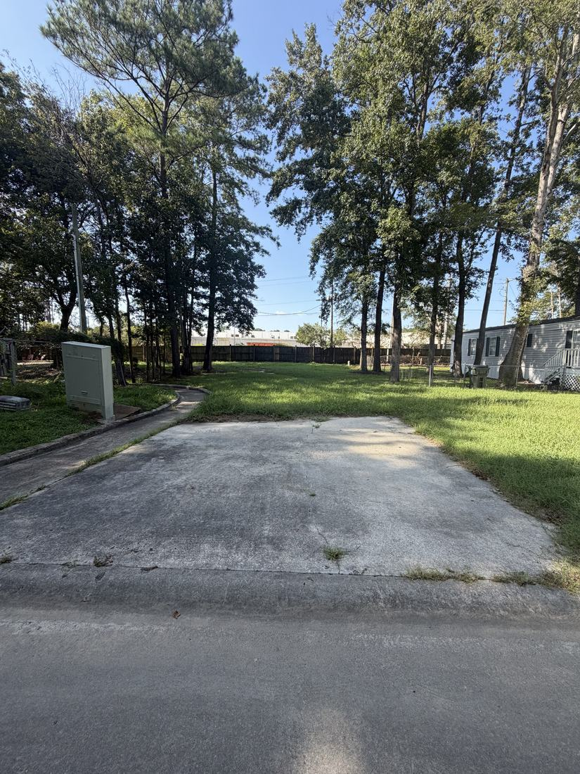
- Front parcel sale 800-900k interested buyer NEEDS A DECISION [PF-0382]
CURB APPEAL & SITE STANDARDS
- Right side fence - ask the sellers if they would split NEEDS A DECISION [PF-0383]
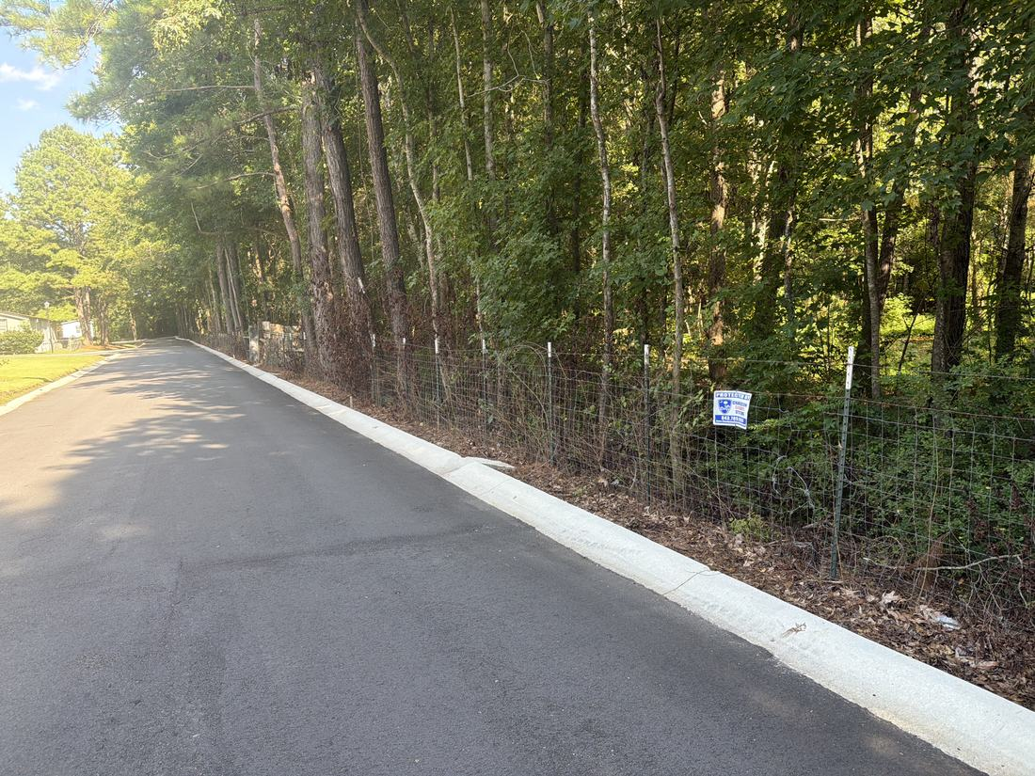
- New mailbox structure looks great WORKING WELL
WHAT WE NEED BACK FROM YOU
Send corrections and status to your regional manager, Liz Santiago. Quote the reference number. Three things help most: what is already finished, what is wrong on this list, and what you would put first if you could only pick one.
Source: August 2026 portfolio roadtrip, site punch list and visit notes, Aug 17‑23, 2026. Compiled 2026-09-02.

