
McGregor Downs
Visit notes · August 2026 portfolio roadtrip
Columbia, SC | 231 units | JREF II | Regional manager: Liz Santiago
25 items logged · 6 needs attention now · 8 waiting on a decision · 1 for next year’s budget
These are our notes from the visit, straight from the walk-through and the conversation on site. Nothing here is a directive yet. If something is already done, wrong, or you disagree with it, say so — that is more useful to us than a clean list. Reference numbers are in brackets so you can quote them back.
CAPITAL & INFRASTRUCTURE
- Tie into city water [PF-0384]
- Partial repaying in back area where drains are sinking - cut them out SAFETY [PF-0385]
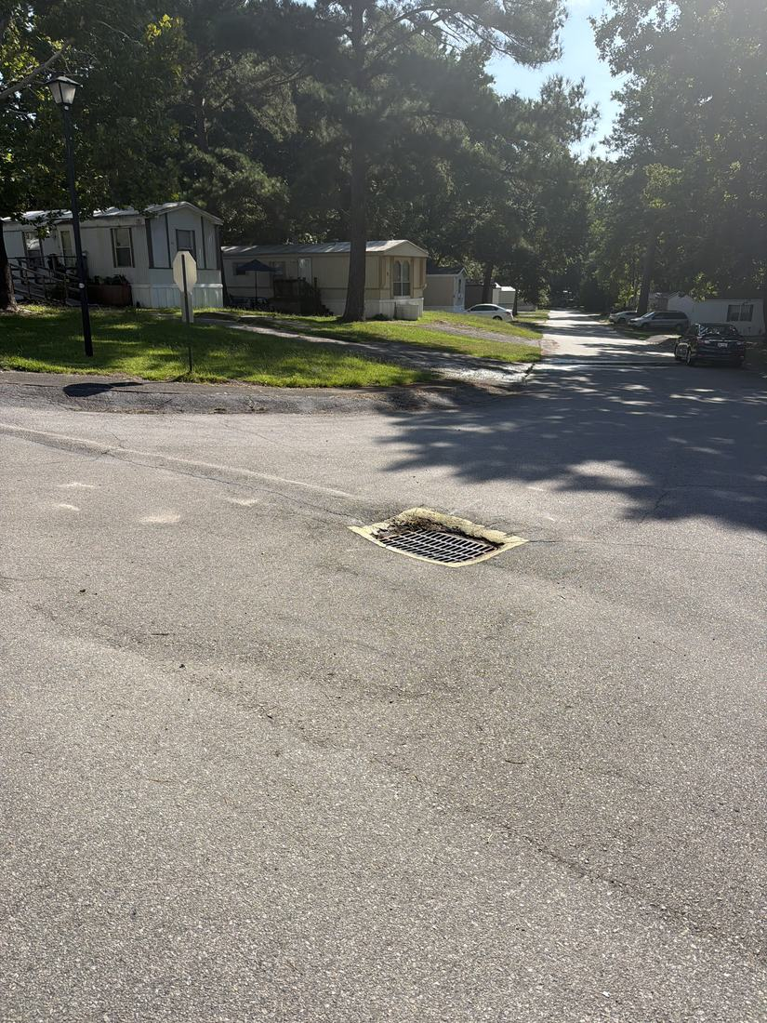
- The recent road project has produced significant flooding and drainage failure, with some storm drains completely plugged. One drain covered with two-by-fours and metal sheathing is an immediate safety risk and needs an assigned owner for mitigation. SAFETY
CONSTRUCTION QUALITY & VENDORS
- Warranty claim against the paving vendor is being pursued: gather all prior communications, confirm warranty terms (believed still in period), send a firm written response, and obtain quotes from national vendors such as Rose Paving to document scope and cost for the file. Legal action is possible if the vendor is unresponsive. NEEDS A DECISION
INFILL, HOMES & SALES
- A prior sale fell through; securing the title is the next critical step. Pricing discussed in ranges of $1,100 rent versus $30,000 purchase. Strategy is to list and gauge market interest before committing to rehab. The property is deemed real property and the county will be contacted for clarification; ability to sell is tied to completion of herbicide/preventative applications. NEEDS A DECISION
- Many prospective applicants start but never complete applications, often over concerns about their history. Strategy is to contact them proactively before they pay the non-refundable fee.
CURB APPEAL & SITE STANDARDS
- Mailbox enclosure [PF-0386]
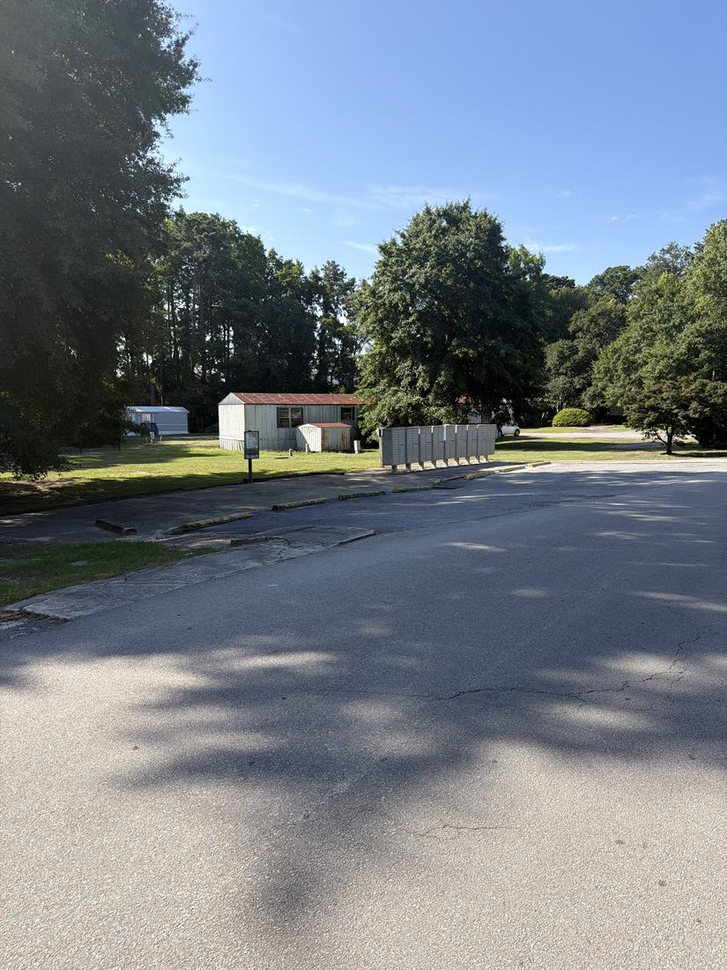
- Budget to renew fencing and remove the unattractive chain link sections. Drainage issue noted where water runs into backyards off a single rolled curb. Mailbox standardization and uniform mini blinds were raised as marketing improvements. 2027 BUDGET
AMENITIES & COMMON AREAS
- Community center - rentals for community parties etc NEEDS A DECISION [PF-0387]
- Repair the concrete pool deck and do the fencing [PF-0388]
- Add playground but there’s a homeless camp behind it. Prostitution and narcotics issues SAFETY NEEDS A DECISION [PF-0389]
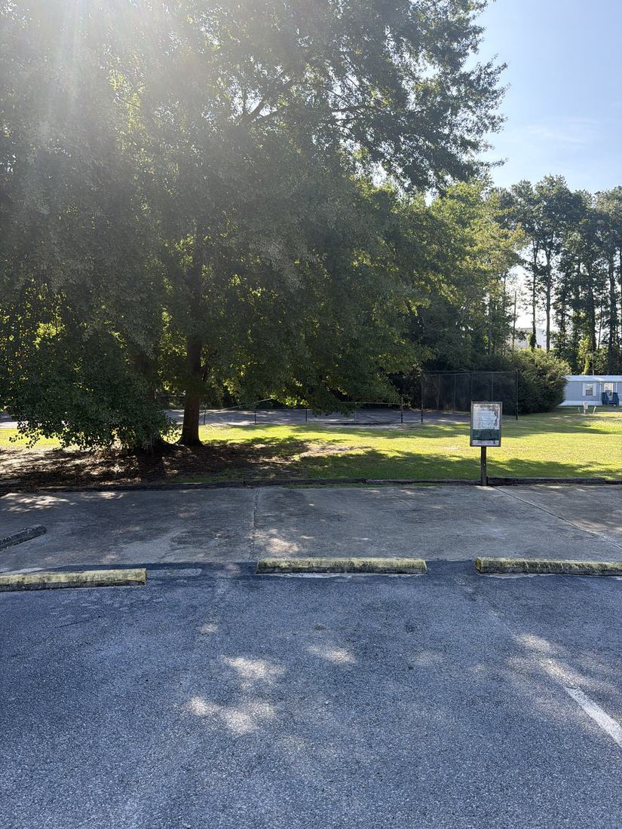
- Fix pool, repair basketball court fence and add hoops [PF-0390]
- Pool is currently unmaintained and closed. Three maintenance service estimates (3, 5 and 7 day) are pending a decision. A permit is in hand but the pool cannot open until the surrounding fence is replaced to meet height compliance. Staff adding chlorine was raised, with concerns about training. Responsibility and budget for the fence are unassigned. NEEDS A DECISION
- Pool/pond has multiple patches, was recently drained, cleaned and refilled but is deteriorating again. Staff certification for water management and grinding and sealing the concrete deck were both suggested.
- Lawn area is used for kids' soccer and dog walking; a small playground or park area was suggested, and a dog park was raised and set aside. Renting the clubhouse for private events would need a rental and deposit model with defined access control and a decision on pool access. No decisions made. NEEDS A DECISION
RESIDENT ISSUES & ENFORCEMENT
- Cameras in office and in front of office too. Also by dumpsters SAFETY [PF-0391]
- Access to cameras via app [PF-0392]
- Follow up on the title issue with sellers manager NEEDS A DECISION [PF-0393]
- Security incidents include children breaking into houses, a car theft, and theft of signs and flowers. A new doorbell camera at the office has reduced aggressive entries. More cameras recommended inside and outside the office, around the park, and at the clubhouse. Locations, equipment standards, retention policy and budget are undefined. SAFETY NEEDS A DECISION
- A back-to-school event with hot dogs and backpacks was held.
SITE OPS, STAFFING & EQUIPMENT
- Pool maintenance - training course for Marcus so he can maintain [PF-0394]
- Look into separate cans garbage for residents [PF-0395]
- Bulk items are blocking dumpsters and preventing haulers from reaching the bins. The team supports moving to individual cans with a chargeback system, plus escalating fines of $75 then $150 for illegal dumping. Vendor selection, distribution, billing, enforcement and resident communication are all undefined. SAFETY
- A maintenance shed containing a zero-turn mower and other equipment was discovered; contents to be inventoried.
- Physical archives (maps, photos, water system documents) to be shipped to the office for scanning and digital backup.
WHAT WE NEED BACK FROM YOU
Send corrections and status to your regional manager, Liz Santiago. Quote the reference number. Three things help most: what is already finished, what is wrong on this list, and what you would put first if you could only pick one.
Source: August 2026 portfolio roadtrip, site punch list and visit notes, Aug 17‑23, 2026. Compiled 2026-09-02. 1 item(s) raised on this visit are not in these notes: personnel matters, which stay with Austin.

