
Oakside
Visit notes · August 2026 portfolio roadtrip
Summerville, SC | 93 units | JREF II | Regional manager: Liz Santiago
4 items logged · 1 waiting on a decision · 1 working well
These are our notes from the visit, straight from the walk-through and the conversation on site. Nothing here is a directive yet. If something is already done, wrong, or you disagree with it, say so — that is more useful to us than a clean list. Reference numbers are in brackets so you can quote them back.
CAPITAL & INFRASTRUCTURE
- County and state road needs paving NEEDS A DECISION [PF-0396]
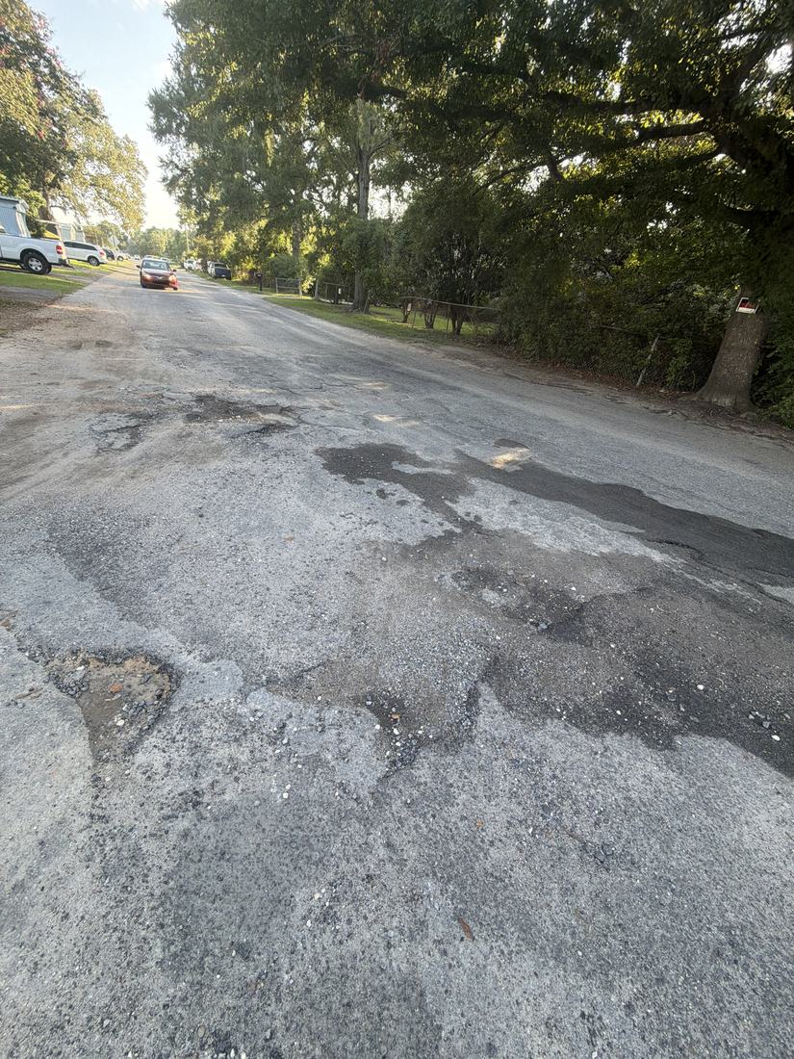
CURB APPEAL & SITE STANDARDS
- Sign looks great WORKING WELL
- Three rail fence up front [PF-0397]
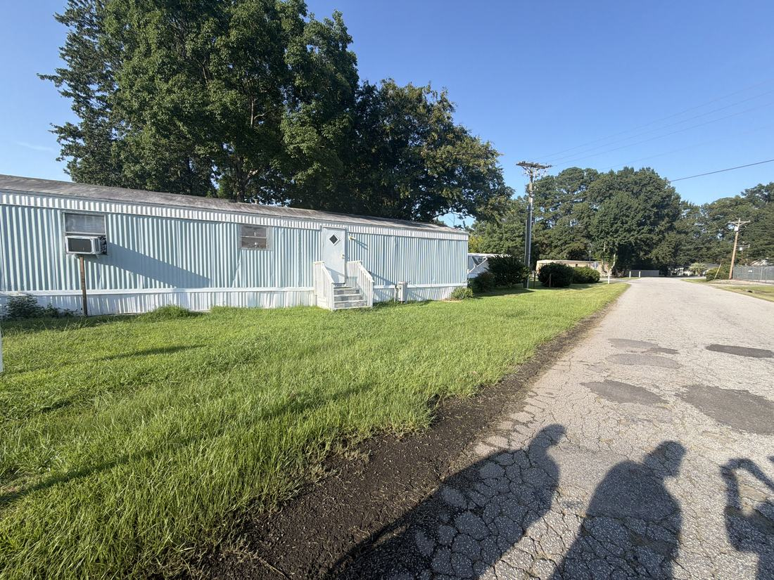
- Mailbox enclosure [PF-0398]
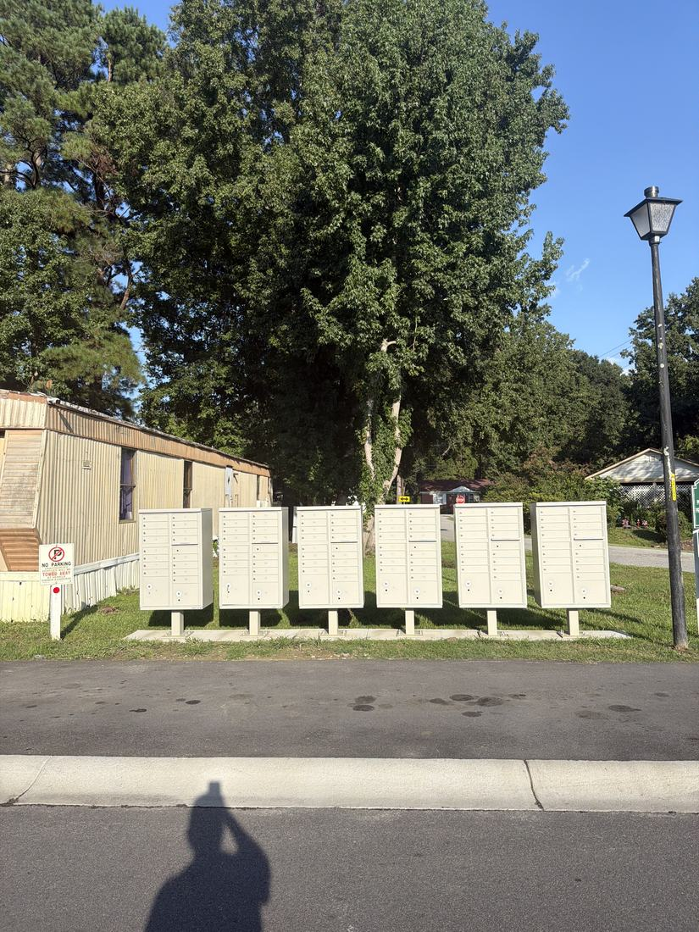
WHAT WE NEED BACK FROM YOU
Send corrections and status to your regional manager, Liz Santiago. Quote the reference number. Three things help most: what is already finished, what is wrong on this list, and what you would put first if you could only pick one.
Source: August 2026 portfolio roadtrip, site punch list and visit notes, Aug 17‑23, 2026. Compiled 2026-09-02.

