
Parkwood
Visit notes · August 2026 portfolio roadtrip
Columbia, SC | 90 units | JREF II | Regional manager: Liz Santiago
6 items logged · 1 waiting on a decision
These are our notes from the visit, straight from the walk-through and the conversation on site. Nothing here is a directive yet. If something is already done, wrong, or you disagree with it, say so — that is more useful to us than a clean list. Reference numbers are in brackets so you can quote them back.
CAPITAL & INFRASTRUCTURE
- Clear out the ditch line [PF-0399]
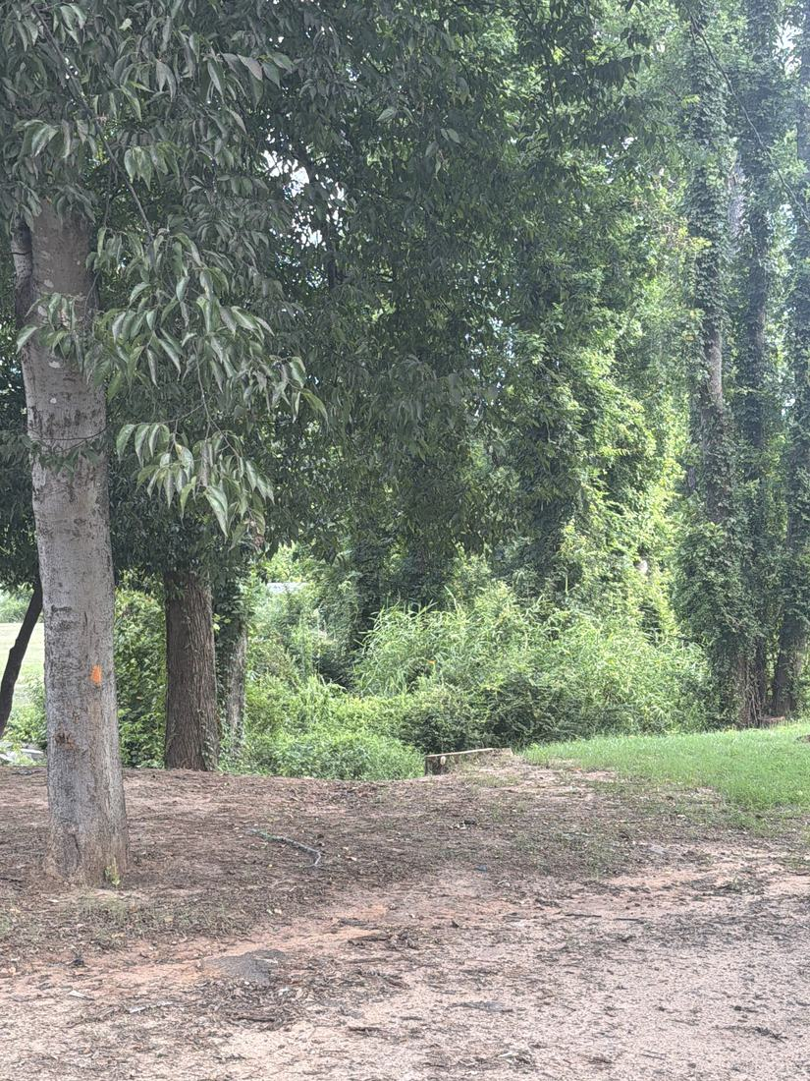
INFILL, HOMES & SALES
- Lot 45 and the other “real property” homes, get flipped so we can sell [PF-0400]
CURB APPEAL & SITE STANDARDS
- New mailbox structures [PF-0401]
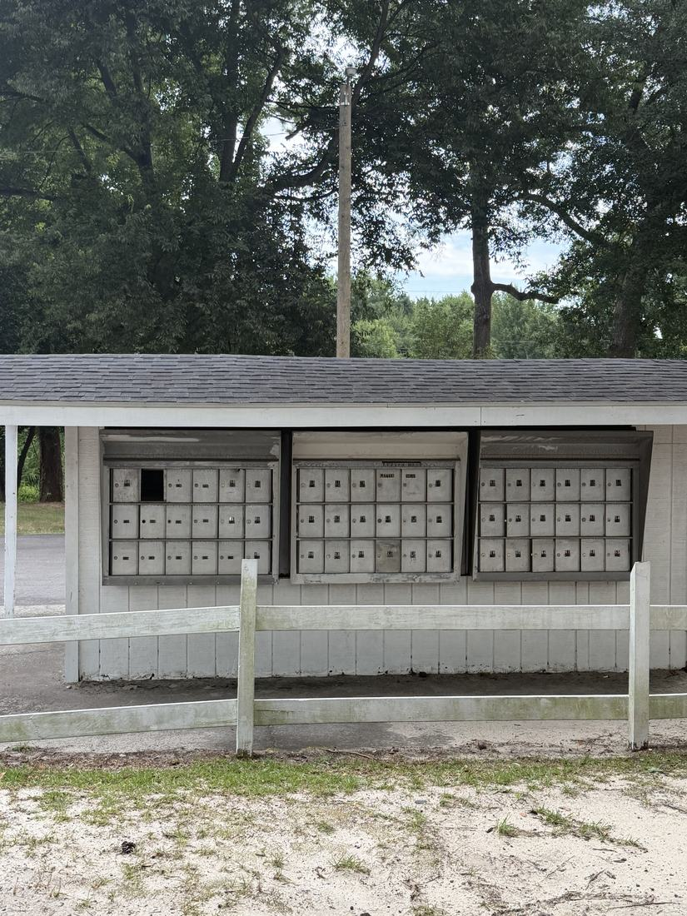
- White fencing improvements throughout [PF-0402]
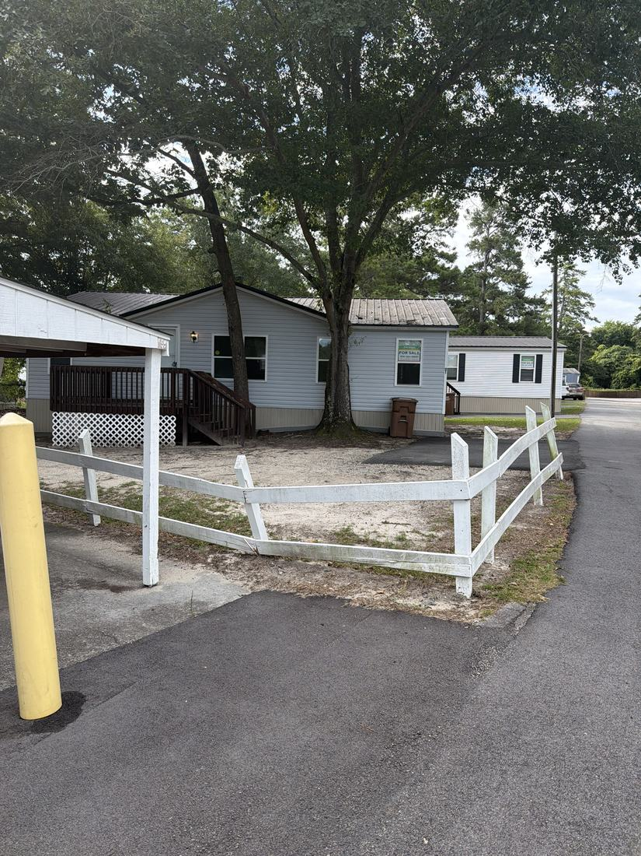
AMENITIES & COMMON AREAS
- Amenity - either playground, grills or pavilion NEEDS A DECISION [PF-0403]
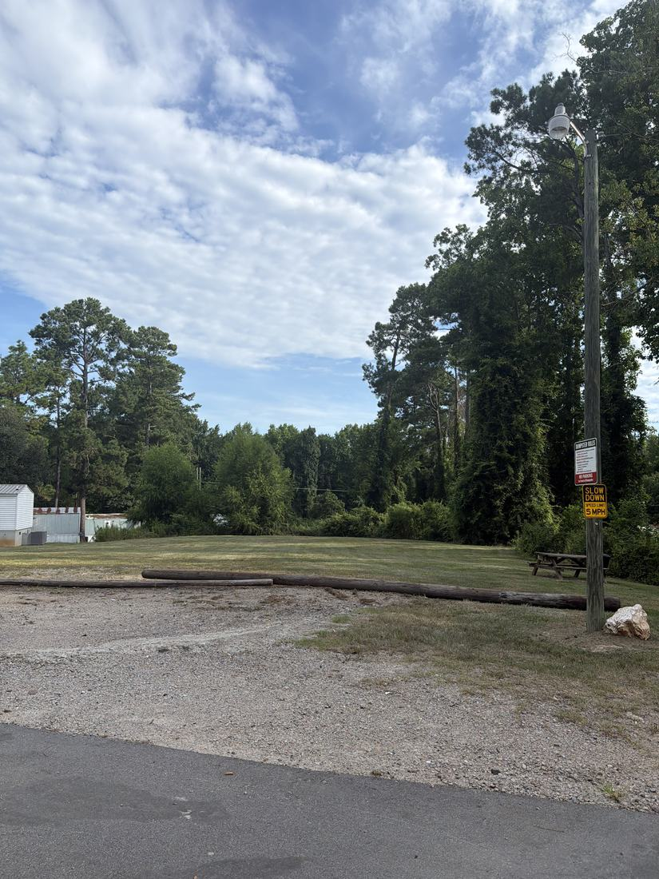
SITE OPS, STAFFING & EQUIPMENT
- Better without dumpsters but now people dump at MCG [PF-0404]
WHAT WE NEED BACK FROM YOU
Send corrections and status to your regional manager, Liz Santiago. Quote the reference number. Three things help most: what is already finished, what is wrong on this list, and what you would put first if you could only pick one.
Source: August 2026 portfolio roadtrip, site punch list and visit notes, Aug 17‑23, 2026. Compiled 2026-09-02.

