
Regency I & II
Visit notes · August 2026 portfolio roadtrip
Savannah, GA | 424 units | JREF II | Regional manager: Liz Santiago
23 items logged · 2 needs attention now · 6 waiting on a decision · 1 for next year’s budget
These are our notes from the visit, straight from the walk-through and the conversation on site. Nothing here is a directive yet. If something is already done, wrong, or you disagree with it, say so — that is more useful to us than a clean list. Reference numbers are in brackets so you can quote them back.
CAPITAL & INFRASTRUCTURE
- Regency I: roads on Green Oak need work; seal coating, patching, or repaving sections were all discussed.
- Regency I: sinkholes reported forming near a speed bump and in the middle of a road. No inspection or repair assigned. SAFETY NEEDS A DECISION
- Regency II: the county's right-of-way for ditch access complicates clearing. A storage shed on the property has no power because the county would not permit it.
CONSTRUCTION QUALITY & VENDORS
- Regency II: sideways doubles on two blocks need enforcement to be properly tied down. SAFETY
INFILL, HOMES & SALES
- Regency I: Convert bulk storage area to rental trailer and rv storage [TD-0072]
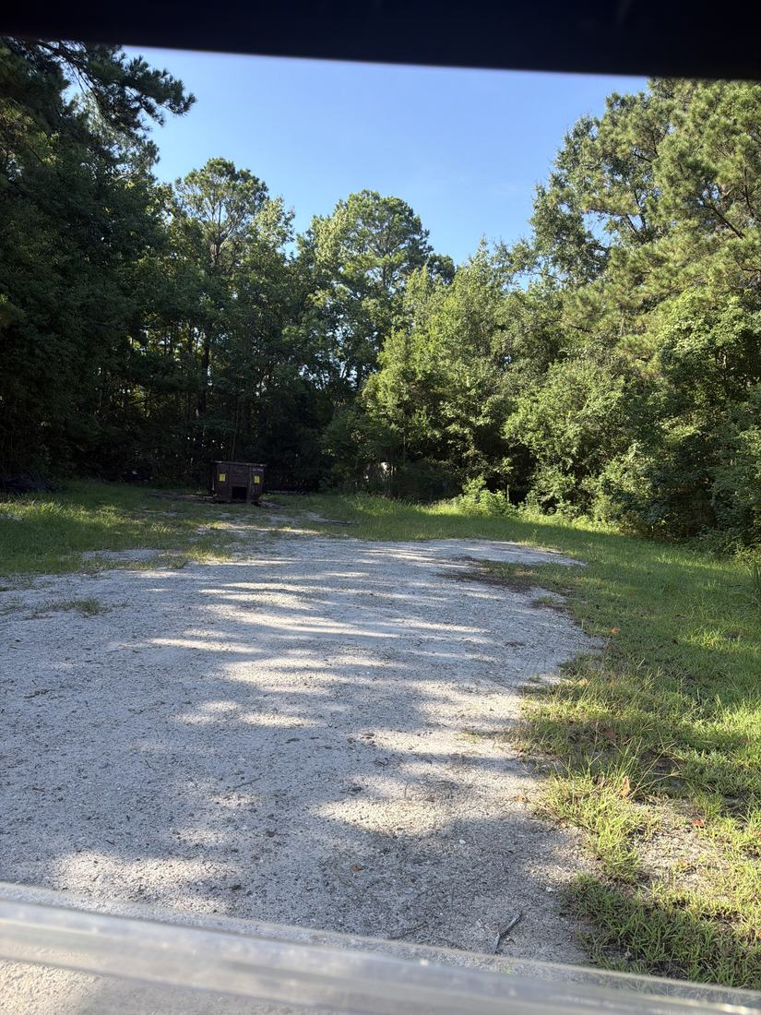
- Regency I: roughly 14-25 vacant lots exist, but many are too small or would require relocating existing homes. Fill plan unclear. NEEDS A DECISION
CURB APPEAL & SITE STANDARDS
- Regency I: New mailboxes and structures [PF-0405]
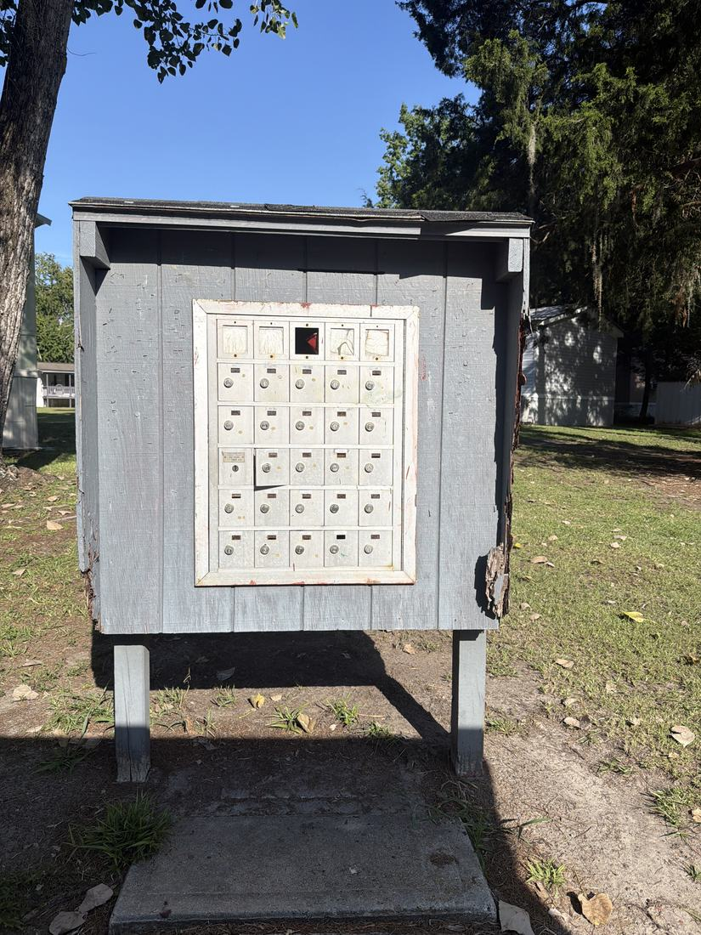
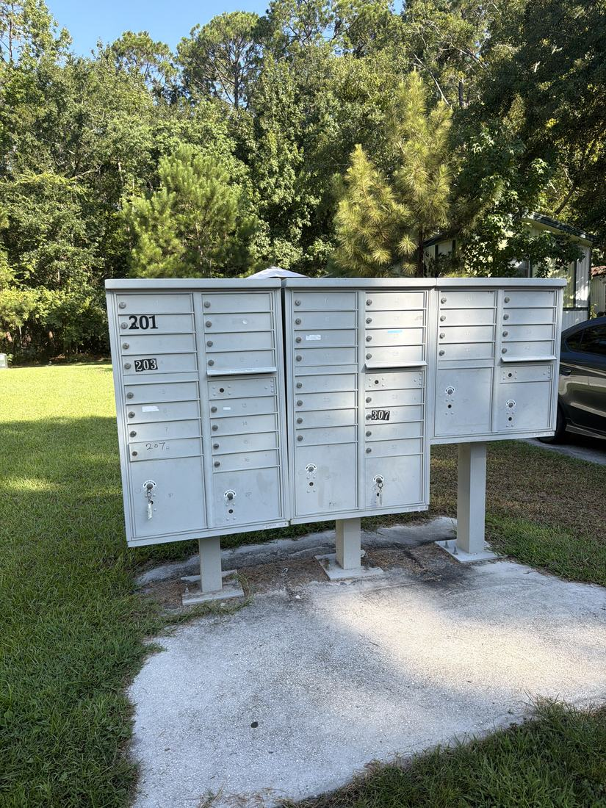
- Regency I: new sign has been delivered and is in the shop awaiting installation. Plan is a white pole with decorative elements added later. Placement in front of the electrical pole is complicated by a city easement on that land.
- Regency I: tree trimming needed, ideally before hurricane season, for both appearance and safety.
- Regency I: existing mailboxes are old and falling apart. Replacement was already approved and a vendor is being sourced; new structures will be larger with better weather protection. Green Oak's units are newer metal.
AMENITIES & COMMON AREAS
- Regency I: New pool furniture [PF-0406]
- Regency I: Gazebo / sitting area at island up front [PF-0407]
- Regency Ii: Covered structure and better picnic area [PF-0408]
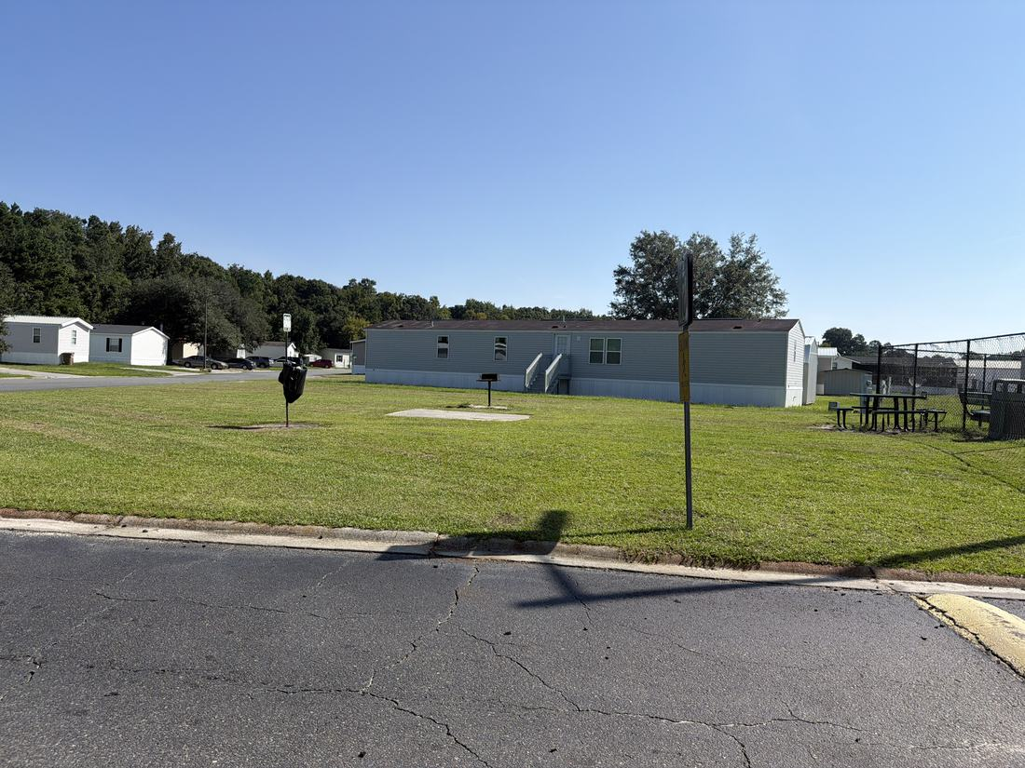
- Regency I: one bathroom needs to be brought into ADA compliance.
RESIDENT ISSUES & ENFORCEMENT
- Regency Ii: Lots of parks charge for double lots. Good to charge landlords NEEDS A DECISION [PF-0409]
- Regency I: over 10 landlords in the park, possibly 20-30. Engaged landlords keep better properties. One landlord holding close to 20 units and charging up to $2,000 rent was identified as a significant problem. No long-term strategy set. NEEDS A DECISION
- Regency I: property is materially cleaner since takeover, and fines for violations are now enforceable, which is motivating residents to clean up their lots. The inspector acknowledged the ongoing licensing process, so operations continue without issue.
- Regency II: road access rules had to be strictly enforced after the park was fined when an ambulance could not get through.
- Regency II: no standard resident lawn-care schedule, producing violations and uneven appearance. A set mowing day was suggested. NEEDS A DECISION
- Regency II: residents have planted bushes and other items on land that is not theirs, including along the county's ditch access, and resist removal. NEEDS A DECISION
SITE OPS, STAFFING & EQUIPMENT
- Regency I: New golf cart [PF-0410]
- Regency I: dumpster area is a persistent problem with tire and bulk dumping, at $395 per month. Plan is to remove the dumpster, clear the container of tires, and convert the space to trailer storage.
- Regency II: a small excavator was identified as the critical long-term purchase, turning ditch and overgrowth clearing into short jobs instead of rentals or outside contractors. The Nissan truck is not adequate for hauling. 2027 BUDGET
WHAT WE NEED BACK FROM YOU
Send corrections and status to your regional manager, Liz Santiago. Quote the reference number. Three things help most: what is already finished, what is wrong on this list, and what you would put first if you could only pick one.
Source: August 2026 portfolio roadtrip, site punch list and visit notes, Aug 17‑23, 2026. Compiled 2026-09-02. 2 item(s) raised on this visit are not in these notes: personnel matters, which stay with Austin.

