Preparing for an Open House

OPEN HOUSES are an important part of sales. A successful open house requires careful planning and preparation. Today we will review the steps to follow to ensure a successful Open House event.

One Month Before
- Marketing: Work with Marketing to coordinate the area paper news ad and/or community Facebook page (with sales promo) to launch the day before. Work to post the open house in the monthly newsletter with a new home and/or featured home for sale picture & don’t forget the resident referral.
- Rent Manager E-Blast, MH Village, Face Book: post daily for Open House, Radio Ads(if applicable), schedule a Sign Spinner on properties off the main roads.
- Get the word out: attend local community meetings, host a community coffee & donuts event and announce the open house to residents. Potential buyers like to talk to the residents. (Don’t forget to mention the resident referral program.)
- Staffing: Decide who is working that day; management, maintenance, host couple (if available), etc. Make a plan of exactly what everyone will be doing.
- Host Couples: If you have a host couple, it’s time to schedule them. Select a couple that loves living in the community to help with the open house. They can sit in the homes, show the clubhouse/pool/chat with the potential residents.
- Identify your meet and greet area. Where will you set up the food? Where will the tour begin? Do you have your tour path down? Where will they register for the raffle?
- Coordinate with Regional Managers: Make sure there are fun events going on during your open house.
- Walk all your inventory homes: Does anything need repair/replaced/landscape freshened up/home cleaned?
- Call all your recent prospects (60 days old): Invite them to join the community wide open house.
- Order prospect & resident gift cards; You should have at least two drawings for a gift basket and $100 host couple gift card (thank you gift). Make a copy of the gift card and have the host couple sign it the day of the open house).

One Week Before
- Displays: Display the gift baskets on a table with your advertisement, listing packet, entry slip drawing bowl and pens.
- Drawings: Make name and phone number tickets for the basket drawing.
- MH Village: Put Open House banners on MH Village.
- Food: Order food platters online from your local grocery store for pick-up the day before (large finger sandwich tray, cheese & meat assortment, fruit tray & cookie tray), book food truck, or buy supplies for BBQ.
- Additional items you may need: Regular & diet soda, small bottled waters, tablecloths, napkins, small paper plates.

Two Days Before
- Print home flyers and all listings from MH Village.
- Outline in red the homes to be open on your community map and make 20 copies.
- Staple the map to the back of your MHV listing packet and your business card in the upper left hand corner.
- Stock homes with water, soda and light bagged snacks.
- Stock office fridge with water.
- If you are having the Meet & Greet in the clubhouse, set up 2 tables for refreshments.
- Get out serving utensils, 2 bowls/tub for ice.
- Have homes ready on inside, full collateral and CLEAN.

Lights Camera Action It’s Open House Day
- 8 am: make coffee, lemon & lime ice water (if available), fill condiments.
- Blow up balloons and tie 3 in a bouquet for resident listings to pick up and add some for decoration to the food table.
- Put the table cloths on the food tables. Set out paper supplies, soda and utensils.
- Maintenance staff to put out open house banners, directional arrows (bandit signs) to community, clubhouse, meet & greet station, A-Frame open house sign at the entrance, l balloons on inventory homes and drive through the community to make sure there is no trash in the street, etc.
- Signs straight in front.
- Ensure lights on in homes.
- Open doors.
- 10:30 put food out & ice in the buckets.

Open House Helping Hands
Host Couple (if available):
- Works 10-4
- Helps with set up and take down
- Assists in greeting the customers, showing the clubhouse & amenities.
- Make sure your host couple knows everything about the open house and what the community has to offer so they can sell it for you.
- Host couple directs any questions regarding price and site rent to sales staff.
- They can also help locking up the homes, turning lights off, bringing in signs and clean-up.
Sales Team:
- Meet and Great your customers! “Welcome to (Community)! What brings you to our open house today? How did you hear about us?”
- Explain how the open house works, give them a listing packet and show them the map on the back that the homes outlined in red are the ones that are open & have balloons in front of them.
- Have them complete an entry slip for the basket drawing (easy way to get their name and number).
- Tell them of any specials you may be having for the open house on new & used.
- Most of all tell them to enjoy themselves and you are here to answer any questions after their tour. Make it fun!  Know your goals: Sell/Rent homes.

Example:

Community Open House Weekend
Date
Saturday, March 20th and Sunday, March 21st 11am-4pm
Objective
Write 3 contracts for inventory homes during the event
Inventory Available
Homes available #19, #57, #70, #90, #98, #139,
Staff scheduled
Assign staff to work over both days and times.
Example:
Saturday Day of Events:
(Please coordinate with activities directors or manager in advance.)
Pool party: 10am-4pm
Kiss My Ice: 12pm-2pm (first 100 residents, FREE snow cone)
DJ Scott: 12pm-2pm
Games: (Horseshoes, shuffleboard,): 10am-4pm
Painting class: Arts & Crafts room ran by resident.

Example:
Refreshment center
Snacks for customers should always be displayed professionally
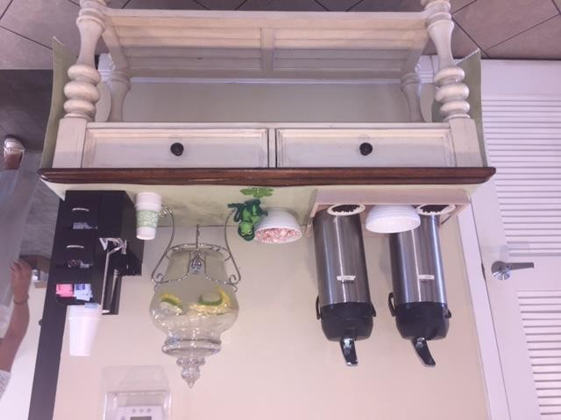
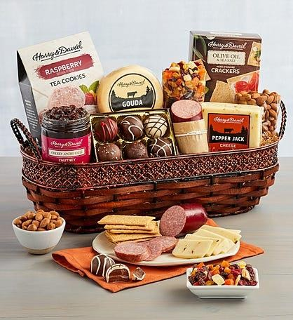
Drawings:
Community Name – Date of open house
Name:__________________________________________
Address:_________________________________________ Phone #:________________________________________
Prospects:
Coordinated by (Assign)
($100) gift card to Wine & cheese deluxe gift basket
www.harryanddavid.com
(if 55 plus community, admin to purchase)
Residents:
Coordinated by Amanda & Theresa
(8)-$25 gift cards for participating in a bocce ball, shuffleboard, mini golf and billiards (8 winners Saturday)
1 lucky resident from Saturday to win a gift basket www.harryanddavid.com

