**PROJECT PROPOSAL ON**

**MUSIC STORE MANAGEMENT SYSTEM**

**PARAKRAM LAMA**

**00175864**

**Computing Project**

**Level 5 Diploma in Computing**

**Softwarica College of IT & E-Commerce**

**Kathmandu, Nepal**

**1st July, 2019**

**SUBMITTED TO: SUDEEP LAL BAJIMAYA**

Contents

Chapter 1: Introduction: 1

1.1 Introduction of the system: 1

1.2 Background of the system: 1

1.2.1 Problem Statement: 1

1.3 Justification of the system: 1

1.4 Overview of the purposed system: 2

Chapter 2: Scope 2

2.1 Aims of the projects: 2

2.2 Objectives of the projects: 2

2.3 Features of the system: 2

2.4 Overview of the scope: 3

Chapter 3: Development Methodology: 3

3.1 Method to be used: 3

3.2 Design Pattern: 4

3.3 System Architecture: 6

Chapter 4: Scheduling: 6

4.1 Work Breakdown Structure (WBS): 6

4.2 Milestone: 8

4.3 Gantt chart: 9

Chapter 5: Risk Management: 9

Chapter 6: Configuration Management: 10

Chapter 7: Conclusion: 11

References: 11

# Chapter 1: Introduction:

# Introduction of the system:

This proposal is based on the project “Music Store”. It will be a computerized management information system that will eliminate all kinds of manual (paper) works completely. This system will include different features and functions that will enhance the efficiency, accuracy of the tasks. The system will be running with minimum resources with best outputs. It will be developed in such a way that every staffs will be able to use it. It will justify all the problems and will help to achieve the organization goals.

# 1.2 Background of the system:

Currently, store is running with manual operation. Every task had to be performed manually by the staffs. This will be the first time; store is going to use an automated system. With the increase in business, management had realized that manual process won’t be able to handle the tasks in future. So, store is willing to introduce an automated system. Management believe that the system will help to perform all the task more efficiently, effectively.

# 1.2.1 Problem Statement:

With the increase in business, management had realized that manual process won’t be able to handle the tasks in future. Manual operation had created different kinds of problems. These problems are annoying and frustrating. Manual work had made staffs physically and mentally tired due to which their efficiency and creativity are decreasing day by day. Resources and time are using more while the results are negative. It also required more knowledge which make it hard to use by everyone. Workload is very high. Information of the items, staffs, etc. are had to kept in paper files. There should be a different book for payments. To generate reports and retrieving the information is also very hard. Security is another drawback of the manual system.

Management had made a right decision of using an automated system. It will solve all the problems created by the manual problems. And it will also perform many tasks that cannot be done manually. It will increase the efficiency, effectiveness and accuracy of the tasks. It will be using minimum resources, energy to operate. The automated system will solve the present problems of manual MIS and it will play a vital role to achieve the organizational goal.

# 1.3 Justification of the system:

With the use of automated system, store will be eliminating all kinds of manual tasks. It will decrease the workload and time. On the other hand, it will be using minimum resources and time to perform various tasks in more effective, efficient and reliable way. Remaining time and resources can be used for other valuable tasks. It will have different kinds of features and functions to perform different tasks. The system will able to manage different kinds of data such as items, staffs’ records, etc. in more scientific and systematic way. To access the systems’ functions every user will have to pass through an authentication process. This method will keep the integrity, confidentiality of the different data. Good human computer interface (HCI) will be other features of the system. Staffs with less technical knowledge will also can use the system easily. It will increase the efficiency of staffs that will help to achieve the organizational goal.

# 1.4 Overview of the purposed system:

The purposed system will be an automated system. It will be containing different features and functions that will perform different tasks. System will have a very good and interactive interface which will make user easy to use it. It will increase the efficiency and accuracy of the task. Authentication method will be there to maintain the security. It will be more reliable to perform any task. It will be help to keep and display information.

# Chapter 2: Scope

# 2.1 Aims of the projects:

The main aim of the project is to:

* Create an inspirational and unique Management information system for the music store.

# 2.2 Objectives of the projects:

* To perform analysis
* To perform design
* To fulfill requirement
* To design database
* To perform testing
* To maintain security
* To keep system functional

# 2.3 Features of the system:

* New user can register
* Report generation
* Verification of user
* Confidentiality will be maintained
* Login data will be stored

# 2.4 Overview of the scope:

The system will be a systematic, reliable and easy to use. It will be performing different tasks. It will be developed in such a way that, any changes, upgrades can be done in the future if needed. This is a versatile system that can perform different thing at a time. The system will able to handle big tasks. The system will be developed in a sustainable way that means the system will be able to use, change and update, update according to time, situation and requirement.

# Chapter 3: Development Methodology:

# 3.1 Method to be used:

To complete this project, we will be using waterfall methodology. The project is not so big so waterfall model will be suitable for development process. Waterfall model is a linear, sequential approach to the software development life cycle. It is divided into different phases and the outputs of one phase is used as the input of the next phase. Phases of the waterfall model are:

1. **Requirement Analysis**: In this phase, all possible requirements of the system to be developed are collected from the client and also documented them.
2. **System Design**: In this phase, planning of the programming language, database or technical details of the project.
3. **Implementation**: This is the phase where the software is coded using different languages.
4. **System Testing**: In this phase, you test the software to verify that it is built as per the requirement given by the client.
5. **System Deployment**: Deploy the system in the respective environment.
6. **System Maintenance**: Corrective, adaptive and perfective maintenance is carried out indefinitely to improve, update and enhance the final product. This could include releasing updated or releasing new version.

There are some advantages and disadvantages of using waterfall model in some projects.

Advantages of using waterfall model are:

* Easy to use, simple and understandable.
* Phases are processed and completed one at a time.
* Cleary defines milestones and deadlines.
* Easy to manage due to rigidity of the model.
* Process and results are well documented.

Disadvantages of using waterfall model are:

* Not flexible as agile.
* Risk and uncertainty are high.
* Not suitable for complex and object-oriented projects.
* No working software is produced until late during the life cycle.
* Difficult to estimate time and cost.

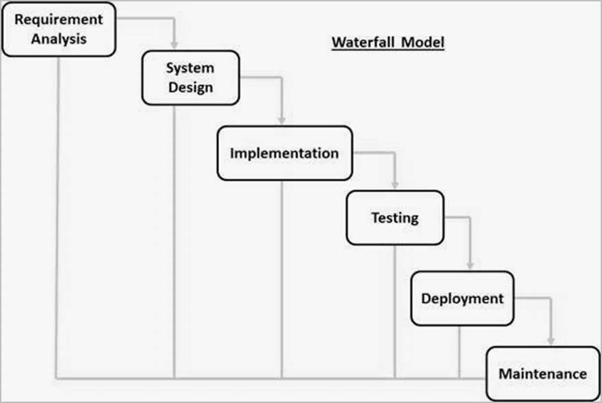

Figure 1: Waterfall Model

# 3.2 Design Pattern:

In software development, design pattern is a general solution to commonly occurring problems. Each pattern is like a blueprint that can be customize to solve a particular design problem in the code. We will be using MVC or Model View Controller design pattern in this project. MVC design pattern specifies that an application consist of data model, presentation information and control information. It separates the logic of different layers in a program in independent units. It is language independent. It consists of three parts:

1. **Model:**

* Central component of the pattern.
* Manages the data, logic and rule of the application.
* Independent to user interface.

1. **View:**

* Model presentation to user in an appropriate interface.
* Allows user to manipulate data.
* Doesn’t store any data.

1. **Controller:**

* Intermediate between model and view.
* Accepts inputs and converts it to commands for the model or view.

The reason behind using this design pattern are:

* It makes application extendable and scalable.
* Parallel development process for model, view and controller is possible.
* Models can have multiple views.
* Ease to modification due to separation.
* Faster development process.

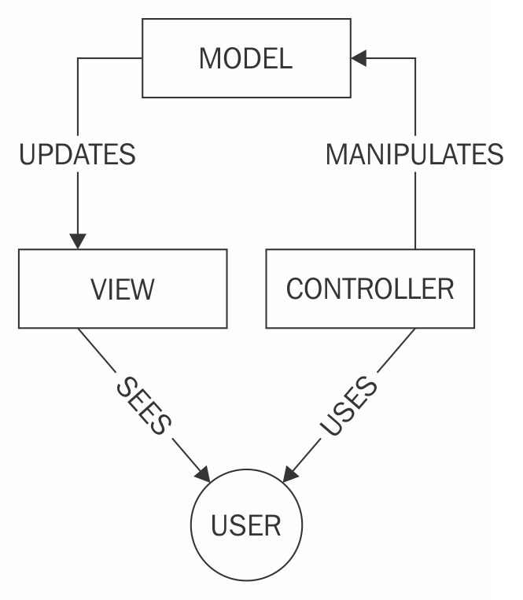

Figure : MVC design pattern

# 3.3 System Architecture:

System architecture is conceptual design of a system that defines the structure, behavior and more views of the system. We will use three tier system architecture in this project. It is composed of three layers or tier of logical computing. The tree tiers in three-tier architecture are:

1. **Presentation tier:** It is also known as first tier. This is the front-end layer and consist of the user interface. It translates the tasks and results to something the user can understand.
2. **Application tier:** It is also known as second tier. This layer coordinates the application, process commands, makes logical decisions and evaluation and perform calculations. It moves and process data between other two tier.
3. **Data tier:** It is also known as third tier. Here information is stored and retrieved from the database. the information is then passed back to the logic tier for processing and then eventually back to the user.

The reason behind using three-tier architecture are:

* Maintainability: - because each tier is independent of the other, updates or changes can be carried out without affecting the affecting the application as a whole.
* Scalability: - because ties are based on the deployment of layers, scaling out an application is reasonably straight forward.
* Flexibility: - because each tier can be managed or scaled independently.
* Availability: - application can exploit the modular architecture of enabling systems.
* Reusability: - components are reusable.
* Faster development: - because of division of work.

# Chapter 4: Scheduling:

# 4.1 Work Breakdown Structure (WBS):

Work breakdown structure defines all the things a project needs to accomplish, organized into multiple levels and displayed graphically. It organizes the team’s work into manageable sections. It basically divides the projects into small parts that makes easy to develop system.

**Music Store**

**Project**

**Management**

**Testing**

**Design**

\

**Analysis**

**Maintenance**

**Implementation**

Unit testing

Requirement

Gathering

Improvement

GUI coding

Planning

Structural model

Maintainability

White box testing

Scope Management

Behavioral model

Database coding

Use case diagram

Task Management

Black box testing

WBS

Database design

Architecture

Integration testing

Configuration Management

GUI design

Analysis specification

Team Management

Risk management

Proposal submission

Figure 3: WBS

# 4.2 Milestone:

|  |  |  |
| --- | --- | --- |
| **S.N.** | **Milestone** | **Date** |
| **1.** | **Project Management**  Planning  Scope management  Task management  WBS  Configuration management  Team management  Risk management  Proposal submission | **6/16/2019 to 7/1/2019**  6/16/2019 to 6/17/2019  6/18/2019 to 6/19/2019  6/20/2019 to 6/22/19  6/23/2019 to 6/25/2019  6/26/2019 to 6/26/2019  6/27/2019 to 6/27/2019  6/28/2019 to 6/29/2019  6/30/2019 to 7/1/2019 |
| **3.** | **Analysis**  Requirement gathering  Use case diagram  Architecture  Analysis specification | **7/2/2019 to 7/30/2019**  7/2/2019 to 7/12/2019  7/13/2019 to 7/19/2019  7/20/2019 to 7/24/2019  7/25/2019 to 7/30/2019 |
| **4.** | **Design**  Structural diagram  Behavioral diagram  UI Design  Database Design | **7/31/2019 to 8/27/2019**  7/31/2019 to 8/7/2019  8/8/2019 to 8/15/2019  8/16/2019 to 8/21/2019  8/22/2019 to 8/27/2019 |
| **5.** | **Implementation**  Database coding  GUI coding | **8/28/2019 to 9/19/2019**  8/28/2019 to 9/2/2019  9/3/2019 to 9/19/2019 |
| **6.** | **Testing**  Unit testing  Black box testing  White box testing  Integrated testing | **9/20/2019 to 10/4/2019**  9/20/2019 to 9/23/2019  9/24/2019 to 9/28/2019  9/29/2019 to 10/1/2019  10/2/2019 to 10/4/2019 |
| **7.** | **Maintenance**  Improvement  Maintainability | **10/5/2019 to 10/11/2019**  10/5/2019 to 10/7/2019  10/8/2019 to 10/11/2019 |

Table : Milestone

# 4.3 Gantt chart:

# Chapter 5: Risk Management:

The process of identifying, monitoring and managing potential risks in order to minimize the negative impact that may have on project.

Table showing likelihood value of risks

|  |  |
| --- | --- |
| **Likelihood** | **Values** |
| Low | 1 |
| Medium | 2 |
| High | 3 |

Table : Likelihood table

Table showing consequences value of risk

|  |  |
| --- | --- |
| **Consequences** | **Values** |
| Very Low | 1 |
| Low | 2 |
| Medium | 3 |
| High | 4 |
| Very High | 5 |

Table : Consequences table

**Impact = Likelihood * Consequences**

|  |  |  |  |  |  |
| --- | --- | --- | --- | --- | --- |
| **S.N.** | **Risk** | **Likelihood** | **Consequences** | **Impact** | **Action** |
| 1. | Software crash | 2 | 5 | 10 | Backup of project |
| 2. | Hardware Failure | 2 | 3 | 6 | Use of good quality & repair |
| 3. | Data theft | 2 | 5 | 10 | Strong security |
| 4. | Software Update | 2 | 3 | 6 | Manual update of software |
| 5. | Virus attack | 2 | 4 | 8 | Use of antivirus |
| 6. | Insufficient time | 3 | 3 | 9 | Proper planning |
| 7. | Natural disaster | 1 | 2 | 2 | Data backup in safe place |

Table : Impact table

# Chapter 6: Configuration Management:

Configuration management is a method to establish and maintain a product performance, function and physical attributes consistent with its requirements, design and operational information throughout its life. The basic directory of the project which maintains efficiency and reliability of the system.

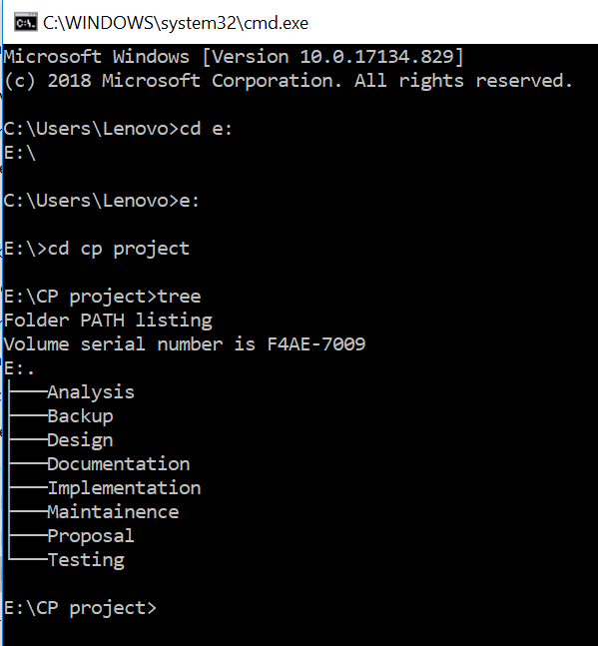

Figure : File directory

# Chapter 7: Conclusion:

Finally, the MIS for the music store will developed. This system will contain different features and functions such as record items, register, report generation. To complete the proper project, it will take 760998 days starting from proposal of project, analysis to end documentation of project. It will increase the efficiency and accuracy. It will be creating by using waterfall model. And the development will be done using MVC pattern.

# References:

1. Workbreakdownstructure.com. (2019). *What is a Work Breakdown Structure (WBS) -Workbreakdownstructure.com*. [online] Available at: https://www.workbreakdownstructure.com/ [Accessed 1 Jul. 2019].
2. Ray, S. and Ray, S. (2019). *The Risk Management Process in Project Management*. [online] ProjectManager.com. Available at: https://www.projectmanager.com/blog/risk-management-process-steps [Accessed 1 Jul. 2019].
3. Plutora. (2019). *Configuration Management: What Is It and Why Is It Important? - Plutora*. [online] Available at: https://www.plutora.com/blog/configuration-management [Accessed 1 Jul. 2019].