

Parallella-4K
Specifications
Rev-16-08-25
ANDREAS OLOFSSON

Specifications

- Basic Features:
  - 256 EE16G301 devices (providing 4096 Epiphany CPU/DSP cores (600MHz))
  - 128 MB Epiphany SRAM software managed cache
  - 4 HPC FMC connectors for off board expansion to FPGA boards (like a Zynq evaluation board)
Components:
  - 4 eLink flex cables
  - 1 carrier card for connecting Parallella-Meta boards together (mostly reset, clock, connectors)
  - Up to 16 Parallella-Meta boards
- Aggregate Performance:
  - 5 TFLOPS
  - 2.5 THz of equivalent CPU performance (4096 * 600MHz)
  - 78 TB/s local SRAM bandwidth
  - 102 GB/s eLink off-board bandwidth
  - 25 GB/s “Ethernet” bandwidth
- Programming Support:
  - Software Tools: GCC, GDB, Eclipse
  - Programming model: C, C++, OpenCL, OpenMP, MPI,
- Power: (per meta board)
  - 1.0V rail for core power (approx 16A)
  - 1.8V rail for LVDS/IO power (approx 8A)
  - Ability to power each Meta card individually through power islands
  - <500W typical power consumption
- Mechanical dimensions:
  - Parallella-4K carrier card is 439 x 451 (mm)
  - Total system size would be 710 x 457 x ?? (mm)

Drawings

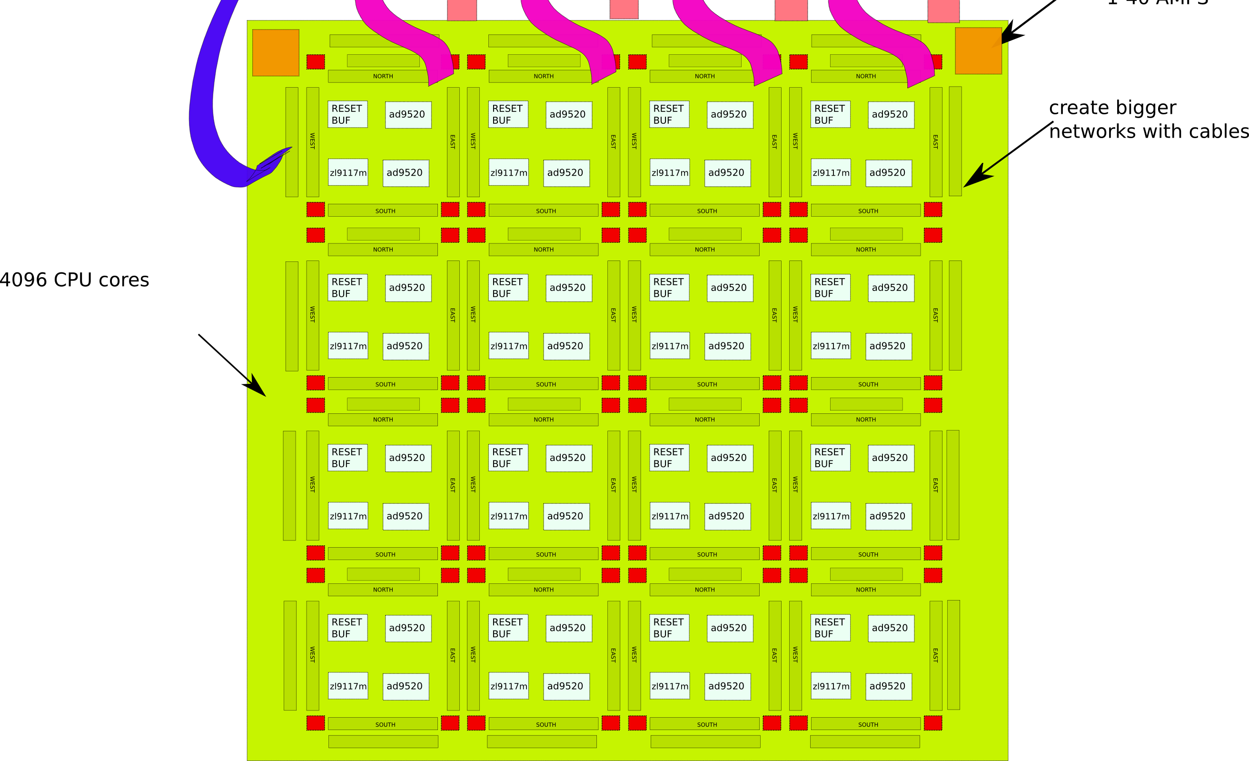
Top side view of server fitting into 19 inch rack. Front panel would be at the bottom of this drawing.

