

Parallella-Meta
Specifications
Rev-16.08.25

ANDREAS OLOFSSON

Overview

The Parallella-Meta board is a PCI-104 form factor board (90.8mm x 95.9mm) that includes 16 E16G301 chips, 5 Samtec BSH-120 connectors for eLink signaling, clocks and power.

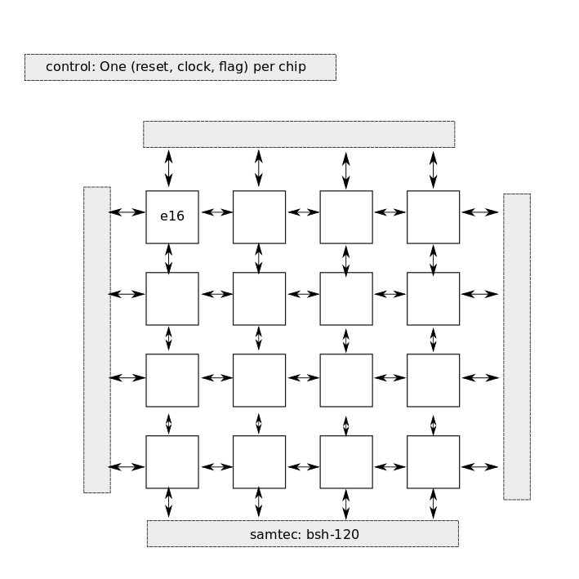

Specifications

- CPU:
  - 256 Epiphany dual-issue RISC CPU cores (4x4 grid of E16G301 chips)
  - 600 MHz nominal operating frequency (overclocking to 1GHz possible, but not guaranteed)
  - 512 autonomous DMA engines
  - 300 GFLOPS (nominal)
  - 256 cores * 600Mhz ~ equivalent to a “153 GHz” of dual issue CPU performance
- Programming Support:
  - Software Tools: GCC, GDB, Eclipse
  - Programming model: C, C++, OpenCL
  - Under development: OpenMP, MPI, POSIX
- Memory System:
  - Distributed shared memory model up to 4096 cores (ie up to 16 meta modules)
  - 8 MB of on-chip single cycle local SRAM memory
  - 4.9 TB/s on chip memory bandwidth
- Mesh Network:
  - Meta module can be scaled “ad infinitum” (beyond 4096 cores) using messaging
  - 38 GB/s on chip cross section bandwidth
  - 6.4 GB/s module cross section bandwidth
- IO:
  - 16 independent bidirectional eLinks
  - 16 GB/s eLink input bandwidth
  - 9.6 GB/s eLink output bandwidth
  - 16 LVDS independent clock inputs (one for each chip)
  - 4 coordinate pins for specifying ROW/COL ID of module
- Power:
  - 1.0V rail for core power (approx 16A)
  - 1.8V rail for LVDS/IO power (approx 8A)
  - <40W typical power consumption
- Mechanical:
  - PCI-104 mechanical form factor, with mounting holes in corners
  - 4 high frequency Samtec type BSH connectors for mating eLinks to carrier card
  - 1 high frequency Samtec type BSH connector for mating clk, power,reset to carrier card
  - 1.5mm uniform height across the top complete top of module
  - Optional bsh / bth contacts on top for stacking
  - Size is 90.8 x 95.9 x 7 (mm)

Mechanical Drawing
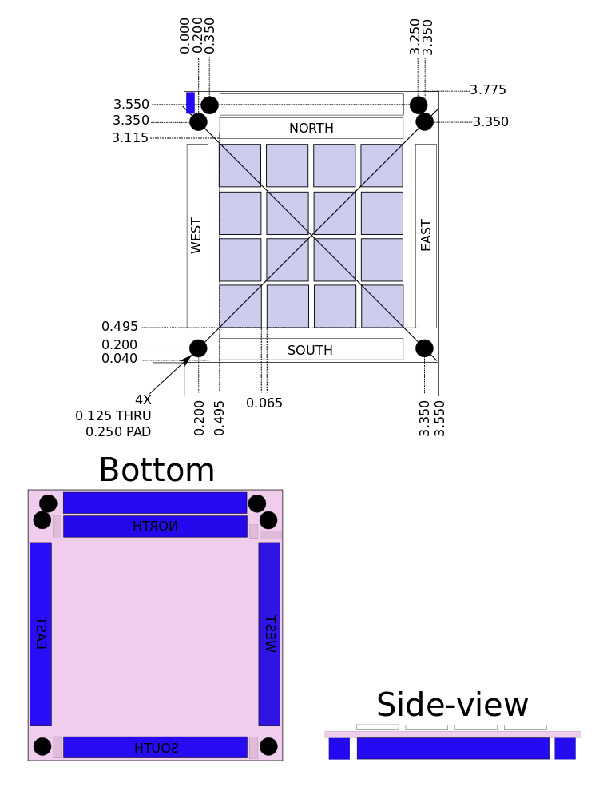
Components

Component | Quantity | Note | Placement
BSH⁃120⁃01⁃F⁃D⁃A | 5 | 240 pin connectors | Bottom
E16G301-SBCU | 16 | Multicore DSP IC | Top
0.1” 3 pin header | 16 | power connector (0.1in), 1.8/1.0/gnd | Bottom
0.1” 3 pin header | 1 | Fan connector | Top
Resistors/Capacitors | - | See Parallella | Bottom of board
Temp Sensors | 1 | ????
LED

Instances

Component | Quantity
H1 | South samtec
H2 | West samtec
H3 | North samtec
H4 | East samtec
H5 | Control smatec
i0 | Upper left E16G301
I1 | To the right of i0
I2 | To the right of i1
I3 | To the right of I2
I4 | Below i0
I5-i15 | Continue in zig-sag pattern
Rx | resistors
Cx | capacitors

