202203041  
OOPS_LAB4

(Python 🡪 Tkinter)  
Q1) Take the name of user as input and displays a personalized greeting in the middle of window.

CODE:

*from* tkinter *import* *  
  
q1 = Tk()  
q1.title("Hello")  
q1.geometry("500x500")  
  
n = input("Name:")  
h = "Hello "  
*for* i *in* range(19):  
 Label(q1, text=" ").grid(row=i, column=i)  
label = Label(q1, text=h + n)  
label.grid(row=10, column=20)  
q1.mainloop()

OUTPUT:  
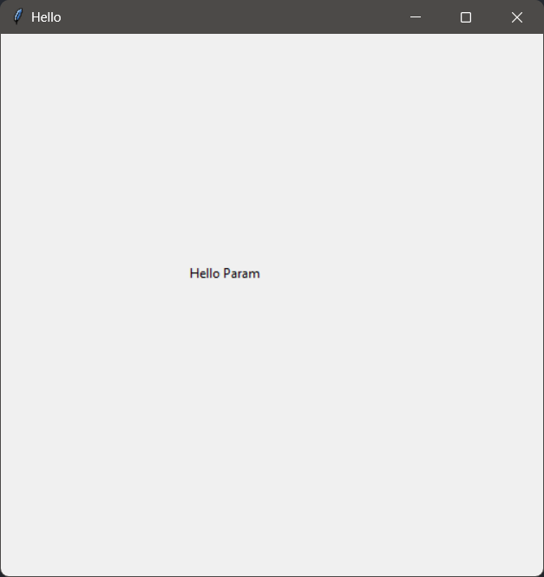

Q2) Change BG by user dropdown selection.

CODE:

*from* tkinter *import* *  
  
q2 = Tk()  
q2.title("BG")  
q2.geometry("500x500")  
  
  
*def* change_bg():  
 q2.configure(bg=click.get()).pack()  
  
  
click = StringVar()  
click.set("White")  
dropdown = OptionMenu(q2, click, "White", "Red", "Black", "Cyan", "Blue", "Yellow")  
dropdown.pack()  
  
button = Button(q2, text="Change Colour", command=change_bg).pack()  
  
q2.mainloop()

OUTPUT:

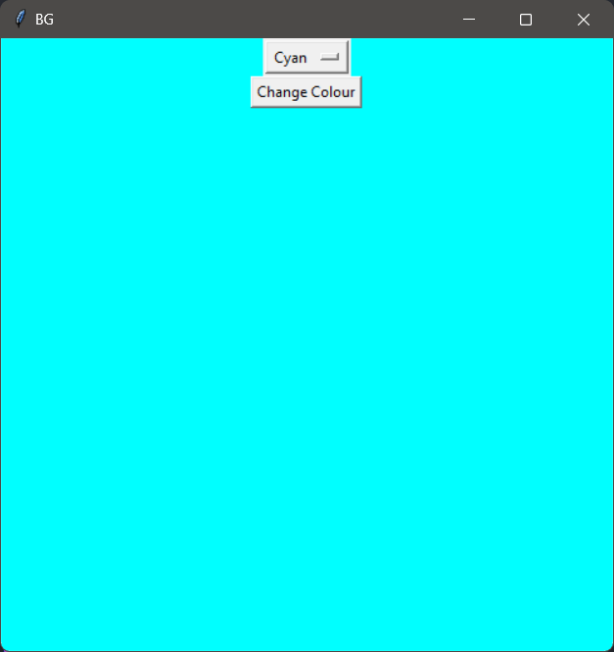

Q3) Simple Calculator

CODE:

*from* tkinter *import* *  
  
q3 = Tk()  
q3.title("calculator")  
e = Entry(q3, width=50, borderwidth=10)  
e.grid(row=0, column=0, columnspan=3, padx=10, pady=10)  
  
  
*def* button_click(num):  
 c = e.get()  
 e.delete(0, END)  
 e.insert(0, str(c)+str(num))  
  
  
*def* buttonClear():  
 e.delete(0, END)  
  
  
*def* buttonAdd():  
 num1 = e.get()  
 *global* n1  
 *global* calc  
 calc = "+"  
 n1 = int(num1)  
 e.delete(0, END)  
  
  
*def* buttonSub():  
 num1 = e.get()  
 *global* n1  
 *global* calc  
 calc = "-"  
 n1 = int(num1)  
 e.delete(0, END)  
  
  
*def* buttonMult():  
 num1 = e.get()  
 *global* n1  
 *global* calc  
 calc = "*"  
 n1 = int(num1)  
 e.delete(0, END)  
  
  
*def* buttonDiv():  
 num1 = e.get()  
 *global* n1  
 *global* calc  
 calc = "/"  
 n1 = int(num1)  
 e.delete(0, END)  
  
  
*def* buttonEqual():  
 num2 = e.get()  
 e.delete(0, END)  
 *if* calc == "+":  
 e.insert(0, n1 + int(num2))  
 *elif* calc == "-":  
 e.insert(0, n1 - int(num2))  
 *elif* calc == "*":  
 e.insert(0, n1*int(num2))  
 *elif* calc == "/":  
 e.insert(0, n1 / int(num2))  
  
  
button0 = Button(q3, text="0", padx=100, pady=33, command=*lambda*: button_click(0))  
button1 = Button(q3, text="1", padx=33, pady=33, command=*lambda*: button_click(1))  
button2 = Button(q3, text="2", padx=33, pady=33, command=*lambda*: button_click(2))  
button3 = Button(q3, text="3", padx=33, pady=33, command=*lambda*: button_click(3))  
button4 = Button(q3, text="4", padx=33, pady=33, command=*lambda*: button_click(4))  
button5 = Button(q3, text="5", padx=33, pady=33, command=*lambda*: button_click(5))  
button6 = Button(q3, text="6", padx=33, pady=33, command=*lambda*: button_click(6))  
button7 = Button(q3, text="7", padx=33, pady=33, command=*lambda*: button_click(7))  
button8 = Button(q3, text="8", padx=33, pady=33, command=*lambda*: button_click(8))  
button9 = Button(q3, text="9", padx=33, pady=33, command=*lambda*: button_click(9))  
button_add = Button(q3, text="+", padx=33, pady=33, command=buttonAdd)  
button_sub = Button(q3, text="-", padx=33, pady=33, command=buttonSub)  
button_mul = Button(q3, text="*", padx=33, pady=33, command=buttonMult)  
button_div = Button(q3, text="/", padx=33, pady=33, command=buttonDiv)  
button_clr = Button(q3, text="<--", padx=33, pady=33, command=buttonClear)  
button_eq = Button(q3, text="=", padx=33, pady=33, command=buttonEqual)  
button7.grid(row=1, column=0)  
button8.grid(row=1, column=1)  
button9.grid(row=1, column=2)  
button4.grid(row=2, column=0)  
button5.grid(row=2, column=1)  
button6.grid(row=2, column=2)  
button1.grid(row=3, column=0)  
button2.grid(row=3, column=1)  
button3.grid(row=3, column=2)  
button0.grid(row=4, column=0,columnspan=3)  
button_add.grid(row=5, column=0)  
button_sub.grid(row=5, column=1)  
button_clr.grid(row=5, column=2)  
button_mul.grid(row=6, column=0)  
button_div.grid(row=6, column=1)  
button_eq.grid(row=6, column=2)  
q3.mainloop()

OUTPUT:

