RetailIQ_AI
AI Powered Retail Sales & Customer Intelligence Platform
AICTE | IBM SkillsBuild Data Analytics with AI 2026
Student: Parameshwar Shelke

Abstract
RetailIQ_AI transforms raw retail transaction data into business intelligence. The project performs data cleaning, exploratory data analysis, KPI generation, customer segmentation, and machine learning to support data-driven decisions.

Problem Statement
Retail businesses collect thousands of transactions daily, but raw data alone does not reveal customer behavior, product performance, or revenue trends. This project converts transactional data into actionable insights.

Objectives
- Clean and preprocess retail transaction data
- Generate business KPIs and interactive dashboards
- Analyze product and country-wise revenue
- Segment customers using RFM analysis
- Build a Random Forest prediction model

Dataset Description
Field | Description
Invoice | Unique invoice number
StockCode | Product code
Description | Product name
Quantity | Items purchased
InvoiceDate | Transaction date
Price | Unit price
Customer ID | Customer identifier
Country | Customer country

Data Cleaning
Removed duplicates, handled missing customer IDs, converted InvoiceDate to datetime, and filtered invalid quantities/prices.

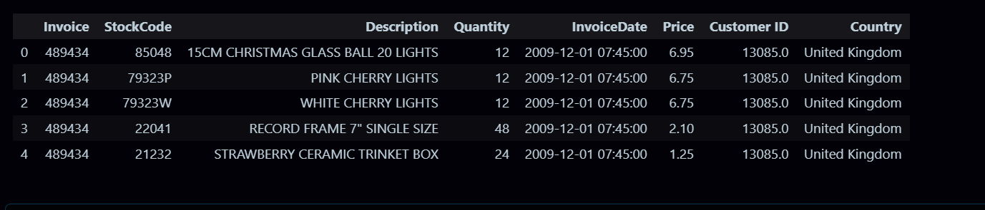

Feature Engineering
Created Revenue, Year, Month, Day, and Hour features to improve analysis and modeling.
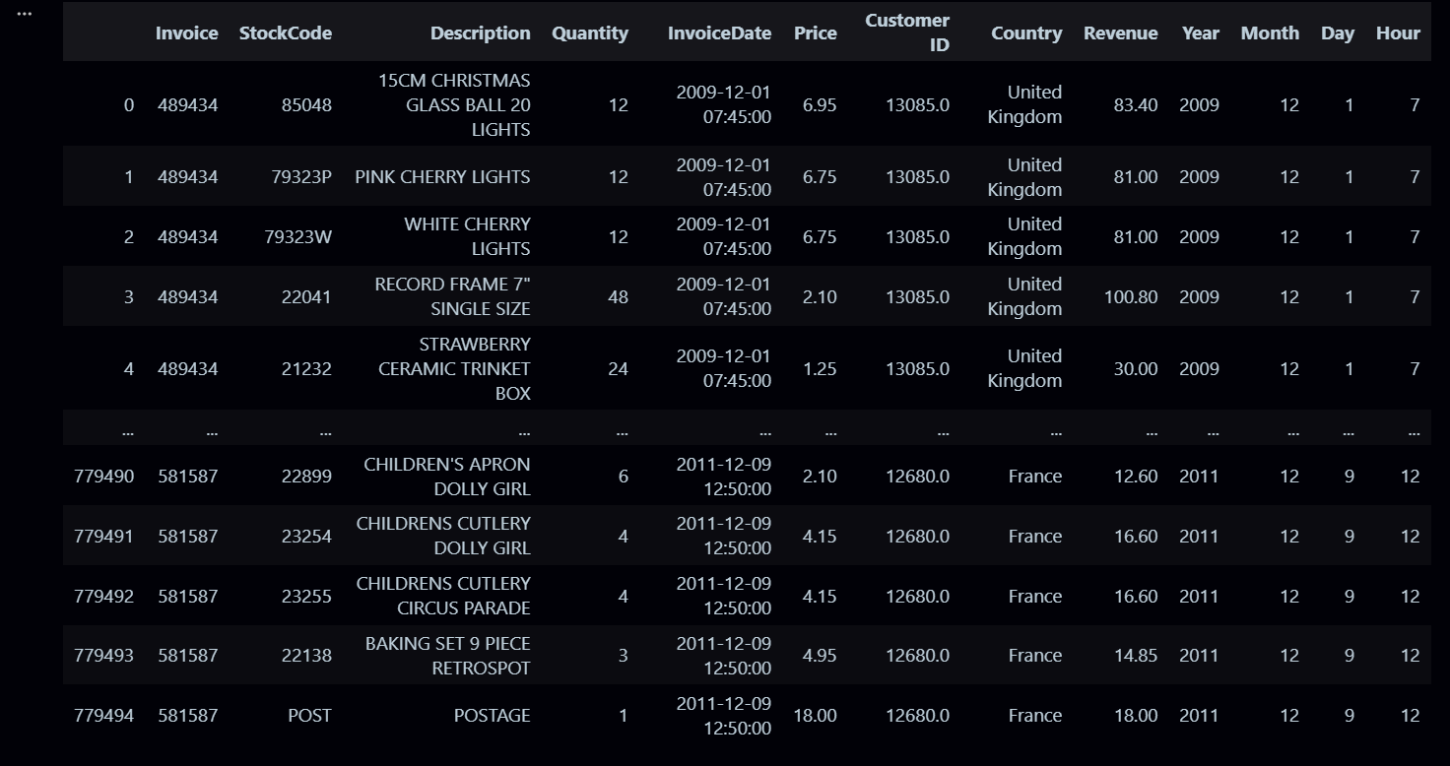

KPI Dashboard
Calculated Total Revenue, Total Orders, Total Customers, and Average Order Value.
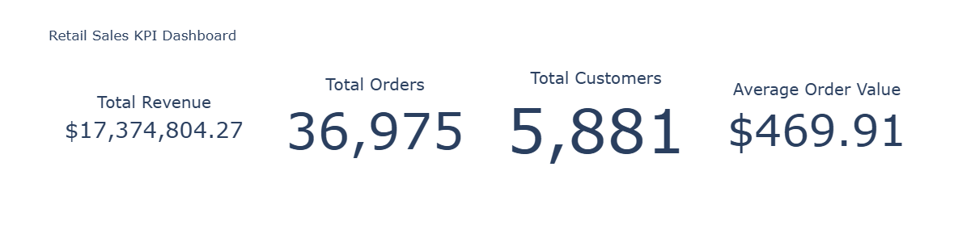

Sales Trend Analysis
Analyzed monthly revenue trends to identify seasonality and growth opportunities.
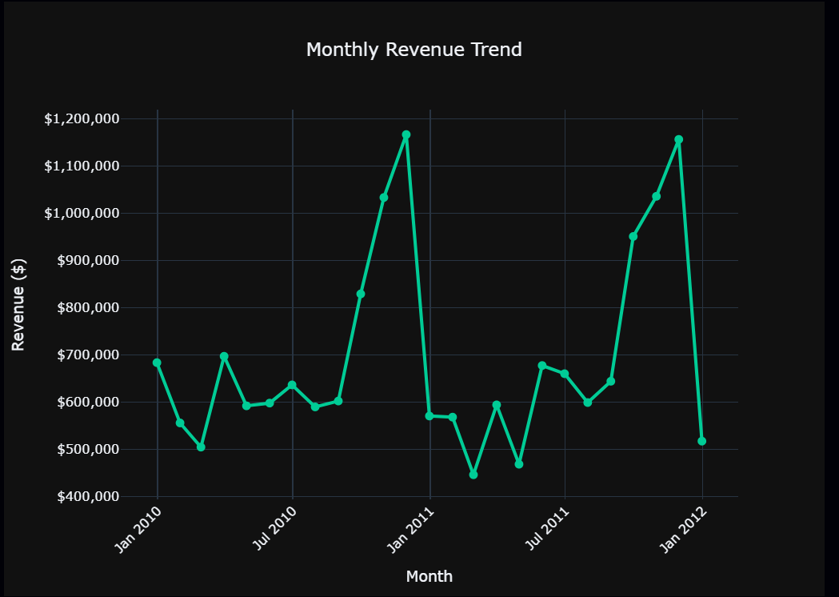

Top Products Analysis
Ranked products by total revenue to identify high-performing inventory.
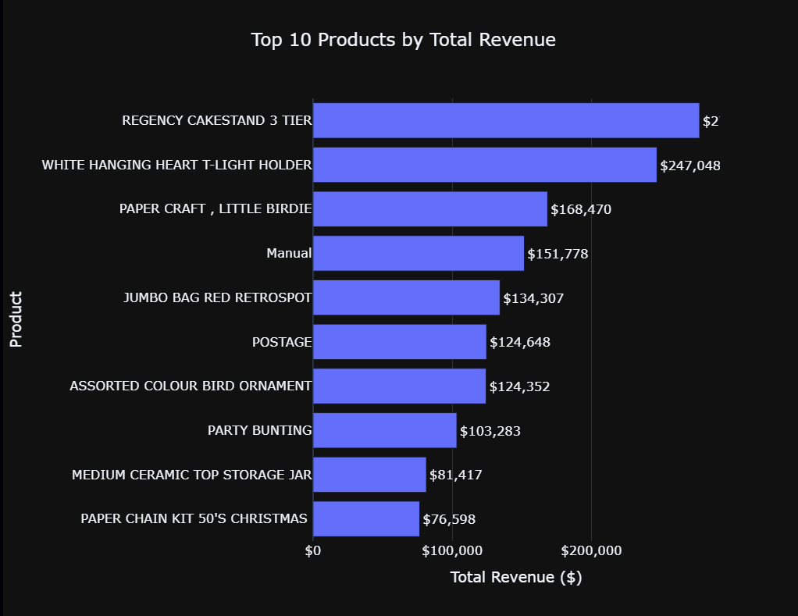

Country Analysis
Compared revenue across countries to identify key markets.
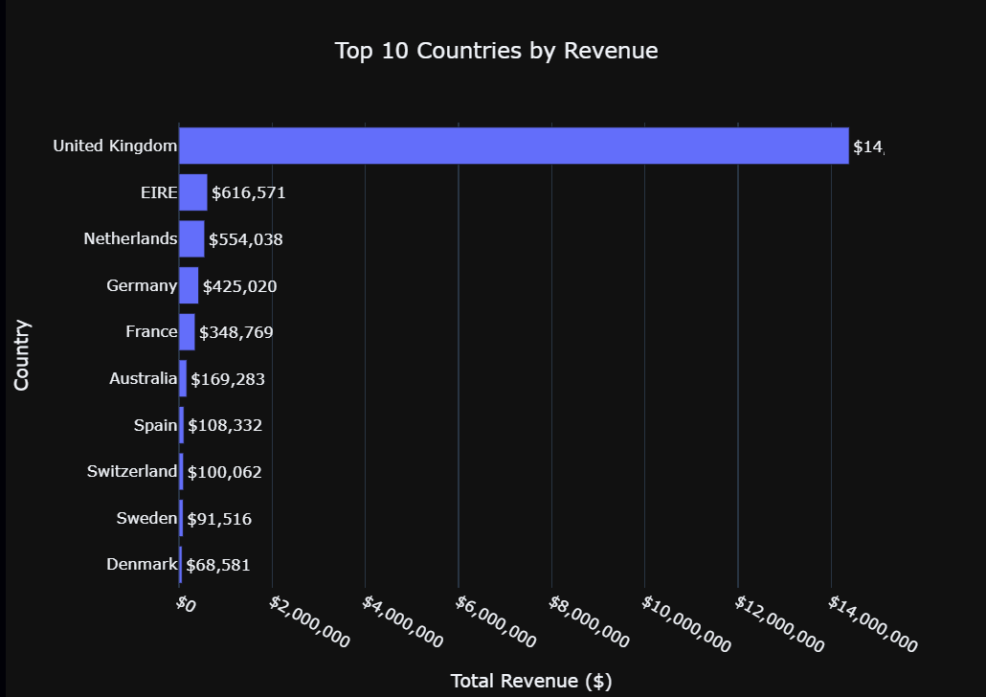

Customer Segmentation
Applied RFM (Recency, Frequency, Monetary) segmentation to classify customers into business groups.
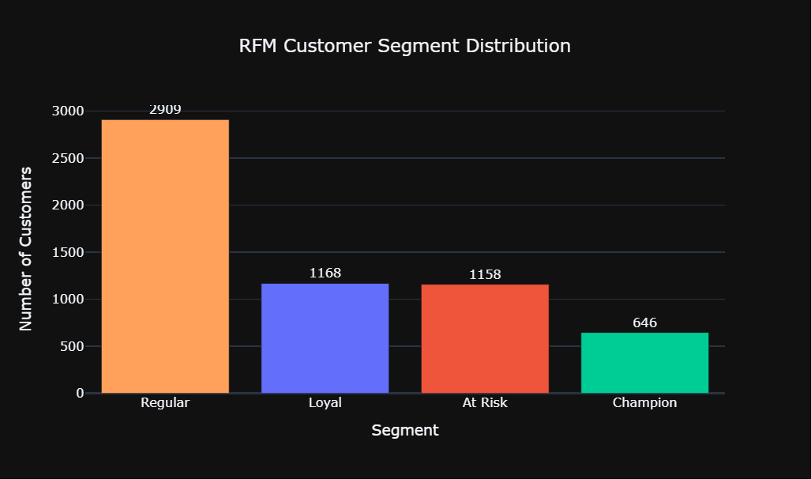

Machine Learning
Built a Random Forest model to predict revenue category and evaluated it using Accuracy, Precision, Recall, F1 Score, and Confusion Matrix.
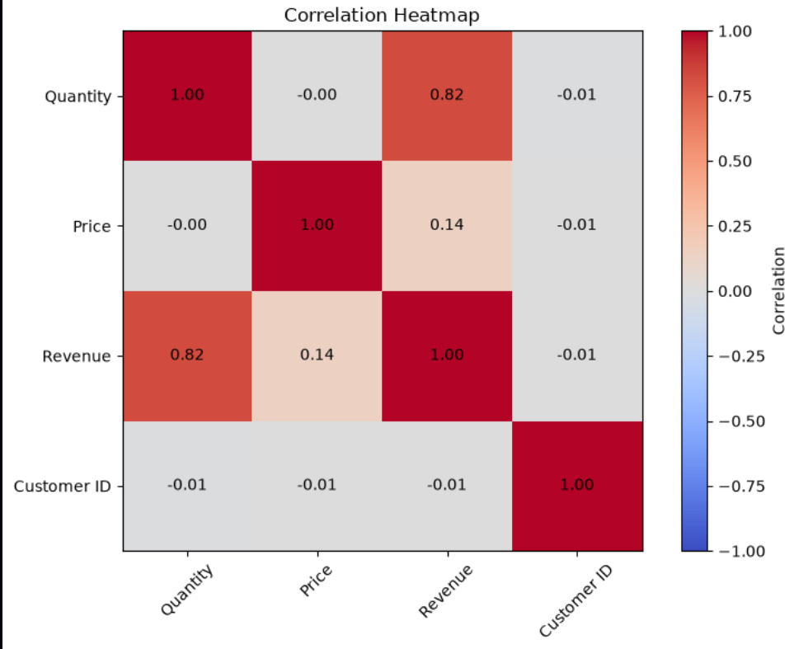

Business Insights
Summarized facts, risks, opportunities, and recommended actions for management.
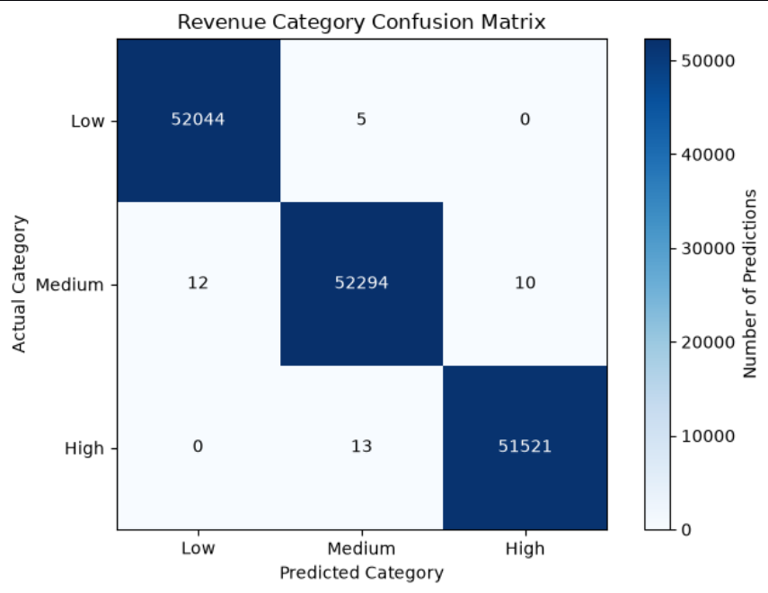

Conclusion
RetailIQ_AI demonstrates how data analytics and AI can convert retail transactions into strategic business decisions.

