______________

**InsightStream: Navigate the News Landscape**

Your Personalized News Assistant

______________

1. Introduction

Team Members:

PARAMESH KUMARAN R( Team Leader)

PRADEEP S (Team Member)

MOHANPRASATH P (Team Member)

SARANRAJ S (Team Member)

______________

2. Project Overview

Purpose:

InsightStream is a dynamic, web-based application designed to revolutionize the way users interact with news. It personalizes news consumption by curating articles from various sources, analyzing trends, and presenting content based on individual preferences, interests, and current events. The app offers intelligent filters, a news trend tracker, and real-time updates, helping users navigate the ever-changing news landscape with ease and efficiency.

Key Features:

• 📰 Personalized News Feed: Curates articles based on user preferences and reading habits.

• 🔍 Smart Search & Filters: Search news by topics, keywords, and trends.

• 📊 Trend Analysis: Real-time analysis of global and regional news trends.

• 🗣️ Opinion Polls & Discussions: Allow users to share opinions on articles and participate in polls.

• 🧑💻 Multi-Source News Aggregation: Collects news from reliable sources across the internet.

• 🌐 Responsive Interface: Optimized for mobile and desktop usage, offering seamless browsing.

• 🔔 Real-time Notifications: Push notifications for breaking news and significant updates.

______________

3. Architecture

Component Structure

Component Description

App.js The main entry point, handling layout and routing.

Header.js Displays navigation bar with sections like Home, Search, Trends, Profile.

NewsFeed.js Displays the personalized news feed.

NewsArticle.js Renders individual news articles with summary and links.

SearchBar.js Allows keyword-based searching of news articles.

TrendTracker.js Visualizes trending topics, articles, and statistics.

Polls.js Manages user polls and allows participation in discussions.

UserProfile.js Handles user preferences, history, and saved articles.

State Management:

The app utilizes Redux for state management, ensuring efficient sharing of user preferences, news data, and trending articles across the application. Redux provides a predictable state container, making it easy to manage and debug the application’s data flow.

Routing (React Router v6)

Route Description

/ Home page with featured and trending articles.

/search Search news articles based on user input.

/trends View trending news, statistics, and analyses.

/article/:id Detailed view of an individual article.

/profile User profile to manage preferences and saved articles.

______________

4. Setup Instructions

Prerequisites

• Node.js v18 or above

• npm v9 or above

Installation

1. Clone the repository

git clone https://github.com/your-repo/InsightStream.git

2. Navigate to the client directory

cd insightstream/client

3. Install dependencies

npm install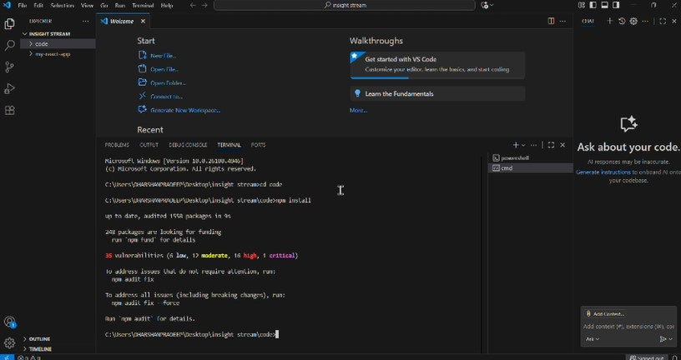

4. Create a .env file with necessary API keys (for news sources and trend analytics):

REACT_APP_NEWS_API_KEY=your_news_api_key_here

REACT_APP_TREND_ANALYTICS_KEY=your_analytics_key_here

5. Start the development server

npm start

The app will run locally at:

➡️ http://localhost:3000/

______________

5. Folder Structure

client/

├── public/

├── src/

│ ├── components/

│ │ ├── Header.js

│ │ ├── NewsFeed.js

│ │ ├── NewsArticle.js

│ │ ├── SearchBar.js

│ │ ├── TrendTracker.js

│ │ ├── Polls.js

│ │ └── UserProfile.js

│ ├── context/

│ │ └── AppContext.js

│ ├── pages/

│ │ ├── Home.js

│ │ ├── Search.js

│ │ ├── Trends.js

│ │ ├── ArticlePage.js

│ │ └── Profile.js

│ ├── utils/

│ │ └── api.js

│ ├── App.js

│ ├── index.js

├── .env

├── package.json

└── README.md

Utilities:

• api.js – Handles requests to the news API providers (e.g., NewsAPI, New York Times API).

• Custom Hooks:

o useFetchNews – Fetches and manages the news data.

o useTrends – Retrieves and displays trending news analysis.

o useUserProfile – Manages user profile data and preferences.

______________

6. Running the Application

To run the application locally, use the following command in the client/ directory:

npm start

The application will be live at:

📍 http://localhost:3000/

______________

Additional Enhancements for the Future:

1. User Authentication:

o Integrating a login/signup system could allow users to save their preferences, voting history, and most-read articles. This can also be extended with social logins.

2. Advanced Analytics & AI Insights:

o Using AI to offer more personalized news recommendations or insights, based on sentiment analysis of articles, could further enhance the user experience.

3. Local News:

o Expanding the service to allow users to get localized news based on their location could be a significant feature, catering to those interested in regional news.

4. News Summarization:

o Integrating a text summarization feature to provide concise versions of lengthy articles would cater to users looking for quick insights.

5. Social Sharing:

o Allow users to easily share articles and their opinions on social media platforms, enhancing the interactivity of the app.

______________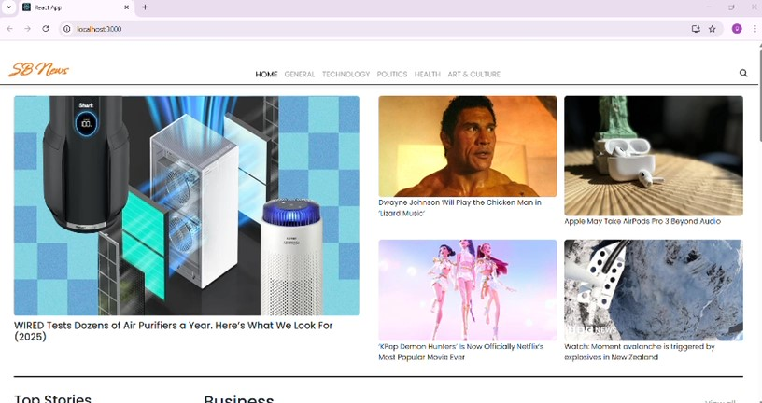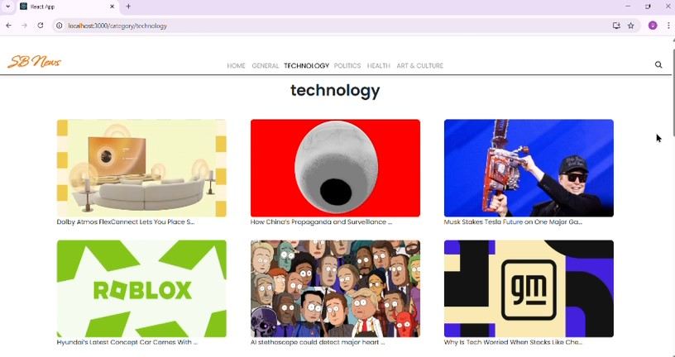

Conclusion:

InsightStream is designed to cater to the evolving needs of modern news consumers. With personalized content, real-time trend analysis, and user interaction features, it aims to be a one-stop destination for navigating the complex news landscape. The future roadmap involves adding more AI-powered features, improving user engagement, and expanding news coverage to make the app more inclusive and informative.