## A Project Report On SkillBee(Freelance Web Service)

DEVELOPED BY:

**IT042** - **Yash Italiya**

**IT043** – **Param Jagani**

Guided By

**Prof. Ravindra Vyas**

Department of Information Technology Faculty of Technology

DD University



**Department of Information Technology Faculty of Technology, Dharmsinh Desai University College Road, Nadiad-387001 March-2024**

**Software Requirements Specification (SRS) for SkillBee**

**1. Introduction**

The SkillBee aims to provides a marketplace where freelancers can offer services to customers. The platform facilitates transactions, communication, and collaboration between buyers and sellers across various categories.

**2. Scope**

The SkillBee will include the following features:

* User registration and authentication
* Profile management for buyers and sellers
* Service listing and browsing
* Ordering and payment processing
* Communication tools for buyers and sellers
* Review and rating system
* Admin dashboard for managing users and services

**3. Functional Requirements**

**3.1 Authentication and Authorization**

* Users can register for a new account.
* Users can log in to their accounts using email/password or google accounts.
* Authentication tokens will be used for secure API communication.
* Role-based access control will be implemented, distinguishing between buyers, sellers, and administrators.

**3.2 User Management**

* Users can edit their profiles, including personal information, profile picture, and payment details.
* Password reset functionality will be available for forgotten passwords.
* Users can deactivate or delete their accounts.

**3.3 Service Management**

* Sellers can create, edit, and delete service listings.
* Each service listing includes a title, description, price, category, and optional extras.
* Buyers can browse and search for services based on categories, keywords, and filters.
* Services will be listed with relevant details, ratings, and reviews.

**3.4 Ordering and Payment**

* Buyers can place orders for services, including optional extras.
* Payment processing will be handled securely using third-party payment gateways (e.g., Gpay, PayPal).
* Sellers receive notifications of new orders and can communicate with buyers to clarify requirements.
* Orders can be cancelled or modified before they are completed.

**3.5 Communication Tools**

* Built-in messaging system for communication between buyers and sellers.
* Real-time notifications for new messages and order updates.
* Files and attachments can be exchanged securely within conversations.

**3.6 Review and Rating System**

* Buyers can leave reviews and ratings for services they have purchased.
* Ratings and reviews will be displayed on service listings to help buyers make informed decisions.
* Sellers can respond to reviews to address feedback or concerns.

**3.7 Admin Dashboard**

* Administrators have access to a dashboard for managing users, services, and reported content.
* Administrators can suspend or ban users, remove inappropriate content, and moderate disputes.

**4. Non-Functional Requirements**

**4.1 Performance**

* The system should handle concurrent user interactions without significant performance degradation.
* Response times for critical operations (e.g., login, order processing) will be minimal.

**4.2 Security**

* User data and communications should be encrypted using industry-standard protocols (e.g., HTTPS, SSL).
* Payment processing should comply with Payment Card Industry Data Security Standard (PCI DSS) requirements.
* User authentication should be secure, using strong password hashing and token-based authentication.

**4.3 Scalability**

* The system architecture should be scalable to accommodate growth in user base and transaction volume.
* Horizontal scaling techniques should be employed to distribute load across multiple servers or instances.

**5. System Architecture**

* The SkillBee will follow a microservices architecture, with separate components for user authentication, service management, order processing, messaging, and administration. These components will communicate via RESTful APIs and message queues.

**6. Technologies Used**

* Frontend: ReactJS, Redux, SCSS, HTML
* Backend: NodeJs, ExpressJs, RESTful APIs
* Database: MySQL, MongoDB
* Messaging: WebSocket, Socket.IO
* Payment Gateway: Gpay, PayPal

**7. Glossary**

* Buyer: A user who purchases services from sellers.
* Seller: A user who offers services for sale on the platform.
* Administrator: A user with administrative privileges for managing the platform.
* Service: A task or project offered by a seller for purchase by buyers.
* Order: A transaction initiated by a buyer to purchase a service from a seller.

This Software Requirements Specification outlines the key features, functionalities, and technical considerations for developing the Fiverr Clone. It serves as a guide for the development team to ensure the successful implementation of the platform.

**Class Diagram for SkillBee:**

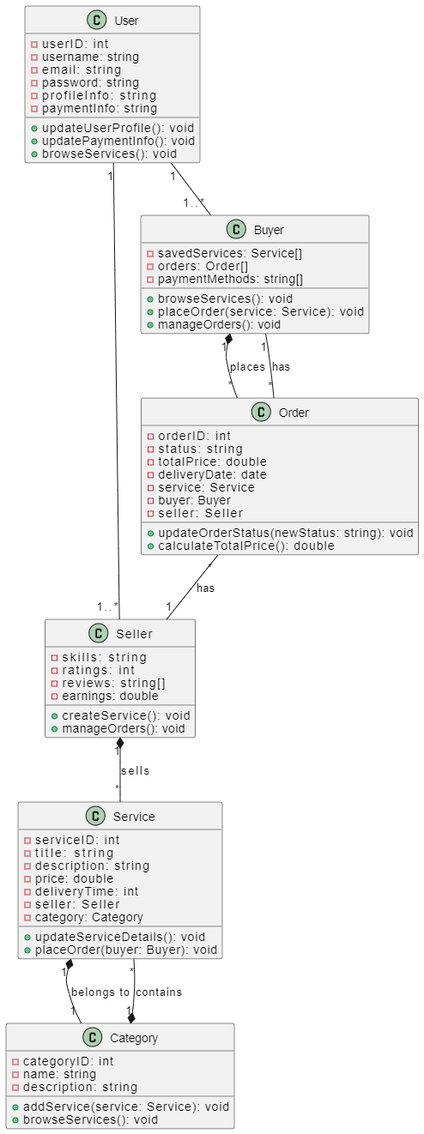

**UseCase Diagram for SkillBee:**

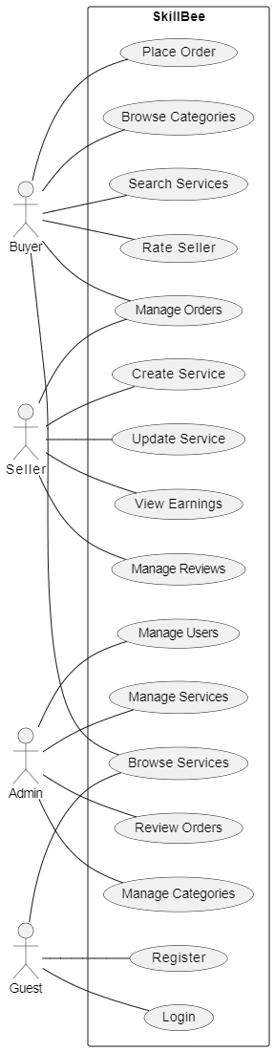

**Activity Diagram for SkillBee:**

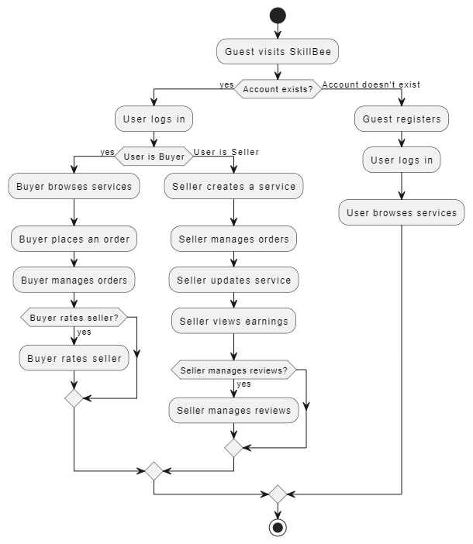

**Sequence Diagram for SkillBee:**

**1.Buyer:**

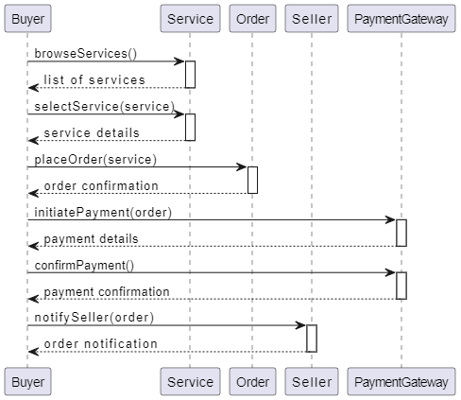

**2.Seller:**

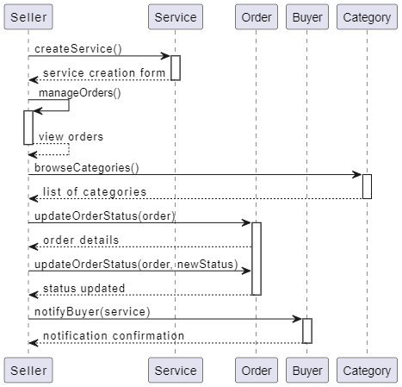

**3.Service:**

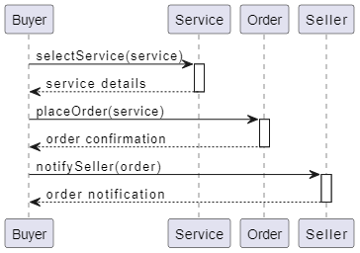

**4.Profile Management:**

