Param Keswani
D15A
27
Batch B

Experiment : 06
AIM : To Connect Flutter UI with fireBase database
THEORY:
Integrating Firebase with a Flutter application involves several steps, and Firebase offers a
variety of backend services that can enhance the functionality of your app. Here's a general
process for integrating Firebase with a Flutter application:

Steps for Firebase Integration in Flutter:

● Go to the Firebase Console and click on "Add Project."

● Add project name:
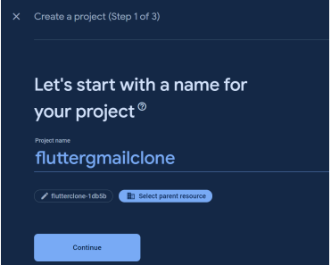
● Create app ,click on Android icon


● Register app
