MAD and PWA Lab
Name: Param Keswani Class: D15A Roll no:27

Aim: Selecting features for application development, the features should comprise of:

1. Common widgets
2. Should include icons, images, charts etc.
3. Should have an interactive Form
4. Should apply navigation, routing and gestures
5. Should connect with FireBase database

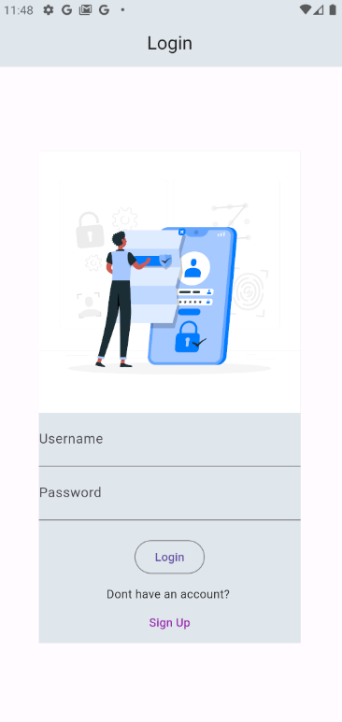 | SIgn In / Sign Up:  1. Username and password  2. Authentication  Firebase authentication  3. Create account for new users
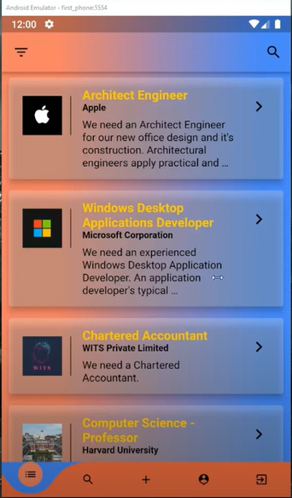 | Display of Jobs :  1.Serach bar  2. Display of cards (jobs)
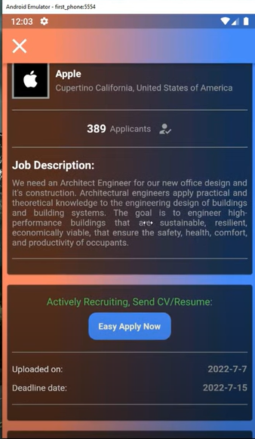 | Details of a job :  1.Apply for the job  2.Details of the job  3.Adding Comments to the post
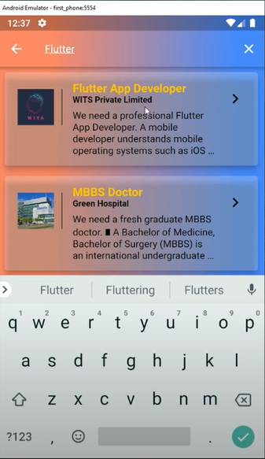 | Search of the jobs :  1.Can open the cards
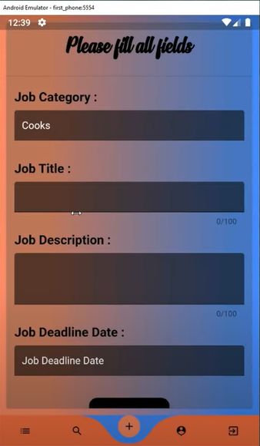 | Form for posting job :  - Form for adding the job  - Contains details of the job

