# Deploy your own whitebeard

This chatbot is based on the aws-genai-llm-chatbot project on aws-samples. Some of the additions on the foundation are the following;

1. Additional Authorization layer based on Amazon Cognito Groups
2. Integration with Federate OIDC for Midway authentication
3. Refactored codebase for better scalability

Follow the following steps to deploy the solution

1. Midway Authentication

Create an OIDC Service Profile on Amazon Federate

* Pre-Prod Environment
  + <https://integ.ep.federate.a2z.com/>
* Production Environment
  + <https://ep.federate.a2z.com/>

Create a Service Profile

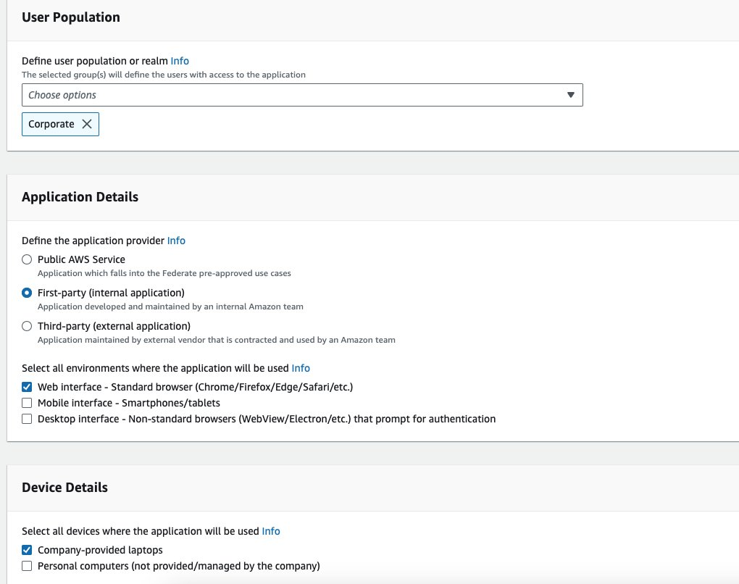

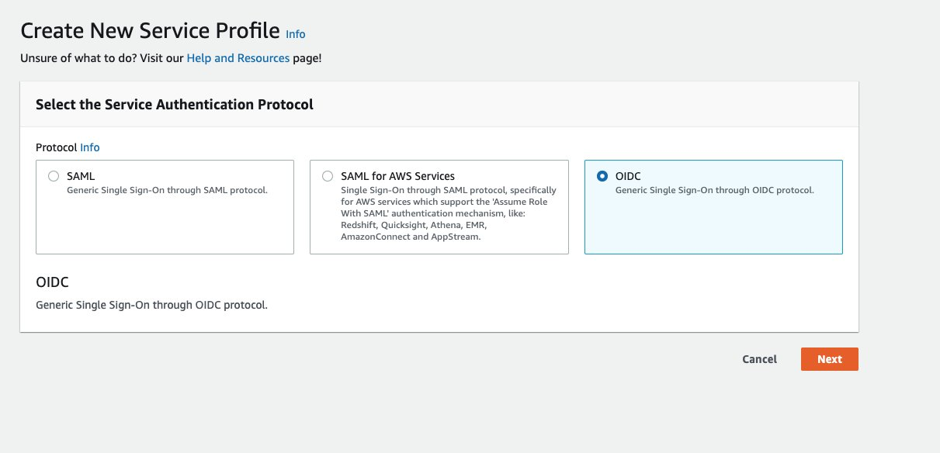

Select the Pre-Approved Use Case: Federate-Cognito Integration

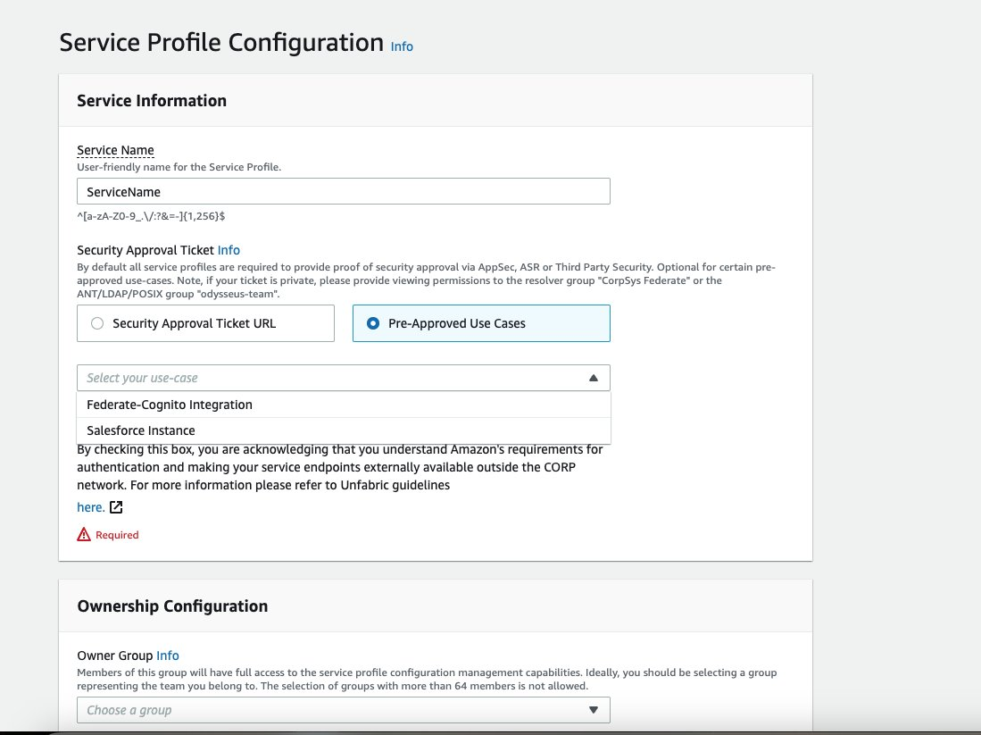

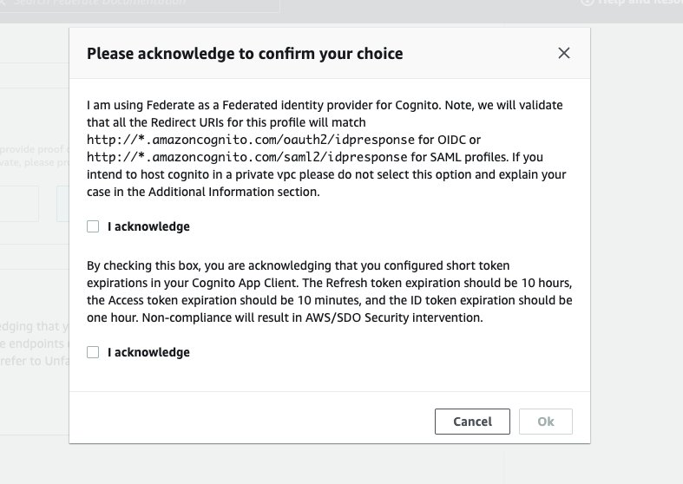

Provide Ownership Information

* Posix Group
* CTI

Click Next

Enter a unique value for Client ID

Enter a dummy redirect uri

Enable the Client Secret Toggle

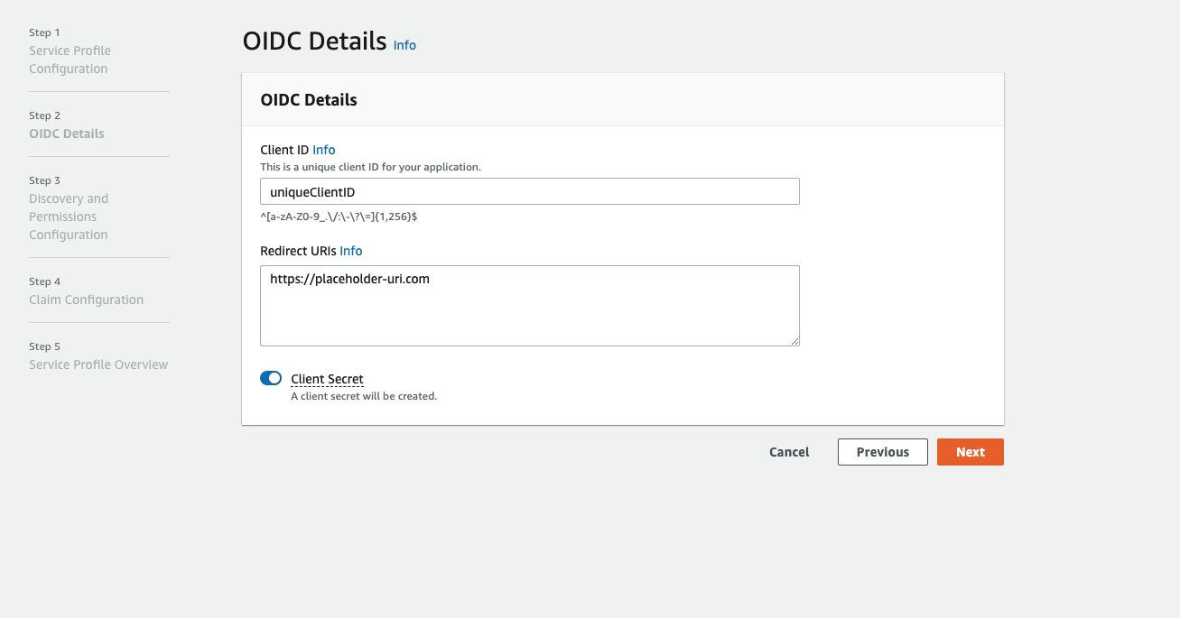

Select Allowed and Restricted LDAP groups to limit permissions. If you want the OIDC profile to be created without any restriction, remove the Restriction Message and Click Next

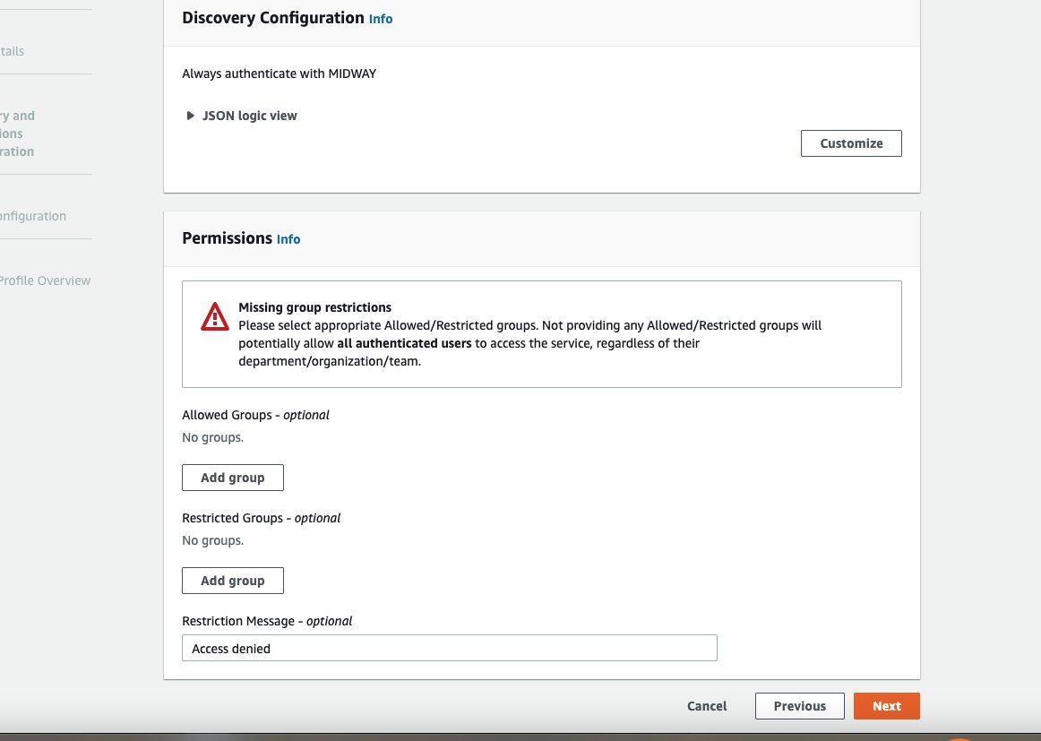

Add the following “FederateUserAttribute” custom claims to auto-create users with basic profile attributes in Amazon Cognito

* EMAIL
* GIVEN_NAME
* FAMILY_NAME

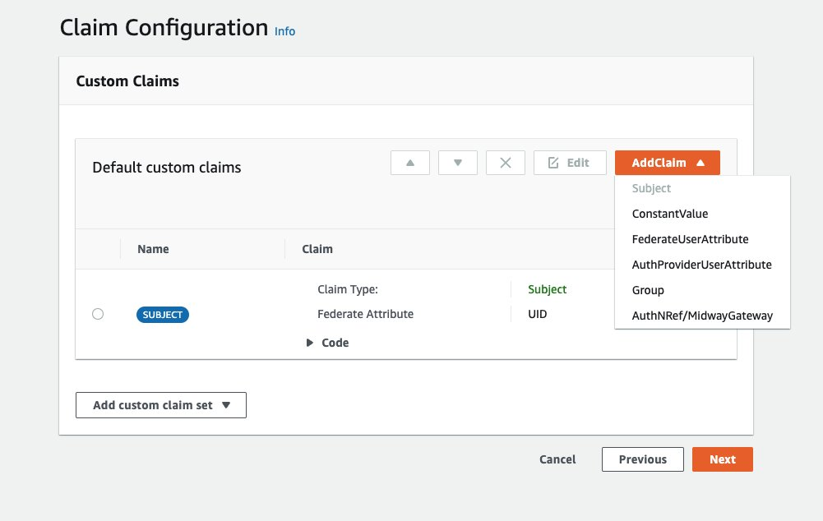

Follow the below Guide to deploy the chatbot in your AWS account

[Deploy | AWS GenAI LLM Chatbot](https://aws-samples.github.io/aws-genai-llm-chatbot/guide/deploy.html)

Select the Advanced Settings during the CDK Config to generate Cognito resources and redirect users automatically to Midway OIDC Provider

[Cognito Federation Overview | AWS GenAI LLM Chatbot](https://aws-samples.github.io/aws-genai-llm-chatbot/documentation/cognito/overview.html)

Navigate to Amazon Cognito User Pool after the build has been completed

Navigate to the App Integration Tab

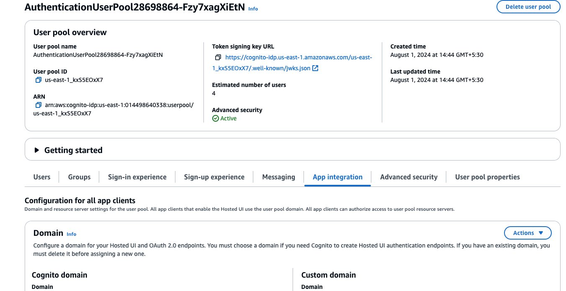

Copy the Domain URL and update the Redirect URI on Federate OIDC Service Profile with the below value

**$COGNITO_DOMAIN_URL/oauth2/idpresponse**

Test the chatbot with the User Interface URI generate as output of the CDK build