INDUSTRY PROJECT : PROJECT REPORT
Industry Project Title | Superstore Profit Analysis
Name of the company | TCS
Name of the institute | JNTU College Of Engineering Manthani

Start Date | End Date | Total Effort(hrs.) | Project Environment | Tools Used
Sep 29th 2025 | Nov 8th 2025 | 90 | Windows OS , Jupyter Notebook, MySQL, Power BI | Python (Pandas, Matplotlib, seaborn),  MySQL, Power BI

TABLE OF CONTENT
- Acknowledgements
- Objective and Scope
- Problem Statement
- Existing Approaches
- Approach / Methodology - Tools and Technologies used
- Workflow
- Assumptions
- Implementation - Data collection, Processing Steps, Diagrams - Charts, Table
- Solution Design
- Challenges & Opportunities
- Reflections on the project
- Recommendations
- Outcome / Conclusion
- Link to code and executable file
- References

Superstore Data Analysis Project Report

1.Acknowledgements
I would like to express my sincere gratitude to my faculty and mentors at TCS, and the management of JNTUH University college of Engineering Manthani for their continuous support, valuable feedback, and guidance throughout this project. I also thank the Department of Computer Science for providing the resources and learning environment necessary to complete this analysis successfully.

2. Objective and Scope
Objective:
The main objective of this project is to design and implement a comprehensive data analytics pipeline and an interactive dashboard to analyze business performance using the Superstore dataset. The system aims to provide deep insights into key metrics such as Sales, Profit, Returns, and Delivery Performance across various Regions, Product Categories, and Time Periods. By integrating Python, SQL, and Power BI, the project seeks to automate data extraction, transformation, and visualization processes to support better decision-making and operational efficiency.
Scope:
- To perform exploratory data analysis (EDA) on the Superstore dataset to identify patterns, trends, and correlations among sales, profit, and customer segments.
- To build a robust data pipeline using Python and SQL for data cleaning, transformation, and integration from multiple sources.
- To analyze sales and profit performance across different regions, categories, and sub-categories, identifying high-performing and underperforming areas.

3. Problem Statement
Businesses often struggle to make informed decisions due to unstructured data and lack of visualization. The goal is to analyze retail data to answer key questions such as:
- Which region or category performs best?
- How do discounts impact profit margins?
- What trends exist in sales performance over time?

4. Existing Approaches
Earlier analytical practices mainly depended on manual data handling and spreadsheet-based reports, which made the process slow and error-prone. Traditional tools like Excel provided only basic visualization features with limited scope for interaction or automation. In contrast, this project introduces an integrated approach using Python, SQL, and Power BI to achieve faster data processing, interactive dashboards, and real-time analytical capabilities.

5. Approach / Methodology - Tools and Technologies Used
Python – Data cleaning, analysis, and transformation
Pandas – Handling and filtering datasets
Matplotlib / Plotly – Creating charts and exploratory visuals
SQL / MySQL – Querying and joining multiple tables
Power BI – Building dashboards and visualization

6. Workflow
1. Planning & Requirements – Define data needs and success criteria.
2. Data Acquisition – Collect CSVs or SQL tables (orders, returns, address, products).
3. Setup – Organize folders for Data, Scripts, Reports, and Documents.
4. Data Cleaning – Handle missing values, duplicates, and formatting issues.
5. Data Transformation – Create metrics such as profit margin and shipping delay.
6. Analysis – Explore trends and patterns using Python.
7. Visualization – Design dashboards in Power BI.
8. Validation – Ensure results match across tools.
9. Reporting – Document and present findings.

7. Assumptions
- All datasets are accurate and sourced from a valid retail data repository.
- Data fields like Order ID, Customer ID, and Region uniquely identify entries.
- Profit is calculated as Sales – Cost.
- Shipping and return data are consistent across tables.

8. Implementation
Phase 1 — Planning & Requirements
- Problem statement, (Sales, Profit, Profit Margin, Order Count, Ship Time), data dictionary, success criteria.
Phase 2 — Data Acquisition
- Sources: Superstore CSV(s) or database tables (orders, order_details, returns,address, product_d, customer_d).
Phase 3 —Setting Up the Environment
- Use folders to organize files:
- Data → for raw and cleaned data
- Scripts → for Python or SQL scripts
- Reports → for Power BI dashboards
- Documents → for project report
Use Python with libraries like Pandas for data handling and Power BI for visualization.
Phase 4 — Loading and Cleaning Data
- Load the dataset into Python or a SQL database.
- Check for missing values, duplicates, and incorrect data types.
- Correct errors (for example, wrong date formats or extra spaces).
- Make sure each table has a unique key like Order ID.
Phase 5 — Data Transformation
- Combine data from multiple tables like Orders, Customers, Products, and Regions.
- Create calculated fields such as:
- Profit Margin = Profit/sales
- Days to Ship = Ship Date - Order Date
- Group data by region, category, and segment for analysis.
Phase 6 — Data Analysis
- Use Python (Pandas, Matplotlib) to understand the data.
- Find patterns and trends:
- Which region earns the most profit?
- How does discount affect sales?
- Which category sells best?
Phase 7 — Visualization in Power BI
- Import cleaned data into Power BI
- Build interactive visuals:
- Bar charts for sales by category
- Map for state-wise performance
- Line chart for monthly trends
- Pie chart for sales in region

Phase 8 — Validation
- Check if the total sales and profit match between Python/SQL and Power BI.
- Fix any mismatched or missing data points.
Phase 9 — Report & Dashboard
- Create a final Power BI dashboard showing insights.
- Include summary visuals for management to understand business performance easily.

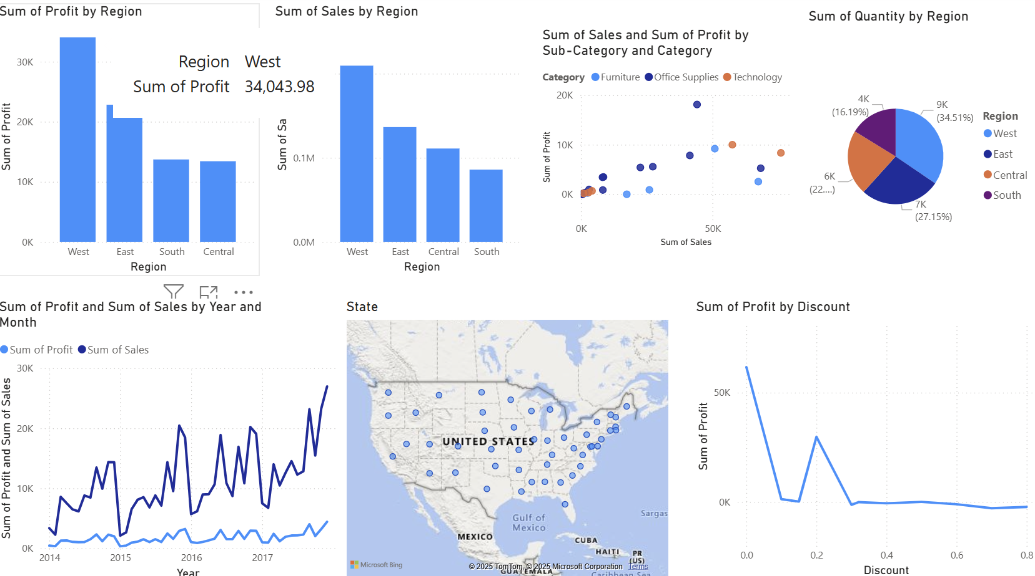

9. Solution Design
The cleaned data is connected to Power BI as the visualization layer. Data transformations are handled via Python scripts. SQL ensures accuracy of joins and calculations. Dashboards in Power BI display KPIs such as Sales, Profit, and Discount Impact interactively.

10. Challenges & Opportunities
Challenges:
- Handling missing and inconsistent data.
- Ensuring accuracy during data joins.
- Syncing results between Python, SQL, and Power BI.
Opportunities:
- Extend to predictive analytics using Machine Learning.
- Integrate real-time dashboards using APIs.
- Expand dataset for global performance comparison.

11. Reflections on the Project
This project enhanced understanding of the data analytics lifecycle – from extraction and cleaning to visualization and validation. It demonstrated how data science tools like Python and Power BI can transform raw data into business intelligence that supports decision-making.

12. Recommendations
- Reduce excessive discounting in Central Region to improve profit margins.
- Increase marketing for Technology products to maximize profit.
- Monitor “Furniture” stock levels to reduce low-margin inventory.

13. Outcome / Conclusion
The project successfully:
- The predicted and validated results confirmed the reliability of the data model and visualizations.
- The Superstore dashboard effectively represents business trends and can support decision-making for profit improvement and inventory planning.
- West region generated the highest profit.
- Central Region showed lower performance due to higher discounts.
- The Superstore Data Analysis project successfully demonstrated the process of data collection, cleaning, transformation, visualization, and validation using modern tools.

14. Link to Code and Executable File
GitHub / Google Drive link (to be added)
Include your .py, .sql, and Power BI .pbix files in a public folder for verification.

15. References
1. Superstore Sample Dataset – Tableau / Kaggle
2. Python Documentation – Link
3. Power BI Official Docs – Link
4. Pandas Library Guide – Link
5. Matplotlib Guide – Link

