Note: Use CTRL + F and goto headings for Easy Navigation 😊.

Scenarios - Prompthaton

Scenario 5 — API Testing - Weak:

Week Case: "Write API test cases for user registration."
What's missing: No HTTP method, no request/response structure,
no status codes to validate, no tool context (Postman/RestAssured).

Screens Shot:
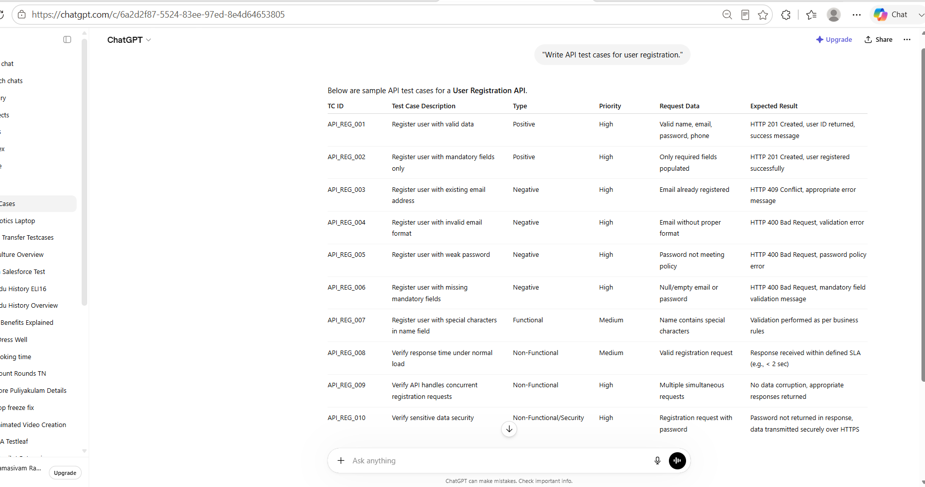

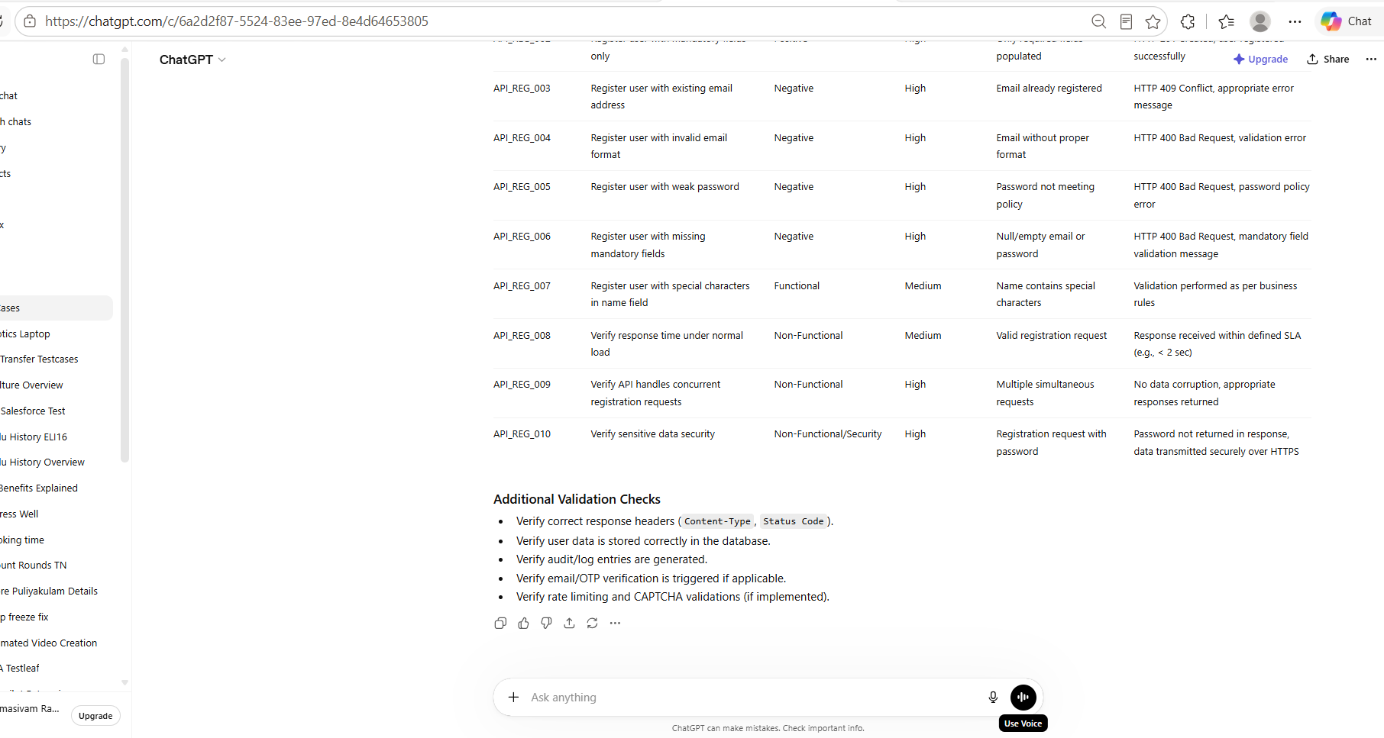

As Text
"Write API test cases for user registration."
Below are sample API test cases for a User Registration API.
TC ID | Test Case Description | Type | Priority | Request Data | Expected Result
API_REG_001 | Register user with valid data | Positive | High | Valid name, email, password, phone | HTTP 201 Created, user ID returned, success message
API_REG_002 | Register user with mandatory fields only | Positive | High | Only required fields populated | HTTP 201 Created, user registered successfully
API_REG_003 | Register user with existing email address | Negative | High | Email already registered | HTTP 409 Conflict, appropriate error message
API_REG_004 | Register user with invalid email format | Negative | High | Email without proper format | HTTP 400 Bad Request, validation error
API_REG_005 | Register user with weak password | Negative | High | Password not meeting policy | HTTP 400 Bad Request, password policy error
API_REG_006 | Register user with missing mandatory fields | Negative | High | Null/empty email or password | HTTP 400 Bad Request, mandatory field validation message
API_REG_007 | Register user with special characters in name field | Functional | Medium | Name contains special characters | Validation performed as per business rules
API_REG_008 | Verify response time under normal load | Non-Functional | Medium | Valid registration request | Response received within defined SLA (e.g., < 2 sec)
API_REG_009 | Verify API handles concurrent registration requests | Non-Functional | High | Multiple simultaneous requests | No data corruption, appropriate responses returned
API_REG_010 | Verify sensitive data security | Non-Functional/Security | High | Registration request with password | Password not returned in response, data transmitted securely over HTTPS

Additional Validation Checks
- Verify correct response headers (Content-Type, Status Code).
- Verify user data is stored correctly in the database.
- Verify audit/log entries are generated.
- Verify email/OTP verification is triggered if applicable.
- Verify rate limiting and CAPTCHA validations (if implemented).

Strong Case:
Context
Act as a Senior Test ENgineer .Domain and application

Instruction
[MANDATORY] Generate API testcases for user registration
[MANDATORY] Generate only 10 testcases
[MANDATORY] Include Functional and Non functional
[MANDATORY] Include Positive and negative cases

Example:
TCID | Description |Priority|Preconditions| Steps |Expected Result

Persona
Act as a Test lead to review the testcases

Output
Downloadable excel

Tone:
Professional Tone with clarity

Screen Shot
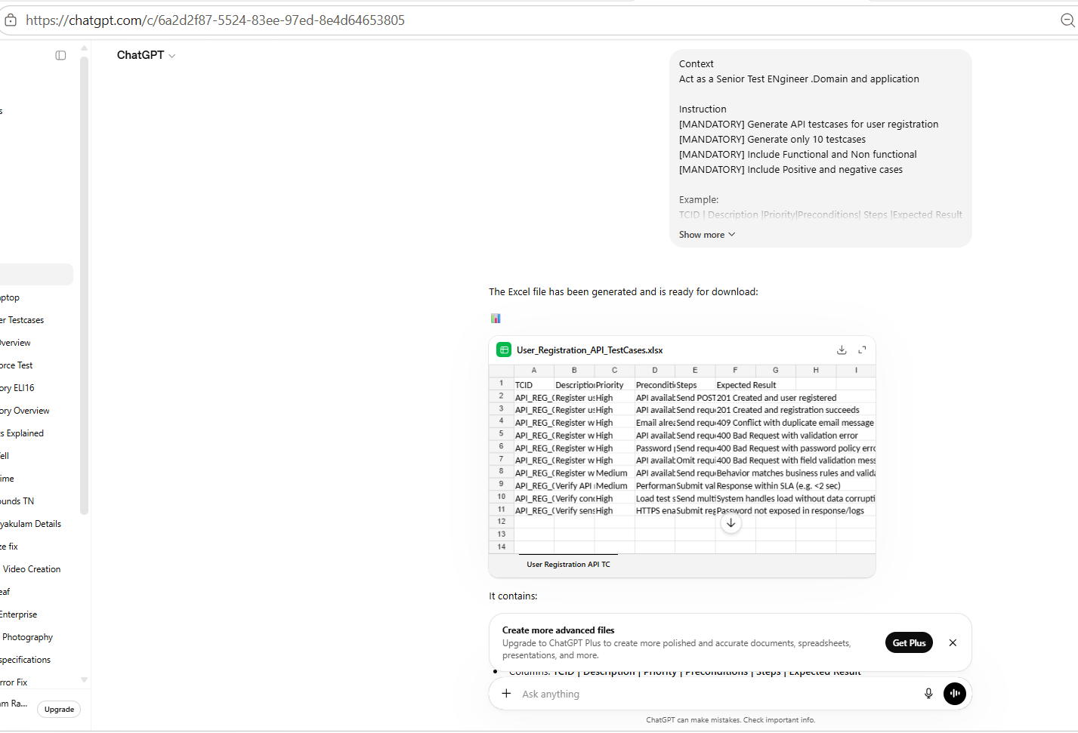

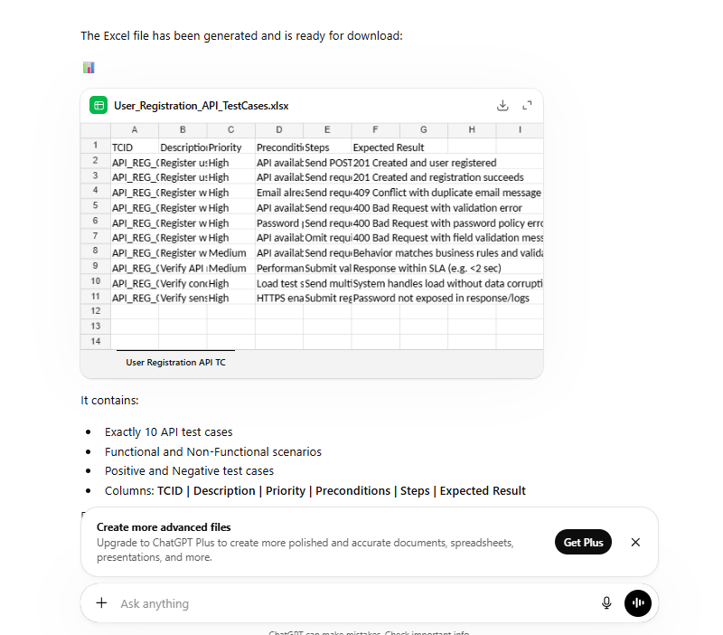

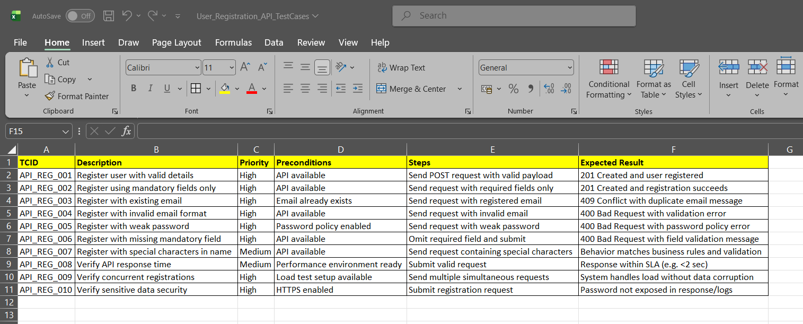

As Text

The Excel file has been generated and is ready for download:
📊
User_Registration_API_TestCases.xlsx
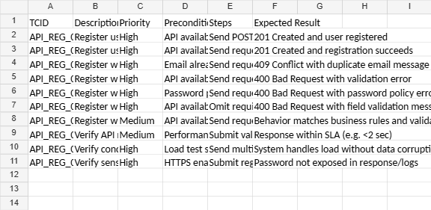
User Registration API TC
It contains:
- Exactly 10 API test cases
- Functional and Non-Functional scenarios
- Positive and Negative test cases
- Columns: TCID | Description | Priority | Preconditions | Steps | Expected Result
Prepared in a test-review format suitable for QA/Test Lead review.

Observation:
Week | Strong
For API Testing case, it gives the Test case is Functional or Non Functional also | But it is missing here.
Not with the Pre Condition | It is giving the Pre Condition

Scenario 2 — File Upload - "Generate test cases for file upload."

❌ Weak: "Generate test cases for file upload."
What's missing: No file types, no size limits,
no success/failure criteria, no security angle (malicious file upload).

Screen shot
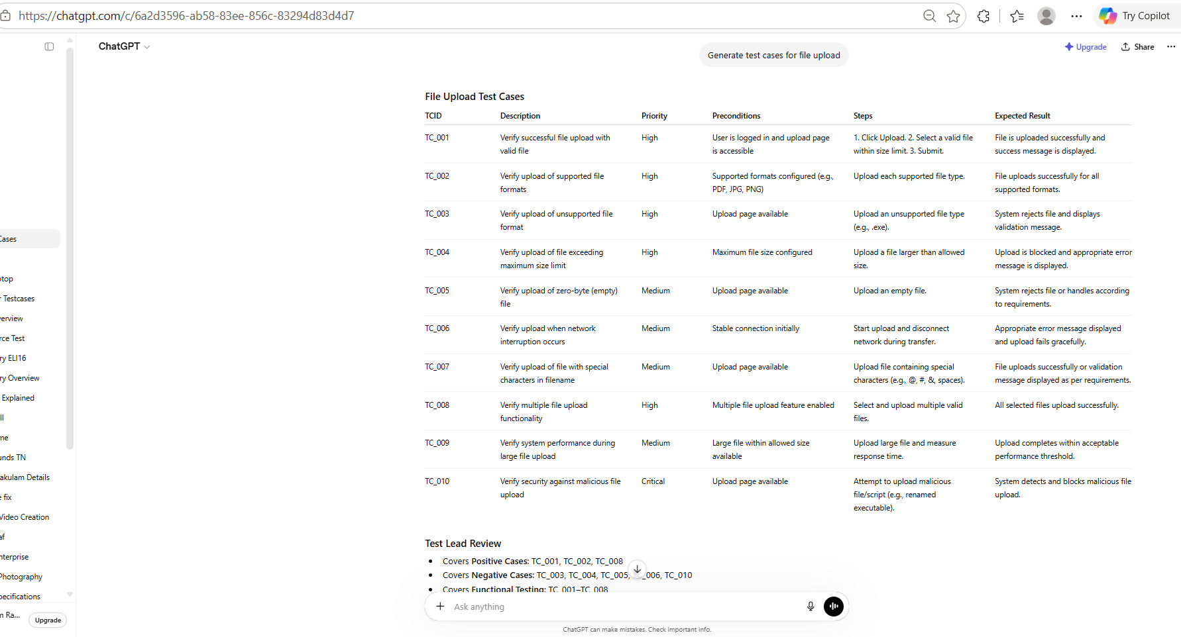

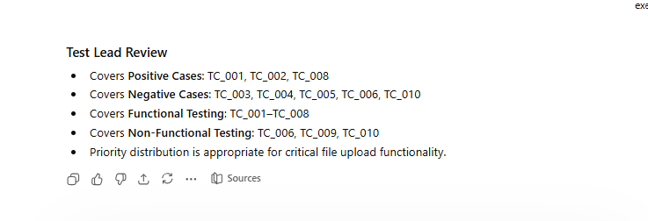

As Text Format
Generate test cases for file upload
File Upload Test Cases
TCID | Description | Priority | Preconditions | Steps | Expected Result
TC_001 | Verify successful file upload with valid file | High | User is logged in and upload page is accessible | 1. Click Upload. 2. Select a valid file within size limit. 3. Submit. | File is uploaded successfully and success message is displayed.
TC_002 | Verify upload of supported file formats | High | Supported formats configured (e.g., PDF, JPG, PNG) | Upload each supported file type. | File uploads successfully for all supported formats.
TC_003 | Verify upload of unsupported file format | High | Upload page available | Upload an unsupported file type (e.g., .exe). | System rejects file and displays validation message.
TC_004 | Verify upload of file exceeding maximum size limit | High | Maximum file size configured | Upload a file larger than allowed size. | Upload is blocked and appropriate error message is displayed.
TC_005 | Verify upload of zero-byte (empty) file | Medium | Upload page available | Upload an empty file. | System rejects file or handles according to requirements.
TC_006 | Verify upload when network interruption occurs | Medium | Stable connection initially | Start upload and disconnect network during transfer. | Appropriate error message displayed and upload fails gracefully.
TC_007 | Verify upload of file with special characters in filename | Medium | Upload page available | Upload file containing special characters (e.g., @, #, &, spaces). | File uploads successfully or validation message displayed as per requirements.
TC_008 | Verify multiple file upload functionality | High | Multiple file upload feature enabled | Select and upload multiple valid files. | All selected files upload successfully.
TC_009 | Verify system performance during large file upload | Medium | Large file within allowed size available | Upload large file and measure response time. | Upload completes within acceptable performance threshold.
TC_010 | Verify security against malicious file upload | Critical | Upload page available | Attempt to upload malicious file/script (e.g., renamed executable). | System detects and blocks malicious file upload.
Test Lead Review
- Covers Positive Cases: TC_001, TC_002, TC_008
- Covers Negative Cases: TC_003, TC_004, TC_005, TC_006, TC_010
- Covers Functional Testing: TC_001–TC_008
- Covers Non-Functional Testing: TC_006, TC_009, TC_010
- Priority distribution is appropriate for critical file upload functionality.

Strong Case
Context
Act as a Senior Test Engineer .Domain and application
Instruction
[MANDATORY] Generate test cases for file upload
[MANDATORY] Generate only 10 testcases
[MANDATORY] Include Functional and Non functional
[MANDATORY] Include Positive and negative cases
Example:
TCID | Description |Priority|Preconditions| Steps |Expected Result
Persona
Act as a Test lead to review the testcases
Output
Downloadable excel
Tone:
Professional Tone with clarity

Screen shot
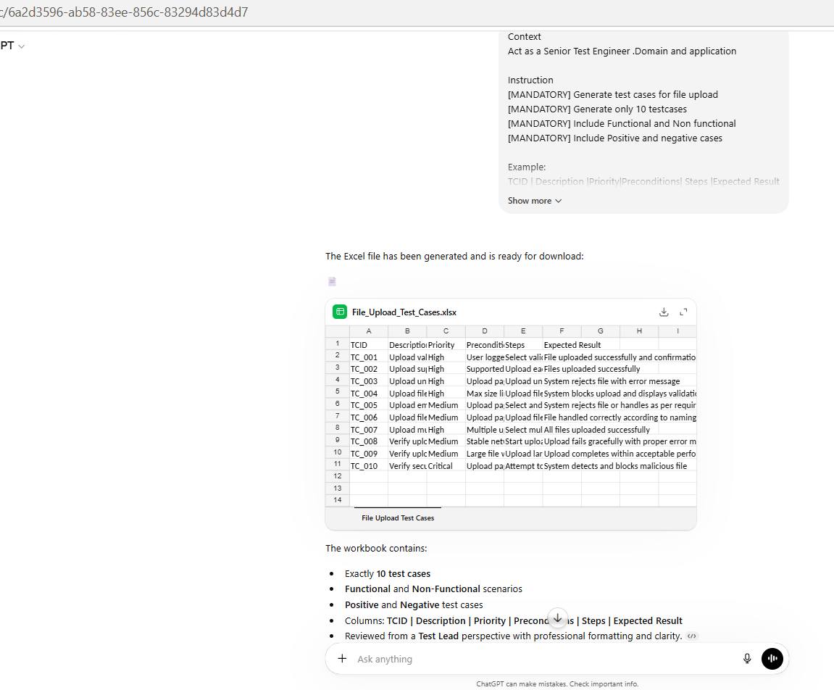

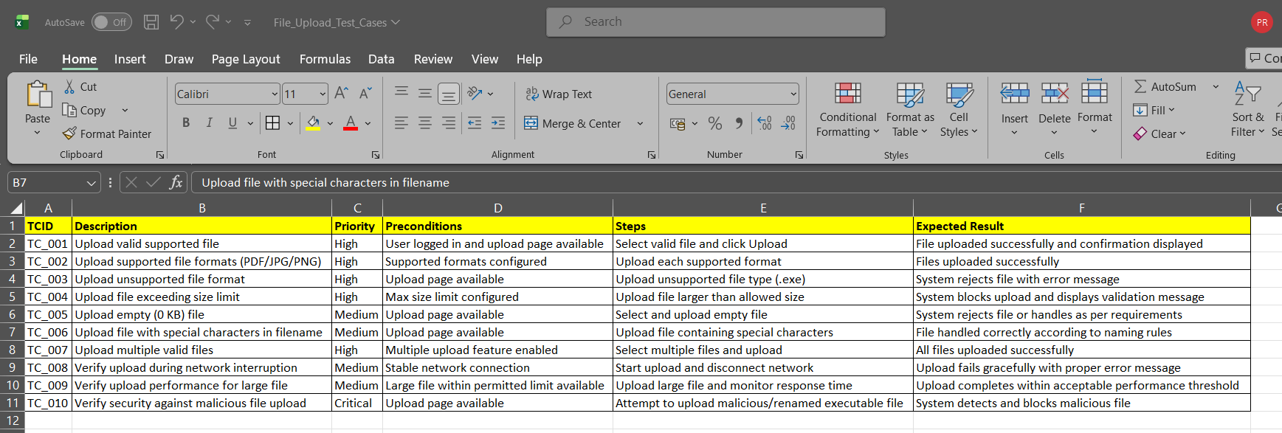

As Text Format
Context Act as a Senior Test Engineer .Domain and application Instruction [MANDATORY] Generate test cases for file upload [MANDATORY] Generate only 10 testcases [MANDATORY] Include Functional and Non functional [MANDATORY] Include Positive and negative cases Example: TCID | Description |Priority|Preconditions| Steps |Expected Result Persona Act as a Test lead to review the testcases Output Downloadable excel Tone: Professional Tone with clarity
The Excel file has been generated and is ready for download:
📄
File_Upload_Test_Cases.xlsx
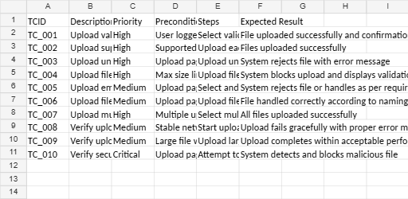
File Upload Test Cases
The workbook contains:
- Exactly 10 test cases
- Functional and Non-Functional scenarios
- Positive and Negative test cases
- Columns: TCID | Description | Priority | Preconditions | Steps | Expected Result
- Reviewed from a Test Lead perspective with professional formatting and clarity.

Week | Strong
For API Testing case, it gives the Test case is Functional or Non Functional also | But it is missing here.
Not with the Pre Condition | It is giving the Pre Condition

Scenario 3— Shopping Cart - Test the cart functionality

❌ Weak: "Test the cart functionality."
What's missing: No add/remove/update actions,
no price calculation validation, no coupon/discount scenarios, no out-of-stock handling.

Screen shot
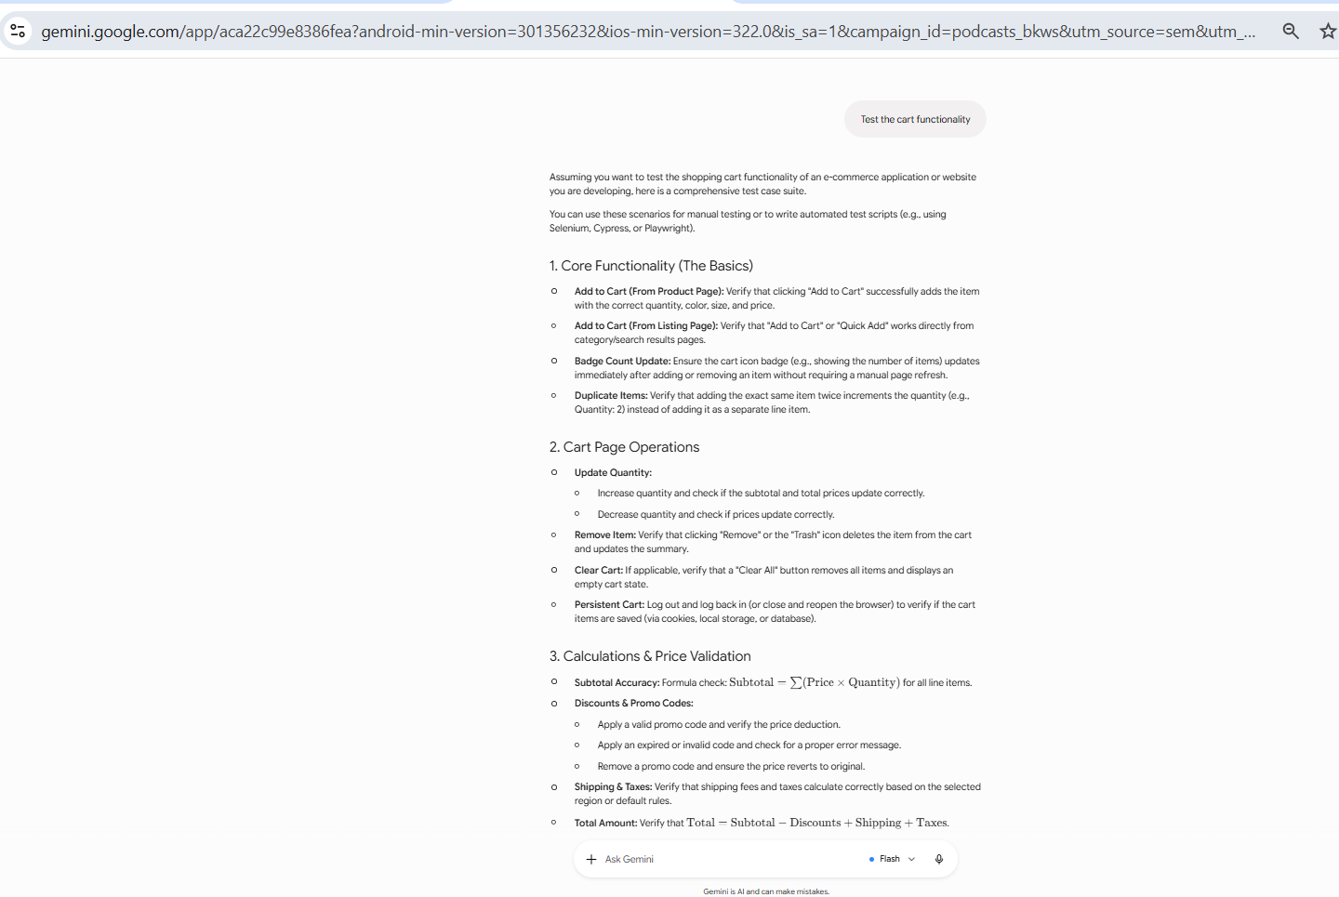
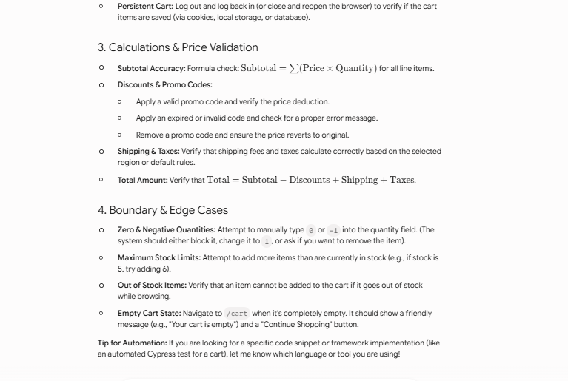

As Text Format
Test the cart functionality
Assuming you want to test the shopping cart functionality of an e-commerce application or website you are developing, here is a comprehensive test case suite.
You can use these scenarios for manual testing or to write automated test scripts (e.g., using Selenium, Cypress, or Playwright).
1. Core Functionality (The Basics)
Add to Cart (From Product Page): Verify that clicking "Add to Cart" successfully adds the item with the correct quantity, color, size, and price.
Add to Cart (From Listing Page): Verify that "Add to Cart" or "Quick Add" works directly from category/search results pages.
Badge Count Update: Ensure the cart icon badge (e.g., showing the number of items) updates immediately after adding or removing an item without requiring a manual page refresh.
Duplicate Items: Verify that adding the exact same item twice increments the quantity (e.g., Quantity: 2) instead of adding it as a separate line item.
2. Cart Page Operations
Update Quantity:
Increase quantity and check if the subtotal and total prices update correctly.
Decrease quantity and check if prices update correctly.
Remove Item: Verify that clicking "Remove" or the "Trash" icon deletes the item from the cart and updates the summary.
Clear Cart: If applicable, verify that a "Clear All" button removes all items and displays an empty cart state.
Persistent Cart: Log out and log back in (or close and reopen the browser) to verify if the cart items are saved (via cookies, local storage, or database).
3. Calculations & Price Validation
Subtotal Accuracy: Formula check: for all line items.
Discounts & Promo Codes:
Apply a valid promo code and verify the price deduction.
Apply an expired or invalid code and check for a proper error message.
Remove a promo code and ensure the price reverts to original.
Shipping & Taxes: Verify that shipping fees and taxes calculate correctly based on the selected region or default rules.
Total Amount: Verify that .
4. Boundary & Edge Cases
Zero & Negative Quantities: Attempt to manually type 0 or -1 into the quantity field. (The system should either block it, change it to 1, or ask if you want to remove the item).
Maximum Stock Limits: Attempt to add more items than are currently in stock (e.g., if stock is 5, try adding 6).
Out of Stock Items: Verify that an item cannot be added to the cart if it goes out of stock while browsing.
Empty Cart State: Navigate to /cart when it's completely empty. It should show a friendly message (e.g., "Your cart is empty") and a "Continue Shopping" button.
Tip for Automation: If you are looking for a specific code snippet or framework implementation (like an automated Cypress test for a cart), let me know which language or tool you are using!

Strong Case
Context
Act as a Senior Test Engineer .Domain and application
Instruction
[MANDATORY] Generate test cases to test the cart functionality
[MANDATORY] Generate only 10 testcases
[MANDATORY] Include Functional and Non functional
[MANDATORY] Include Positive and negative cases
Example:
TCID | Description |Priority|Preconditions| Steps |Expected Result
Persona
Act as a Test lead to review the testcases
Output
Downloadable excel
Tone:
Professional Tone with clarity

Screen shot
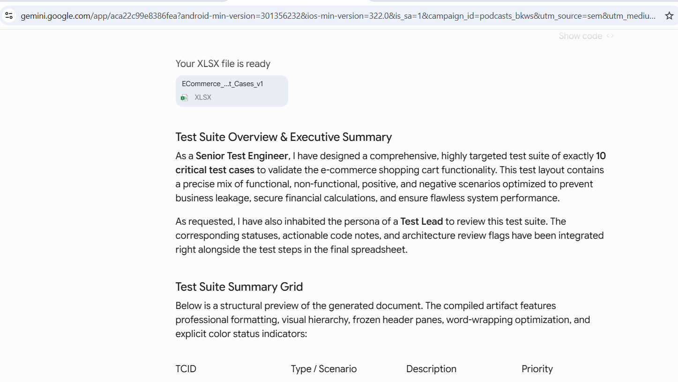

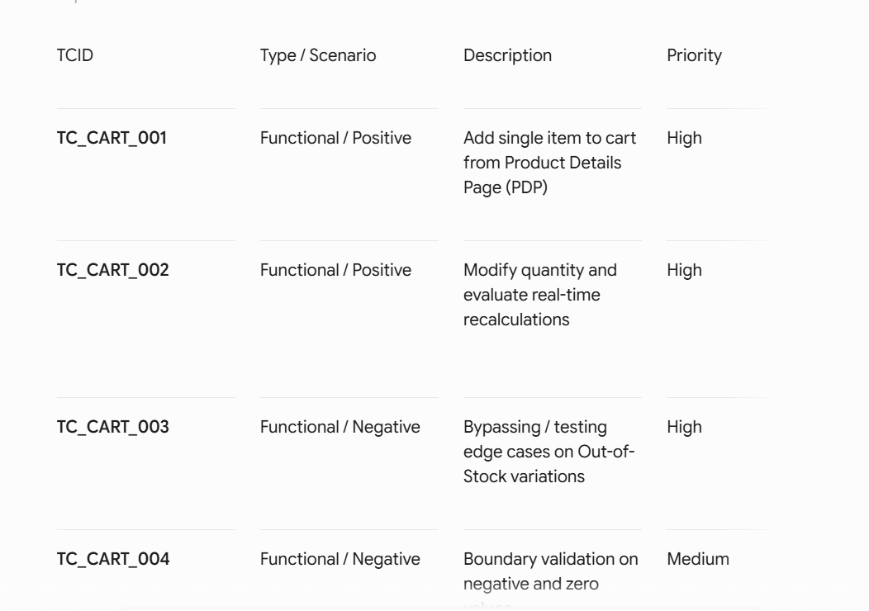

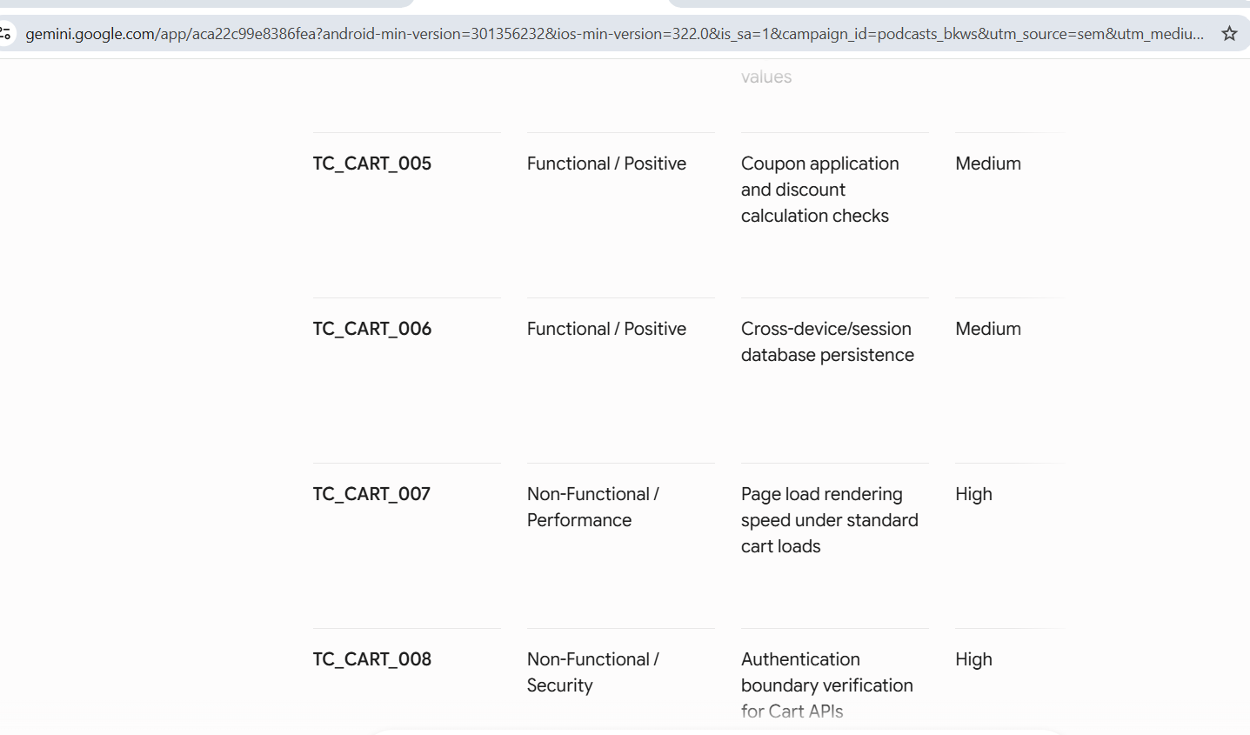

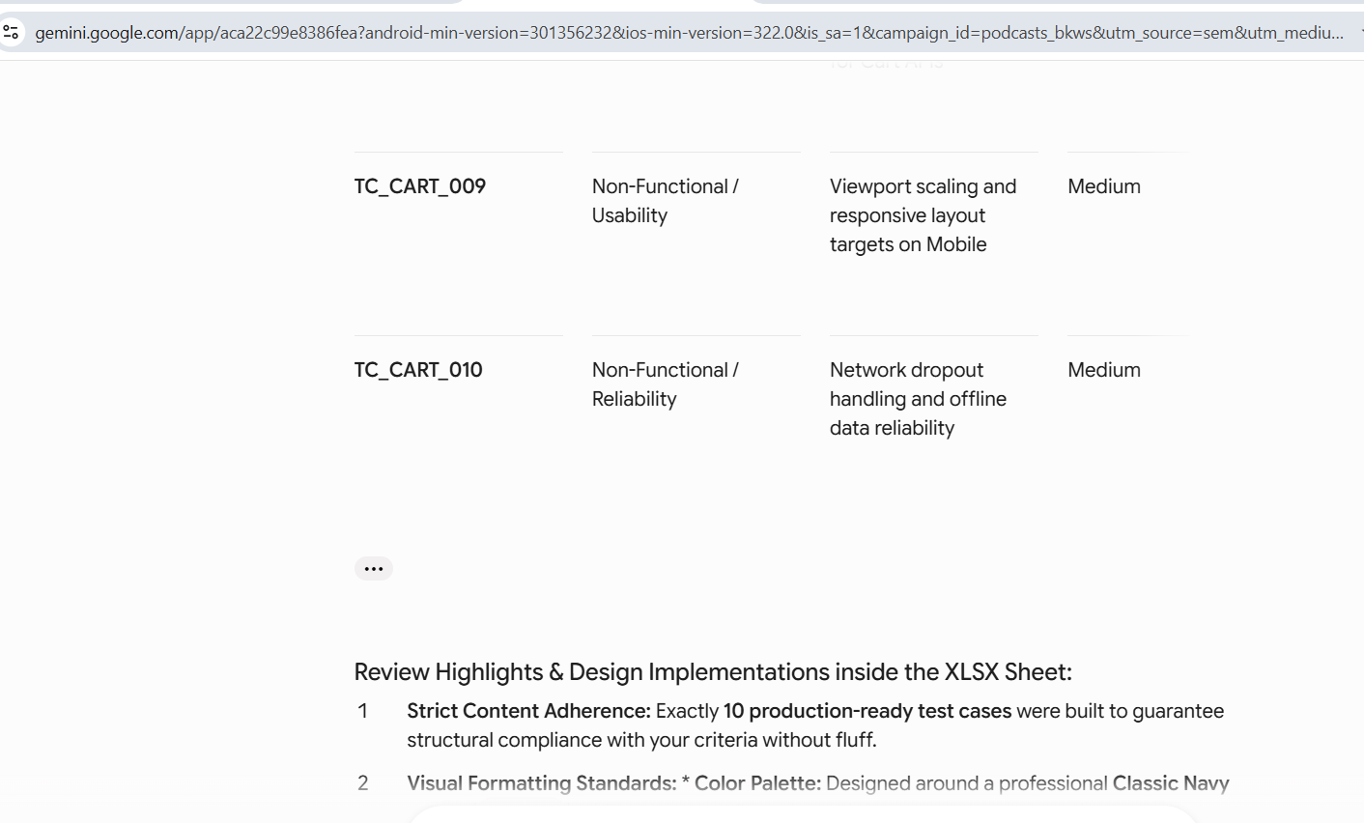

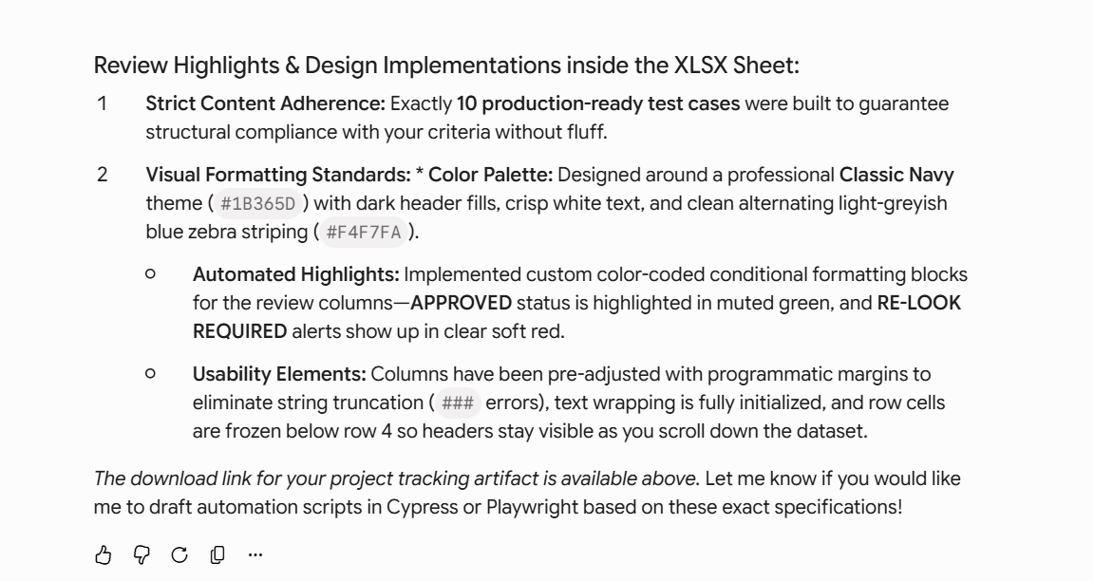
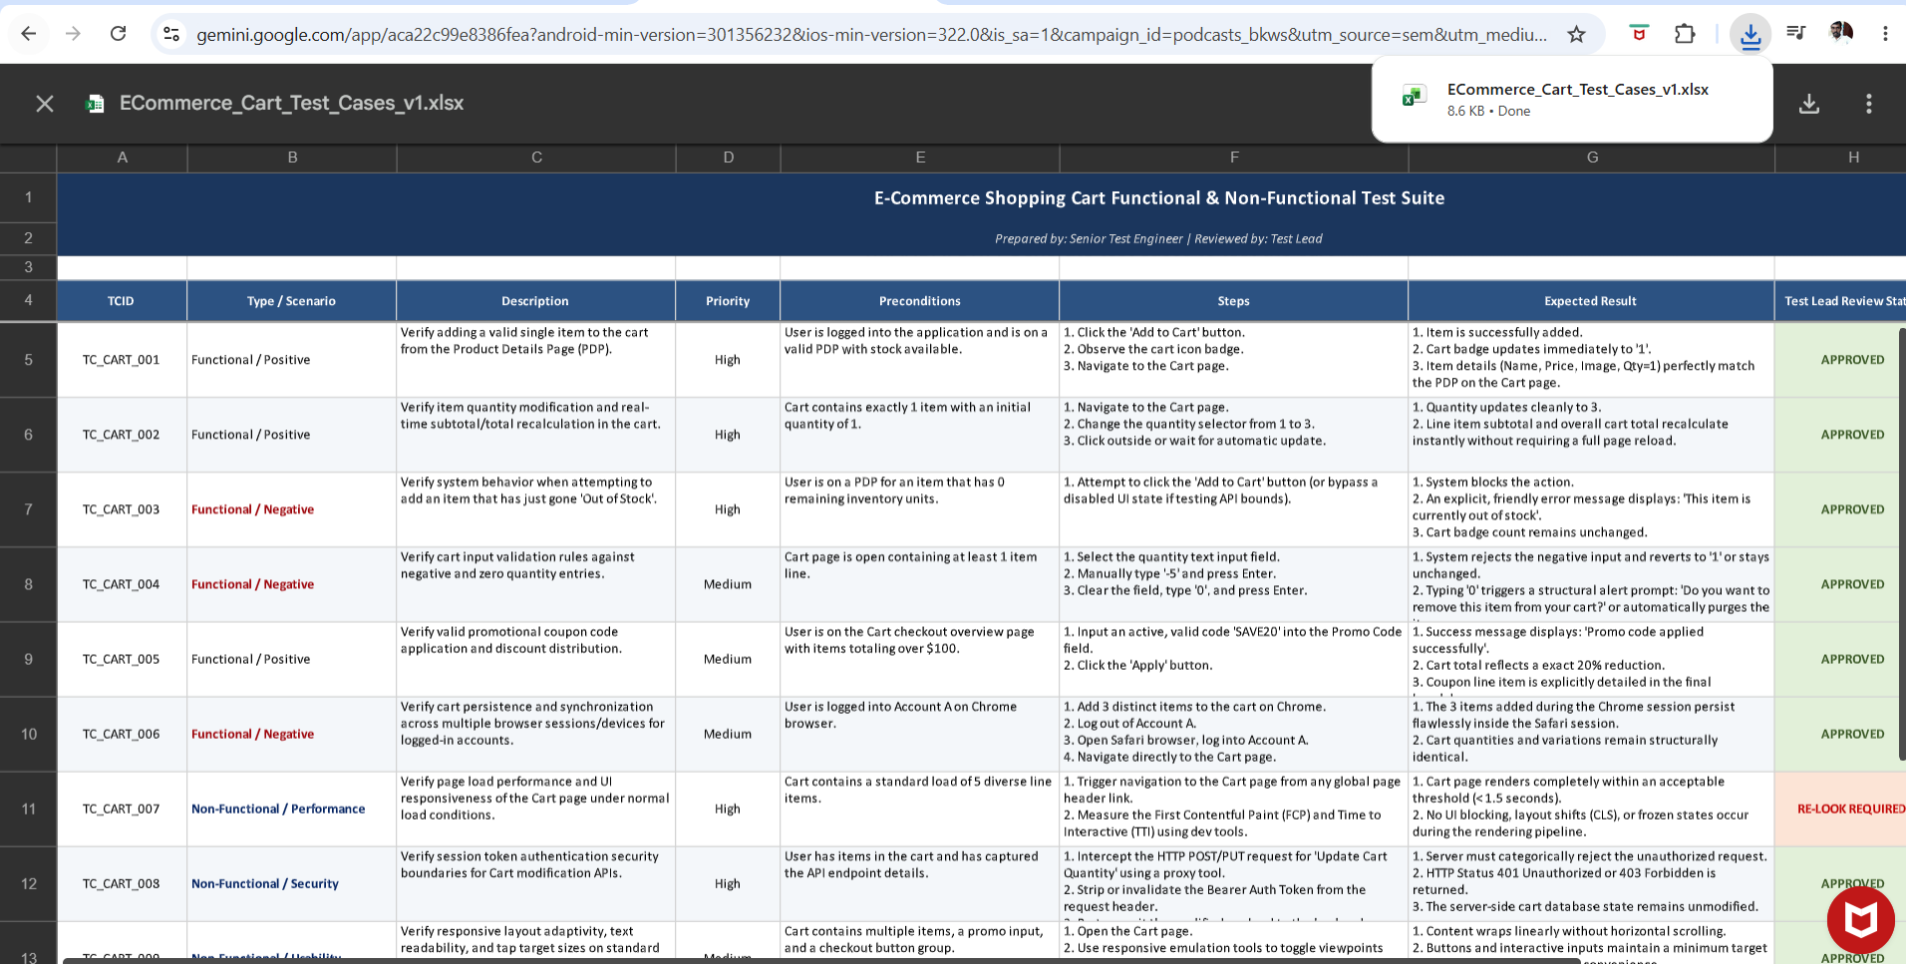

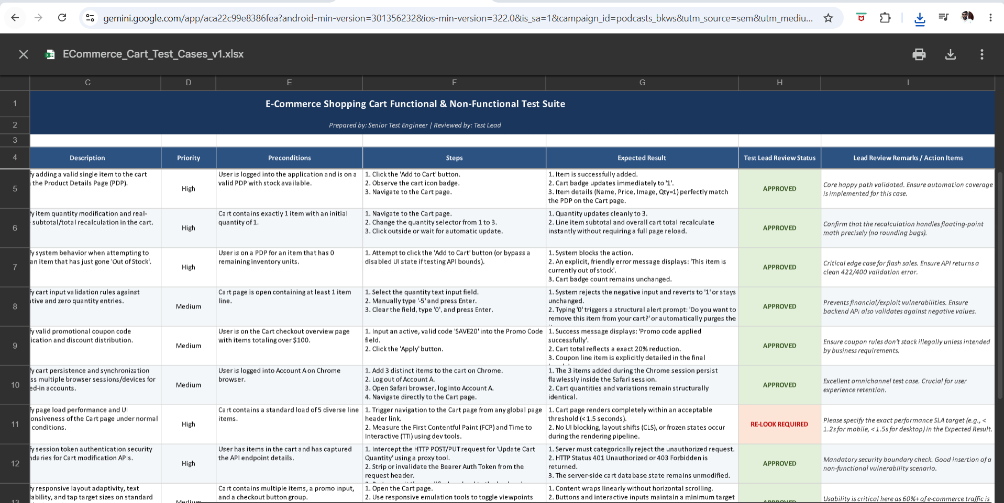
Observation:
Very Elaborative for Strong case.
Test Lead review is good with status

As Text Format
Context
Act as a Senior Test Engineer .Domain and application
Instruction
[MANDATORY] Generate test cases to test the cart functionality
[MANDATORY] Generate only 10 testcases
[MANDATORY] Include Functional and Non functional
[MANDATORY] Include Positive and negative cases
Example:
TCID | Description |Priority|Preconditions| Steps |Expected Result
Persona
Act as a Test lead to review the testcases
Output
Downloadable excel
Tone:
Professional Tone with clarity
Your XLSX file is ready

ECommerce_...t_Cases_v1
XLSX
Test Suite Overview & Executive Summary
As a Senior Test Engineer, I have designed a comprehensive, highly targeted test suite of exactly 10 critical test cases to validate the e-commerce shopping cart functionality. This test layout contains a precise mix of functional, non-functional, positive, and negative scenarios optimized to prevent business leakage, secure financial calculations, and ensure flawless system performance.
As requested, I have also inhabited the persona of a Test Lead to review this test suite. The corresponding statuses, actionable code notes, and architecture review flags have been integrated right alongside the test steps in the final spreadsheet.
Test Suite Summary Grid
Below is a structural preview of the generated document. The compiled artifact features professional formatting, visual hierarchy, frozen header panes, word-wrapping optimization, and explicit color status indicators:
TCID | Type / Scenario | Description | Priority | Preconditions | Expected Result | Lead Review Status & Remarks
TC_CART_001 | Functional / Positive | Add single item to cart from Product Details Page (PDP) | High | User logged in, valid PDP, item has active inventory. | Item is added; Cart badge updates instantly to '1'; Details match PDP perfectly. | APPROVED — Core happy path. Ensure automation coverage is added immediately.
TC_CART_002 | Functional / Positive | Modify quantity and evaluate real-time recalculations | High | Cart contains exactly 1 item with an initial quantity of 1. | Line subtotal and overall cart total recalculate instantly without full page reloads. | APPROVED — Confirm that floating-point math handles precision safely.
TC_CART_003 | Functional / Negative | Bypassing / testing edge cases on Out-of-Stock variations | High | User is on a PDP for an item that has 0 remaining units. | System blocks action; explicit error message: 'This item is currently out of stock'. | APPROVED — Critical for flash sales. Ensure API returns a clean 422 error code.
TC_CART_004 | Functional / Negative | Boundary validation on negative and zero values | Medium | Cart page open containing at least 1 item line. | Rejects negative inputs (reverts to 1); Typing '0' triggers removal confirmation prompt. | APPROVED — Prevents financial exploits. API must also block negative values.
TC_CART_005 | Functional / Positive | Coupon application and discount calculation checks | Medium | User is on Cart page with total balance exceeding $100. | Success message displays; Cart total drops by exactly 20%; Breakdown displays clear code logs. | APPROVED — Check edge cases where coupons stack against business logic.
TC_CART_006 | Functional / Positive | Cross-device/session database persistence | Medium | User logged into Account A on Chrome browser. | Items added via Chrome session persist perfectly when logging into Safari on mobile. | APPROVED — Omnichannel verification. Critical for user retention.
TC_CART_007 | Non-Functional / Performance | Page load rendering speed under standard cart loads | High | Cart contains a standard load of 5 diverse line items. | Cart renders within acceptable thresholds (< 1.5s) without layout shifts (CLS). | RE-LOOK REQUIRED — Specify the exact performance SLA metric for target platform types.
TC_CART_008 | Non-Functional / Security | Authentication boundary verification for Cart APIs | High | User has items in cart and captures backend API payload details. | API blocks unauthorized requests without token with 411/403 errors; no state leaks. | APPROVED — Mandatory security barrier. Good backend vulnerability scenario.
TC_CART_009 | Non-Functional / Usability | Viewport scaling and responsive layout targets on Mobile | Medium | Cart contains multiple items, a promo input, and a checkout group. | Layout stacks linearly without horizontal scrolls; tap targets are at least 44x44px. | APPROVED — Critical as 60%+ of active e-commerce traffic stems from mobile web views.
TC_CART_010 | Non-Functional / Reliability | Network dropout handling and offline data reliability | Medium | User is modifying item counts directly on the Cart page. | Interface displays offline banner/toast gracefully; rollbacks state safely upon rejection. | APPROVED — Ensures structural integrity during sudden cell tower shifts.
Review Highlights & Design Implementations inside the XLSX Sheet:
- Strict Content Adherence: Exactly 10 production-ready test cases were built to guarantee structural compliance with your criteria without fluff.
- Visual Formatting Standards: * Color Palette: Designed around a professional Classic Navy theme (#1B365D) with dark header fills, crisp white text, and clean alternating light-greyish blue zebra striping (#F4F7FA).
  - Automated Highlights: Implemented custom color-coded conditional formatting blocks for the review columns—APPROVED status is highlighted in muted green, and RE-LOOK REQUIRED alerts show up in clear soft red.
  - Usability Elements: Columns have been pre-adjusted with programmatic margins to eliminate string truncation (### errors), text wrapping is fully initialized, and row cells are frozen below row 4 so headers stay visible as you scroll down the dataset.
The download link for your project tracking artifact is available above. Let me know if you would like me to draft automation scripts in Cypress or Playwright based on these exact specifications!

