NAME: PARAMBIR SINGH BAJWA REG NO: 12218674

TASK - 1

CREATING A BUCKET WITH THE NAME: PARAMBUCKET

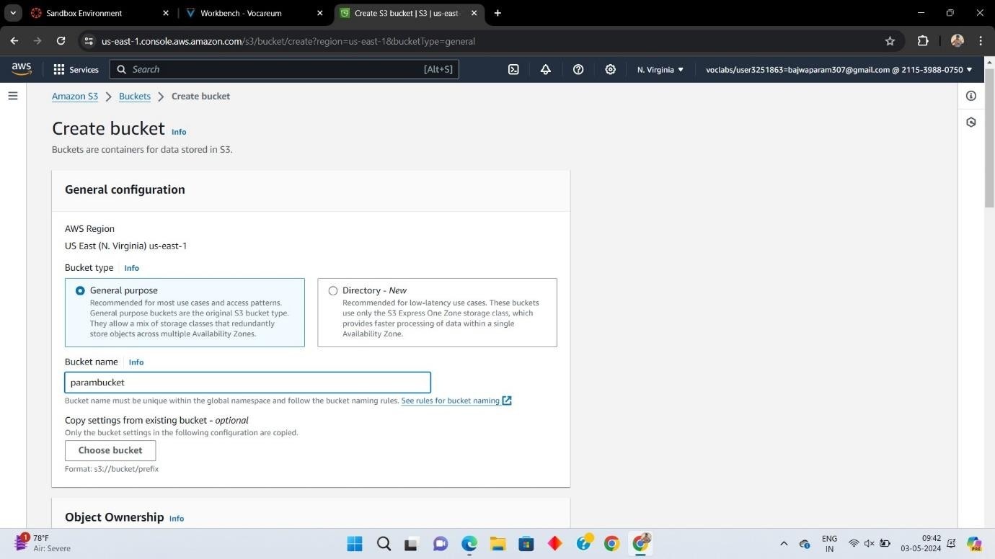

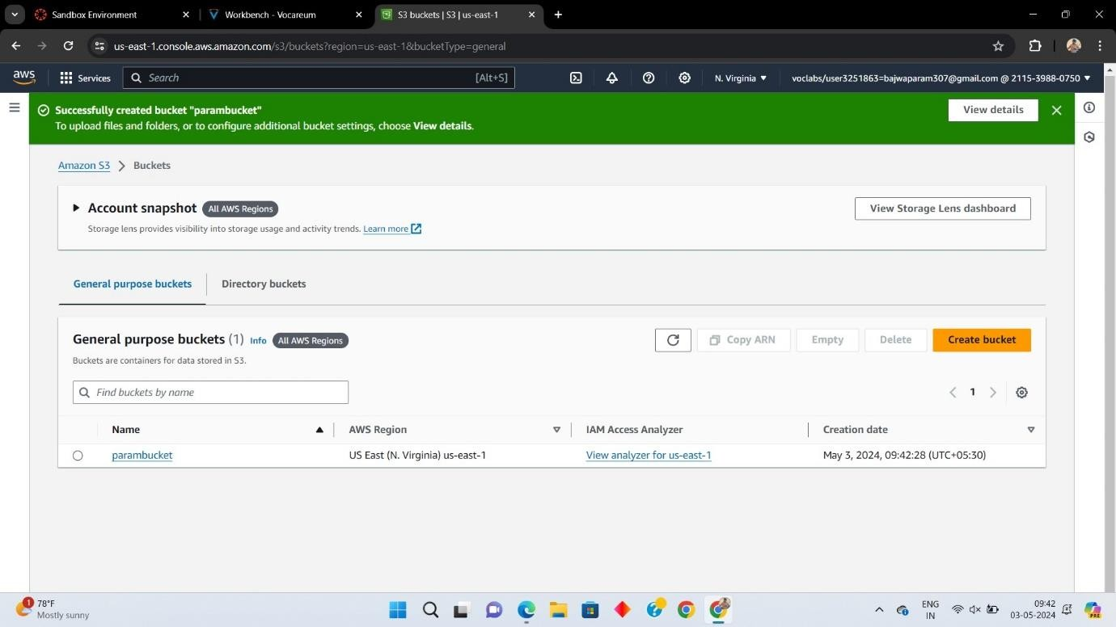

UPLOADING THE INDEX HTML FILE OF THE WEBSITE TO BE HOST

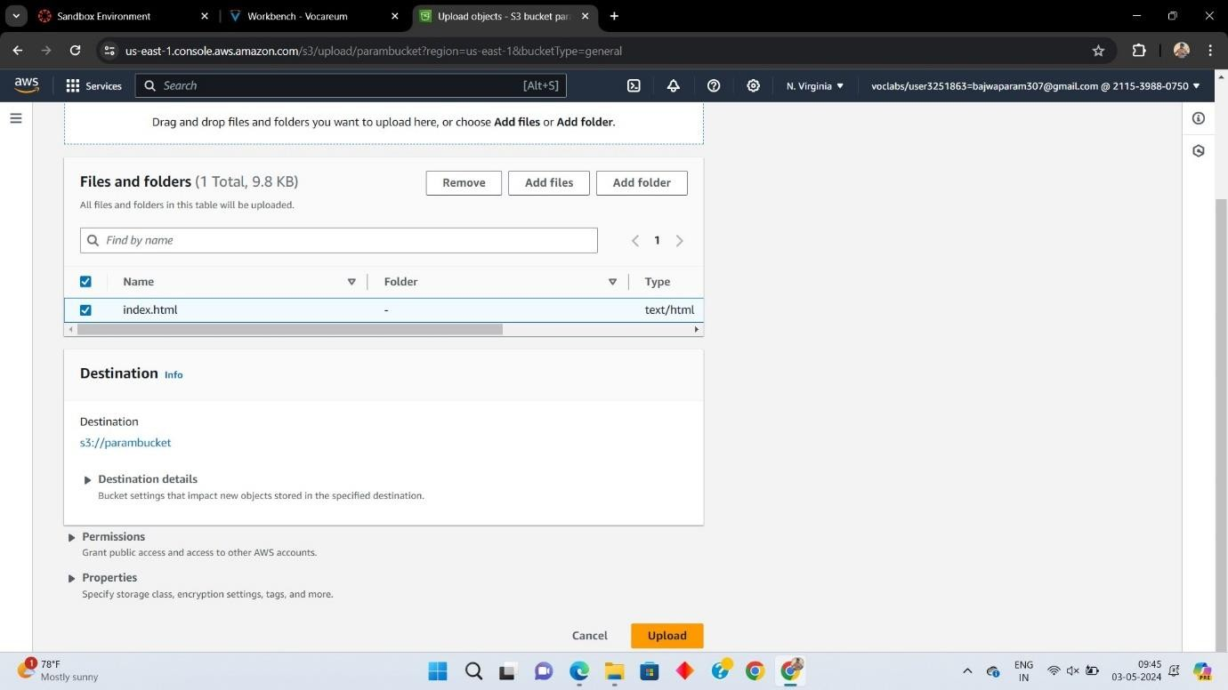

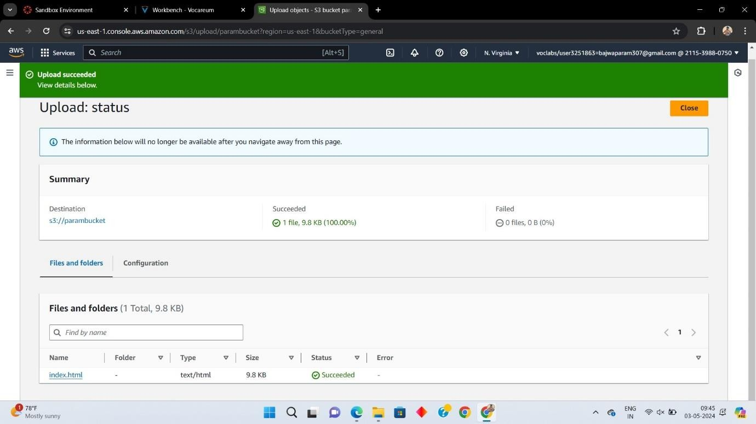

# ENABLING AND EDITING HOSTING THE STATIC WEBSITE HOSTING

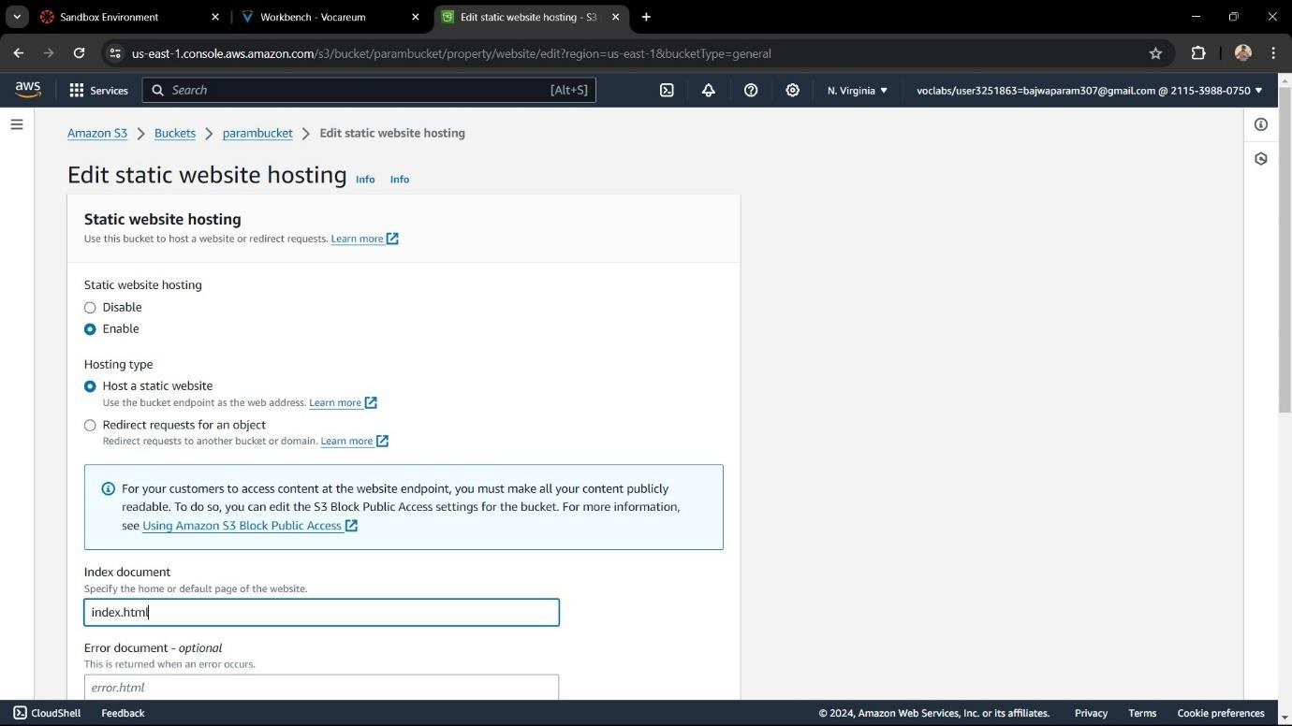

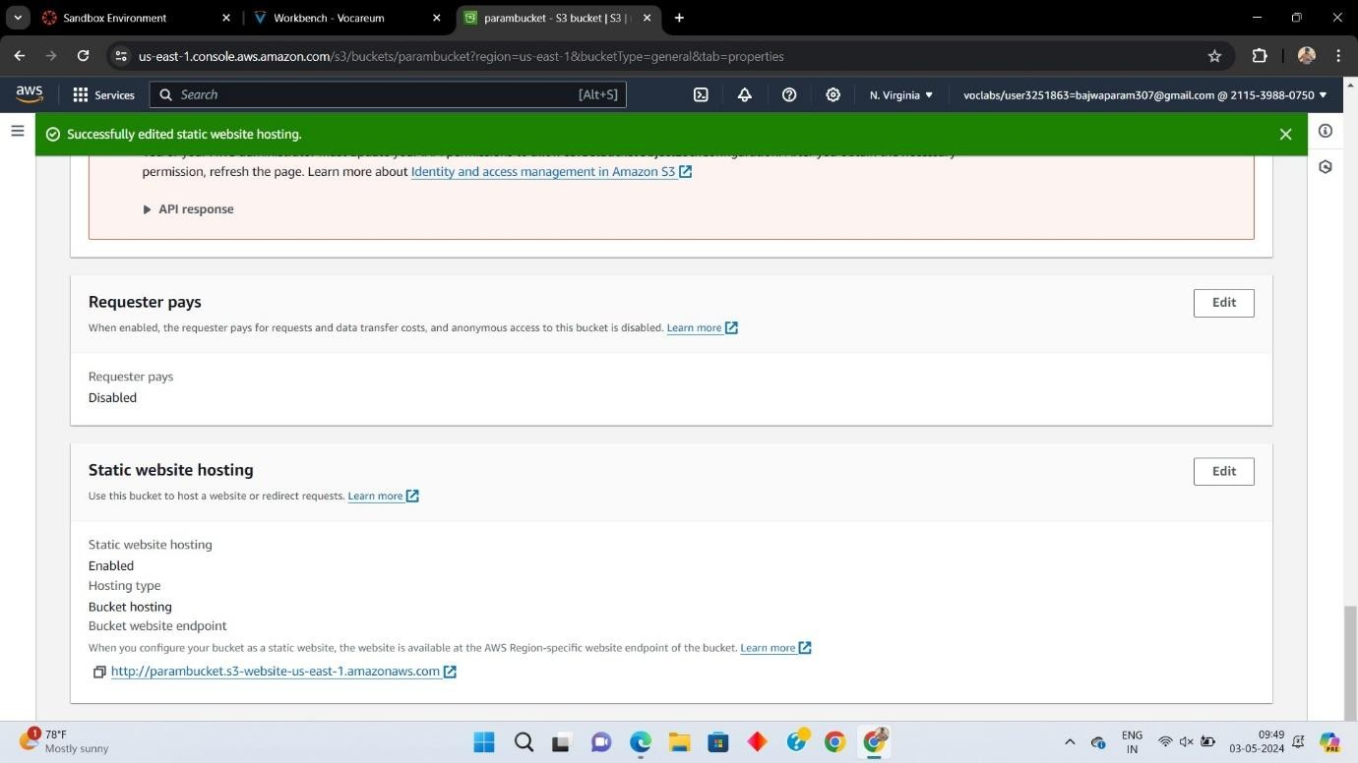

NOW HOSTING A STATIC WEBSITE IN AMAZON S3

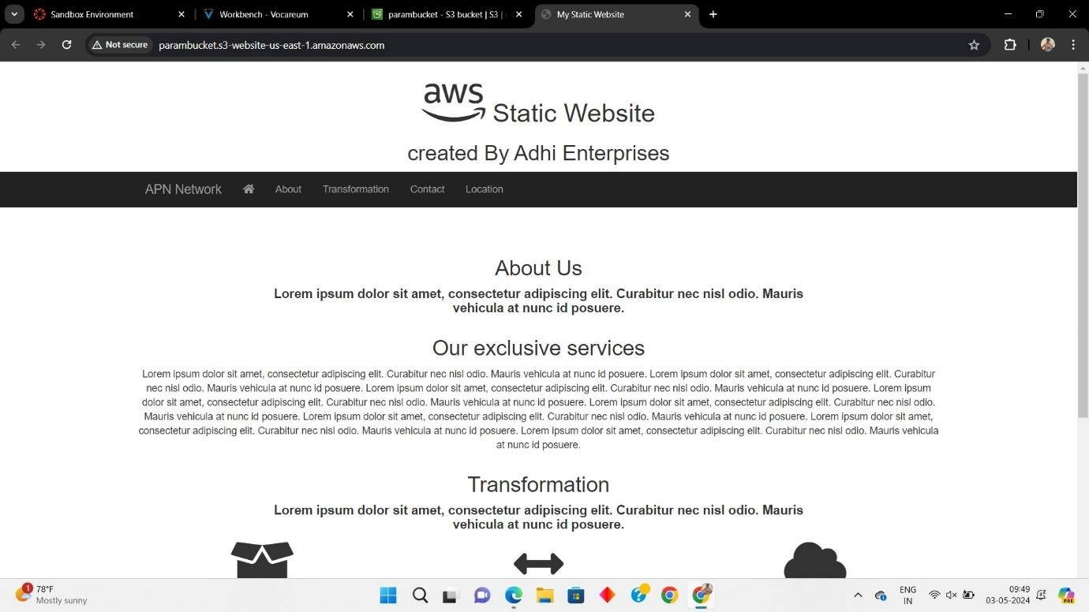

# TASK - 2

DISABLING THE BLOCK PUBLIC ACCESS

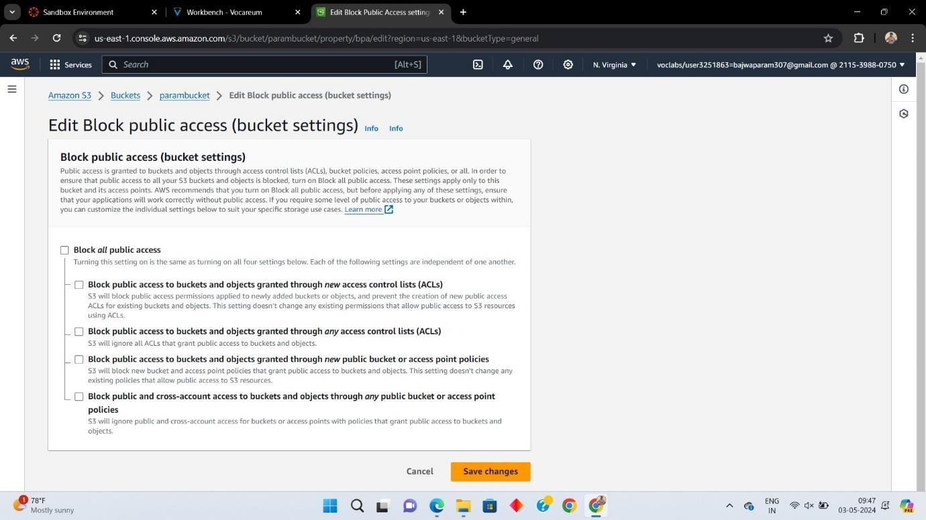

# TURNED OFF THE BLOCK PUBLIC ACCESS

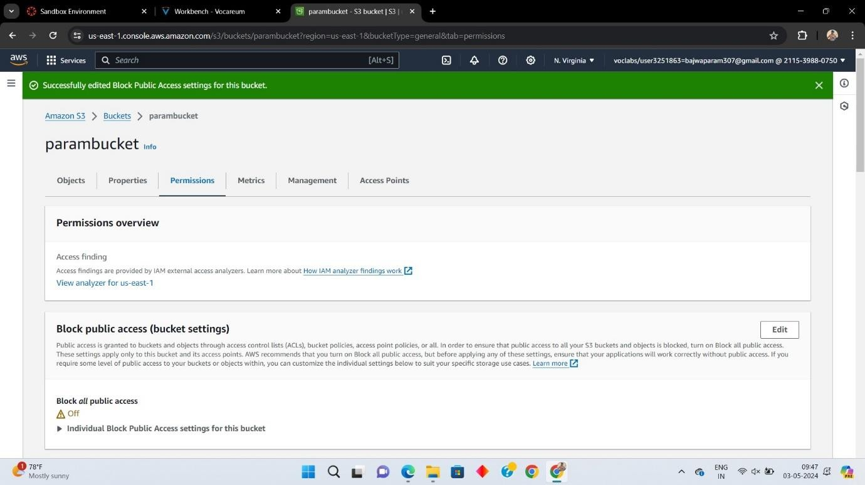

EDITING THE BUCKET POLICY SETTINGS TO MAKE IT CONTENTS AVAILABLE PUBLICLY

