

Software Requirements Specification (SRS)
for
CRO/UX Analytics Dashboard

Course Code: CS-31001
Submitted To: Dr. Saurabh Bilgaiyan

Submitted by:
Param Dubey
B.Tech CSE, KIIT University, Bhubaneswar

1. Introduction

1.1 Purpose
This document outlines the requirements and structure for the CRO/UX Analytics Dashboard project. The system helps visualize e-commerce user behavior and conversion metrics, using the Retail Rocket dataset (available in Kaggle).

1.2 Product Scope
It supports data-driven CRO (Conversion Rate Optimization) and UX improvement.The system enables marketing and product teams to:
1, Analyze session-level user engagement (bounce, browser, converter, engaged clusters).
- Visualize funnel conversion from view → add-to-cart → purchase.
- Identify time-based conversion trends.
- Study product-level conversion metrics and item performance.
- Presents all analytics in a Streamlit-powered interactive web dashboard.

1.3 Definitions, Acronyms and Abbreviations
CRO – Conversion Rate Optimization
UX – User Experience
EDA – Exploratory Data Analysis
KPI – Key Performance Indicator
DFD – Data Flow Diagram
ER – Entity Relationship

1.4 Technologies to be Used
Python 3.x, Streamlit, Pandas, Numpy, Matplotlib, Seaborn, Pillow, and Microsoft Word for documentation.

2. Overall Description

2.1 Product Perspective
The dashboard is a self-contained analytical tool built in Streamlit. It reads processed datasets and displays various user-behavior analytics through static plots and brief insights.

2.2 User Classes and Characteristics
1. Marketing Teams – Evaluate conversion trends.
2. UX Designers – Identify drop-offs and engagement gaps.
3. Data Analysts – Extend analysis using Python.
4. Faculty/Students – Academic use and learning.

2.3 Operating Environment
Runs on Python 3.x and Streamlit in any modern browser. Compatible with Windows, macOS, or Linux systems.

2.4 Software Interfaces
CSV data inputs(MS Excel/WPS Office), visualization libraries (Matplotlib/Seaborn), and Streamlit as the front-end framework.

2.5 Hardware Interfaces
Minimum 8GB RAM and 4-core processor for smooth performance.

2.6 External Forces
2.6.1 Dependencies: Python 3.x, Streamlit, Pandas, Matplotlib, Numoy.
2.6.2 Constraints: Dashboard depends on pre-generated plots (no real-time computation), limited to descriptive analytics only (not predictive analytics), Dataset too large for live computation and internet for deployment.

3. System Features

3.1 Functional Requirements
- Load preprocessed datasets.
- Display EDA, funnel, and session analyses.
- Include product-level conversion analysis.
- Provide navigable dashboard UI.
- Show insights alongside visuals.

3.2 Non-functional Requirements
- Performance: Loads precomputed plots for speed.
- Usability: Intuitive layout and clean visuals.
- Portability: Cross-platform.
- Scalability: Easy to extend for more analytics.
- Reliability: Handles missing data smoothly.

4. Design

4.1 System Design (Front-End Design)
The Streamlit-based interface consists of a sidebar for navigation and central area for visualizations with insights.

4.1.1 Use Case Diagram

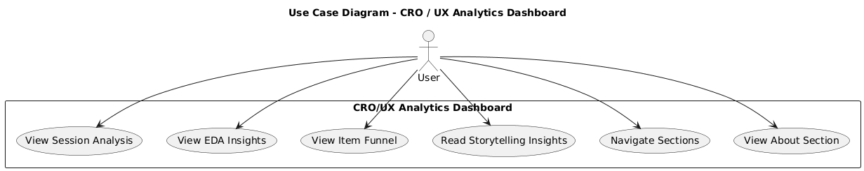

4.1.2 Class Diagram

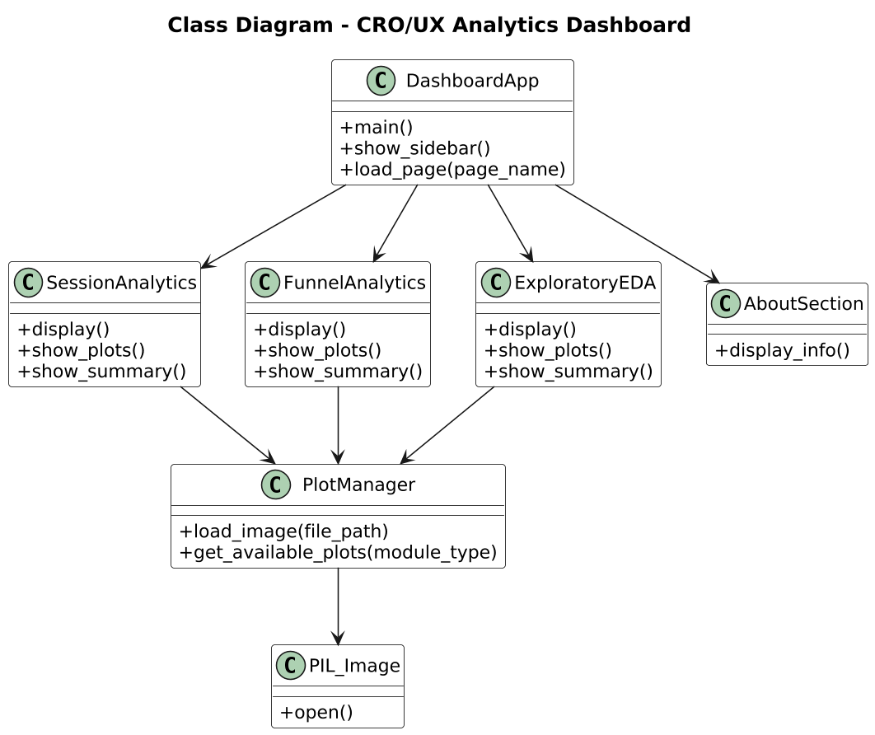

4.1.3 Sequence Diagram

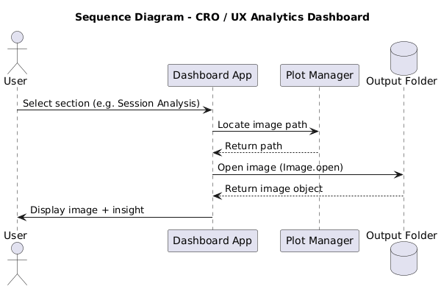

4.1.4 Collaboration Diagram

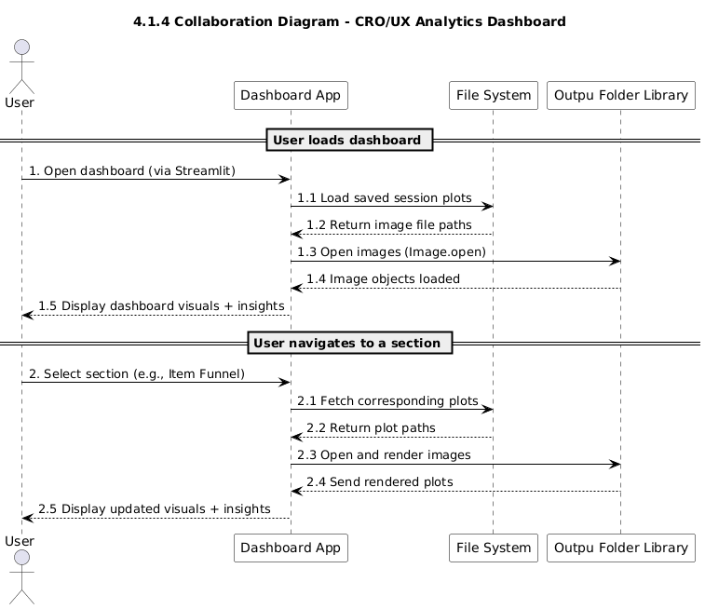

4.1.5 State Chart Diagram

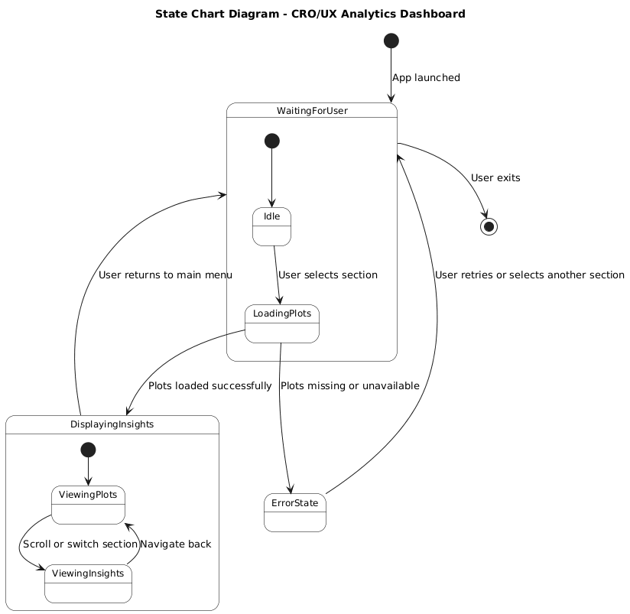

4.1.6 Activity Diagram

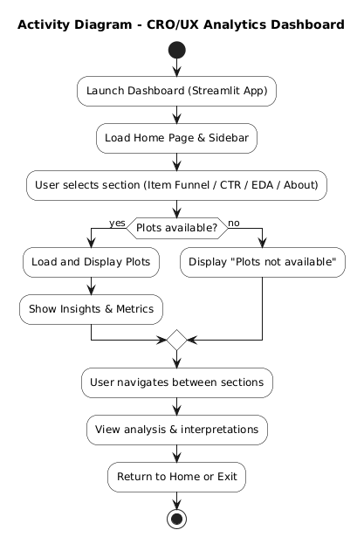

4.1.7 Data Flow Diagram

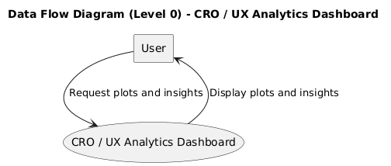

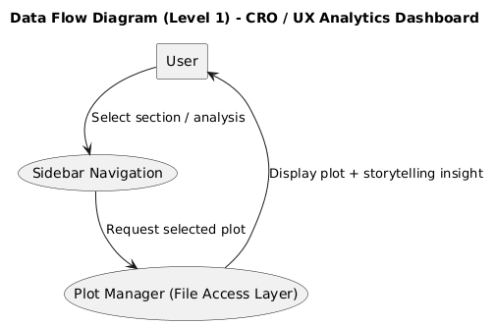

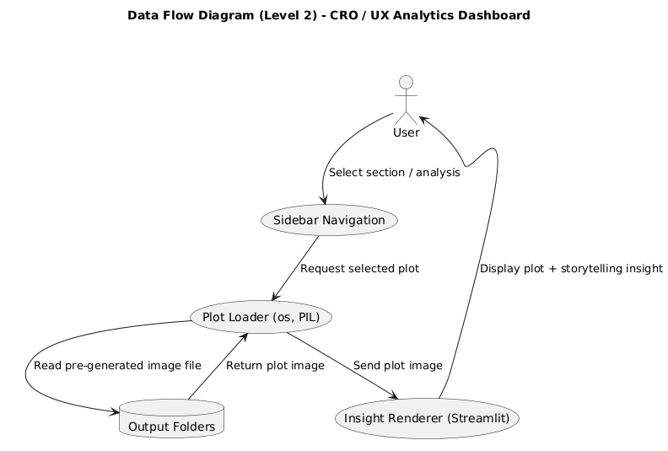

4.2 Database Design

4.2.1 E-R Diagram

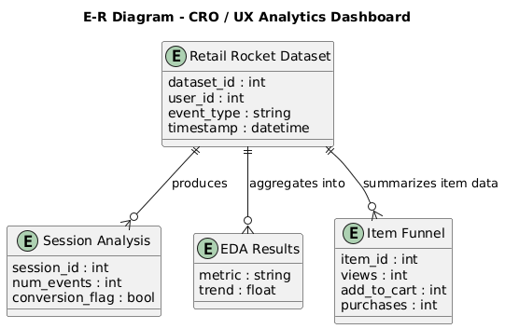

5. GUI
The GUI maintains a clean dark background with white text. Sidebar allows easy switching between sections.
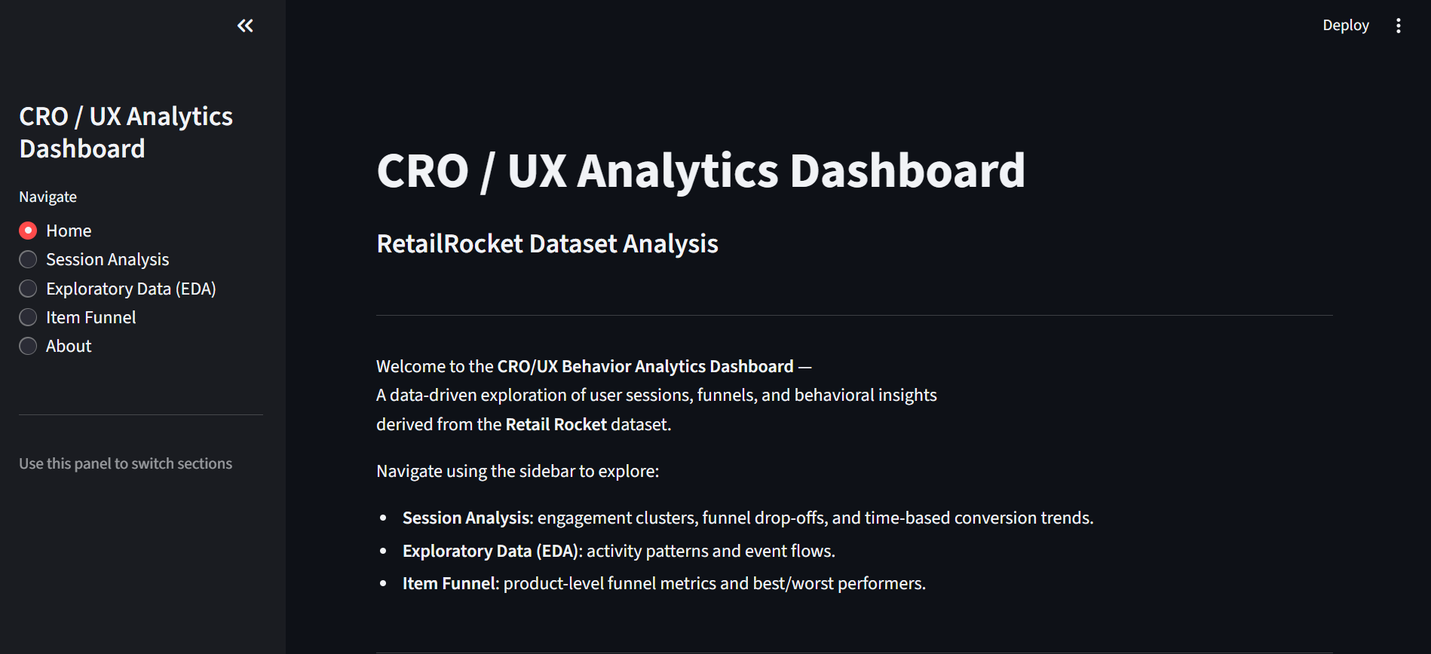

Plots are centered and medium-sized, followed by interpretation text.
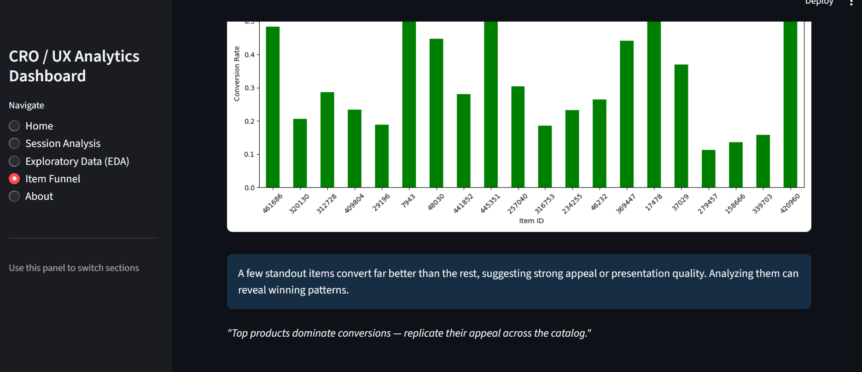

6. Future Scope
1. Add live analytics with real-time analytics.
2. Include predictive models for user churn.
3. Add other types of analysis like click heatmaps.
4. Host as a full-scale web application.
5. Enable interactive dashboards.

7. Conclusion
The CRO/UX Analytics Dashboard combines data analysis, visualization, and storytelling to help interpret user behavior in e-commerce environments. It provides a compact example of how data can drive design and conversion decisions.

8. References
1. Retail Rocket Dataset - Kaggle (https://www.kaggle.com/datasets/retailrocket/ecommercedataset/discussion?sort=hotness)
2. Streamlit Documentation (https://docs.streamlit.io/)
3. Pandas Documentation (https://pandas.pydata.org/docs/)
4. Matplotlib Documentation (https://matplotlib.org/stable/index.html)
5. StarUML Documentation (https://docs.staruml.io/)
6. PlantUML Documentation (https://plantuml.com/guide)
7. Alex The Analyst Youtube Tutorials (https://www.youtube.com/@AlexTheAnalyst)
8. Fundamentals of Software Engineering- By Rajib Mall (5th Edition)

