CO 2 – ASSESSMENT TOOL -3 COURSE CODE: DSA0308 COURSE NAME: NLP
Reg no:192324194 Name: K.Parameshwar Reddy

Scenario-Based questions:
Q3. Error Analysis of Stemming in News Article Classification

How does stemming affect feature extraction?
Stemming reduces words to their root or stem form. It helps reduce the number of features in a dataset. However, incorrect stemming can remove important meanings and affect classification accuracy.

Identify incorrect stems generated by Porter Stemmer.

Original Word | Stem | Problem
organization | organ | Meaning is lost
organizer | organ | Meaning is lost
organizing | organ | Meaning is lost
organized | organ | Meaning is lost
organization's | Depends on tokenization | Possessive form

Would lemmatization improve classification?
Yes. Lemmatization uses vocabulary and linguistic rules to convert words into meaningful base forms.
Examples:
  - organizing → organize
  - organized → organize
  - organizations → organization
Lemmatization preserves meaning better than stemming in many cases.

Compare preprocessing methods.
Method Advantages Disadvantages Without stemming Preserves original words Large vocabulary Porter stemming Reduces vocabulary size May lose meaning
Lemmatization Produces meaningful base forms Takes more processing time

Conclusion
Lemmatization is a good choice when preserving semantic meaning is important. The best method should be selected by comparing classification accuracy on the dataset.

Q4. Morphological Error Analysis in an Information Retrieval System

Analyze stemming errors affecting search relevance.
Stemming removes word endings to find related words. Incorrect stemming can produce irrelevant search results and reduce search accuracy.

Categorize each error.

Word | Root | Morphology
watches | watch | Inflectional
watching | watch | Inflectional
washable | wash | Derivational
washer | wash | Derivational
washed | wash | Inflectional

Why should certain suffixes not be removed?
Inflectional suffixes change grammatical forms, while derivational suffixes can change a word's meaning or grammatical category.
For example:
Watching: A form of the verb watch. Washer: A device or person that washes. Washable: Something that can be washed.

Removing all suffixes may combine words with different meanings, reducing product-search relevance.

Propose an improved morphological preprocessing strategy.
  - Convert all words to lowercase.
  - Remove unnecessary punctuation.
  - Tokenize the text into words.
  - Use lemmatization for appropriate inflectional forms.
  - Preserve important derivational distinctions.
  - Test the search system using precision and recall.
Conclusion: An improved morphological preprocessing strategy increases search relevance and helps users find the correct products.

Q5. Correct the Porter Stemmer Program

Identify the coding errors.
The original code is:

from nltk.stem import PorterStemmer import pandas as pd

ps = PorterStemmer()

data = pd.read_csv("BBCNews.csv")

data["Processed"] = data["Text"].apply(ps.stem)

print(data["Processed"].head())

Errors:
  - ps.stem() expects a single word, not a complete news article.
  - The text is not tokenized into individual words.
  - Punctuation is not handled.
  - The program assumes the CSV file contains a column named Text.

Why is the output incorrect?
The stemmer is designed to process individual words. Applying it directly to an entire article does not correctly stem each word separately.

Corrected program
import re
from nltk.stem import PorterStemmer

ps = PorterStemmer()

text = "connected connection connecting connectivity studies studied studying study"

words = re.findall(r"[a-zA-Z]+", text.lower())

print("Original Word -> Stemmed Word")

for word in words:
print(word, "->", ps.stem(word))

OUTPUT:
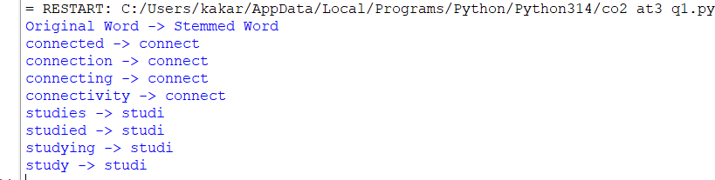

Conclusion: The corrected program tokenizes the text before stemming, producing properly processed words. Lemmatization may be preferable when preserving meaning is important.

Q6. Error Analysis of a Finite-State Morphological Parser

Identify the logical errors.
Original code:
def parser(word):
if word.endswith("s"):
return word[:-2], "Plural Noun" else:
return word, "Singular"

words = ["cars", "boxes", "cities", "children"]

for w in words: print(parser(w))
Error: word[:-2] removes two characters instead of one for regular plurals. For example, cars becomes ca instead of car.

Corrected Python program
irregular = { "children": "child",
"men": "man",
"women": "woman",
"mice": "mouse",
"feet": "foot",
"teeth": "tooth", "people": "person"
}

def parser(word):
word = word.lower()

if word in irregular:
return word, irregular[word], "Plural Noun"

elif word.endswith("ies"):
return word, word[:-3] + "y", "Plural Noun"

elif word.endswith(("ches", "shes", "xes", "zes", "sses")): return word, word[:-2], "Plural Noun"

elif word.endswith("s") and not word.endswith("ss"): return word, word[:-1], "Plural Noun"

else:
return word, word, "Singular or Unknown"

words = ["cars", "boxes", "cities", "children"]

for w in words: print(parser(w))

OUTPUT:
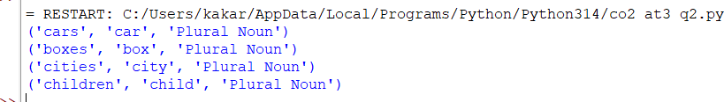
Conclusion: The corrected parser handles regular plurals, -es, -ies, and selected irregular plurals. A lexical database such as WordNet can improve its accuracy.

