CO 2 – ASSESSMENT TOOL -1 COURSE CODE: DSA0308 COURSE NAME: NLP

Reg no:192324194 Name: K.Parameshwar reddy

Q1. Morphological Analysis of Connected, Connecting, Connection

Aim
To design a morphological analysis pipeline that decomposes words into roots and suffixes, classifies the suffixes, and normalizes words for document indexing.

Morphological Analysis

Original Word | Root | Suffix | Type | Normalized Form
connected | connect | -ed | Inflectional | connect
connecting | connect | -ing | Inflectional | connect
connection | connect | -ion | Derivational | connect

Explanation:
  - Connected: The suffix -ed indicates past tense.
  - Connecting: The suffix -ing indicates a continuous or progressive verb form.
  - Connection: The suffix -ion changes the verb connect into a noun, so it is derivational.
  - All three words are normalized to connect for document indexing.

Python Program

def analyze_word(word): rules = {
"connected": ("connect", "-ed", "Inflectional"),
"connecting": ("connect", "-ing", "Inflectional"),
"connection": ("connect", "-ion", "Derivational")

}

root, suffix, category = rules[word]

return {
"Original Word": word, "Root": root,
"Suffix": suffix, "Type": category,
"Normalized Form": "connect"
}

words = ["connected", "connecting", "connection"]

print(f"{'Word':<15}{'Root':<12}{'Suffix':<10}" f"{'Type':<15}{'Normalized Form'}")

for word in words:
result = analyze_word(word) print(f"{result['Original Word']:<15}"
f"{result['Root']:<12}"
f"{result['Suffix']:<10}"
f"{result['Type']:<15}" f"{result['Normalized Form']}")

- OUTPUT
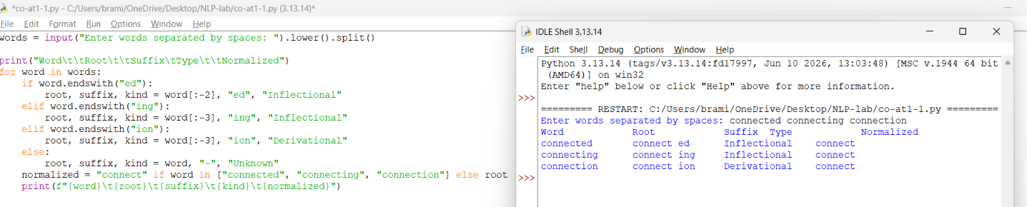

Q2. Morphological Parsing of Unhappy, Happiness, Happily

Aim
To design a rule-based morphological parsing module for sentiment analysis.

Morphological Analysis

Original Word | Prefix | Base Form | Suffix | Type | Normalized Root
unhappy | un- | happy | None | Derivational | happy
happiness | None | happy | -ness | Derivational | happy
happily | None | happy | -ly | Derivational | happy

Explanation:
  - Unhappy: The prefix un- adds a negative meaning to happy.
  - Happiness: The suffix -ness changes the adjective happy into the noun happiness. The spelling changes from y to i.
  - Happily: The suffix -ly changes the adjective happy into the adverb happily. The spelling changes from y to i.
  - All three words are derived from the base happy.
All transformations are derivational because they create new meanings or grammatical word forms rather than merely expressing tense, number, or agreement.

Python Program
def analyze_word(word): rules = {
"unhappy": { "Prefix": "un-",
"Base": "happy",
"Suffix": "None", "Type": "Derivational",
"Normalized Root": "happy"
},
"happiness": { "Prefix": "None",
"Base": "happy",
"Suffix": "-ness",

"Type": "Derivational", "Normalized Root": "happy"
},
"happily": { "Prefix": "None",
"Base": "happy",
"Suffix": "-ly",
"Type": "Derivational", "Normalized Root": "happy"
}
}

return rules[word]

words = ["unhappy", "happiness", "happily"]

print(f"{'Word':<15}{'Prefix':<12}{'Base':<10}"
f"{'Suffix':<10}{'Type':<15}{'Normalized Root'}")

for word in words:
result = analyze_word(word) print(f"{word:<15}"
f"{result['Prefix']:<12}"
f"{result['Base']:<10}"
f"{result['Suffix']:<10}"
f"{result['Type']:<15}" f"{result['Normalized Root']}")

- OUTPUT

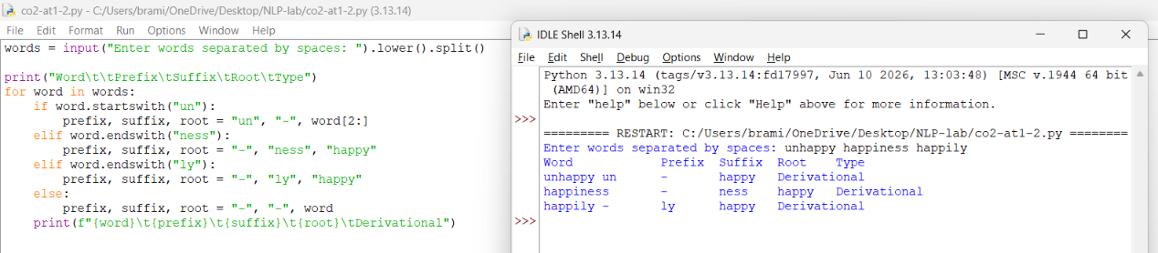

Q3. Stemming of Played, Player, Playing

Aim
To develop a stemming-based preprocessing module for a search engine that extracts stems and normalizes related words.

Morphological Analysis

Original Word | Stem | Removed Affix | Transformation Type | Normalized Form
played | play | -ed | Inflectional | play
player | play | -er | Derivational | play
playing | play | -ing | Inflectional | play

Explanation:
  - Played: Removing -ed gives play. The suffix represents past tense.
  - Player: Removing -er gives play. Here, -er forms a noun referring to a person who plays, so it is derivational.
  - Playing: Removing -ing gives play. The suffix represents a progressive or participial verb form.
All three words are normalized to play, improving search consistency.

Python Program
def stem_word(word): rules = {
"played": ("play", "-ed", "Inflectional"),
"player": ("play", "-er", "Derivational"),
"playing": ("play", "-ing", "Inflectional")
}

stem, affix, category = rules[word]

return {
"Original Word": word, "Stem": stem, "Removed Affix": affix,
"Transformation Type": category, "Normalized Form": "play"
}

words = ["played", "player", "playing"]

print(f"{'Word':<12}{'Stem':<10}{'Affix':<12}" f"{'Type':<15}{'Normalized Form'}")

for word in words:
result = stem_word(word) print(f"{result['Original Word']:<12}"
f"{result['Stem']:<10}" f"{result['Removed Affix']:<12}" f"{result['Transformation Type']:<15}" f"{result['Normalized Form']}")

- OUTPUT

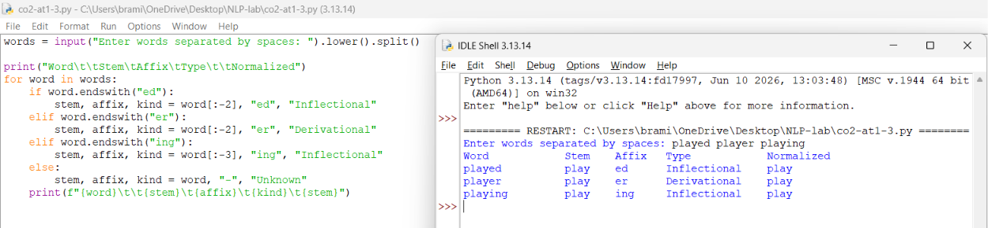

Q4. Finite-State Morphological Parsing of Writes, Writing, Written

Aim
To design a finite-state morphological parser that identifies regular and irregular verb forms and normalizes them to a common root.

Finite-State Model
A finite-state machine uses states and transitions to recognize morphological patterns.

States
  - q0: Start state.
  - q1: Recognize the verb root write.
  - q2: Recognize the suffix -s.
  - q3: Recognize the suffix -ing.
  - q4: Recognize the irregular past participle written.
  - qf: Final accepting state.

State Transitions

Input Word | State Transition Path | Morphological Breakdown | Type | Normalized Form
writes | q0 → q1 → q2 → qf | write + -s | Regular inflection | write
writing | q0 → q1 → q3 → qf | write + -ing | Regular inflection | write
written | q0 → q4 → qf | write → written | Irregular inflection | write

Explanation:
- Writes: The suffix -s marks third-person singular present tense.
- Writing: The suffix -ing forms the present participle. The final e in write is dropped before adding -ing.
- Written: This is an irregular past participle. It cannot be correctly analyzed by simply removing a regular suffix from write.
All forms are normalized to write.

Python Program
def finite_state_parser(word): transitions = {

"writes": {
"path": "q0 -> q1 -> q2 -> qf", "root": "write",
"breakdown": "write + -s", "type": "Regular inflection", "normalized": "write"
},
"writing": {
"path": "q0 -> q1 -> q3 -> qf", "root": "write",
"breakdown": "write -> writ + -ing", "type": "Regular inflection", "normalized": "write"
},
"written": {
"path": "q0 -> q4 -> qf",
"root": "write",
"breakdown": "write -> written", "type": "Irregular inflection", "normalized": "write"
}
}

return transitions[word]

words = ["writes", "writing", "written"]

for word in words:
result = finite_state_parser(word)

print("\nWord:", word)

print("State Path:", result["path"]) print("Root:", result["root"]) print("Breakdown:", result["breakdown"]) print("Type:", result["type"])
print("Normalized Form:", result["normalized"])

- OUTPUT
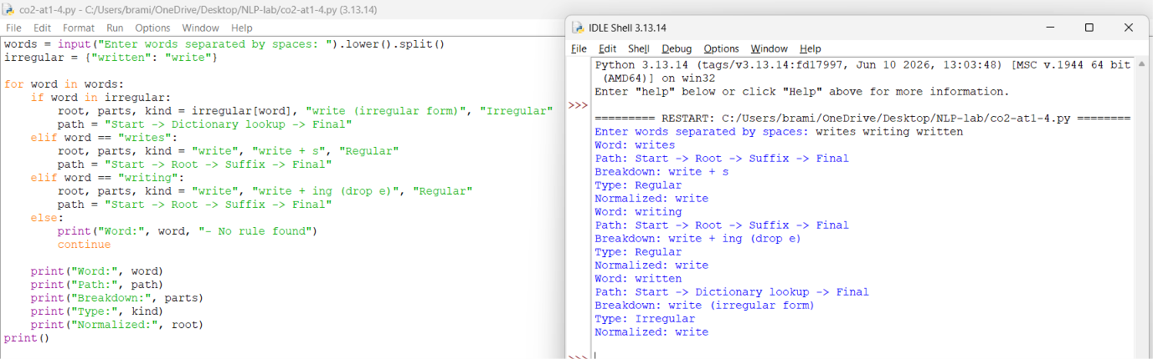

Q5. Porter Stemmer for Relational, Relation, Relate

Aim
To implement Porter stemming for document retrieval and normalize related words by applying suffix-removal rules.

Stemming Analysis
The Porter stemming algorithm removes certain suffixes in stages to produce a stem. Unlike morphological analysis, stemming does not always produce a complete dictionary word.

Original Word | Stemming Rule | Intermediate Form | Final Stem
relational | -ational → -ate | relational → relate | relat
relation | Remove -ion | relation → relat | relat

Original Word | Stemming Rule | Intermediate Form | Final Stem
relate | Remove final -e | relate → relat | relat
Step-by-step explanation:
- Relational
  - The Porter algorithm's Step 2 changes -ational to -ate when the measure condition is satisfied.
  - relational becomes relate.
  - Step 5 removes the final e under the algorithm's measure conditions.
  - Final stem: relat.
- Relation
  - Step 4 removes -ion only when the preceding letter is s or t.
  - In relation, the preceding letter is t.
  - relation becomes relat.
  - Final stem: relat.
- Relate
  - Step 5 removes the final e when its measure condition is satisfied.
  - relate becomes relat.
  - Final stem: relat.
Note: The Porter stemmer is rule-based and may produce relat rather than the dictionary word relate. This is expected.

Python Program Using NLTK

from nltk.stem import PorterStemmer

stemmer = PorterStemmer()

words = ["relational", "relation", "relate"]

print(f"{'Original Word':<18}{'Porter Stem'}") print("-" * 35)

for word in words:

stem = stemmer.stem(word) print(f"{word:<18}{stem}")

- OUTPUT
