Maven –

Build management tool similar to Ant|  
It helps to building our code in our project.  
It helps to project management tool. Help to generate report and dependecy mangement tool which helps to download the dependent jars.

Common problems and activities that Maven do usually

Multiple jars  
Dependecies and versions  
Project structure  
Building, publish and deploying

**Maven set up from scratch:**

Download Maven and set up the env variable paths.  
M2_Home - C:\Users\HOME\Downloads\apache-maven-3.6.0-bin\apache-maven-3.6.0  
path - C:\Users\HOME\Downloads\apache-maven-3.6.0-bin\apache-maven-3.6.0\bin

Then check maven properly installed or not by executing command

Mvn –version  
how helps in creating project structure – Maven have some repositories online and maven talks to that repositories and helps to create this project structers.

Then to generate project in our specified folder

Mvn archetype:generate

Archetype is a model how the project structure should be.

Steps:

Mkdir myapp  
mvn archetype:generate  
Then it will ask the model number and version number.

Model number – 1303  
It displays the versions in that model. Then type version – 12  
Then it will ask groupid and artifactid  
groupid: refers package name like com.dbs  
artifact id: refers project name like SGIB_Automation (This is the name of the jar or war after building or deploying the proejcts)  
then it ask version number of snapshot and default it will be 1  
then type Y . Its finished

Then nav to the folder path of where pom exist

Mvn compile (it will download all related dependencies mentioned in pom.xml and compile java classes and also downloads the plugins required)

Mvn package – this package into a jar file.

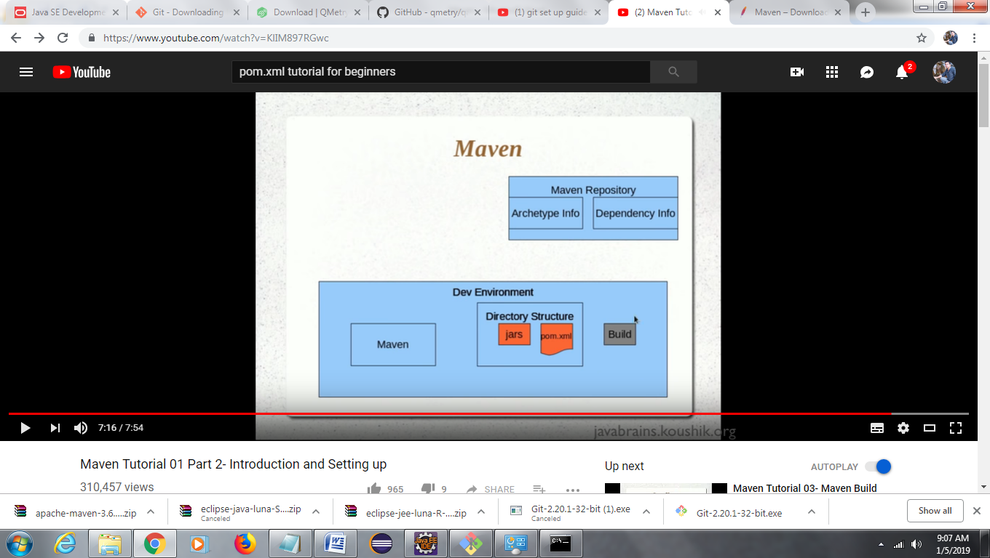

Maven Build:

References: https://www.youtube.com/watch?v=KlIM897RGwc