How Can Machine Learning Help Us Navigate Parking Lots?
Introduction
The AEC (Architecture, Engineering, and Construction) field has completely transformed with the evolution and development of technology. Of course, we must adapt to this evolution. Today, we will discuss machine learning in various fields and will certainly continue to talk about it... The data that allowed it to be transformed using “Shapely” and “Numpy” can enable us to use ML in our scenario. Once the data is ready for machine learning, it can easily analyze the data, determine those that are close to each other, group them, and reanalyze their neighborhood relationships. Thus, hundreds of data points can be analyzed in a matter of seconds.
I used a radius value to interact with the neighborhood relationships for each data point. If the radius value is 500 cm, here is the resulting graph below:
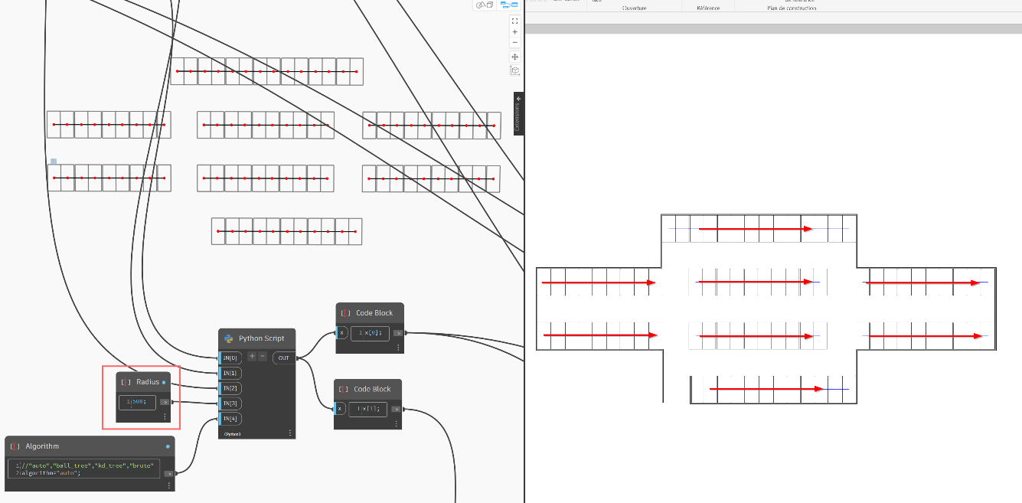
This is what the graph tells us: they managed to group and rank, but unfortunately, they could not communicate with each other because the radius value we decided on was insufficient to find their neighborhoods.
What if the radius value would have been more than 500cm? Here is the result of the graph below.
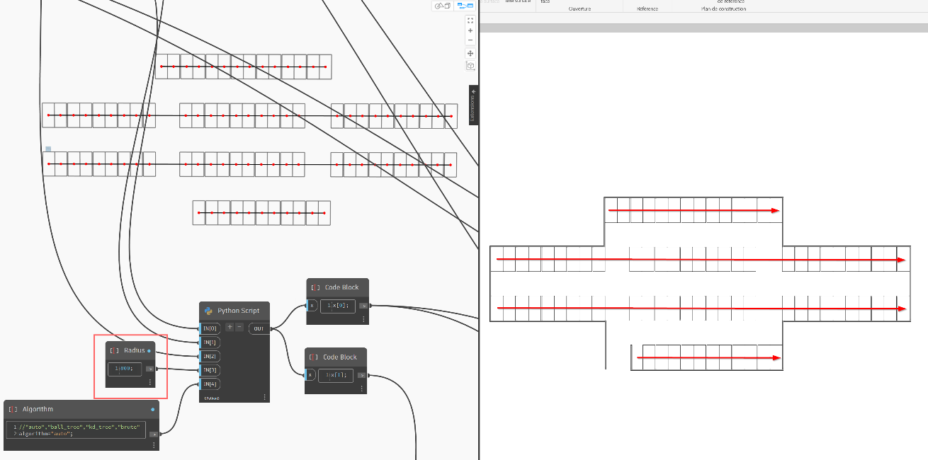
It is much better, but still not perfect because the radius value is still not sufficient to complete their relationships. Despite this, the middle of the parking lot communicates, and we still cannot say that our scenario is “correct” given those above and those below.

What if the radius value would have been more than 800cm? Here is the result of the graph below.
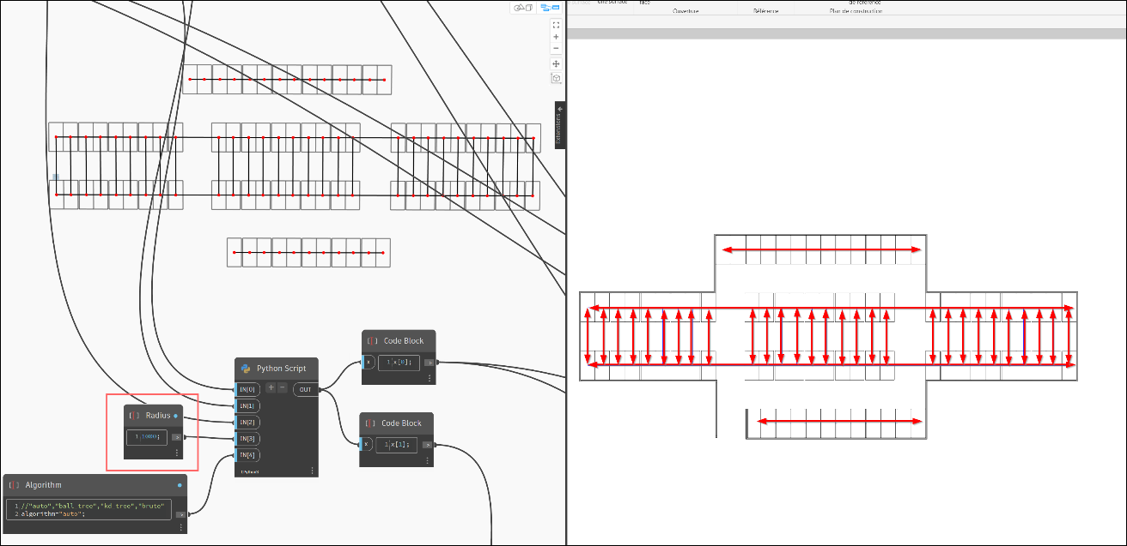
It gave us a completely different result from the others. We can observe that the central part is now completely connected, and the grouping is random. It's really not bad; however, it's not enough for us because it still hasn't communicated with those above and below.
What if the radius value would have been more than 1100cm? Here is the result of the graph below.
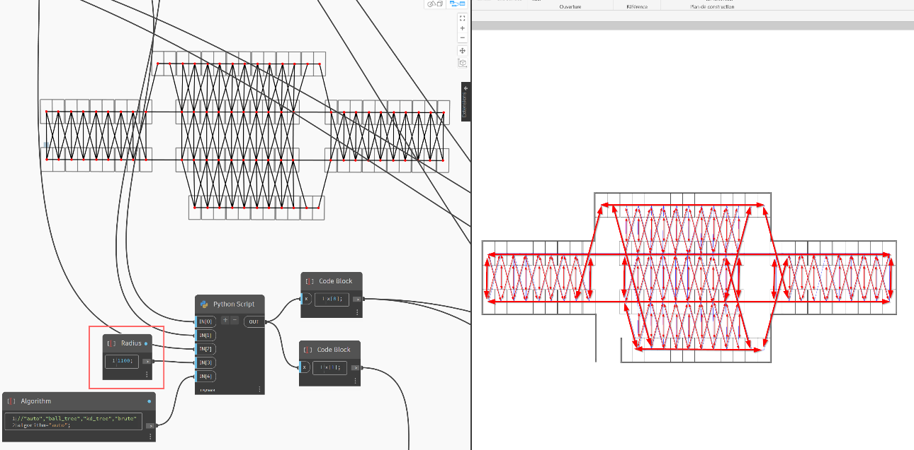
It obtained the result we wanted. Each part communicates with the others, and they are all perfectly grouped. We can say that this result is really useful for continuing the analysis. During the neighborhood analysis, ML can indicate those that are connected to each other. Here is an example in 3D.
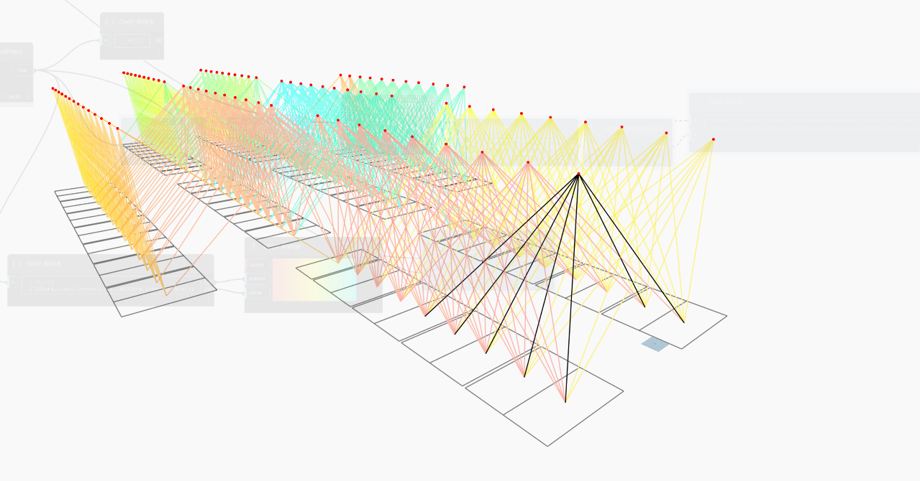

However, it is also necessary to consider the weights of these connections. The weight values are extremely important during the analysis because we can use these values (red rectangle) to find the starting point and their orientations.
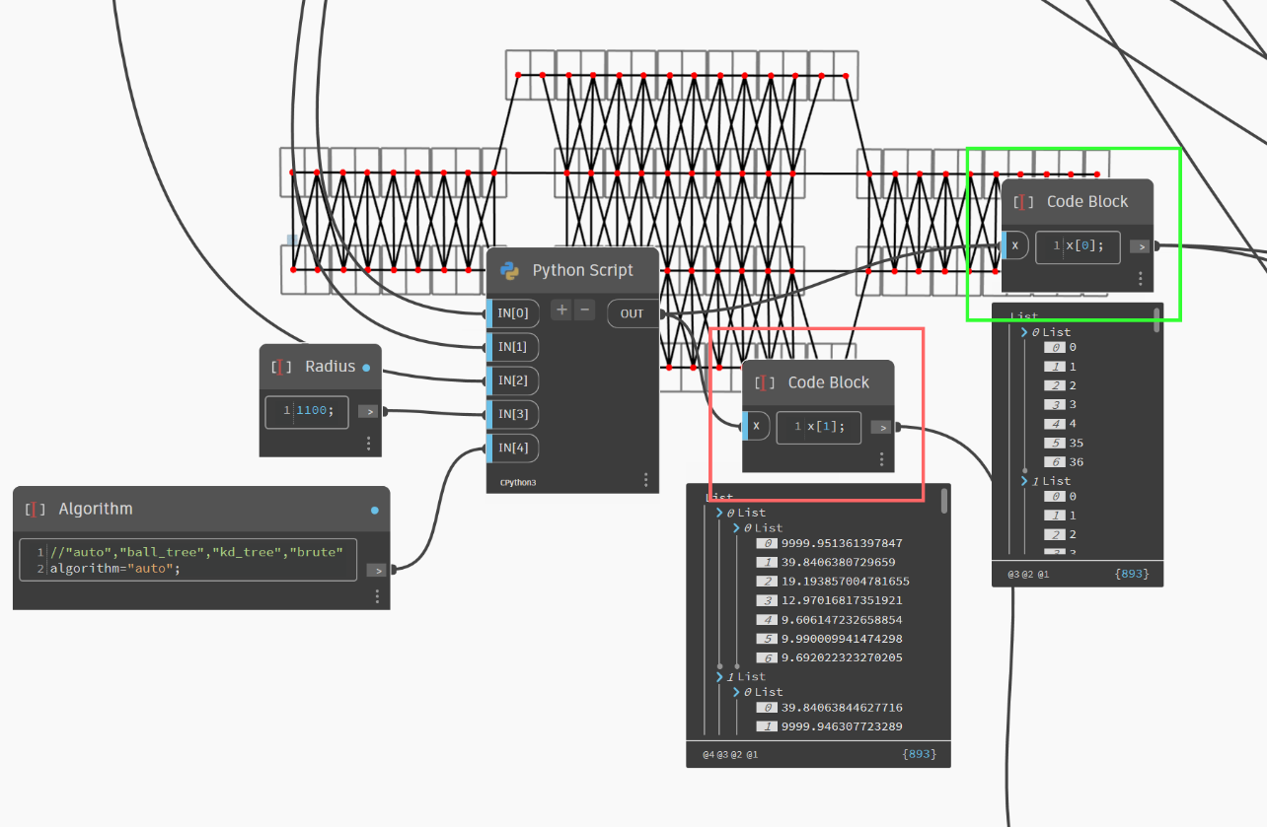
Summary

This scenario uses various data sources to analyze the location of vehicles in parking spaces and then to classify and assign optimal numbering to them. In particular, we use “weights” to make the location data more meaningful. This has significantly improved the performance of our model. The results show that the developed model is capable of efficiently sorting and numbering parking spaces. Additionally, we make predictions about the applicability of this system and how it can be used in real-world scenarios.
In conclusion, this study provides an innovative solution for the management and optimization of parking spaces and lays a solid foundation for future improvements and extensions.

