- Start Revit 2013

- Before coding, make sure all processes are detached.
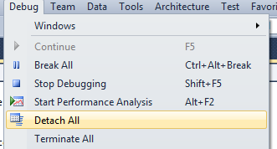

- After coding, build solution and attach to Revit process.
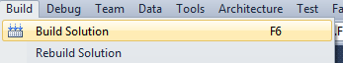

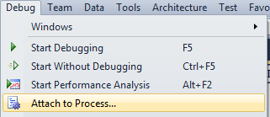

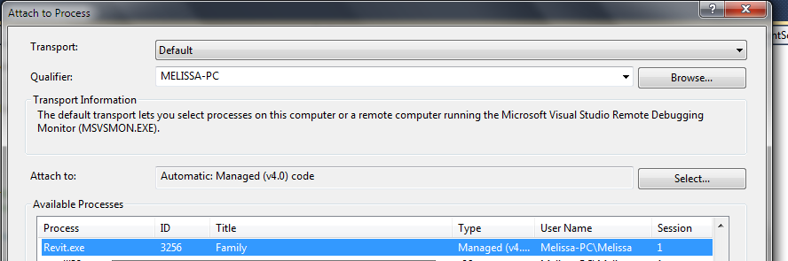

- In Revit, go to the Add-Ins tab > Add-In Manager > (re)load desired dll.
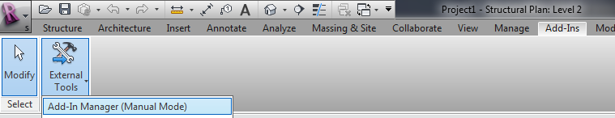

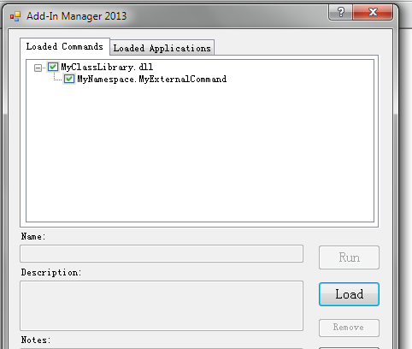

- Run desired external command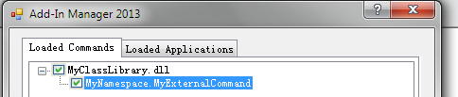

- Repeat steps 2 to 5.

