Supporting Dark Theme for Revit Addins/Addons

Switching the Theme
Setting the UI Active Theme will switch the appearance of the Ribbon between light gray and dark blue.
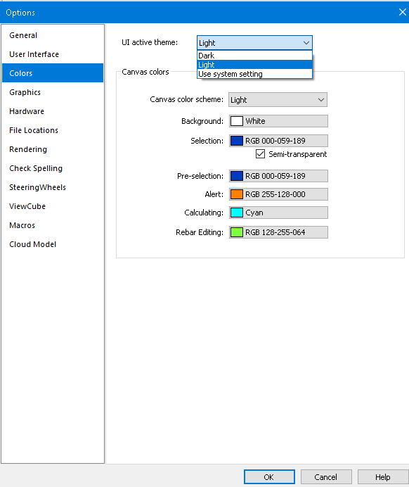
- Light
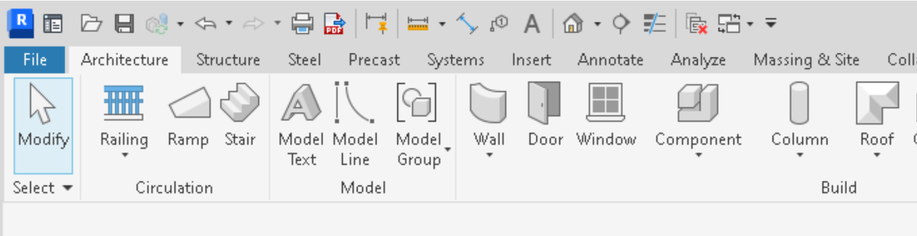
- Dark
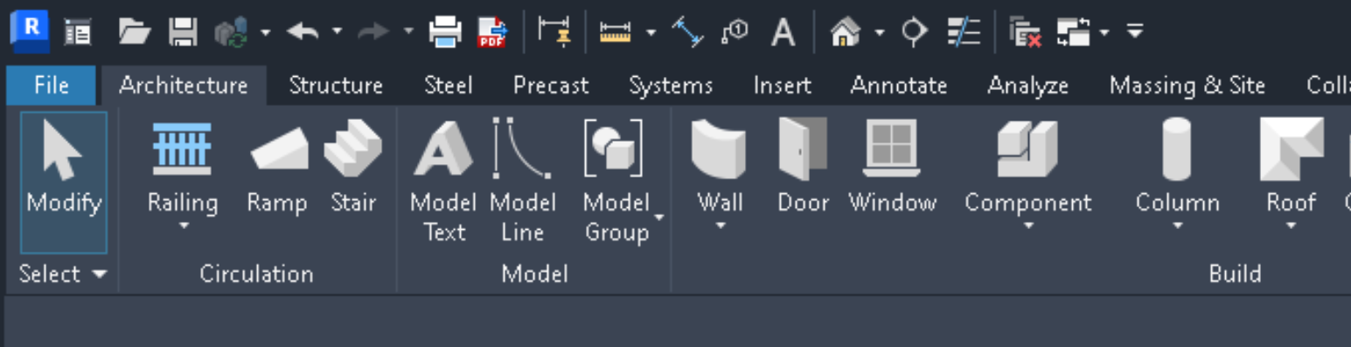
- Use system setting
Windows supports light and dark color schemes. If you choose this option, Revit will use the Windows color scheme and switch to a matching theme accordingly.

Information for Revit API Developers
- ThemeChangedEventArgs – Arguments for the ThemeChanged event
- UIThemeManager.CurrentTheme – Allows you to set /get the overall theme for the Revit session
- UIThemeManager.FollowSystemColorTheme – Allows you to set /get if the overall theme follows operating system color theme
- UIThemeManager.CurrentCanvasTheme – Allows you to set/get a canvas theme for the current Revit session (as opposed to the default theme)
- ColorOption – Allows you to set/get the colors in the current canvas theme

Information for Revit Addins/Addons Designers

Colors
  - Ribbon Background
Light
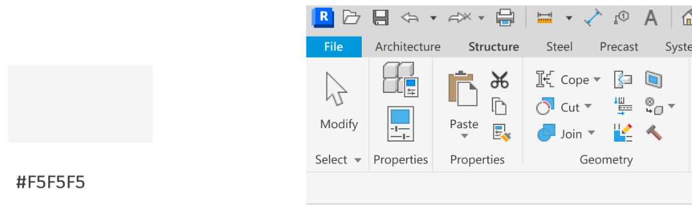
Dark
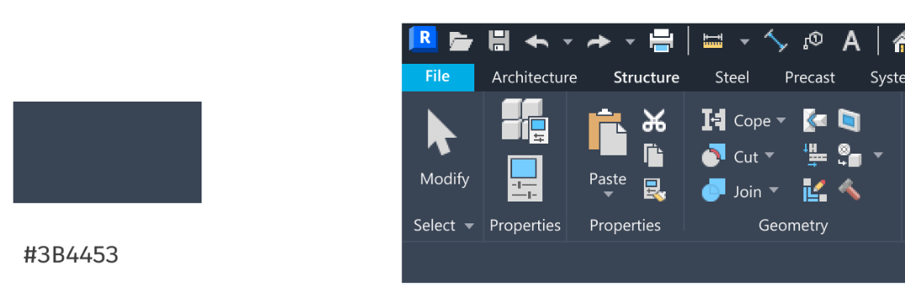

  - Ribbon Buttons
Light
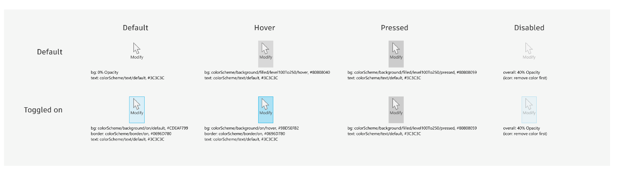
Dark
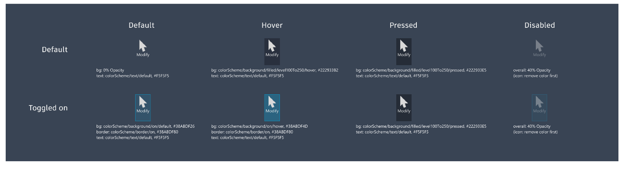

Size: small button - 16x16px, large button - 32x32px

Resolution: 96 DPI
- Icons

Example: Add Themed Icons on Ribbon

internal class TestRibbon : IExternalApplication
{
private PushButton m_ribbonBtn;
public Result OnStartup(UIControlledApplication application)
{
var ribbonPanel = application.CreateRibbonPanel("33900745-04F5-4CC2-9BAC-3230716E3A54", "Test");
var buttonData = new PushButtonData("Test", "Test", typeof(CmdEntry).Assembly.Location, typeof(CmdEntry).FullName);
buttonData.AvailabilityClassName = typeof(CmdEntry).FullName;
m_ribbonBtn = ribbonPanel.AddItem(buttonData) as PushButton;
updateImageByTheme();
application.ThemeChanged += ThemeChanged;
return Result.Succeeded;
}
private void setButtonImage(string pic, string largePic)
{
var assemblyLocation = typeof(TestRibbon).Assembly.Location;
var assemblyDirectory = Path.GetDirectoryName(assemblyLocation);
var imagePath = Path.Combine(assemblyDirectory, pic);
var largeImagePath = Path.Combine(assemblyDirectory, largePic);
if (File.Exists(imagePath))
m_ribbonBtn.Image = new System.Windows.Media.Imaging.BitmapImage(new Uri(imagePath));
if (File.Exists(largeImagePath))
m_ribbonBtn.LargeImage = new System.Windows.Media.Imaging.BitmapImage(new Uri(largeImagePath));
}
private void updateImageByTheme()
{
UITheme theme = UIThemeManager.CurrentTheme;
switch (theme)
{
case UITheme.Dark:
setButtonImage("dark.png", "darkLarge.png");
break;
case UITheme.Light:
setButtonImage("light.png", "lightLarge.png");
break;
}
}
private void ThemeChanged(object sender, Autodesk.Revit.UI.Events.ThemeChangedEventArgs e)
{
updateImageByTheme();
}
}

Other notes
- Please note that only the 1st level UI supports dark theme.

