paramita 22

[Email address]

BookManagement System

Architecture

Abstract

Books have long been the best friend of the civilized society. Apart from providing knowledge, it is the propagation of  
communication that transcends into an intellectual and psychological broadening of the minds of the superior species, the humans.  
Most printed material have opened new domains of evolution, ideas, research, and a barter of information. The Online book shop  
carries the tradition of a better improved society that chooses to buy books, trace and track readers as well as buyer-sellers to  
interact.  
The system is primarily an eCommerce application, that is a mega Book mart intended to connect anybody and everybody  
interested in reading in print. The age-old tendency to widen view with reading is being enhanced by the system.  
The system connects people who are book collectors and often feel the necessity to lend their books in exchange of  
money to people who might carry on their legacy. In a scenario of recent trends to read pdf’s and rely on online materials, the  
system demands commendable respect as it tends to connect readers across the globe, online.

Books have long been the best friend of the civilized society. Apart from providing knowledge, it is the propagation of  
communication that transcends into an intellectual and psychological broadening of the minds of the superior species, the humans.  
Most printed material have opened new domains of evolution, ideas, research, and a barter of information. The Online book shop  
carries the tradition of a better improved society that chooses to buy books, trace and track readers as well as buyer-sellers to  
interact.  
The system is primarily an eCommerce application, that is a mega Book mart intended to connect anybody and everybody  
interested in reading in print. The age-old tendency to widen view with reading is being enhanced by the system.  
The system connects people who are book collectors and often feel the necessity to lend their books in exchange of  
money to people who might carry on their legacy. In a scenario of recent trends to read pdf’s and rely on online materials, the  
system demands commendable respect as it tends to connect readers across the globe, online.

Table of Contents

Abstract

1. ERD 2

**2. Data Dictionary………………………………………………………………………………………………………………………………………………………………………..3-4**

3. Complete Structure…………………………………………………………………………………………………………………………………………………………5 -10

**ENTITY RELATIONSHIP DIAGRAM:** Shows the complete structure to prepare the database of the system.

: attributes

: connectivities 1

**1 1**

conirms

system admin

n

Payment_details

1

has

reads

reads

opts

allows

allows

gives

gives

has

has

Old_books

opts

Book_purchase

Book_sale

reading_track

New_books

Users

n n

1

n n

1 n n n

1

n

n n

n

n

n

n

DATA DICTIONARY : (FOR DATABASE : (onlinebookshop)

A data dictionary is an ordered list of items which helps in designing software. This is a major component in developing a structured model analysis of the system. A data dictionary in software analysis holds records of objects in the database. It shows data ownership and relationship with other data. It helps in finding data from a description.A data dictionary is a centralized repository of metadata. Metadata is data about data. Some features of a data dictionary are:

* The names of fields contained in all of organisation’s databases.
* The table’s each field contains.
* The databases each field exists in.
* The data types of all field’s in the organisation’s databases.
* The size of all field’s in the organisation’s databases.
* An explaination of what each field means.
* The source of the data for each field.
* The relationship between field’s in the organisation’s databases.
* Default values that exists in all of the organisation’s databases.
* Who has access to each field.

A data dictionary may be used to validate the operator as a user and control attributes such as ownerships and provide cardinality relationships

1. system_admin

|  |  |  |  |  |  |
| --- | --- | --- | --- | --- | --- |
| **Field name** | **Data type** | **Field length** | **Constraints** | **Description** | **Reference** |
| admin_id | Varchar | 30 | primary key | sets an identity for admin | none,unique |
| admin name | Varchar | 45 | not null | sets admin name in database->by admin | none,unique |
| userid | Int | 45 | foreign key | userid generated after registrartion with email, password and email verification of user->by admin | users table |
| acc_id | Int | 45 | foreign key | identify payment details of each user making payment, ->by admin | payment_details table |
| nbid | Int | 45 | foreign key | Identify new books | new_books table |
| old_bookid | Int | 45 | foreign key | Identify old books | old_books table |

1. users

|  |  |  |  |  |  |
| --- | --- | --- | --- | --- | --- |
| **Field name** | **data type** | **field length** | **Constraints** | **Description** | **Reference** |
| Userid | int | 20 | primary key | identify each user of system by admin | Unique |
| user_fname | varchar | 45 | not null | first name entered by user during registration | Unique |
| user_lname | varchar | 45 |  | last name entered by user | Unique |
| user_email | varchar | 45 | not null | email entered during registration by user | Unique |
| user_password | varchar | 45 | not null | password entered during registration by user | Unique |
| contact_no | varchar | 45 | not null | address entered by user during registration | Unique |
| Address | varchar | 45 | not null | phone no. entered by user during registration | Unique |
| user_feedback | longtext |  |  | given by user to share opinion and suggestions | unique |
| acc_id | int | 20 | foreign key | identify the account details of user in payment portal by  admin | payment details  ,system_admin tables |
| profile_pic | mediumblob |  |  | Given by user | unique |

##### 3.payment_details

|  |  |  |  |  |  |
| --- | --- | --- | --- | --- | --- |
| **Field name** | **Data type** | **Size** | **Constraints** | **Description** | **Reference** |
| acc_id | int | **30** | primary key | Identifies account held by user | users |
| payment_mode | varchar | **45** | not null | Mode of payment made | unique |
| merchant_bank | varchar | **45** |  | Bank where the user account resides | unique |
| pin_cvv | int | **45** | not null | Pin is unique no | unique |
| amount_paid | int | **45** | not null | Amount paid on transaction |  |
| amount_received | int | **45** | not null | Amount received on transaction |  |
| wallet | varchar | **45** | not null | Amount held by each user |  |
| userid | int | **30** | foreign key | Unique no. of user to identify |  |

1. new_books

|  |  |  |  |  |  |
| --- | --- | --- | --- | --- | --- |
| **Field name** | **Data type** | **Size** | **Constraints** | **Description** | **Reference** |
| nbid | Int | **30** | primary key | Uniquely identifies each new book | unique |
| book_name | varchar | **45** | not null | Name of book | Book_sale,book_purchase |
| author_name | varchar | **45** |  | Name of author | Book_sale, book_purchas |
| subject | varchar | **45** | not null | which domain does it refer to | Book_sle, book_purchase |
| hardcover_copies | varchar | **45** | not null | Type of binding of the book | unique |
| online_versions | varchar | **45** | not null | Soft copy of the book | unique |
| cost | varchar | **45** | not null | Cost of the book | Payment_details |
| userid | Int | **30** | foreign key | Identifies user | users |
| book_cover | longblob |  |  | The picture and design of cover | unique |

1. old_books

|  |  |  |  |  |  |
| --- | --- | --- | --- | --- | --- |
| **Field name** | **Data type** | **Size** | **Constraints** | **Description** | **Reference** |
| old_bookid | int | **30** | primary key | Uniquely identifies old books | Book_sale, book_purchase |
| old_book_name | varchar | **45** | not null | Name of book | Book_sale, book_purchase |
| authorname | varchar | **45** |  | Name of writer/author | Book_sale, book_purchase |
| subject | varchar | **45** | not null | Domain to which the topics belong | Book_sale, book_purchase |
| hardcover | varchar | **45** | not null | Denotes the cover type |  |
| online_version | vachar | **45** | not null | Denotes soft copy |  |
| other_formats |  |  |  | Other fornats of books |  |
| cost | varchar | **45** | not null | Price to be paid |  |
| donorid | varchar |  |  | Book obtained by a prior reader |  |
| userid | int | **30** | foreign key | Identifies each user |  |
| book_cover | longtext |  |  |  |  |

1. reading_track :weak entity

|  |  |  |  |  |  |
| --- | --- | --- | --- | --- | --- |
| **Field name** | **Data type** | **Size** | **Constraints** | **Description** | **Reference** |
| userid | Int | **30** | primary key | Identifies users |  |
| nbid | Int | **45** | not null |  |  |
| old_bookid | Int | **45** |  |  |  |
| date | date | **45** | not null |  |  |
| read_count_new | Int | **45** | not null |  |  |
| read_count_old | Int | **45** | not null |  |  |

1. booik_sale: weah entity

|  |  |  |  |  |  |
| --- | --- | --- | --- | --- | --- |
| **Field name** | **Data type** | **Size** | **Constraints** | **Description** | **Reference** |
| ISBN | int | **30** | primary key |  |  |
| book_name | varchar | **45** | not null |  |  |
| author_name | varchar | **45** |  |  |  |
| sellerid | varchar | **45** | not null |  |  |
| buyerid | varchar | **45** | not null |  |  |
| Cost | int | **45** | not null |  |  |

|  |  |  |  |  |  |
| --- | --- | --- | --- | --- | --- |
| **Field name** | **Data type** | **Size** | **Constraints** | **Description** | **Reference** |
| ISBN | Int | **30** | primary key |  |  |
| book_name | varchar | **45** | not null |  |  |
| author_name | number | **45** |  |  |  |
| selling_price | number | **45** | not null |  |  |
| date_purchase | number | **45** | not null |  |  |

1. Book_purchase

**COMPLETE STUCTURE :** Database is generated based on this structure that is based on the ERD drawn previously.

* + The database of the project has been developed on **mysql workbench8.0 CE** version(21.4.2). Database name: orcl
  + The DDl, DML commands have been run on the **Query mode**
  + The driver used for connecting database to the Eclipse IDE is **oracle8.jar**(and the other jar files in the driver), on the build path of the project OnlineBookShop Dynamic webproject

**Database Schema**

1. **Table:system_admin primary key : (admin_id)**

|  |  |  |  |
| --- | --- | --- | --- |
| **Field name** | **Data type** | **Size** | **Constraints** |
| admin_id | varchar | **30** | primary key |
| admin_name | varchar | **50** | not null |
| Userid | int | **20** | foreign key |
| acc_id | int | **20** | foreign key |
| Iqexamcode | int | **20** | foreign key |
| Ctestcode | int | **20** | foreign key |

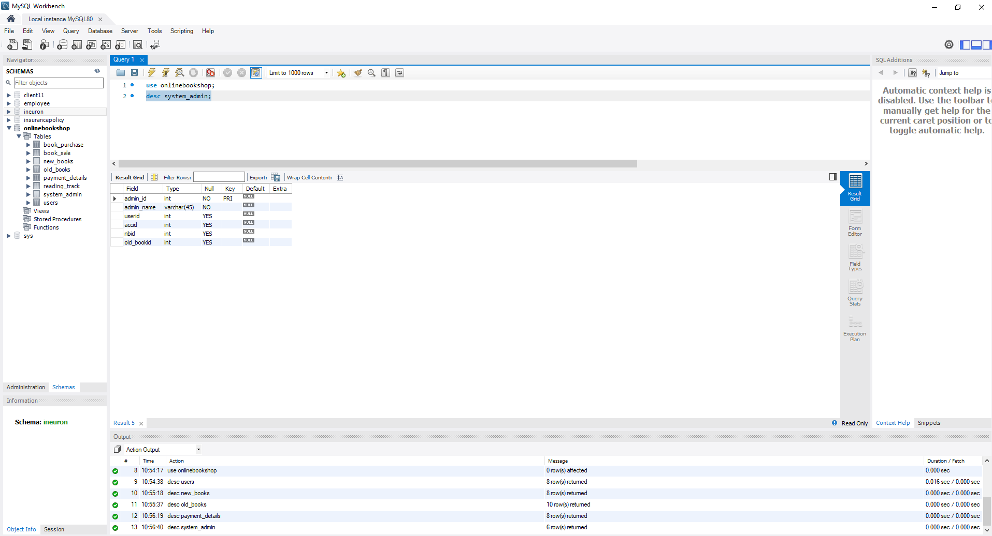

1. Table:users

primary key:userid

|  |  |  |  |
| --- | --- | --- | --- |
| **Field name** | **Data type** | **Size** | **Constraints** |
| userid | int | **30** | primary key |
| user_fname | varchar | **45** | not null |
| user_laname | varchar | **45** |  |
| user_email | varchar | **45** | not null |
| user_password | varchar | **45** | not null |
| contact_no | int | **45** | not null |
| address | varchar | **45** | not null |
| acc_no | int | **30** | foreign key |
| feedback | longtext |  |  |
| profile_pic | mediumblob |  |  |

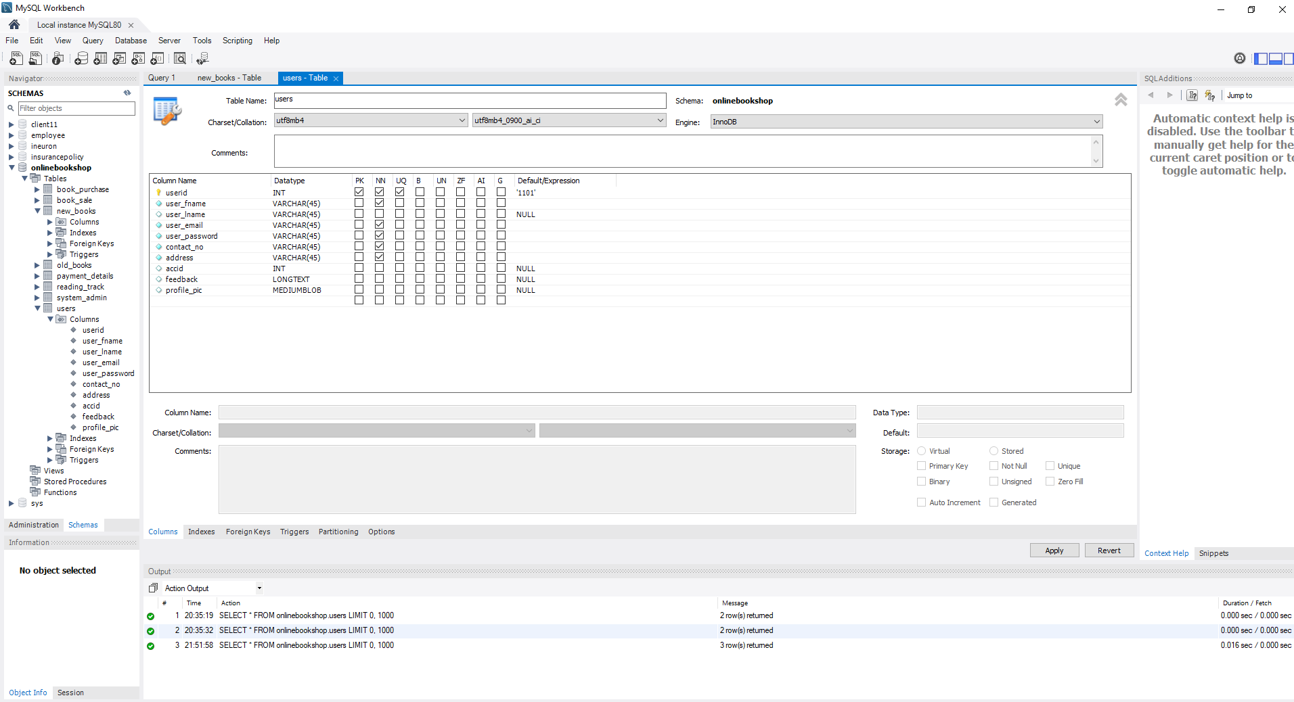

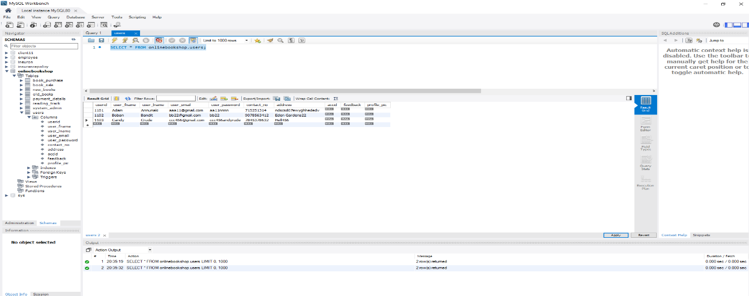

1. Table : payment_details

Primarykey : acc_id

|  |  |  |  |
| --- | --- | --- | --- |
| **Field name** | **Data type** | **Size** | **Constraints** |
| acc_id | int | **30** | primary key |
| payment_mode | varchar | **45** | not null |
| merchant_bank | varchar | **45** |  |
| pin_cvv | int | **45** | not null |
| amount_paid | int | **45** | not null |
| amount_received | int | **45** | not null |
| Wallet | varchar | **45** | not null |
| Userid | int | **30** | foreign key |

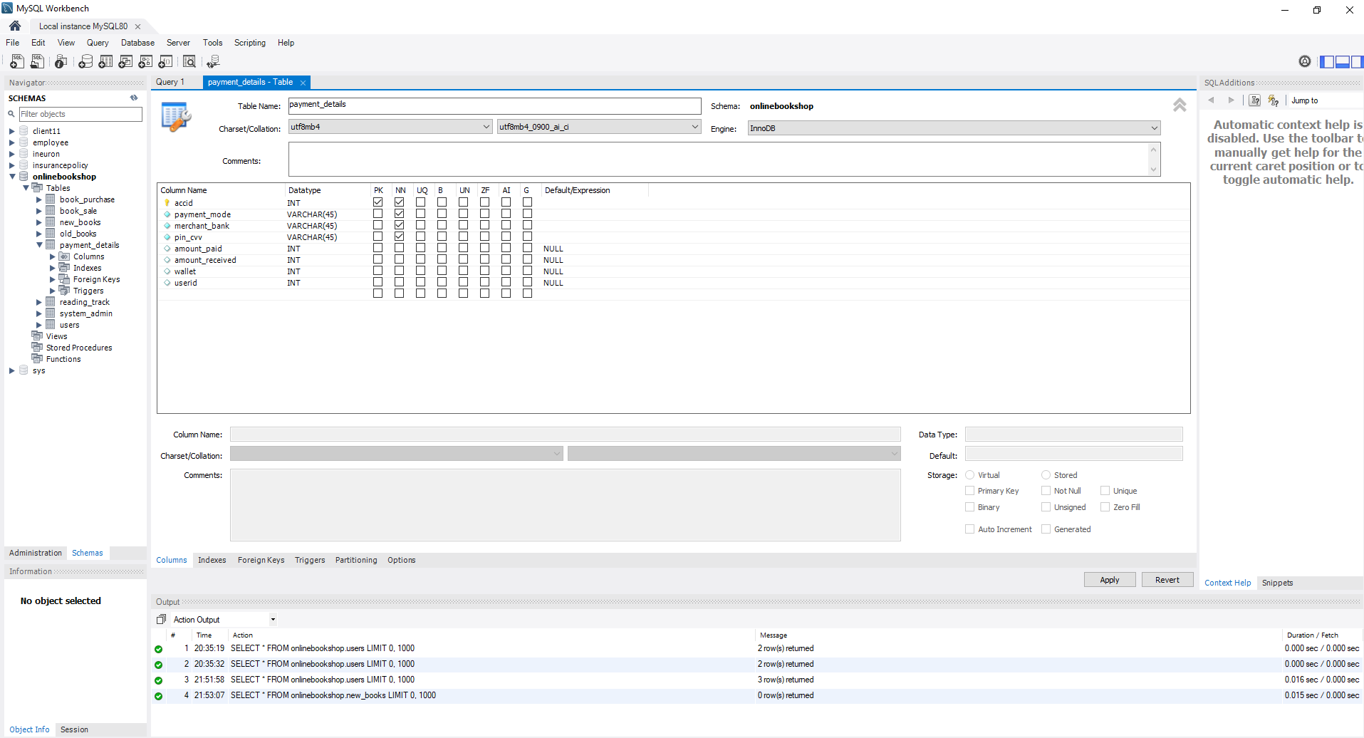

1. Table:new_books

Primary key:nbid

|  |  |  |  |
| --- | --- | --- | --- |
| **Field name** | **Data type** | **Size** | **Constraints** |
| nbid | int | **30** | primary key |
| book_name | varchar | **45** | not null |
| author_name | int | **45** |  |
| subject | varchar | **45** | not null |
| hardcover_copies | varchar | **45** | not null |
| online_versions | varchar | **45** | not null |
| cost | varchar | **45** | not null |
| userid | int | **30** | foreign key |
| book_cover | longblob |  |  |

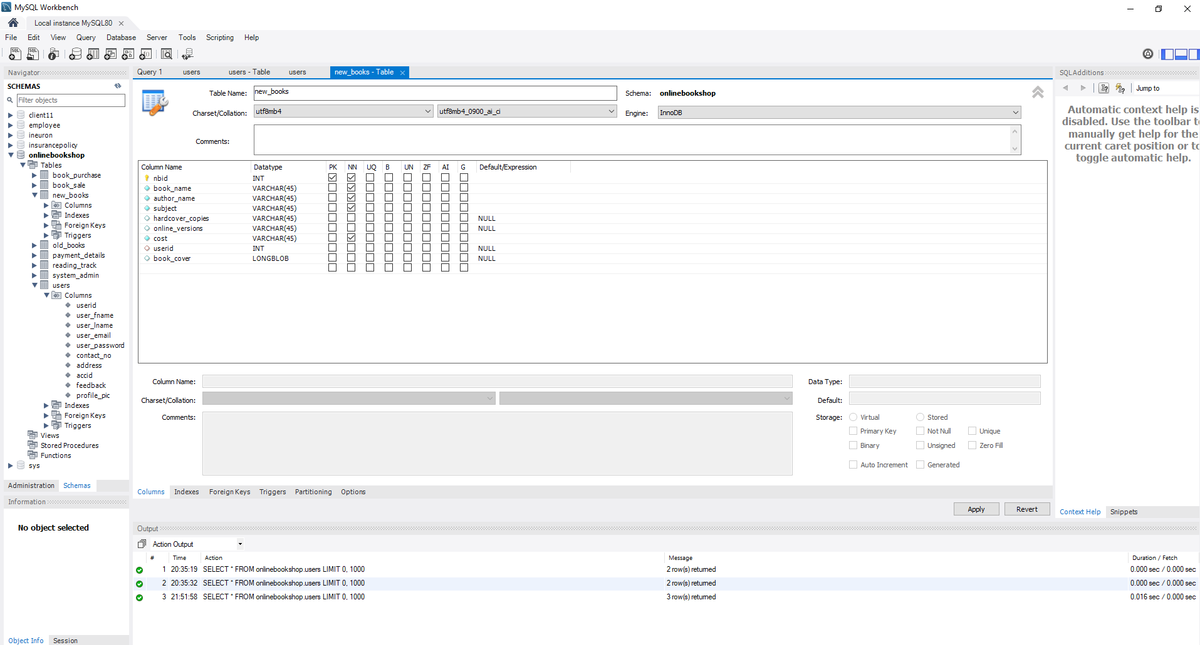

Table : old_books

Primary key: old_bookid

|  |  |  |  |
| --- | --- | --- | --- |
| **Field name** | **Data type** | **Size** | **Constraints** |
| old_bookid | int | **30** | primary key |
| old_book_name | varchar | **45** | not null |
| authorname | varchar | **45** |  |
| subject | varchar | **45** | not null |
| hardcover | varchar | **45** | not null |
| online_version | vachar | **45** | not null |
| other_formats |  |  |  |
| Cost | varchar | **45** | not null |
| donorid | varchar |  |  |
| userid | int | **30** | foreign key |
| book_cover | longtext |  |  |

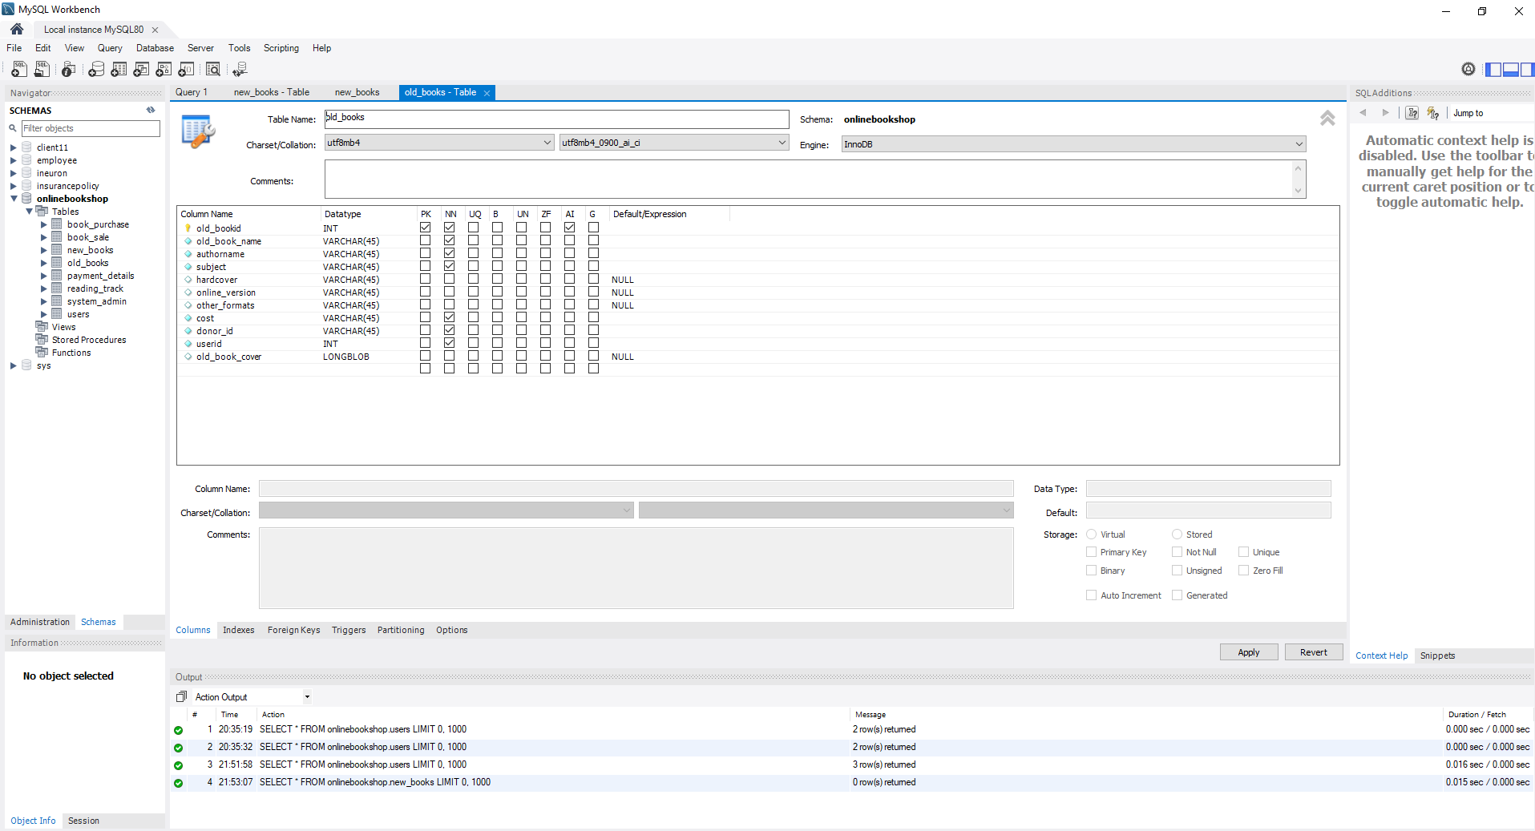

Table : reading track

Primary key: none

|  |  |  |  |
| --- | --- | --- | --- |
| **Field name** | **Data type** | **Size** | **Constraints** |
| Userid | int | **30** | primary key |
| Nbid | int | **45** | not null |
| old_bookid | int | **45** |  |
| Date | date | **45** | not null |
| read_count_new | int | **45** | not null |
| read_count_old | int | **45** | not null |

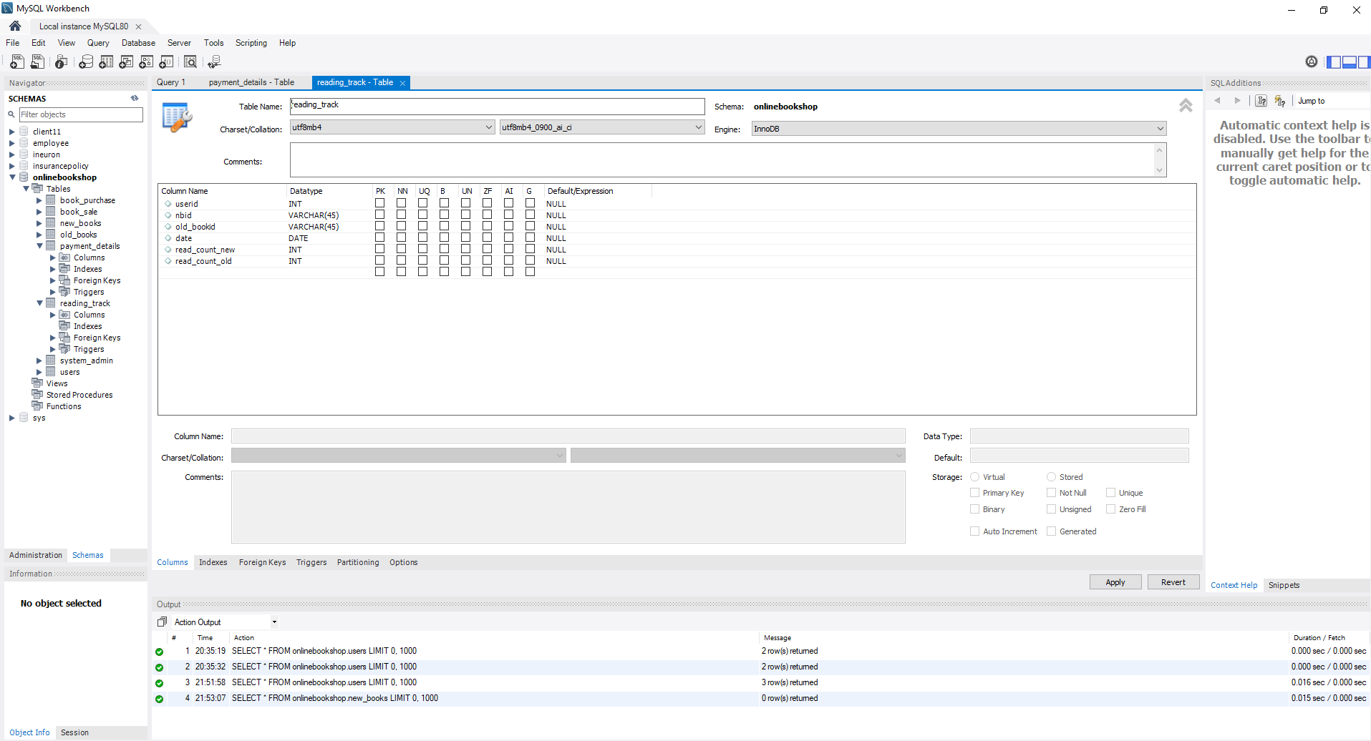

Table : book_sale

No primary key

|  |  |  |  |
| --- | --- | --- | --- |
| **Field name** | **Data type** | **Size** | **Constraints** |
| ISBN | int | **30** | primary key |
| book_name | varchar | **45** | not null |
| author_name | varchar | **45** |  |
| sellerid | varchar | **45** | not null |
| buyerid | varchar | **45** | not null |
| Cost | int | **45** | not null |

|  |  |  |  |
| --- | --- | --- | --- |
| **Field name** | **Data type** | **Size** | **Constraints** |
| ISBN | int | **30** | primary key |
| book_name | varchar | **45** | not null |
| author_name | number | **45** |  |
| selling_price | number | **45** | not null |
| date_purchase | number | **45** | not null |

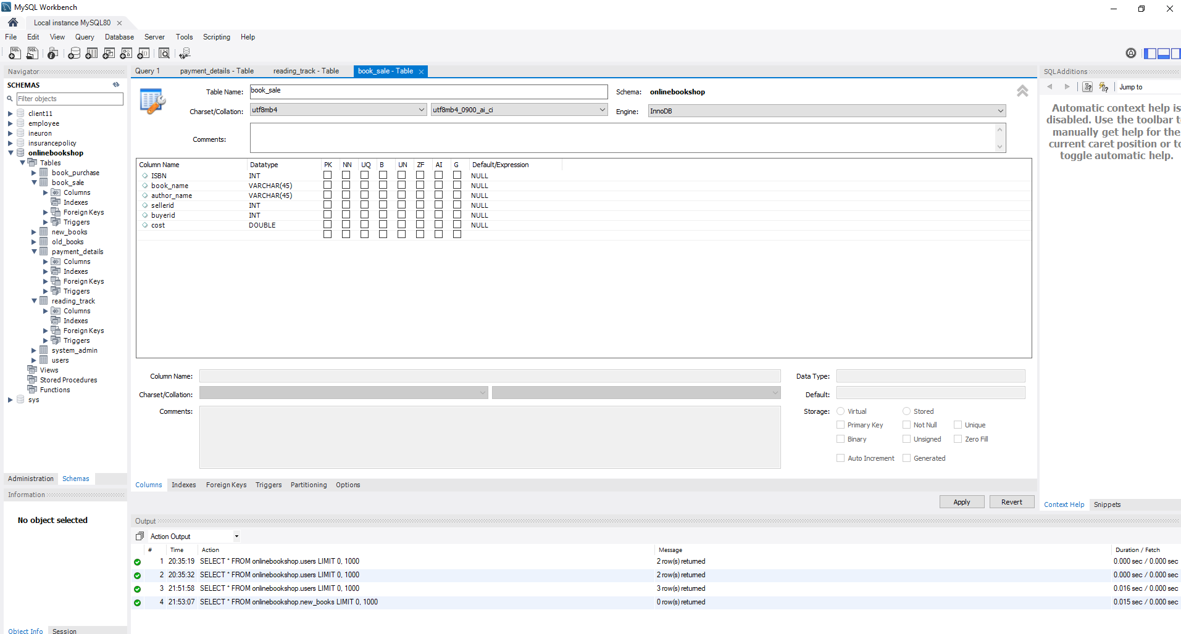

Table : book_purchase

No primary key

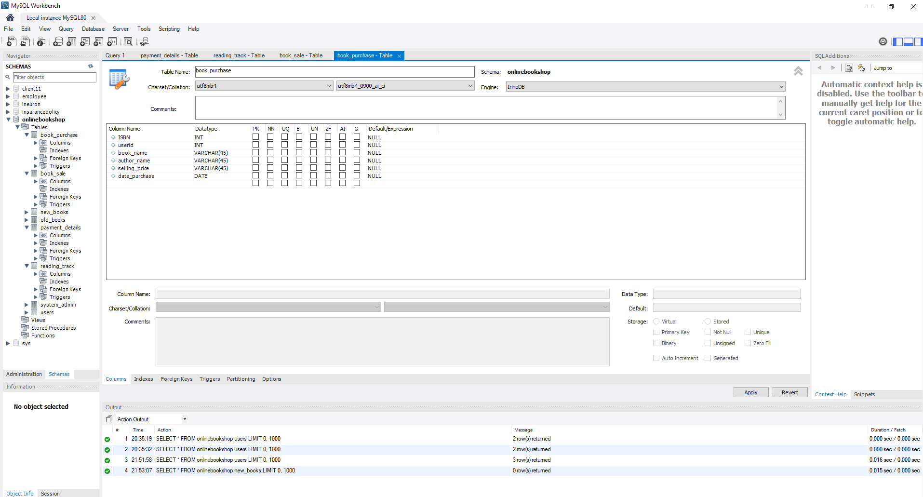

**WORKFLOW MODEL:**

New UserRegistration

UserLogin

Logout

Get BookOrder

Access PaymentPortal

Choose BookSale/ BookPurchase from Catalogue

Set Profile, read and get ReadingTrack

Is User valid?