2023

**High Level Design Documentation**

**of**

**the project on**

**Online Book Shop System**

Submitted by

Paramita

Registered email: [paramitapp10@gmail.com](mailto:paramitapp10@gmail.com)

|  |
| --- |
| Abstract 2  1 Introduction 3  1.1 Need of a High-Level Design Document: 3  **1.3.** **Project Objectives** 4  **2.2.** **Software Requirements** 5  3. . SOFTWARE DEVELOPMENT METHODOLOGY 6  **3.1.** **SOFTWARE LIFECYCLE MODEL** 6  **1.1.** SOFTWARE REQUIREMENTS SPECIFICATION 8  **2.** PROJECT PLANNING AND SCHEDULING 14  3. ANALYSIS 18  **4.3.** STATE TRANSITION DIAGRAM 41  **4.5.** DATA DICTIONARY : (FOR DATABASE : iqtest) 43  **1.** system_admin 43 |
|  |

# Abstract

Books have long been the best friend of the civilized society. Apart from providing knowledge, it is the propagation of communication that transcends into an intellectual and psychological broadening of the minds of the superior species, the humans. Most printed material have opened new domains of evolution, ideas, research, and a barter of information. The Online book shop carries the tradition of a better improved society that chooses to buy books, trace and track readers as well as buyer-sellers to interact.

The system is primarily an eCommerce application, that is a mega Book mart intended to connect anybody and everybody interested in reading in print. The age-old tendency to widen view with reading is being enhanced by the system.

The system connects people who are book collectors and often feel the necessity to lend their books in exchange of money to people who might carry on their legacy. In a scenario of recent trends to read pdf’s and rely on online materials, the system demands commendable respect as it tends to connect readers across the globe, online.

# Introduction

## Need of a High-Level Design Document:

The high-level Design Document marks out the software requirements of the application to be developed. High level designing contains the overview of the architecture to be developed. The HLD performs the requirements analysis and presents the Software Requirements Specifications. High level designing aims at marking the Hardware and software interfaces to be used in ther project. It consists of the algorithm and details about classes/ methods to achieve the required functionality in terms of business requirements. The Low Levell design aims to achieve the functional and non-functional requirements by giving a technical roadmap for it. The document divided into various sections to make the code reusable and scalable.

The main objective of the project is to make a connection between the people who have a demand for books and those who need the books.

This project shall be delivered in a manner that suggestive changes may be easily implemented without disturbing the already existing data..

* 1. **Definitions**
     + **SRS-Software Requirements Specification**
     + **Firewall –Functionality that can allow or block certain ports and addresses.**
     + **IPTables – A firewall built into the Linux kernel.** 
       - **IPForwarding / IPMasquerading – The ability to forward traffic.**
       - **JDBC – A possible Java-based interface between IPTables and the Database.**
       - **JSP – The language that will be used for displaying user history and administrative functionality.**
       - **Tomcat – a free, open-source implementation of Java Servlet and JavaServer Pages technologies developed under the Jakarta project at the Apache Software Foundation.**
       - **Apache - An open source Web server**
     + **ER – Entity Relation Diagram**
     + **CBQ –Class-Based Queuing. Limits bandwidth at the IP/port level.** 
       - **Kernel – Core of an operating system, a kernel manages the machine’s hardware resources (including the processor and the memory), and provides and controls the way any other software component can access these resources**
     + **DHCP – (Dynamic Host Configuration Protocol) – This is a protocol that lets network administrators centrally manage and automate the assignment of IP Addresses on the corporate network.**
* **DFD - Data Flow Diagram**
  + - **Gateway –Bridges the gap between the internet and a local network.**

**Overview**

* + The HLD will:
    - present all of the design aspects and define them in detail
    - describe the user interface being implemented
    - describe the hardware and software interfaces
    - describe the performance requirements
    - include design features and the architecture of the project
    - list and describe the non-functional attributes like:
* security
* reliability
* maintainability
* portability
* reusability
* application compatibility
* resource utilization
* serviceability

## **Project Objectives**

**1.2.1. Admin Objectives**

This software system will be a Web application This system will be designed to locate all interested readers to find their books easily as well as those who have hold on to resources, to share it.

In the application, registered users will be given a chance to get hold of books of their interest in various formats and from most of the domains.

Books may be bought and sold likewise. Books may be acquired in physical form in hardcover or as online pdf versions. Other formats of acquirement of physical copies with a compromise on the covering and printing formats may be available for books.

Old book acquirement is a special feature of the system. Donors may directly send their books to the onsite address of the shop or may make available .pdf, .png of their acquired resources online. They would also be given a chance to sell the physical copies at their onsite address, if deemed fit by the owners of the system.

The overall effort of the system is to enhance the habit of self-study and an appreciation to the effort the human race has made to preserve its evolution in languages and its preservation in the form of printed books.

**2**. **HARDWARE AND SOFTWARE REQUIREMENTS**

* 1. **Hardware Requirements**

 Processor: Intel Pentium microprocessor with RYZEN

 Main memory: 512 MB

 Hard disk : 256 MB required

 Keyboard: Standard

 Monitor: 600x800 Resolution or above

 Mouse: Scroll

 Secondary storage: 32GB

### **Software Requirements**

##### Tools and platforms used

֎ Operating System: Windows11

֎ Front End: HTML, CSS, JAVA, JSP, JS

֎ Back End: MySQL[ WorkBench] 8.0 CE

֎ Platform: ECLIPSE IDE[2022-09]

֎ Language: JAVA, JS, JSP

##### Software interfaces

* Application: Eclipse IDE[2022-09] for javaEE]
* Server: Tomcat 9.0
* Database: MySQl
* Browser : FIREFOX
* Additional API : MS OFFICE

# **. SOFTWARE DEVELOPMENT METHODOLOGY**

### **SOFTWARE LIFECYCLE MODEL**

**The software to be developed depends on the series of identifiable stages that would eventually lead to the product. The diagrammatic representation would follow in building the logical framework. It** would be based on the requirements analysis and the design phase. The proposed software is planned after the requirements analysis and therefore may be developed by means of the iterative waterfall model. In order to give it a stage to analyse the effects of the prior stage, the iterative approach has been followed.

REQUIREMENTS ANALYSIS

SYSTEM ANALYSIS

SOFTWARE DESIGN

CODING

DEPLOYMENT

MAINTENANCE

TESTING

1. **REQUIREMENTS ANALYSIS**
   1. **PROBLEM SPECIFICATION**

The system to be developed is based on online application development of a book shop. The catalogue of books is made available to prospective clients.

* Clients need to register on the platform to view the different available catalogues.
* After a successful login clients are required to choose domains and subjects of their choice.
* This leads to the choice of old vs new books.
* New Books are available in printed and different formats.
* Physical copies as well as online pdf fomats are available. Some material is available in .png formats.
* Old Books may be ordered according to the residence of the clients and the prospective seller, if the physical copy of the book is not available to the system admin.
* All Readers can be a prospective seller as well.
* They are directed according to their personal choices to access the payment portal and webpages meant for the same.
* All users of the system are requested to follow guidelines and updated information on the applications social media pages
  1. **FEASIBILITY STUDY:** The development of any Software depends on the fact that whether it is feasible for development or not. This study is done for the various factors which might affect the software development, deployment and maintenance. It is also targeted for Customer Relationship Management in future.

##### **4.2.1. TECHNICAL FEASIBILITY:**

It includes the hardware software and other technical requirements of the system. It would require at least 256MB of RAM for its smooth functioning. The System requirements are to be fulfilled by the PC on which the system is to be primarily developed. The Software is to be developed in eclipse IDE as a Dynamic Web based Java2EE project. Java, JSP, and Java Script are to be used in Front End. Backend Database is managed in Container Database mysql using the MySQL Workbench. The Intel microprocessor with Ryzen is used in the PC.

The Software is to be managed and maintained after deployment

on an iterative basis,

i.e. updating requirements according to changing needs. As maintainability is easy and development is based on technical updations of academics and availability, the Software is technically feasible. The Software is least prone to attacks as the data involves each individual personally. Less threat for virus and worms are expected as customized data is only to be accessed by registered and authenticated individuals.

* + 1. **SOCIAL FEASIBILITY:** This software is expected to have deep social implications. Society and its improvement is dependent on the academic achievements in recent times. If individuals can have easy and better access to different printed formats of knowledge share, they might utilize their time better. Students can contribute better if they can refer up subjects according to their choices. The habit of reading and brain development has long contributed in distinguishing the human kind as superior life forms.
    2. **ECONOMIC FEASIBILITY:** The users are provided with a free preview to all books once they successfully register in the system. The payment is only to be made once they decide on procuring books in the system. This has been made keeping in view the huge number of users who use a website at the first instance for something they can acquire for free. However, there may be users with a vivid approach who might be interested in actual physical purchase or sale. abilities for a particular domain. These interested users are provided with paid services for earnings of the websites development as well as connecting inanimate resources with human resource.

##### **LEGAL FEASIBILITY:**

The Legal feasibility of the system development is based on whether an individual should use the system with a definite purpose. As the registration of the user is done on his/ her own discretion with an acceptance of an Agreement provided by the website developers, no legal action may be taken against the System. The selling of books on the admin site or uploading requests for procurement is based on user discretion and acceptance of full responsibility, the system stands free of any malpractice conducted on physical acquirement of printed material decisions.

The feasibility study conducted on the system has helped its development and further maintenance.

### **SOFTWARE REQUIREMENTS SPECIFICATION**

This part of the document provides a comprehensive description of the Software to be developed by the system. The different subsections provide the information of the Software and hardware to be used by the system.

**4.1.1. PURPOSE**: The SRS aims at the development of the system requirements. The Online Book Shop aims at bringing the Purchasers, Buyers, readers and authors under one organization.

**The** vision of the system is an unified platform of printed media in storable format.

**The mission** is to strive towards the goal carrying All new publications and old books along.

* + 1. **SCOPE:** The system may be used by an individual after registration to determine his/ her interest in books.
* The report is generated for the system in the form of a readers interest, orders and reading abilities. The Webpage of Readers profile is maintained for the purpose.
* The Report generated would be a monthly and weekly as well as annual analysis of reading habits. These would be valued by employers or other organisations to form an opinion of a person based on recognized standards.
* The suggestions for individuals would also be based on search or recent trends
* . ABBREVIATIONS:

|  |  |
| --- | --- |
| SRS | Software Requirements Specification |
| DFD | Data Flow Diagram |
| ERD | Entity Relationship Diagram |
| ID | Identification Definition |
| OBS | Online Book Shop |
| PP | Payment Portal |
| IDE | Integrated Development Environment |

Table : 5.1.

**Specification: IEEE STD 830-1993**

* + 1. **FUNCTIONAL REQUIREMENTS:**

This gives specific the system is supposed to behave after deployment in the virtual machine. It also gives what inputs are provided to which process and what is the expected output of each. It also denotes how the system might behave and what are the specific data manipulations and calculations.

##### **User perspective:**

* + - 1. 1. User Registration on the system.

Input: Providing user details. Output: User ID.

* + - * 1. User login to the system.

Input :User ID and password

Output : Forwarding to the Catalogue Overview page.

* + - * 1. User profile set up.

Input: Uploading of Photo and files related to academics, work experience, writing and reading abilities.

. Output: User is given a chance to download profile as a further laurel in jobs, career and other areas of interest.

5.1.3.1.3. Catalogue overview page

Input: Choice of subjects, primary and secondary interests are to filled in popups.

Output: Detailed pages on user Choice opens.

* + - * 1. NewBooksPage

Input: New releases and trending books are shown Output: Forwarded to the buyBook Page or CheckPreview

* + - * 1. Old Books Page

Input: Old Books are shown according to choice

Output: Reader choice saved

* + - * 1. User Payment Portal page:

Input: User chooses to buy books

Output: Redirection to payment portal.

* + - * 1. User Payment portal.

Input: Payment mode and card details.

Output: Confirmation of payment and redirection to Book Orders

screen.

* + - * 1. User Reading Track Page

Input: User email id to check Reading track

Output: Tracks Reading for Weeks, month and Year

* + - * 1. User NewBooks Order page

Input: user ID , email, choice of book, choice of format

Output : BookOrderReceipt

* + - * 1. User Old Books Order Page

Input: user email, choice of old book, format, Acquiring methods

Output: Order Receipt

* + - * 1. User Bppk Selling Page

Input: Book ISBN, subject, Title, description, and Cost

Output: Book to be Sold screen

* + - * 1. User feedback

Input: feekback on thank you page Output: Greetin

##### **Admin Perspective:**

* + - * 1. Admin login

Input : admin ID and password.

Output : admin access to system with successful login

* + - * 1. Admin dashboard

Input : addition of new books

Output : updation of new Books page in system.

* + - * 1. Authentication of users

Input : checking user ID and password for authentication Output: Output: Availability of system to authenticated users.

* + - * 1. Generation of Payment receipt

Input: answer choice of users on test screen

Output : Generating score with set rules and marks.

* + - * 1. Generation of order receipt for new books

Input: Book Title, author

Output: Book ISBN, subject, and Cost

* + - * 1. Generation of Order receipt and confirmation for old books order:

Input: Book Title, author

Output: ISBN, subject, Cost

* + - * 1. Generation of Reading Track

Input : Books Read till date by user

Output : Greetings, Gifts and a record of Search Intent

* + - * 1. Book Sell Option

Input : User choice of selling methods, cost guidelines

Output: Book to be sold registered and other users notified

**NON-FUNCTIONAL REQUIREMENTS:** These are directly related to the functioning of the system. The main constraints of the system are

* **Authentication of users :** This feature will provide the login to user profile only when the user inputs registered userID, password and the mobile number registered is validated with a button sent to it for 2 way authentication**.**
* **Presentation of flawless testing screens:** This would depend on the IDE used, wifi Connection and speed. This would also depend on the SceneBuilder which would help build the Graphics used in System.
* **Generation of authentic score :** This would depend on the logic of Calculation and the access of data from Database. The feature of userID would allow the right user to receive the score.
  + - 1. Hardware interface:
* Screen Resolution of 600x800.
* Mouse for scroll
* PC or Laptop with WiFi Connection for the Web based project.
  + - 1. Software Interfaces:

֎MySQL WorkBench 8.0 CE

֎ Eclipse IDE for developing Code and webapps

֎ Windows 10 OS

* + - 1. Communications Interfaces: None

5.4.4.5. Performance requirements: Http will be used

* + 1. Software System attributes:

Security : Achieved with authentication and the 7-Zip (Encryption tool ) downloaded with Softwares, provide security features and do not allow intrution into the System.

Maintainability: This is achieved by updating the system on the basis of present requirements and implementation of Client demand techniques, as gathered from feedback of users.

Portability : This feature is achieved by using JAVA as a programming language. The OOPS feature helps the system to have a portable feature. It is therefore made to run on any Operating System on any machine.

1. **PROJECT PLANNING AND SCHEDULING**

|  |  |  |
| --- | --- | --- |
| **NAME OF PHASES SUB PHASES OR DESCRIPTION** | | |
| **Requirements analysis** | Problem definition |  |
|  | Feasibility study |  |
|  | Software requirements analysis |  |
| **Milestone : Successful SRS and Feasible System. Proceeding to Designing the System** | | |
| **System analysis** | Project planning and  scheduling |  |
|  | System DFD |  |
|  | System Designing |  |
|  | Structure designing |  |
| **Milestone :Completion of Design. Proceed to code the System** | | |
| **Coding** | Coding with Comments |  |
|  | Code Efficiency |  |
|  | Error handling |  |
|  | Parameter Passing |  |
|  | Validation Checking |  |
| Milestone : Error free Code | | |
| Testing | Integrated Testing |  |
|  | System Testing |  |
|  | Debugging |  |
| **Milestone : Successful Testing** | | |
| **Implementation and Maintenance** | Deployment and improvement |  |
| Milestone : Successful Implementation | | |
|  | | |

Table:6.1

* 1. **GANTT CHART:** A horizontal bar chart which visually represents a project plan over time. The chart shows status of each task in the project.

|  |  |  |
| --- | --- | --- |
| TASK | START DATE | DAYS TO COMPLETE |
| Requirements analysis | **22nd – 23rd February, 2023** | **2 days** |
| System Analysis | **23rd February** | **1 day** |
| System Design | **23rd -24th February** | **1 day** |
| Coding | **24th February- 1st March** | **5 days** |
| Testing | **1st - 3rd March, 2023** | **2 days** |
| Build | **3rd -8th March, 2023** | **5 days** |

|  |  |  |  |  |  |  |  |  |  |  |  |  |  |  |  |  |  |
| --- | --- | --- | --- | --- | --- | --- | --- | --- | --- | --- | --- | --- | --- | --- | --- | --- | --- |
| 22nd | **22nd Feb.** | | 23rd |  | | **23rdFeb,** | **25th Feb.** | **26th Feb.** | **28th Feb.** | | **1st March** | **2nd Mar.** | **3rd March** | | **4th march** | **8th March** | |
|  |  |  | |  |  | |
|  | **Feb.** |  | |  |  | |
| **Requireme nts Analysis** |  | |  |  | |  |  |  |  | |  |  |  | |  |  | |
|  |  |
| **System Analysis** |  | |  |  | |  |  |  |  | |  |  |  | |  |  | |
| **System Design** |  | |  |  |  |  |  |  |  | |  |  |  | |  |  | |
| **Coding** |  | |  |  | |  | | | |  |  |  |  | |  |  | |
| **Testing** |  | |  |  | |  |  |  |  | |  | | |  |  |  | |
| **Build** |  | |  | | |  |  |  |  | |  |  |  | |  | |  |

Gantt Chart

Fig. : 6.1

* 1. **Pert Chart:** A PERT Chart is a project management tool that provides a graphical representation of a project’s timeline. The **Program Evaluation Review Technique** breaks down the individual tasks for project analysis.

start

1 day

5 days

1 day

Days

1 day

Days

2 days

Days

PERT

Fig. 6.2

stop

5 days

Days

Build

**3rd -8th March, 2023**

Coding

**24th February- 1st March**

Testing

**1st - 3rd March,2023**J

System design

**23rd -24th February**

Requirements analysis

**22nd – 23rd February, 2023**

System analysis

**23rd February**

* 1. **Kanban board**

**According to The ineuron IntershipPortal guidelines a Kanban Board is provided for project scheduling and marking of completion of the project webpages. All Webpages were designed following a schedule. The Kanban Board gives an opportunity to schedule tasks and keep track of backlogs and completed tasks. The board does not allow the user to keep track of every proceeding. The dates are not reflected each time after login. The testing after every phase puts the burden of ultimate testing at the maintenance phase.**

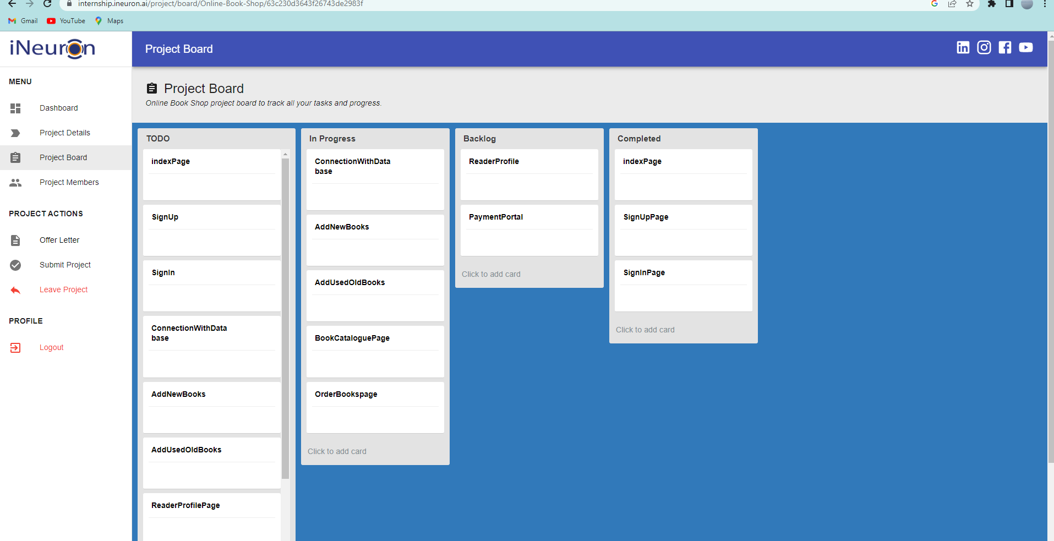

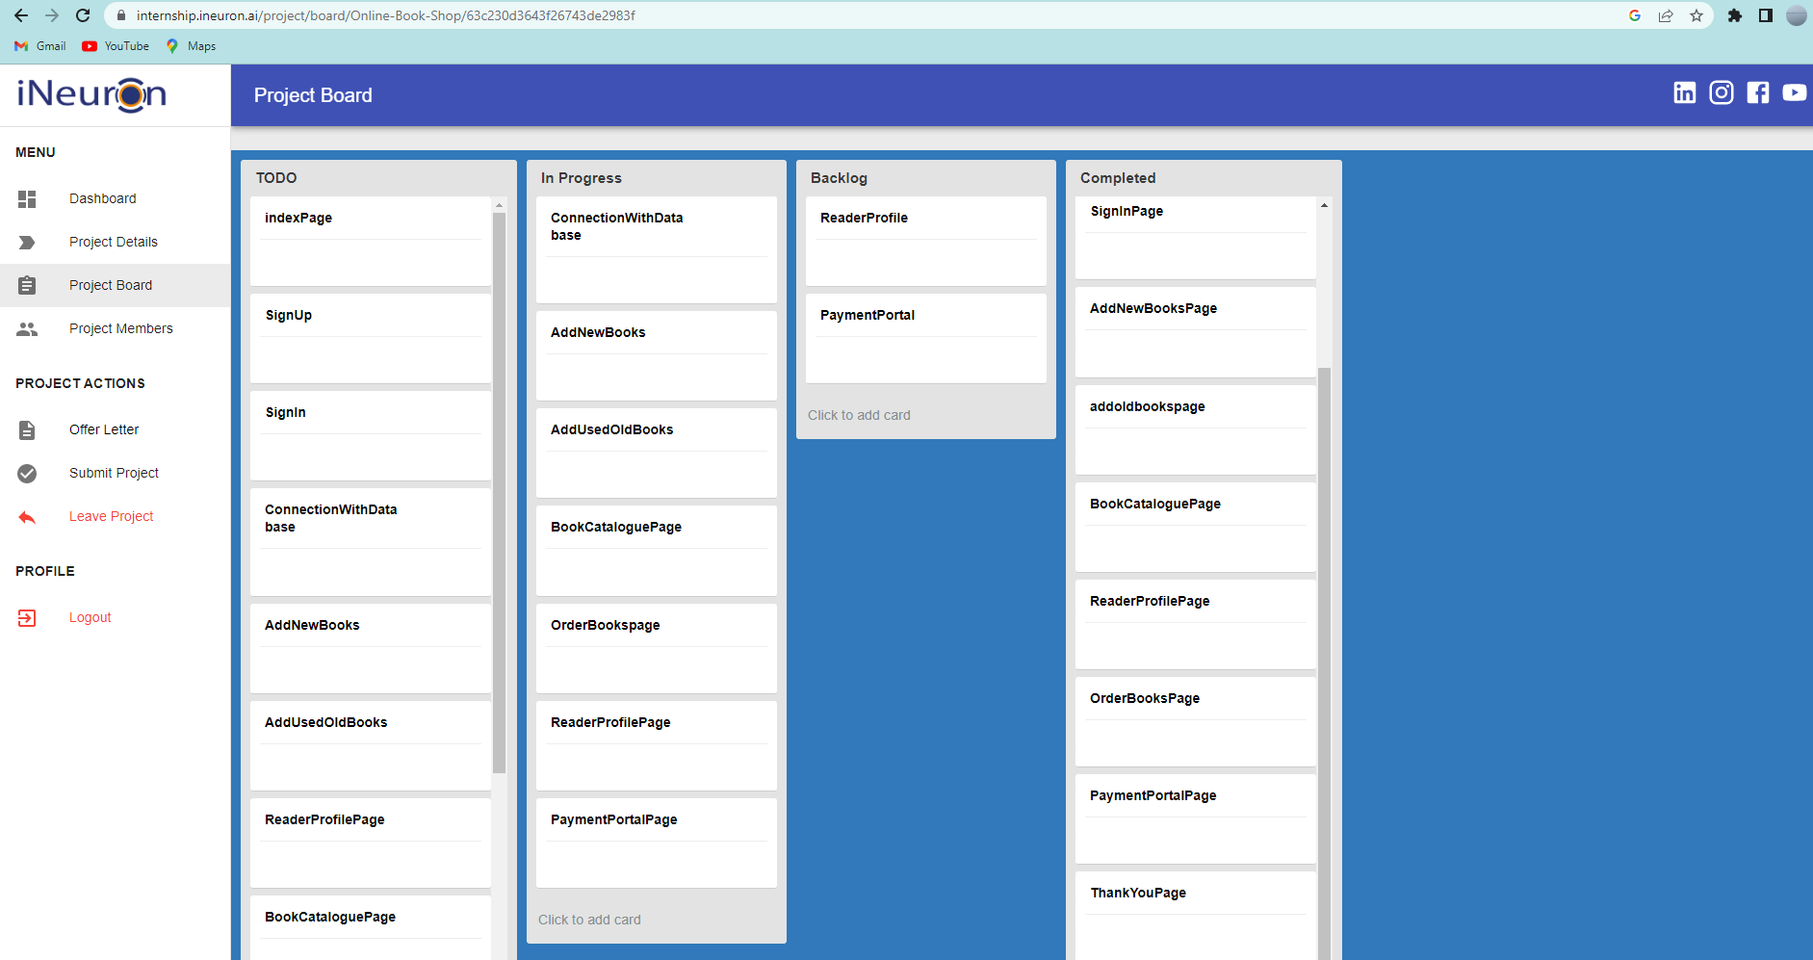

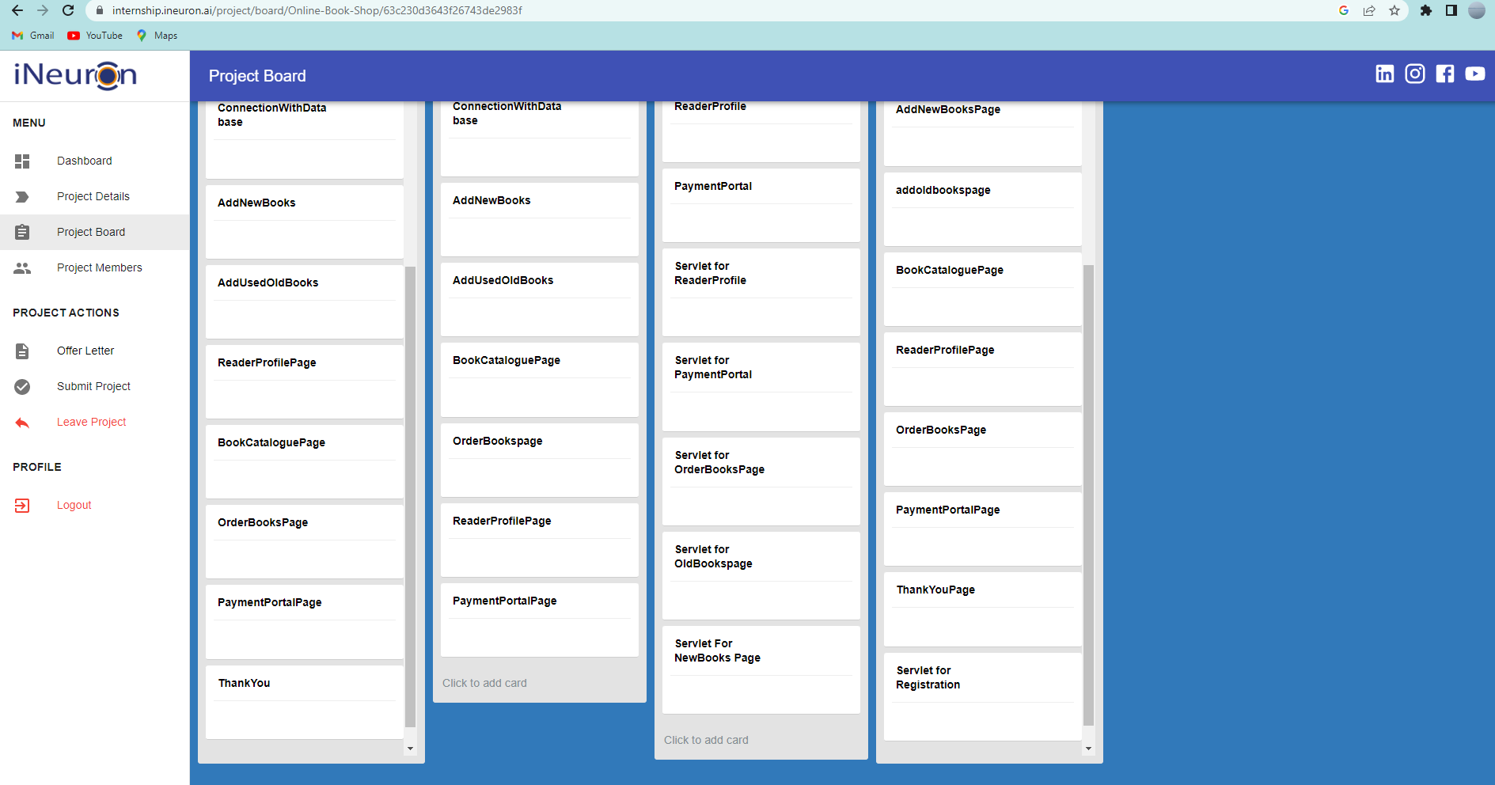

I have enrolled for the project alone without any other members. As a lone member assignee of the project, I have had to pay heed to my :

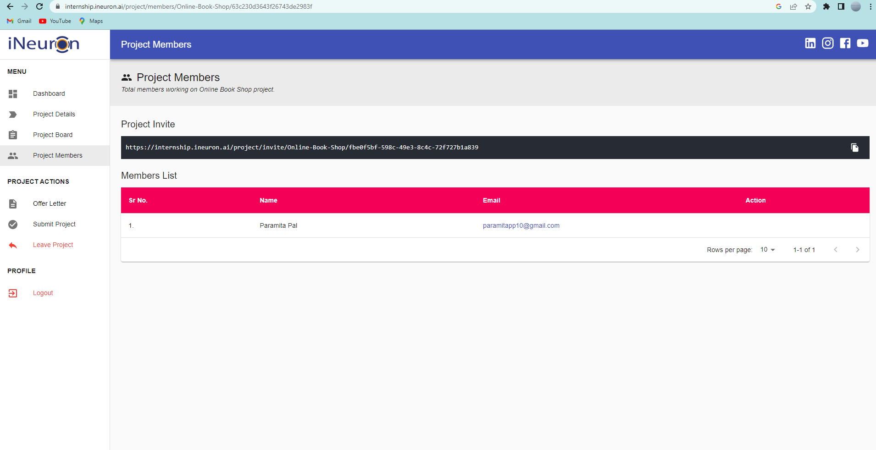

# ANALYSIS

* 1. **DATA FLOW DIAGRAMS (DFD**): Drawn to show the flow of data between processes and entities of a System. It has no control flow. It is a mapping to demonstrate the flow of input and output from a process or entity.
     1. **CONTEXT LEVEL (ZERO LEVEL) DFD OF THE SYSTEM**

Admin

Old Book and New Books catalogue

**New books to read/ order, borrow and sell.**

User

**User email, user password, old books sold by user**

**User email, userid, user choice of books, user old books**

##### **LEVEL 1 DFD**

* + - 1. **System**

**userid**

verified login

1.0

**User SignUp**

Admin

**3.0**

**Catalogue and book Overview**

**5.0**

ard no, bank name, mode

**Book Sell**

User details

**2.0**

**User Sign In**



User

**5.0**

**Payment Portal**

Purchaser id, name  **user**

**name,**

**cost contact user deatils**

author authentication

**Book Sell**

User_email

User_password

feedback

user

Payment details

check

New Books

**6.0**

**Thank you**

Old Books

**4.0**

**Book Order**

Old books list

Old book ISBN

New books list

User_email, user_password

,

**6.1.3.1. PAYMENT PORTAL(LEVEL 2 DFD**)

test_id

4.5

**Users**

New Books



**SYSTEM ADMIN**

,ct_id

##### **5.2.**

**Choice of payment**

**5.1.**

**Choice of No. of New Book/ Old Book**

Old book choice

userid, book name, author

##### **5.3.**

**Choice of Merchant**

##### **Bank**

Old books

**mode**

Chooses payment mode

##### 4.4.

**Enter card**

Payment mode option

Amount payable

banid,

bankid

name

card_no,expiry, cvv, amount

##### details and make payment

card_no, expiry_dat e,cvv

**FLOW CHART**

* + 1. **Module 1: user_login:** This module is activated after user_registration and the user is provided the login button. If the user presses the login button the user is presented with the login module. The user enters the user_email and user_password. The users table in database stores an userid generated from user_email and password. The entered credentials are checked with stored ones. If the match occurs verification is done On successful completion of the processes, the user is verified as authentic and allowed access.

Stop

Is user registered?

Login

Authenticated

Start

Registration

user_email,

user_password

users

userid, user_email user_password matching

System_login

NoNo

No Is userid==userid(stored)&&

user_email==user_email(s)& &user_password==stored?

Yes

Yes

No

* + 1. **Module 2: BookCatalogue :** This module is available to all users who have registered and made a successful login. After login, users are given usual instructions and information about the application and its working procedure. Making a profile on the site is optional. However, users with profiles are kept updated with new updations and available advantages of the BookManagement System

Y

Do you want to visit the New Books page?

Do you

want to continue?

Do you

want

old books?

No

Yes

No

New Book Choice

Yes

No

Old Book Choice

answer

Yes

stop

Redirection to New Book page

start

Give choice of Books

New Book

Old Books

* + 1. **Module 3: payment_portal :** The payment portal is to be accessed by the users who wish to buy old or new books. This portal is also used by Book selling enthusiasts. Each mode has its own cost , the user may enquire and access this mode if desired.

Stop

Book Order

Receipt

Do you want

to continue?

**Old Book**

start

Book name , ISBN, author_name

Amout to be paid for each Book

New Book

Payment process

Yes

No

Do you want to proceed?

Confirmation of payment

Enter merchant bank and payment mode

Enter card_no,expir y,cvv,amount

Yes

No

* + 1. **Module 4 : Book Resell:** This test module may be accessed by interested individuals who want to be updated on their inherent and acquired skills for the provided fields, considered to be important in obtaining services as marked necessary by organizations and institutions:





start

No

Is user ready to sell?

to proceed ?

Yes

No

Do you want to

submit test ?

Yes

Book details

uploaded

Generation of ISBN if not present in system

User Resell option

Books Owned by user

test

stop

Score,marks and suggestions

with educational and training sites

Score card generation

1. **SYSTEM DESIGN**: The design phase focuses on the detailed implementation of the system recommended in the feasibility study. Emphasis is on translating performance specifications into design specification. The design phase is a transition from a user- oriented document (system proposal) to a document oriented to the programmers or data base personnel.
   1. **CLASS DIAGRAM**: It is used as a mapping to design systems in Object Oriented languages. It is a static representation of each class, interface, association and constraint involved in designing the system.

has

1

1

**System admin**

**-userid: String**

n **-password: String**

**-add questions()**

1

n

take

1

n

##### Tests

**Users**

##### -userid:integer

**-username:string**

##### -userpassword:string

**-user_address:string**

##### -user_phnone:integer

1

1

**+register()**

##### +login()

**+validate user()**

**+rate scorecard()**

**+provide improvement sugg**()

##### -test_id:Int

**-test_name:String**

##### -test_dur:time

**+start test()**

##### +submit()

1

##### +profile()

**+givetest()**

##### +choose test()

**+make_paymenty**()

+feedback()

provides 1

gives

1

gives 1

1

makes

##### Payment

**-pay_id:Int**

##### -cardNo:Int

**-cvv:Int**

##### -OTP:Int

**+no_of_courses()**

##### +make_payment()

**Customized test**

**-ct_id:Integer**

**-ct_name:String**

**-date_time:Date**

**-ct_cost:Integer**

**-ct_no_ans:integer**

**+test screens()**

**+questions(()**

1

* 1. **USE CASE DIAGRAM :** Shows interaction and relation with the system of

different use cases.

System register



System Login

user

System admin

General test

payment

Customized test

Score Card and suggestions

IQ Score

feedback

test

### STATE TRANSITION DIAGRAM



System login

**General test**

Do : login

**Do: Give Test**

**Generate IQscore**

**Customised Test**

**Generate IQscore and suggestions**

**Choose**

Payment

Give test

Fig 8.3

* 1. **SEQUENCE DIAGRAM :** These diagrams design, document and validate the the architecture, interface and the logic of the system by describing the sequence of actions to be performed to complete a system or task. They provide a dynamic view of the system with time.

System

users

system login()

authenticate user()

correct option and

test mode()

gives general test()

gives

customized test()

generates IQ score()

TEST

1. **SYSTEM TESTING AND IMPLEMENTATION METHODOLOGY :** After development of the software it is implemented by the developer by Web hosting and deployment. The various techniques that are adopted at this level are the following :
   1. **Alpha Testing :** Apha testing is simulated and actual operational testing is done by users/customers or an independent test teamat the developer’s site. Alpha testing is employed for off the shelf software as a form of internal acceptance testing before the software goes to beta testing.

Different Webpages were tested to understand whether they were functioning properly:

* 1. **Web Space Booking:** Web space allows a user to browse 3d scenes on the World Wide Web, either loclly or remotely(once connected to the Internet) Web space supports the VRML and Open inventor file formats. VRML is the Virtual Reality Modelling language, a subset of open inventor.

User can use the interface through the webmail program. Any user can go to a domain address in any web browser and login using the username and password. When the Website icon is visible one can use the browse button to find files to upload.

To upload files user can use FTP, which is available through web publishing programmes and FTP clients can also be accessed through web browsers. The web page is made available once the user registers in the site’s register_user page. Successful login may be made with the use of users registered emailed,password and phone number. To access the profile page and test pages.

* 1. **Implementation Of Security Mechanisms At Various Levels**

Software testing is a crucial element and it represents the ultimate review of specification design & coding. There are two types of test approaches. They are-

Black Box testing and White Box testing

When computer software is considered, *black-box testing* alludes to tests that are conducted at the software interface. Black-box tests are used to demonstrate that software functions are operational, that input is properly accepted and output is correctly produced, and that the integrity of external information (e.g., a database) is maintained.

On the other hand, white box testing of the software is predicted on a close examination of procedural details.

 **Conditional testing**

This testing is done to check the Boolean operator errors, Boolean variable errors, and Boolean parenthesis.

##### Data Flow testing:

The *data flow testing method* selects test paths of a program according to the locations of definitions and uses of variables in the program. A number of data flow testing strategies have been studied and compared.

##### Loop testing:

This testing is performed to check simple loops and Nested Loops for proper execution as