ChatServer:

Scope:

This document describes the steps to set up the Chatserver and use it for group chats.

Software Requirements:

1. Java 1.8
2. Jersey2.41
3. React JS 18.3.1
4. Node.js 20.17.0
5. Npm 10.8.2
6. Vite.js
7. Maven 4.0
8. EclipseIDE
9. VSCode
10. Tomcat 9.0

Steps to set up Chatserver:

1. Install JDK 1.8
2. Install Eclipse IDE(Integrated Development Environment) for development of J2EE projects. Ensure Eclipse IDE has maven plugin installed in it. Maven is a build tool , which is used to create project structure and deliverables like .war file. It is also used to download and configure jar files in the classpath by updating the POM file.
3. Install Node.js , Npm by running the command “npm install -g npm” in the command prompt and using the node.js installer. You can also check the version of node.js and npm by using “npm -v” and “node -v” command.
4. Open VSCode editor. Download chatclientptroj project from GitHub repository and open it in VSCode .
5. Download the chatserver java project from GitHub and import it as a maven project in eclipse workspace.
6. Finally deploy it in tomcat server from eclipse workspace and start the tomcat server. In VSCode terminal , go to chatclientptroj project and type “npm run dev” .
7. Open the chatclient using explorer/chrome/opera by entering url <http://localhost:5173> . It will take you to the login page .

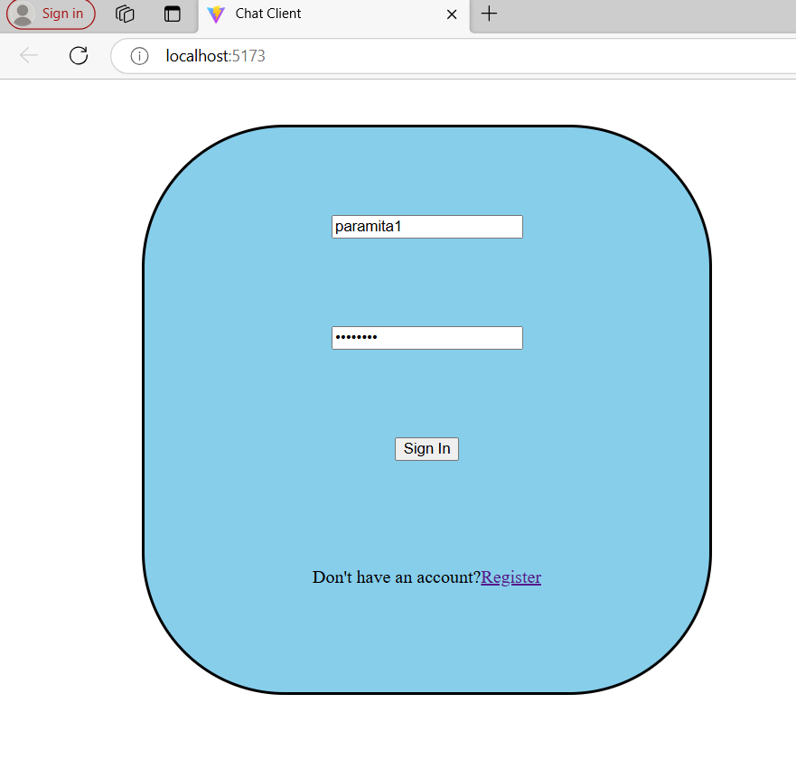

1. In chrome open another login page and login using a different userid/passwd , say paramita2/pass1234.

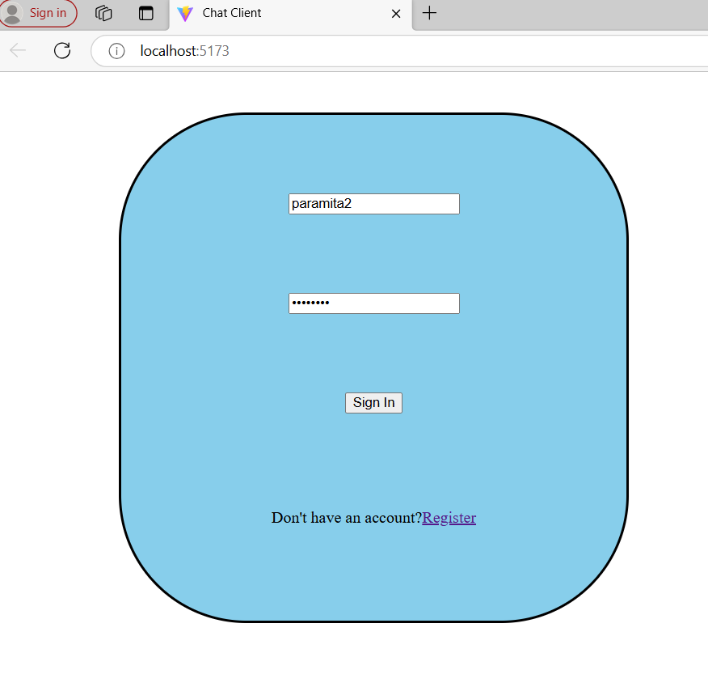

1. In Opera ,open another login page using userid/passwd paramita3/pass1234.

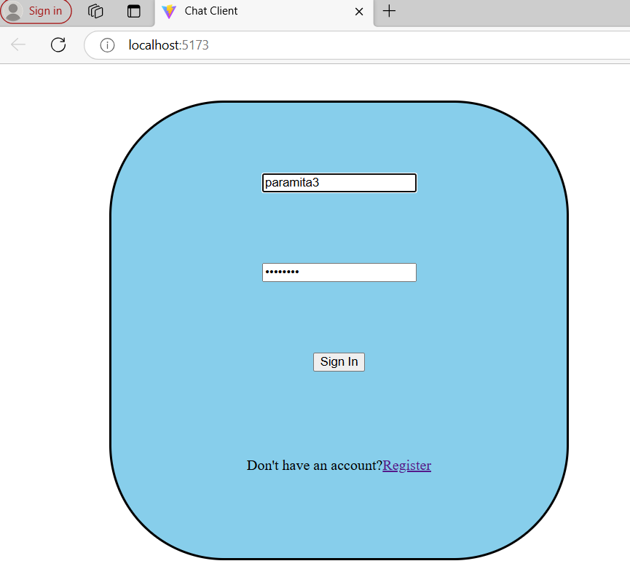

1. Everytime you login , you should be taken to home page.

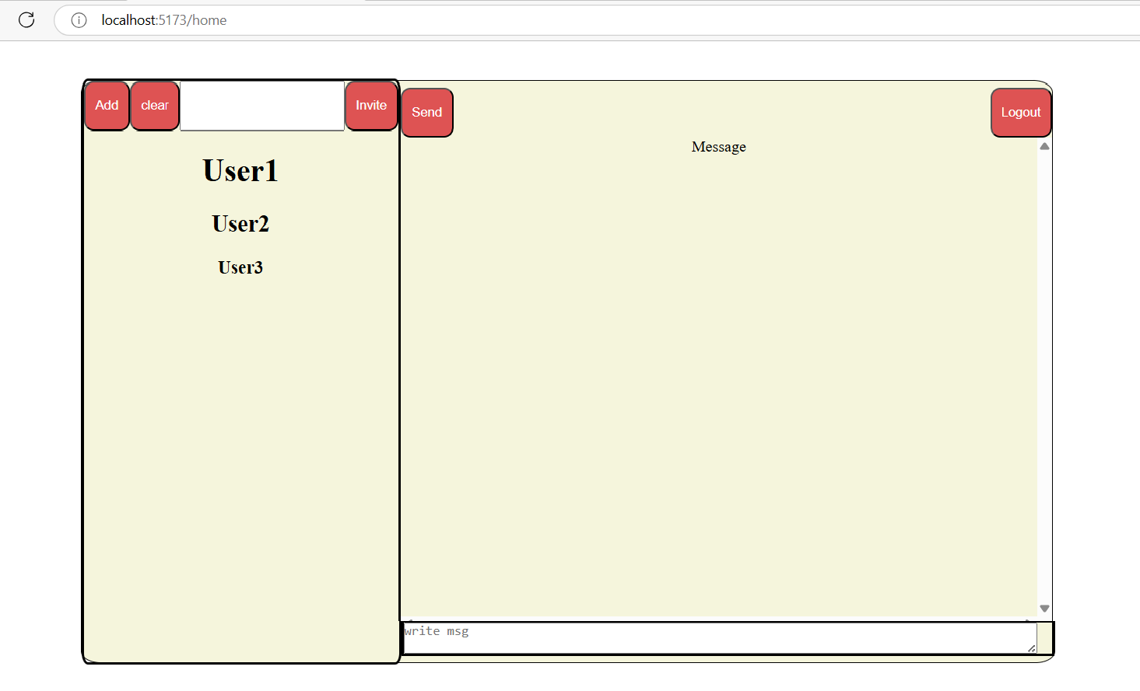

1. Now you can invite paramita2and paramita3 using Add and Invite buttons.

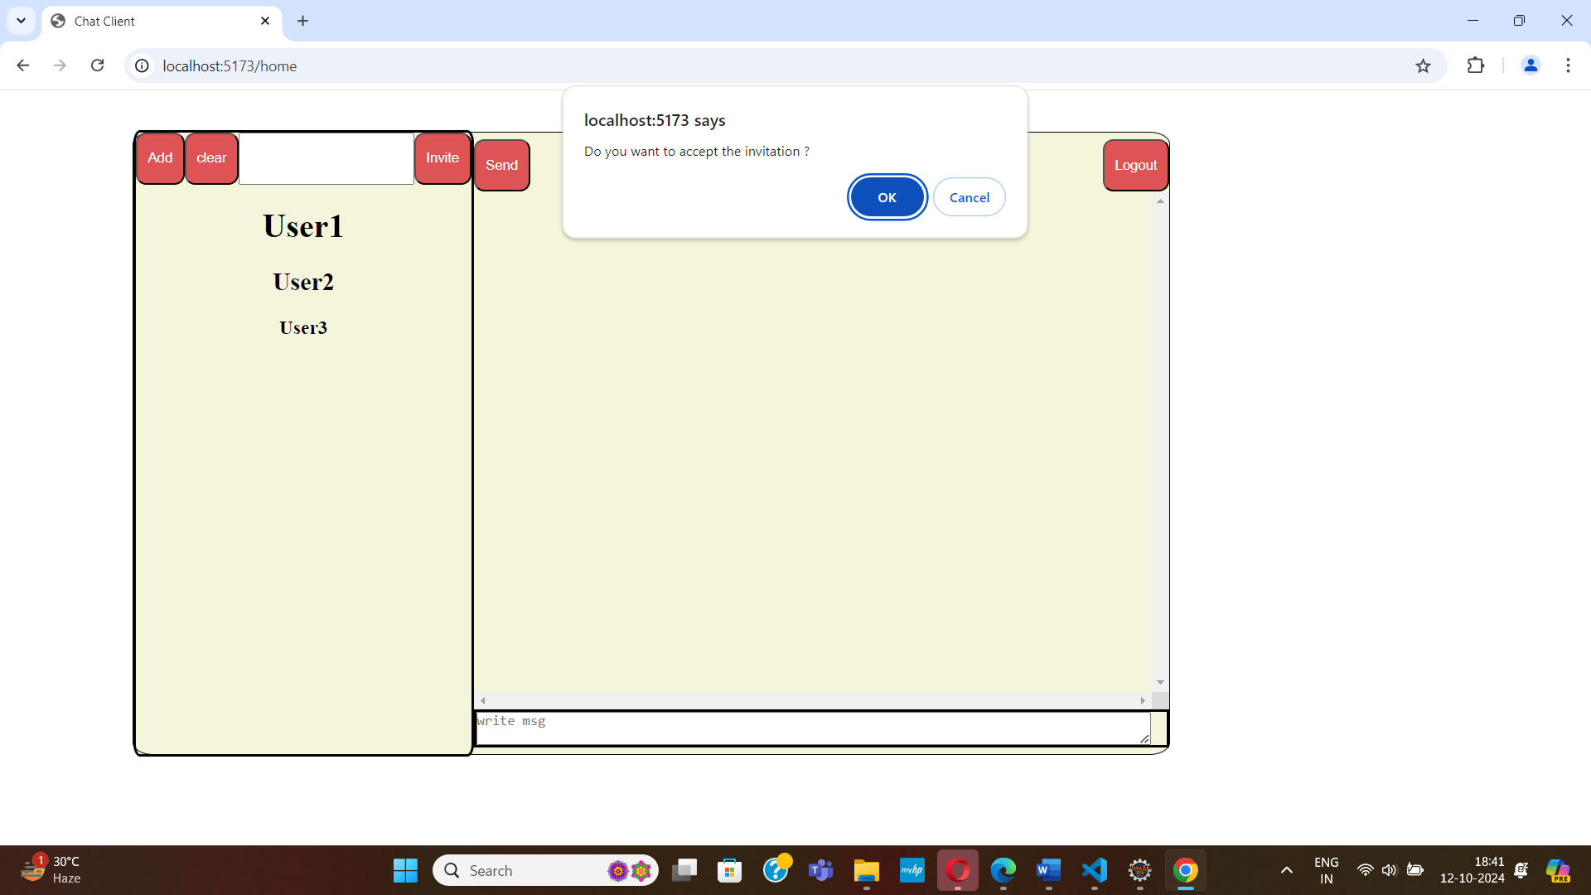

1. Accept the invitation by clicking on the ok button of the popup box.
2. Now you have a chat group of three paramita1/paramita2/paramita3 .
3. Enter any message in below textbox .It will appear on the Message panel of all three.

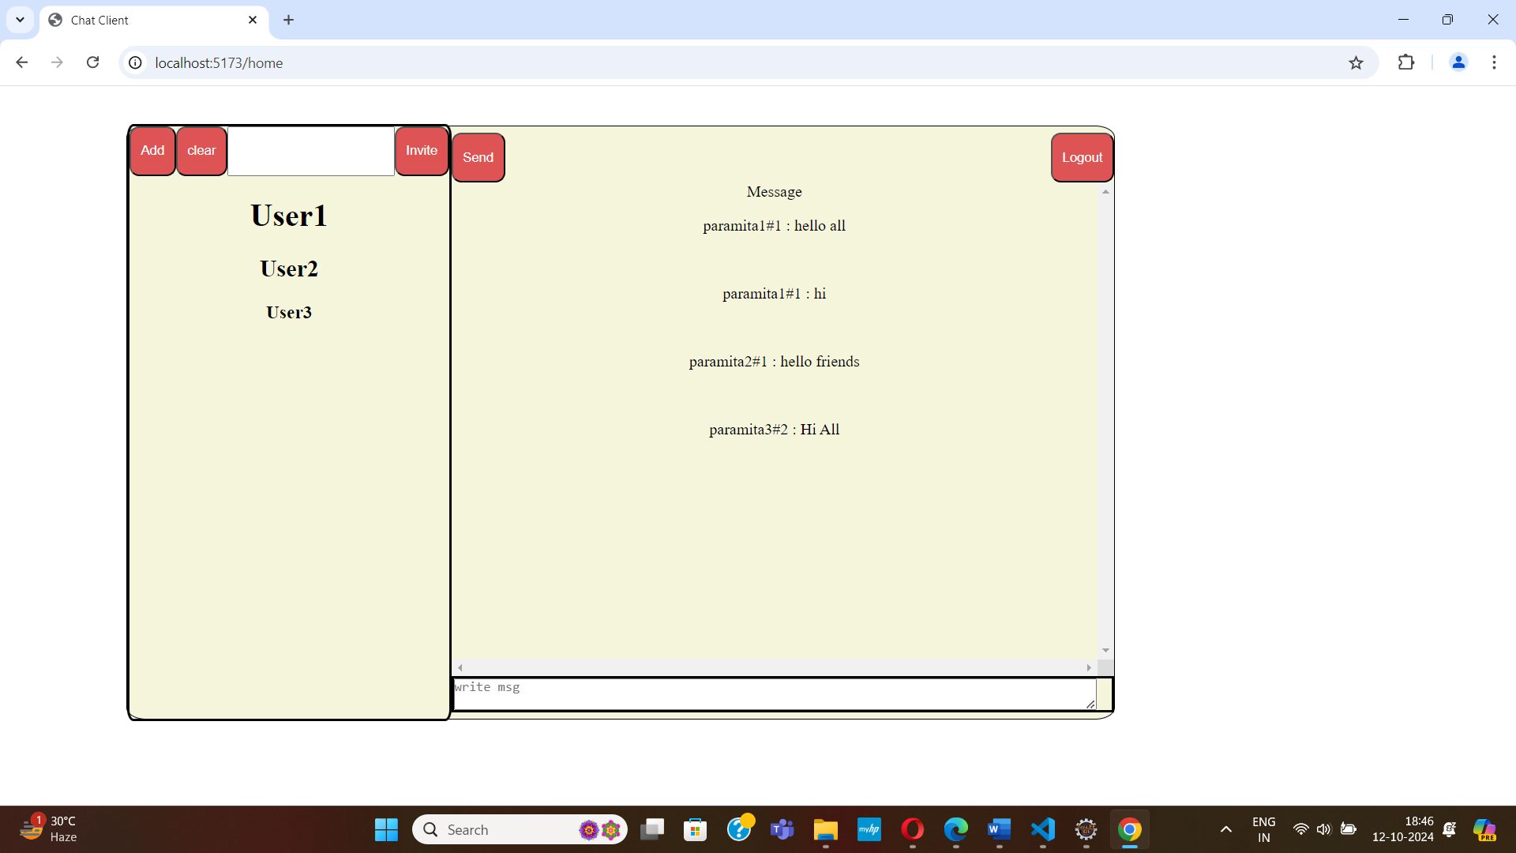

1. When click on the Logout button it will take you back to the Login Page.
2. You can go Register page from Login Page by clicking the Register link in the

Thank you.