Spring Core 7
Agenda
- What is Spring Framework
- Prerequisite of a spring based software
- When to use Spring Framework
- Key features
- Dependency Injection & Inversion of Control
- Different ways of putting beans together
- Autowiring of Beans
- Limitations of Autowiring
- Excluding Beans from Autowiring
- Different bean scopes
- Validation, Databinding and Type Conversion
- Internationalization
- What is Profile
- Spring Expression Language(SpEL)
- Aspect Oriented Programming (AOP)

- What is Spring Framework
Spring framework is one of the most feature-rich, Java based framework to create enterprise ready software. Spring framework came into being in 2003. Since 2003 it has evolved to accommodate new features to ensure its compliance with all major J2EE application servers. Spring is modular in design ,i.e., entire spring framework can be split into modules and developer can add modules in the classpath of the application as per requirement, thus creating a smaller deliverable .

- Prerequisite for a spring-based software
- Java 17+
- Spring Core 7.02
- Maven 3.6.3 or later
- Any java or spring framework compatible IDE , such as eclipse
- Required modules (spring-mvc module etc.)

- When to use Spring Framework
When your application has a complex domain model, instead of wiring the beans by writing code, developer can rely on Spring Framework. Spring framework will take care of application infrastructure related code so that developer can focus of business logic.
- Key Features
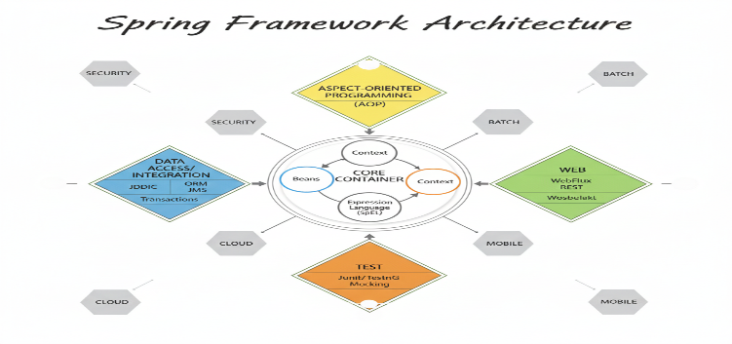
Spring Core comes bundled with multiple features :
- Dependency Injection or DI and Inversion of Control
- Spring Expression Language (SpEL)
- Aspect Oriented Programming (AOP)
- Spring validation, databinding and type conversion

- Dependency Injection & Inversion of Control
Dependency Injection (DI) is the process of defining dependency of bean instance on other beans. DI is also known as specialized IOC. A bean can define its dependencies through constructor, setter methods or a factory method.
To implement DI, Spring Framework may any use any of the two interfaces as a context . BeanFactory interface and ApplicationContext interface. ApplicationContext is a sub interface of BeanFactory .
ApplicationContext is used if the product requires more features, such as:
- Easier integration with Spring AOP
- Message resource handling for implementing internationalization.
- Event Publication
- Application-layer specific contexts such as the WebApplicationContext for use in web applications.
- Different ways of putting beans together
Developers uses java configuration file, xml file or annotation to wire beans together instead of instantiating the beans using new keyword.
- Using Java Configuration File:
When POJOs are part of third party libraries, to wire them we can use Java based configuration files.
What we need are one or more java configuration files annotated with @Configuration. The java file will contain @Bean annotated methods specifying required bean configuration.
You can also define @Bean annotated methods inside @Component annotated class. This is called lite mode. In lite mode, generated beans are not proxy-enabled and as a result , every time a @Bean annotated method is called a new bean is returned. Clearly, lite mode approach is not scalable.
Code Example
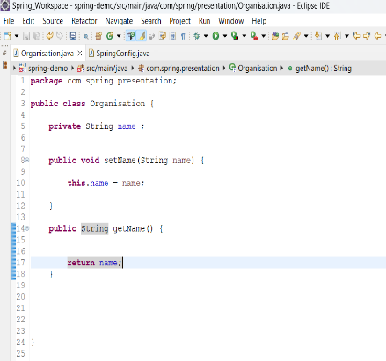
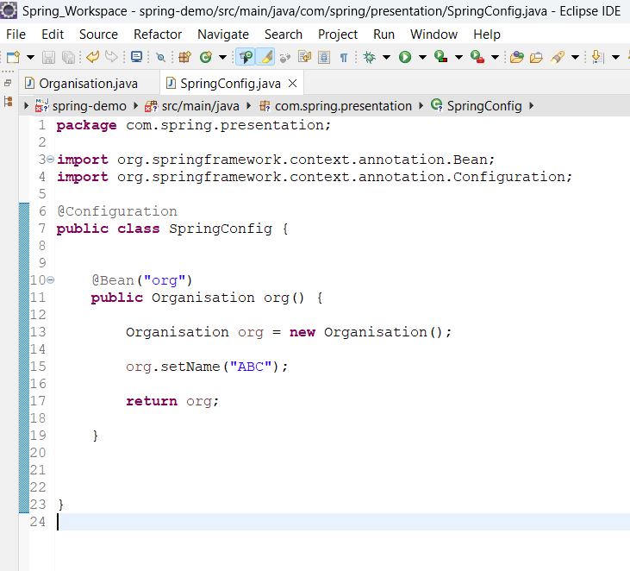
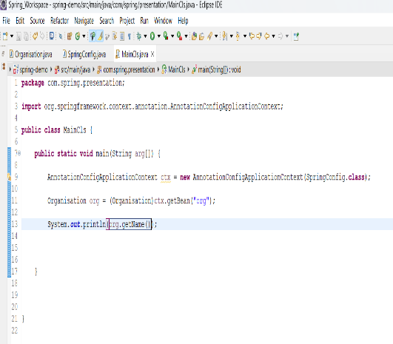
In the above example , we have a POJO of type Organisation and the configuration file SpringConfig.java . To create a bean of type Organization, we don’t use new() operator. Rather, we create a @bean annotated method and specify the name of Organisation as “ABC” . In the MainCls, we need to create a context which is AnnotationConfigApplicationContext in this case. This is an ApplicationContext . We can read configured bean class Organisation using this context.
In a nutshell , configuration metadata specify the bean wiring of POJOs and passed into the Spring Container to create a fully configured system.
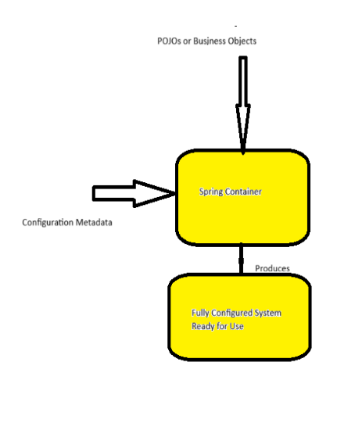
- XML configured system
Configuration metadata can also be a XML file wherein bean definition can be specified .
XML File Example:
<?xml version="1.0" encoding="UTF-8"?>
<beans xmlns="http://www.springframework.org/schema/beans"
xmlns:xsi=http://www.w3.org/2001/XMLSchema-instance
xsi:schemaLocation="http://www.springframework.org/schema/beans https://www.springframework.org/schema/beans/spring-beans.xsd">
<bean id="org” class="com.spring.presentation.Organisation">
<property name="name" value ="ABC"/>
</bean>
<bean id="..." class="...">
<!-- collaborators and configuration for this bean go here -->
</bean>
<!-- more bean definitions go here -->
</beans>
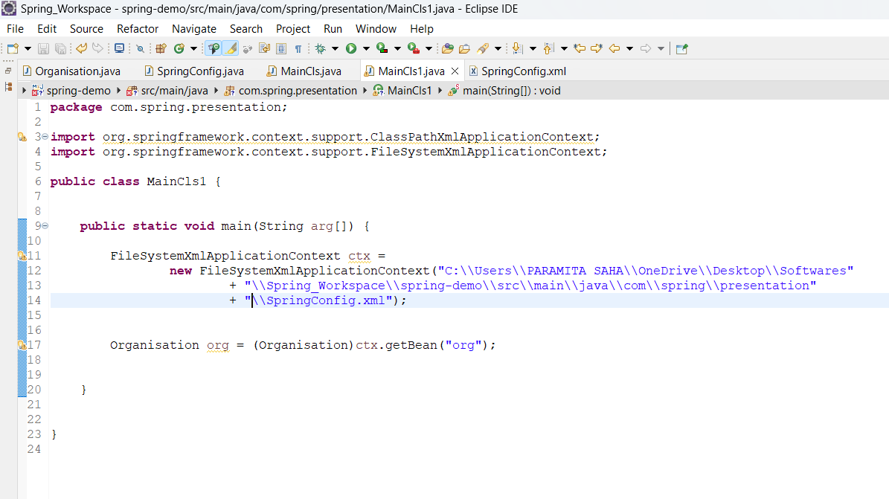
Even if multiple xml configuration files are available , we can club them together in a single xml file and pass the final xml file to the Spring container. Hence , if we keep on adding xml configuration files , we need to modify the final configuration file , but source code remains unaltered.
If we have another xml file named Services.xml, we can add Services.xml in SpringConfig.xml using <import> so that in the spring container we can add only the final xml file which is SpringConfig.xml file . Shared the xml configuration snippet below:
<?xml version="1.0" encoding="UTF-8"?>
<beans xmlns="http://www.springframework.org/schema/beans"
xmlns:xsi="http://www.w3.org/2001/XMLSchema-instance"
xsi:schemaLocation="http://www.springframework.org/schema/beans
https://www.springframework.org/schema/beans/spring-beans.xsd" default-autowire-candidates="">
<import resource="services.xml"/>
<bean id="org" class="com.spring.presentation.Organisation">
<property name="name" value ="ABC"/>
</bean>
</beans>
If we have used both xml file and java based configuration file to define beans , we can add the xml configuration file in the java based configuration file using @importResource annotation so that in the spring container we can add only the java configuration file instead of adding multiple xml files.
- Wiring Beans Using Annotation
If we are creating our domain model , i.e. , POJOs from scratch, we can annotate the POJOs with @Component annotation , specifying the bean id and annotate a java based configuration file with @ComponentScan annotation . @ComponentScan specify the base package names which are looked up for POJOs.
Example:
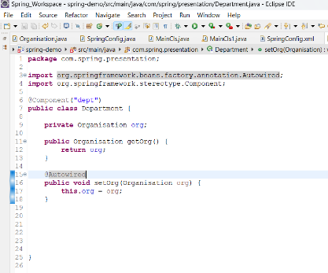
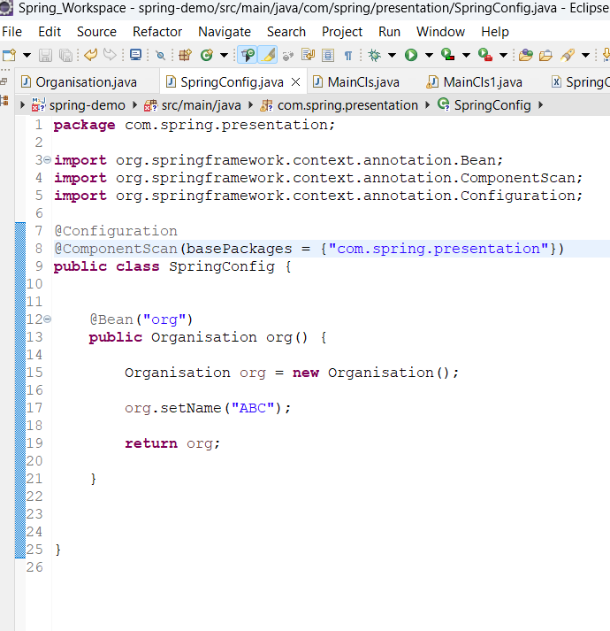
In the above code newly added component is Department and we have added Department in the spring container using @Component annotation as there is no @Bean annotated method returning Department.
- Different Ways of Wiring Beans:
We can put together two beans using constructor argument, setter method or factory methods. These three ways are quite distinguishable in xml configuration.
XML Configuration File:
Constructor Argument : Here we have a POJO ExampleBean and it has two arguments years and ultimateAnswer.
<bean id="exampleBean" class="examples.ExampleBean">
<constructor-arg name="years" value="7500000"/>
<constructor-arg name="ultimateAnswer" value="42"/>
</bean>
We can make the configuration more concise using c-namespace.
<beans xmlns="http://www.springframework.org/schema/beans"
xmlns:xsi="http://www.w3.org/2001/XMLSchema-instance"
xmlns:c="http://www.springframework.org/schema/c"
xsi:schemaLocation="http://www.springframework.org/schema/beans
https://www.springframework.org/schema/beans/spring-beans.xsd">
<bean id="beanTwo" class="x.y.ThingTwo"/>
<bean id="beanThree" class="x.y.ThingThree"/>
<!-- c-namespace declaration with argument names -->
<bean id="beanOne" class="x.y.ThingOne" c:thingTwo-ref="beanTwo"
c:thingThree-ref="beanThree" c:email="something@somewhere.com"/>
</beans>

Setter based Dependency Injection: Here ExampleBean has three properties beanOne, beanTwo, integerProperty . So, setter based dependency injection have been used.
<bean id="exampleBean" class="examples.ExampleBean">
<!-- setter injection using the nested ref element -->
<property name="beanOne">
<ref bean="anotherExampleBean"/>
</property>
<!-- setter injection using the neater ref attribute -->
<property name="beanTwo" ref="yetAnotherBean"/>
<property name="integerProperty" value="1"/>
</bean>
<bean id="anotherExampleBean" class="examples.AnotherBean"/>
<bean id="yetAnotherBean" class="examples.YetAnotherBean"/>
</beans>
We can make the configuration more concise using the p-namespace.
<beans xmlns="http://www.springframework.org/schema/beans"
xmlns:xsi="http://www.w3.org/2001/XMLSchema-instance"
xmlns:p="http://www.springframework.org/schema/p"
xsi:schemaLocation="http://www.springframework.org/schema/beans
https://www.springframework.org/schema/beans/spring-beans.xsd">
<bean id="myDataSource" class="org.apache.commons.dbcp.BasicDataSource"
destroy-method="close"
p:driverClassName="com.mysql.jdbc.Driver"
p:url="jdbc:mysql://localhost:3306/mydb"
p:username="root"
p:password="misterkaoli"/>
</beans>
Dependency Injection using Factory Method: Here the ExampleBean has a factory method createInstance which takes as an argument two beans and a property . All these properties are wired using factory method.
<bean id="exampleBean" class="examples.ExampleBean" factory-method="createInstance">
<constructor-arg ref="anotherExampleBean"/>
<constructor-arg ref="yetAnotherBean"/>
<constructor-arg value="1"/>
</bean>
<bean id="anotherExampleBean" class="examples.AnotherBean"/>
<bean id="yetAnotherBean" class="examples.YetAnotherBean"/>
public class ExampleBean {
// a private constructor
private ExampleBean(...) {
...
}// a static factory method; the arguments to this method can be
// considered the dependencies of the bean that is returned,
// regardless of how those arguments are actually used.
public static ExampleBean createInstance (
AnotherBean anotherBean, YetAnotherBean yetAnotherBean, int i) {
ExampleBean eb = new ExampleBean (...);
// some other operations...
return eb;
}
}

- A Few Points to remember while wiring beans using XML File
- Instead of simple “ref” attribute in the xml config file to wire beans , we may use “idref” . Using idref ensures that the configuration is validated at deployment time.
- Using xml config allows to inherit parent bean definition by child bean definition without instantiating parent bean definition.
Example XML Config Snippet:
<bean id="inheritedTestBean" abstract="true"
class="org.springframework.beans.TestBean">
<property name="name" value="parent"/>
<property name="age" value="1"/>
</bean>
<bean id="inheritsWithDifferentClass"
class="org.springframework.beans.DerivedTestBean"
parent="inheritedTestBean" init-method="initialize">
<property name="name" value="override"/>
<!-- the age property value of 1 will be inherited from parent -->
</bean>
As per the example configuration, only a bean of name DerivedTestBean will be instantiated with name = “overrride” and age = 1.
- Value attribute of property element takes a primitive or a string value . Spring’s conversion service is used to convert the string to appropriate object.
- We can create inner bean definitions within another bean definition to create beans which are not wired into any other bean.
- We can also wire List, Set, Map , Properties bean into a bean definition.
- Every bean definition can have a depends-on attribute to specify one or more beans which are to be initialized prior to the enclosing bean definition.
- Lazy-init attribute ensures that the enclosing beans must be instantiated lazily when they are accessed.

- Autowiring Collaborators
Autowiring is an important feature of Spring Framework. Collaborating beans can be autowired without any additional configuration in the configuration metadata. It reduces the amount of configuration required. Autowiring can be performed using xml configuration and java based configuration as well.
Autowiring Example Using Java :
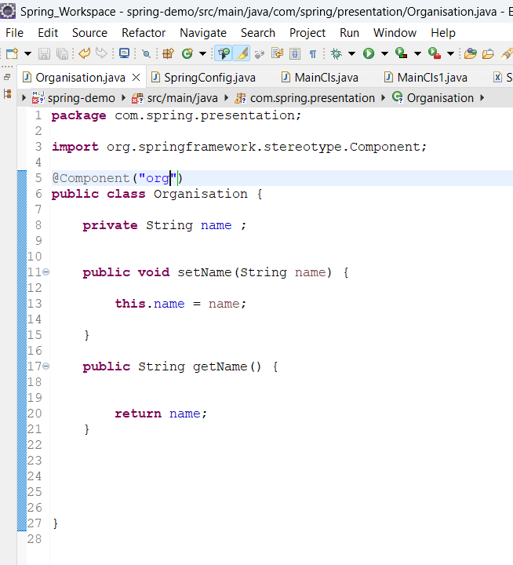
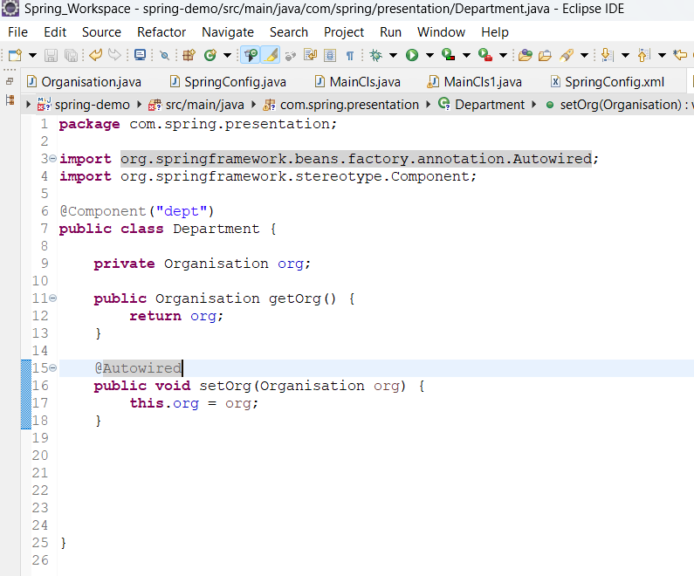
Here to tie Department and Organisation together, we need to use only @Autowired annotation.
You can also use xml configuration to implement autowiring .
- Limitations of Using Autowiring

- We can not autowire simple types such as primitive types , classes and string.
- If we have multiple beans of the same type , simple @Autowired will throw an exception . In such a case we need to use @Qualifier annotation on top of @Component annotated class and @Autowired annotation.

- Excluding Beans from Autowiring
If we are using xml configuration , we can set autowire-candidate attribute to false to prevent the bean from becoming an autowire candidate. Thus, if we have more than one bean definition of the same type, we can dodge the Exception thrown during autowiring.
- Different bean scopes
Spring beans can be one of the following scopes:
- Singleton -> Default scope. Only one bean instance is present per ApplicationContext . It improves the scalability of the application as every time you require an instance of that bean , the same instance is returned.
- Prototype -> Everytime we retrieve a bean from context , a new instance of the bean gets created.
- Request -> A bean in the request scope in available as long as the request is around.
- Session -> Bean is present as long as the session is present.
- Application -> Scopes a single bean definition to the lifecycle of a ServletContext. Only valid in the context of a web-aware Spring ApplicationContext.
- Websockegt -> Scopes a single bean definition to the lifecycle of a WebSocket. Only valid in the context of a web-aware Spring ApplicationContext.

When we inject a shorter-lived bean(such as , prototype bean) into a longer-lived bean(such as , singleton bean) , spring injects the proxy of the shorted-lived bean. When a request comes to access the injected bean , it’s intercepted by the proxy.

- Validation, Databinding and Type Conversion
Validation of data generally happens at Front-end as it saves the precious bandwidth. But it’s recommended to add validation logic at the backend as well. In Spring there are two ways to perform validation of the received data.
- The Bean Validation API (Jakarta Validation) for declarative, annotation-based validation .
- The Spring Validator interface for programmatic, custom validation logic.

Declarative , Annotation based API : We use annotation such as @NonNull , @NonEmpty etc. to annotate fields of POJO. To trigger validation of the inbound data , we annotate the model(POJO)with @Valid annotation in the Spring Controller method.

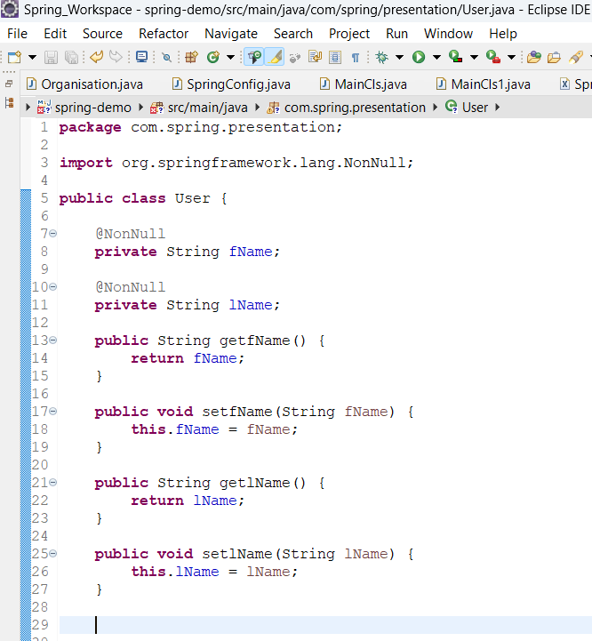

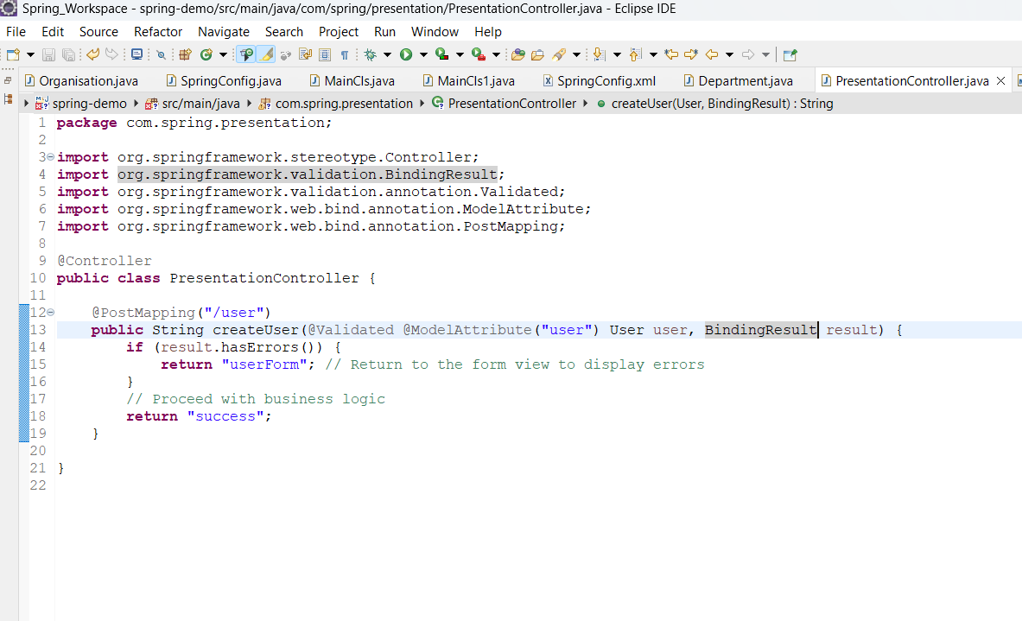

Spring Validator Interface :

Spring's Validator interface provides a way to validate objects within the framework itself, working with an Errors object to report validation failures. In this process, every POJO comes bundled with a validator . Pojo and its validator reside in the same package. For example, for the Employee POJO we have EmployeeValidator class which implements Validator interface available in Spring Framework.

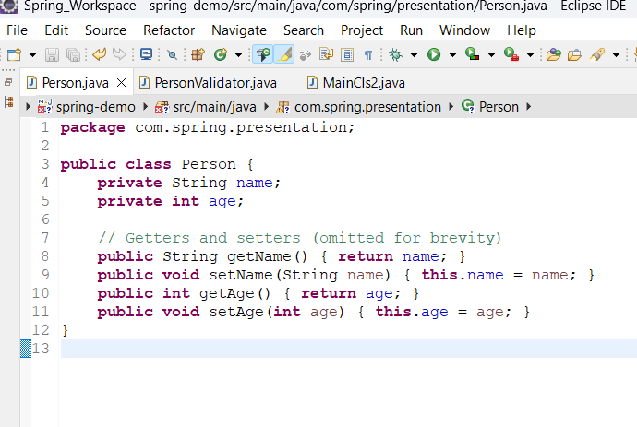

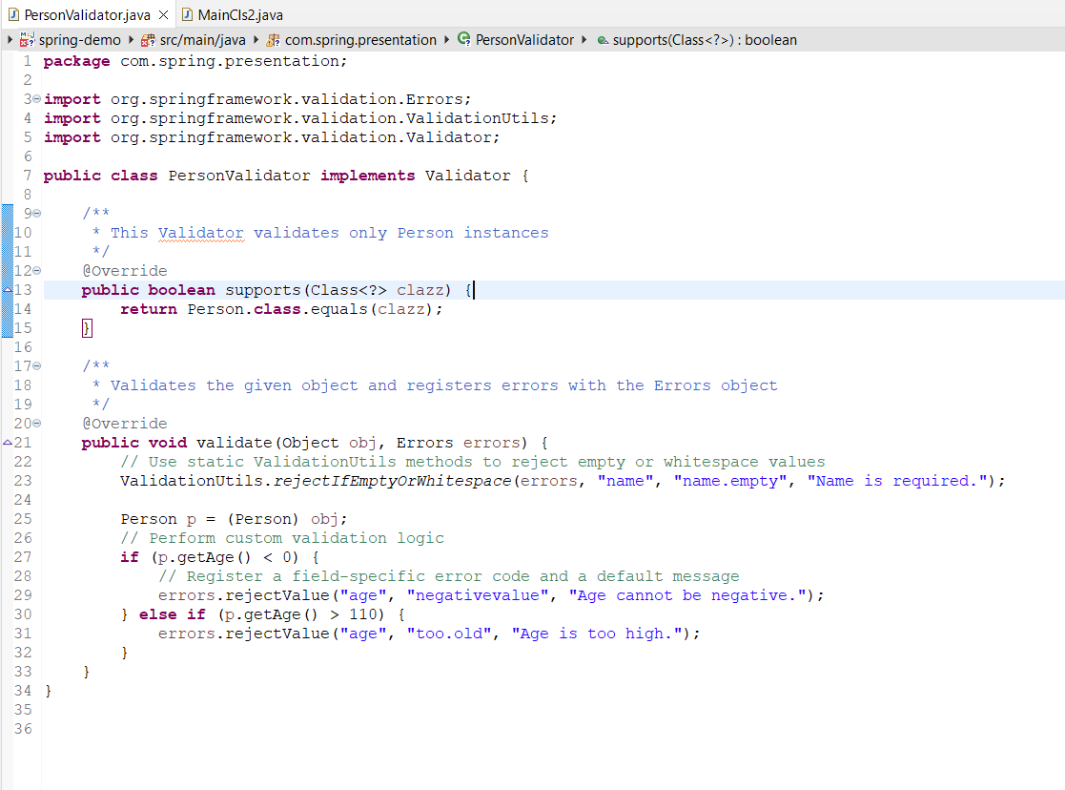

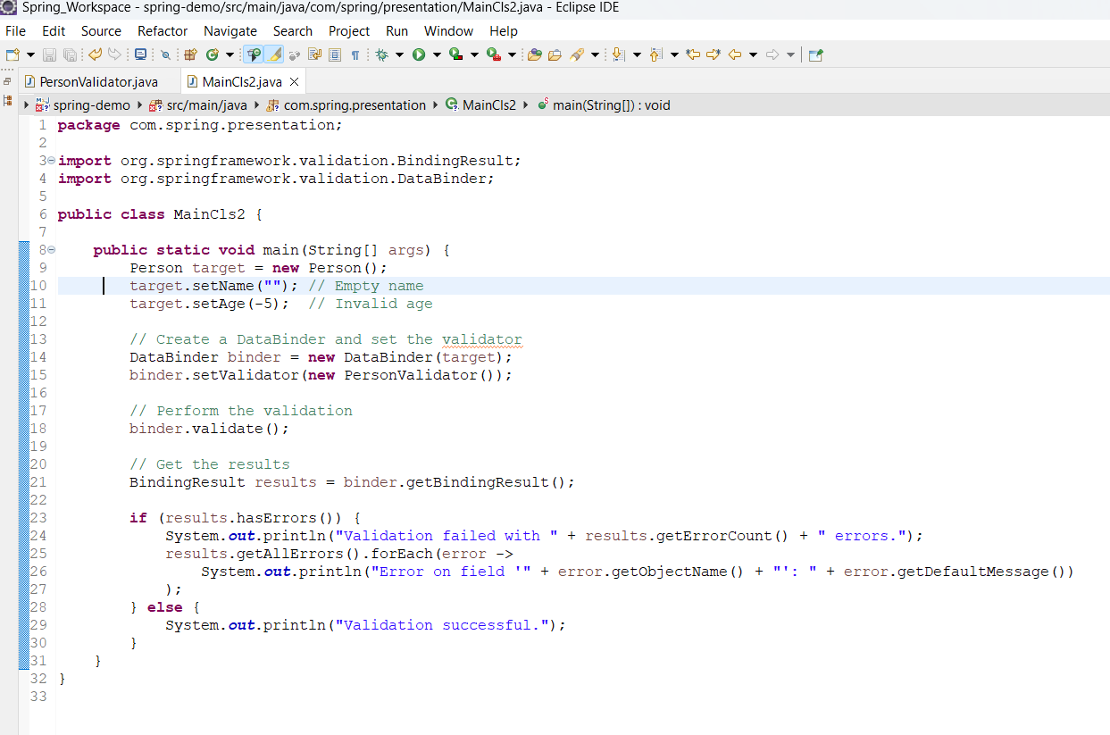

- Data Binding

By applying databinding input data is transformed into a target object. There are two types of binding – constructor binding and property binding .

Constructor Binding:

The target class should have a single public constructor or a single non-public constructor with arguments. If there are multiple constructors, then a default constructor if present is used.

By default, argument values are looked up via constructor parameter names. Spring MVC and WebFlux support a custom name mapping through the @BindParam annotation on constructor parameters or fields if present.

Example Code:

- Create a DTO using @BindParam

package com.example.demo.dto;

import org.springframework.web.bind.annotation.BindParam;

public record Account(
@BindParam("first_name") String firstName,
@BindParam(“last_name”)String lastName
) {}

- Create a Controller
package com.example.demo.controller;

import com.example.demo.dto.Account;
import org.springframework.web.bind.annotation.GetMapping;
import org.springframework.web.bind.annotation.RestController;

@RestController
public class AccountController {

@GetMapping("/create-account")
public String createAccount(Account account) {
// Access the bound parameters using the Java field names
return "Account created for: " + account.firstName() + " " + account.lastName();
}
}

Example Request:

https://localhost:8080/create-account?first_name=Jane&last_name=Doe

When Type Conversion happens it performs following tasks:

- constructor binding creates both the target object and any objects it contains.
- Constructor binding supports List, Map, and array arguments either converted from a single string, for example, comma-separated list, or based on indexed keys .
Example Code :
package com.example.demo.config;
import org.springframework.boot.context.properties.ConfigurationProperties;
import java.util.List;
@ConfigurationProperties(prefix = "app.users")
public class UserProperties {
private final List<User> users;
// Spring automatically uses this constructor for binding
public UserProperties(List<User> users) {
this.users = users;
}
public List<User> getUsers() {
return users;
}
}

package com.example.demo.config;
public class User {
private final String username;
private final int id;
public User(String username, int id) {
this.username = username;
this.id = id;
}
// Getters, equals, hashCode, toString...
public String getUsername() { return username; }
public int getId() { return id; }
}
package com.example.demo.converter;
import com.example.demo.config.User;
import org.springframework.core.convert.converter.Converter;
import org.springframework.stereotype.Component;

@Component
public class StringToUserConverter implements Converter<String, User> {
@Override
public User convert(String source) {
if (source == null || source.isEmpty()) {
return null;
}
// Example: Convert "john:101" to a User object
String[] parts = source.split(":");
if (parts.length == 2) {
String username = parts[0];
int id = Integer.parseInt(parts[1]); // Default conversion handles int
return new User(username, id);
} else {
throw new IllegalArgumentException("Invalid user format: " + source);
}
}
}
When the application starts:
- Spring reads the app.users.users property as a single String.
- The DataBinder identifies that the target type for the constructor argument is a List<User>.
- It uses the ConversionService to convert the comma-separated String into a List.
- The built-in collection converter iterates through the elements and uses the custom StringToUserConverter to create each User instance.
- Finally, the fully populated UserProperties bean is created and injected where needed.

- Property Binding with BeanWrapper
A bean is a standard POJO with a default no-argument constructor and a bunch of properties. Using BeanWrapper, we can convert the inbound message into a target object.
Example Code:
public class Company {
private String name;
private Employee managingDirector;

public String getName() {
return this.name;
}
public void setName(String name) {
this.name = name;
}
public Employee getManagingDirector() {
return this.managingDirector;
}
public void setManagingDirector(Employee managingDirector) {
this.managingDirector = managingDirector;
}
}
public class Employee {
private String name;
private float salary;
public String getName() {
return this.name;
}
public void setName(String name) {
this.name = name;
}
public float getSalary() {
return salary;
}
public void setSalary(float salary) {
this.salary = salary;
}
}
BeanWrapper company = new BeanWrapperImpl(new Company());
// setting the company name..
company.setPropertyValue("name", "Some Company Inc.");
// ... can also be done like this:
PropertyValue value = new PropertyValue("name", "Some Company Inc.");
company.setPropertyValue(value);

// ok, let's create the director and tie it to the company:
BeanWrapper jim = new BeanWrapperImpl(new Employee());
jim.setPropertyValue("name", "Jim Stravinsky");
company.setPropertyValue("managingDirector", jim.getWrappedInstance());

// retrieving the salary of the managingDirector through the company
Float salary = (Float) company.getPropertyValue("managingDirector.salary");
- PropertyEditors
Spring uses PropertyEditor to convert a string input into a bean. We can use built-in PropertyEditor or custom editors of type PropertyEditor. We also need to register the custom PropertyEditor using a BeanWrapper or declaratively using spring config files.
Setting properties on beans is done by using PropertyEditor implementations. When you use String as the value of a property of some bean that you declare in an XML file, Spring (if the setter of the corresponding property has a Class parameter) uses ClassEditor to try to resolve the parameter to a Class object.
standard JavaBeans infrastructure automatically discovers PropertyEditor classes (without you having to register them explicitly) if they are in the same package as the class they handle and have the same name as that class, with Editor appended. For example, Employee.java and EmployeeEditor.java should be in the same package if developer don’t register the EmployeeEditor.java
BeanInfo Mechanism:
BeanInfo mechanism to explicitly register one or more PropertyEditor instances with the properties of an associated class.
Code Example:
public class SomethingBeanInfo extends SimpleBeanInfo {
public PropertyDescriptor[] getPropertyDescriptors() {
try {
final PropertyEditor numberPE = new CustomNumberEditor(Integer.class, true);
PropertyDescriptor ageDescriptor = new PropertyDescriptor("age",Something.class) {
@Override
public PropertyEditor createPropertyEditor(Object bean) {
return numberPE;
}
};
return new PropertyDescriptor[] { ageDescriptor };
}
catch (IntrospectionException ex) {
throw new Error(ex.toString());
}
}
}
Here the Something class containing property age uses the SomethingBeanInfo to tie the CustomeNumberEditor with the age property.
So, if we need to associate one or more propertyEditors with some properties of a bean , we need to use a corresponding BeanInfo class.
- Custom PropertyEditors:
Example Code:
package example;
public class ExoticType {
private String name;
public ExoticType(String name) {
this.name = name;
}
}
public class DependsOnExoticType {
private ExoticType type;
public void setType(ExoticType type) {
this.type = type;
}
}
To wire these beans together , we use following snippets :
<bean id="sample" class="example.DependsOnExoticType">
<property name="type" value="aNameForExoticType"/>
</bean>
Also , we need to implement the propertyEditor interface:
package example;

import java.beans.PropertyEditorSupport;
// converts string representation to ExoticType object
public class ExoticTypeEditor extends PropertyEditorSupport {
public void setAsText(String text) {
setValue(new ExoticType(text.toUpperCase()));
}
}
Finally, the following example shows how to use CustomEditorConfigurer to register the new PropertyEditor with the ApplicationContext, which will then be able to use it as needed:
<bean class="org.springframework.beans.factory.config.CustomEditorConfigurer">
<property name="customEditors">
<map>
<entry key="example.ExoticType" value="example.ExoticTypeEditor"/>
</map>
</property>
</bean>
To register PropertyEditor with the Spring container we can also use an PropertyEditorRegistrar which is mostly used if we are using Spring MVC module-based applications.
- Implementation of Internationalization:
Internationalization is the process of displaying contents in the application based on Locale. For example, we have a page with contents written in English. Using internationalization, we can create the same page in Bengali or in any other language.
In Spring, we have an interface called MessageSource which allows you to implement internationalization in your application. There are different in-built implementations of MessageSource and we mostly use ResourceBundleMessageSource class in which you can specify the basename. When you invoke the getMessage() , you pass in the message key you want to read and Locale to identify the properties file. Of course, you have to define a MessageSource bean having the id “messageSource” and a property called “messageSource” which will be annotated with @Autowired.
Code Example:
Spring Configuration File
import org.springframework.context.MessageSource;
import org.springframework.context.annotation.Bean;
import org.springframework.context.annotation.Configuration;
import org.springframework.context.support.ResourceBundleMessageSource;

@Configuration
public class AppConfig {
@Bean
public MessageSource messageSource() {
ResourceBundleMessageSource messageBundleResrc = new ResourceBundleMessageSource();
messageBundleResrc.setBasename("messages"); // Corresponds to the base file name "messages"
messageBundleResrc.setDefaultEncoding("UTF-8");
return messageBundleResrc;
}
}
Properties Files:
Messages.properties
greeting.hello=Hello world
greeting.username=Hello {0}, how are you?
error.notFound=Resource not found
Messages_fr.properties
greeting.hello=Bonjour le monde
greeting.username=Bonjour {0}, comment allez-vous?
error.notFound=Ressource introuvable
Java Class to Read From Properties Files:
import org.springframework.beans.factory.annotation.Autowired;
import org.springframework.context.MessageSource;
import org.springframework.stereotype.Service;
import java.util.Locale;
@Service
public class GreetingService {

private final MessageSource messageSource;

@Autowired
public GreetingService(MessageSource messageSource) {
this.messageSource = messageSource;
}

public String getFrenchGreeting() {
// Resolve "greeting.hello" for the French locale
return messageSource.getMessage("greeting.hello", null, Locale.FRANCE);
}

public String getParameterizedGreeting(String username, Locale locale) {
// Resolve "greeting.username", passing an argument (username) for a specific locale
Object[] params = new Object[] {username};
return messageSource.getMessage("greeting.username", params, locale);
}
}
- What is Profile
The beans , that contribute to the infrastructure of your application, may differ in different environments. For example, jdbcTemplate bean needs to point to prod database in prod environment and to dev database in dev environment. So, we need to have different beans activated in different environments. Instead of deploying different jar files in different environment, we can deploy the same jar file, activating different profiles. All you need to do is to annotate the @Component annotated class or @Bean annotated method with @Profile annotation and while starting the application specify active profile.
Code Example:
@Configuration
@Profile("dev")
public class DevDatabaseConfig {
@Bean
public DataSource dataSource() {
// Use an H2 in-memory database for development
System.out.println("Using H2 database for Dev environment");
return new H2DataSource();
}
}

@Configuration
@Profile("prod")
public class ProdDatabaseConfig {
@Bean
public DataSource dataSource() {
// Use a PostgreSQL database for production
System.out.println("Using PostgreSQL database for Prod environment");
return new PostgresDataSource();
}
}
Command Line Argument: Specify the active profile when running the application JAR using a JVM system property.
java -jar -Dspring.profiles.active=prod myapp.jar
Spring Expression Language:
SpEL is basically used to modify property values dynamically at run time .
A Few Examples:
public class PropertyValueTestBean {
private String defaultLocale;
@Value("#{ systemProperties['user.region'] }")
// Here the value of “user.region” systemProperty is injected
public void setDefaultLocale(String defaultLocale) {
this.defaultLocale = defaultLocale;
}

public String getDefaultLocale() {
return this.defaultLocale;
}
}
public class ShapeGuess {
private double initialShapeSeed;
@Value("#{ numberGuess.randomNumber }")
// we are assuming that there is a bean named numberGuess containing randomNumber property which is injected in initialShapeSeed
public void setInitialShapeSeed(double initialShapeSeed) {
this.initialShapeSeed = initialShapeSeed;
}
public double getInitialShapeSeed() {
return initialShapeSeed;
}
}
- Aspect Oriented Programming
Sometimes we need to invoke the same piece of code at different junctures in our code again and again. Instead of littering the existing business logic code with these modules , also known as cross cutting concerns, we can implement a new way of tying them together . This new approach is known as Aspect Oriented Programming. Spring framework comes bundled with its own Spring AOP and we don’t need to add any separate jar for AOP in the classpath.
Key Concepts in AOP:
Aspect : The class containing advices.
JoinPoint : Where the advice is to be applied , e.g. methods or at the occurence of exception .
Pointcut : Advice is associated with a pointcut expression. For example , execution of a method with a certain name.
Advice : applied before, after or around the joinPoints
Introduction: Declaring additional methods or fields on behalf of a type
Target object: An object being advised by one or more aspects.
AOP proxy: An object created by the AOP framework in order to implement the aspect contracts
In the Spring Framework, an AOP proxy is a JDK dynamic proxy or a CGLIB proxy.
Weaving: linking aspects with other application types or objects to create an advised object.Spring AOP, like other pure Java AOP frameworks, performs weaving at runtime.

- Spring AOP includes the following types of advice:

Before advice: Advice that runs before a join point but that does not have the ability to prevent execution flow proceeding to the join point (unless it throws an exception).
After returning advice: Advice to be run after a join point completes normally (for example, if a method returns without throwing an exception).
After throwing advice: Advice to be run if a method exits by throwing an exception.
After (finally) advice: Advice to be run regardless of the means by which a join point exits (normal or exceptional return).
Around advice: Advice that surrounds a join point such as a method invocation.
Around advice can perform custom behavior before and after the method invocation. It is also responsible for choosing whether to proceed to the join point or to shortcut the advised method execution by returning its own return value or throwing an exception.
Spring AOP Capabilities and Goals:
Spring AOP does not need to control the class loader hierarchy and is thus suitable for use in a servlet container or application server.
Spring AOP currently supports only method execution join points

- AOP Proxies:
Spring AOP defaults to using standard JDK dynamic proxies for AOP proxies. This enables any interface (or set of interfaces) to be proxied.
Spring AOP can also use CGLIB proxies.
By default, CGLIB is used if a business object does not implement an interface.
- Enabling @AspectJ Support with Java Configuration:

@Configuration
@EnableAspectJAutoProxy
public class AppConfig {
}

Enabling @AspectJ Support with XML Configuration:

To enable @AspectJ support with XML-based configuration, use the aop:aspectj-autoproxy element, as the following example shows:

<aop:aspectj-autoproxy/>

Declaring an Aspect: We need to annotate the Aspect class with @Aspect annotation. Aspect class is nothing but a java class containing all pieces of advice , pointcut definition and joinpoints.

package com.spring.aop;

import org.aspectj.lang.ProceedingJoinPoint;
import org.aspectj.lang.annotation.After;
import org.aspectj.lang.annotation.AfterReturning;
import org.aspectj.lang.annotation.AfterThrowing;
import org.aspectj.lang.annotation.Around;
import org.aspectj.lang.annotation.Aspect;
import org.aspectj.lang.annotation.Before;
import org.aspectj.lang.annotation.Pointcut;
import org.springframework.core.annotation.Order;
import org.springframework.stereotype.Component;

@Aspect
@Component
@Order(2)
public class MyAspacts {

@Pointcut("execution( public void display())")
private void pcExecution() {}

@Order(2)
@Before("pcExecution()")
public void adviceBefore() {

System.out.println(" Before Advice applied................");
}
}
Due to the proxy-based nature of Spring’s AOP framework, calls within the target object are, by definition, not intercepted. For JDK proxies, only public interface method calls on the proxy can be intercepted. With CGLIB, public and protected method calls on the proxy are intercepted (and even package-visible methods, if necessary). However, common interactions through proxies should always be designed through public signatures.
When the aspect is included in the jar file , adviceBefore() method is invoked automatically before running any display() method. Here the pros of this application is we need to not to modify any existing class file to add the adviceBefore() method.

