Aion Luxury Website Updates
- On the Story page, under the Production Process section, the images are appearing compressed. Kindly adjust and stretch them slightly for a better visual appearance.
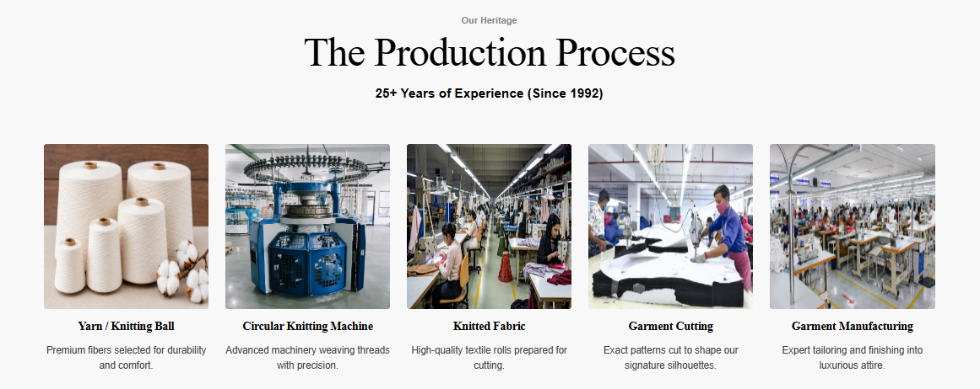

- Add an FAQ section to the website.

- In the mobile version, the lion logo is overlapping the content, and the India flag is not visible. Kindly fix the alignment and visibility issues.
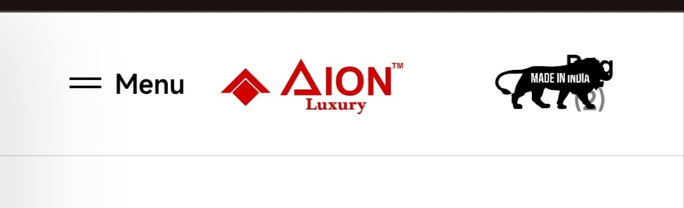
- In the mobile version, the product zoom feature is not available. Please enable the zoom functionality for product images.

- Under the T-Shirts section, the color selection options do not match the actual T-shirt colors shown in the images. Kindly update the color swatches to accurately reflect the product colors.
