CoSA UniversalAPI

URL: https://webapps9dev.sanantonio.gov/UniversalAPI/api/Document

This is API is secured using the API key authentication method. The API key will vary between environments and should be kept secured. CoSA will work with vendor to provide the appropriate API key per environment. The API key should not be passed in the url and should be in the Headers of all requests to this endpoint.

This API will contain both GET and POST endpoints.
NOTE: When using Postman to test this endpoint please make sure you configure Postman to use the API key provided from CoSA. The screenshots below will be utilizing Postman.
GET:
The GET endpoint is expecting two parameters “guid” and “ApplicationID”. The guid is the identifier for the document that needs to be retrieved the ApplicationID is the value that CoSA has provided to identify the application making the request. These should be passed as a query string. Below is an example screenshot from Postman:
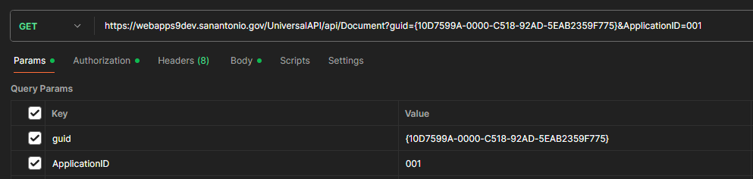

The return will be a byte array representing the content requested.
POST:
The POST method will be utilizing the multipart/form-data format to better handle large (> 50MB) files. On a successful POST this method will return the FileNet generated guid as a string.
The parameters expected are listed below:

ApplicationID (Provided by CoSA): string descriptor used to determine the id of the requesting application. Assigned and provided by CoSA.
DocumentFields: JSON object with document properties associated with the file.
File: binary (Content to be published to FileNet)

Below is an example of the setup of a POST request in Postman:
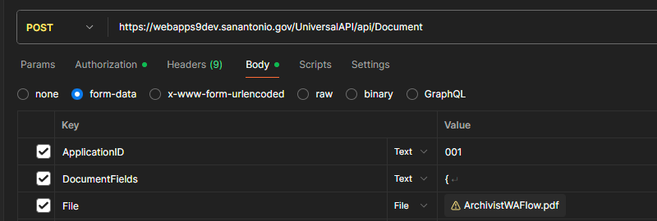

Here is an example of the DocumentFields object:
{
"DocumentTitle": "UniversalAPI Test 6",
"DocumentDescription": "Testing API again",
"Department": "EDD",
"Security": "Legally Confidential",
"RecordTitleCode": "Candidacy Applications And Certifications - EL3125-02a",
"FilePlanLocation": "/Records Management/CoSA FilePlan/ELECTION/RECORDS OF CANDIDACY AND CAMPAIGN FINANCE/EL3125-02A - CANDIDACY APPLICATIONS AND CERTIFICATIONS",
"ERMApplicationName": "EDD SalesForce",
"TriggerDate": "12/15/2025",
"MimeType": "application/pdf"
}
The response will be a FileNet generated guid – string.

NOTE: The JSON object used for in the example above is subject to change. The following property values will need to be determined in a collaborative process based on the content/record type being published:
- Security – Used to determine visibility within FileNet
- Department – Is used to identify the department that is responsible for the record creation. This will be a 3 letter acronym provided by CoSA
- RecordTitleCode – This is used to assign the record to the correct retention series in FileNet
- FilePlanLocation – This is used to assign the record to the FilePlan in FileNet during the autodeclaration process
- TriggerDate – This date may or may not be know at the time of publishing to FileNet. If it is, then it should be provided in order to trigger the correct disposition tracking in FileNet
All other properties (DocumentTitle, DocumentDescription, ERMApplicationName and MimeType) are general descriptions about the content and should come from the system publishing the content.
All requests will be logged on the CoSA WebApps server for debugging/troubleshooting.

