**OneDrive to DS Transfer tool**

**About**

Utility has been designed to not only transfers the data from OneDrive to Data studio but also has ability to convert XML files to jSON files (newline-delimited format).

**Pre-requisites**

Before using this tool, following tools should be pre-installed in your machine -

1. RClone tool (<https://rclone.org/downloads/>)
2. 7-Zip tool (<https://www.7-zip.org/download.html>)

Required access for:

* One drive
* Google cloud storage
* Google Data studio

**Using the tool**

1. Create a folder named “API_Results” under “Downloads” folder
2. Place all the XML run results under the created “API_Results” folder
3. XML files should be named properly as –

* Each API result file should start with “API” as prefix Eg : API_50Dragons_.xml
* Each Recovery result file should start with “Recovery” as prefix Eg : Recovery_50Dragons_.xml

1. Run “APIDataTool.sh” file by double tapping on same
2. You will see different menu options as:

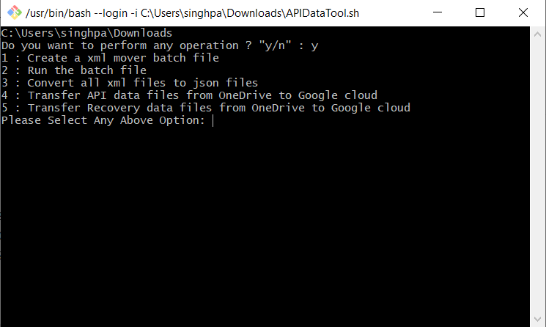

* Create a xml mover batch file – Will create a “xmlmover.bat” file
* Run the batch file - Will move all files from all folders and sub folders inside “API_Results” folder to a new folder named “XMLs”
* Now in “XMLs” folder, there would be xml and non-xml files. Save non-xml files as xml. If using “Notepad++”, before saving the file as .xml ensure that “Encoding” is UTF-8. Menu -> Encoding -> Select “UTF-8”

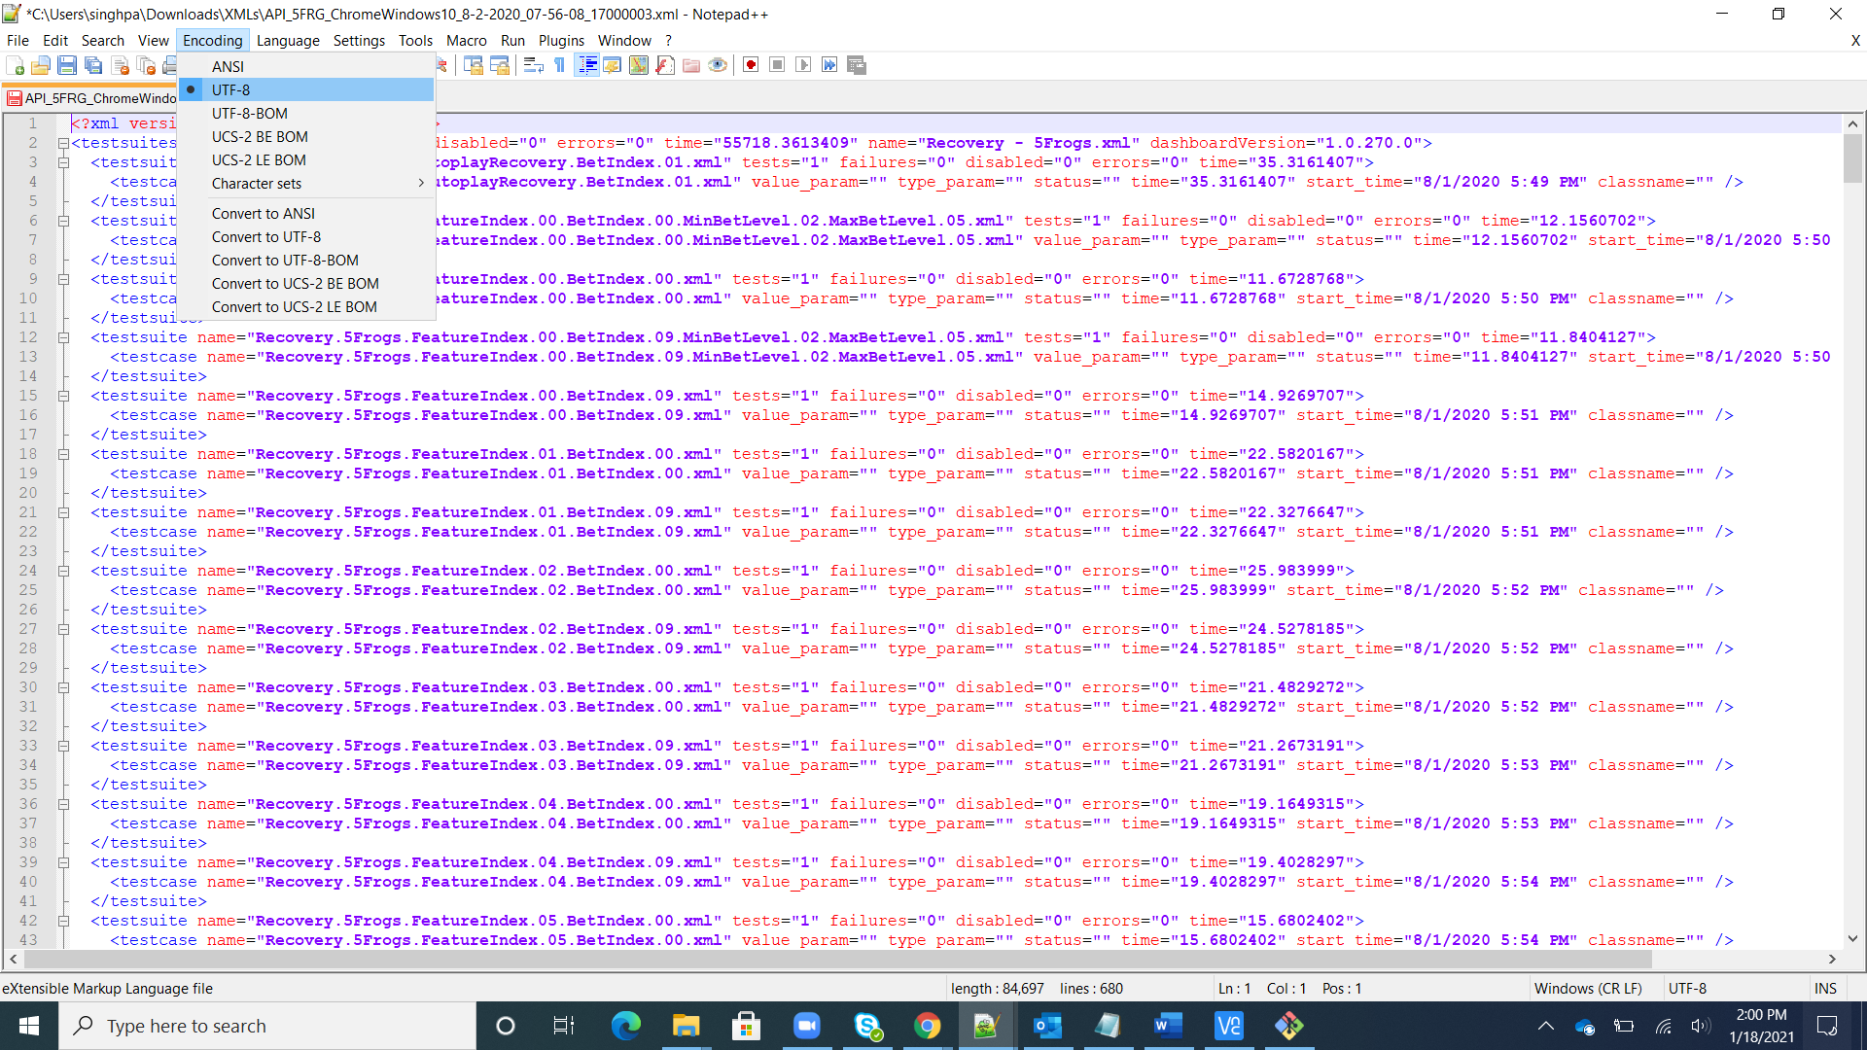

* Remove/delete the .png or any other image file present in “XMLs”
* Also, ensure the files are named as per Point 3
* Convert all xml files to json files – As the name suggests, this option will convert all XMLs to jSON files(newline-delimited format) and place them under “JSONs” folder
* Upload the API and recovery json files to their respective OneDrive folders (All_API_Results, All_Recovery_Results)

Folder structure under “Downloads” will look like –

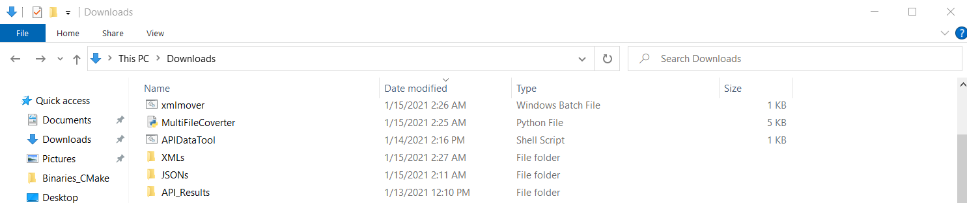

API_Results

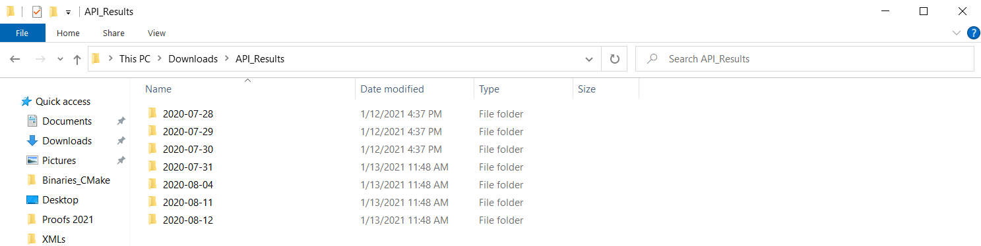

XMLs

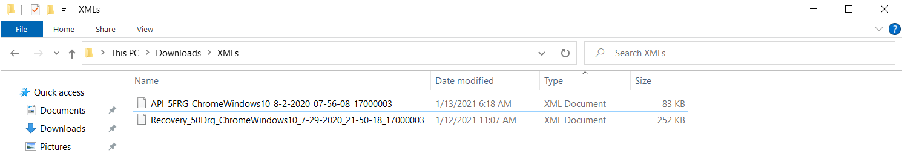

JSONs

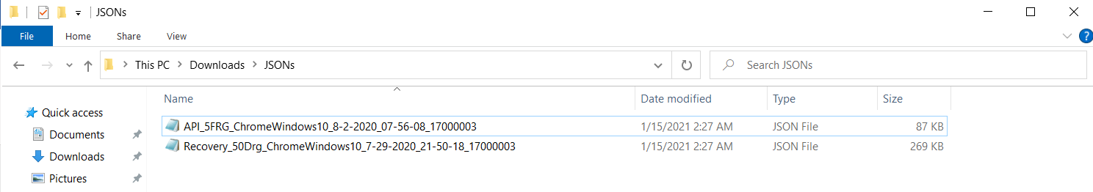

* Transfer API data files from OneDrive to Google cloud – This option will now transfer the API jSON files from OneDrive to Google cloud storage

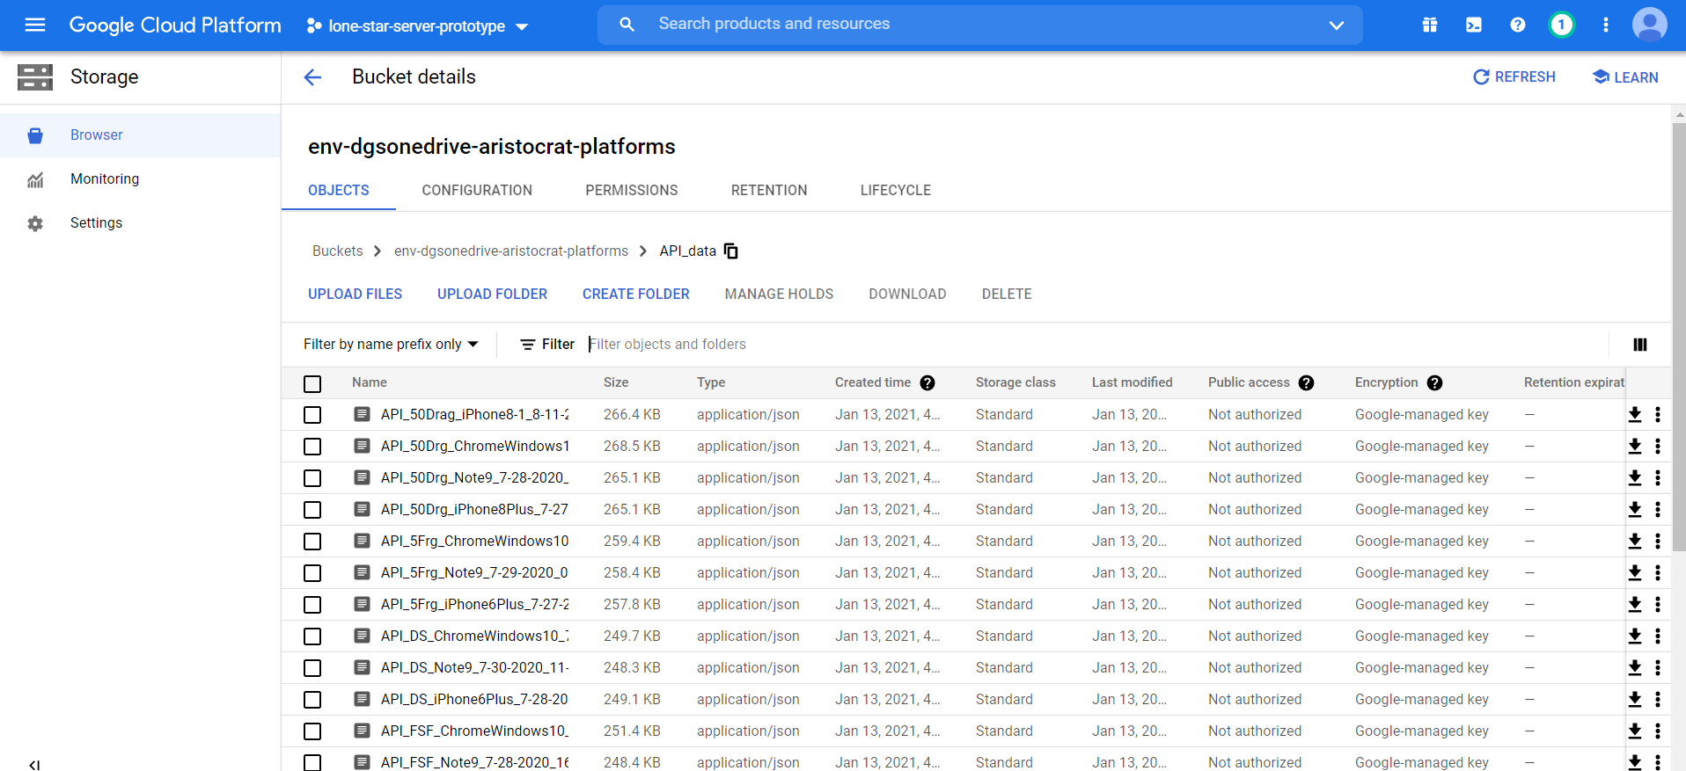

* Transfer Recovery data files from OneDrive to Google cloud – This option will now transfer the Recovery jSON files from OneDrive to Google cloud storage

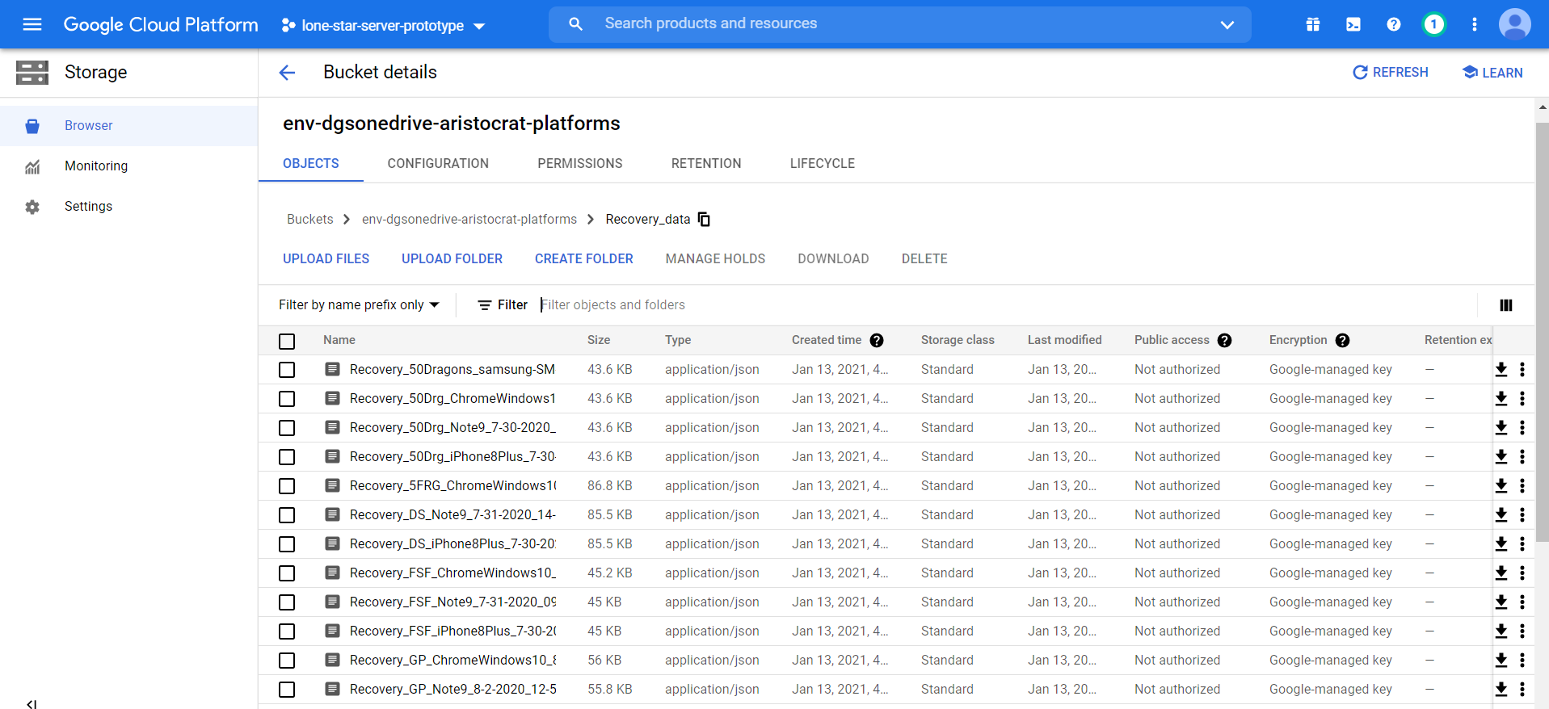

1. One transfer is done, now “Google cloud Data Transfer API” will publish the data stored in storage buckets to bigQuery tables

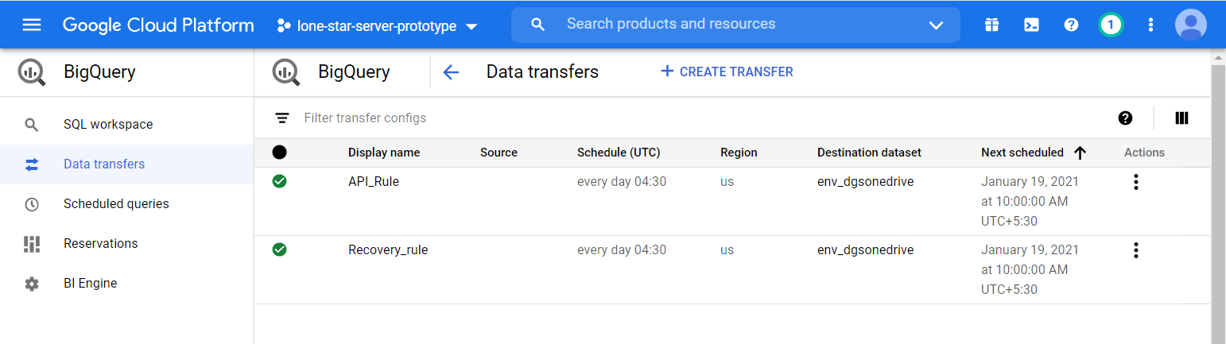

1. Now user can run queries on bigQuery tables and export the data to “Data studio”.

**legacy_api_run_results**

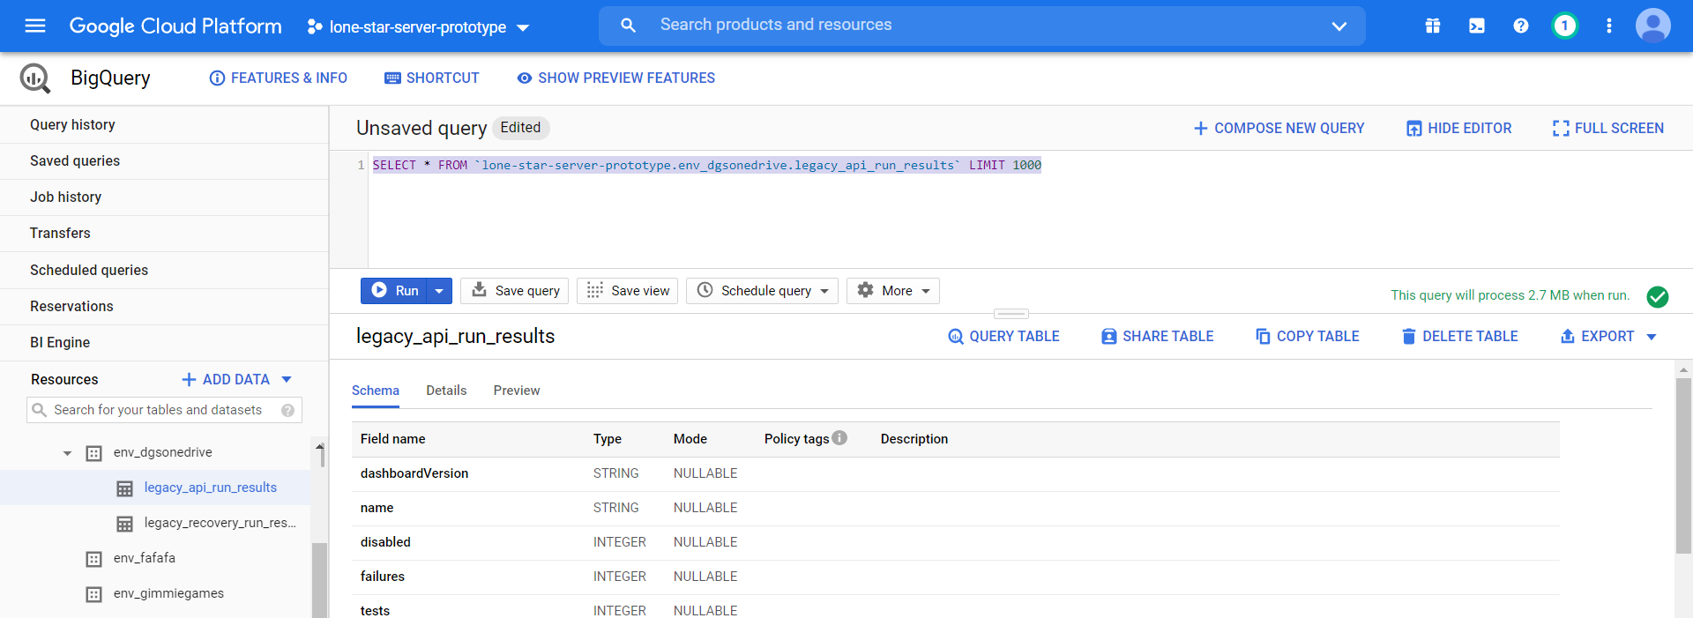

**legacy_recovery_run_results**

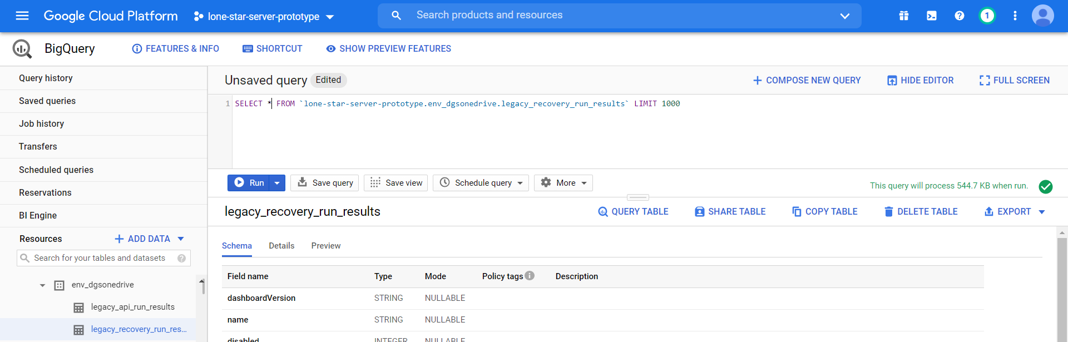

1. Now, User can explore the data in Data studio. Click on “Explore Data -> Explore with Data Studio” option after running query on big table

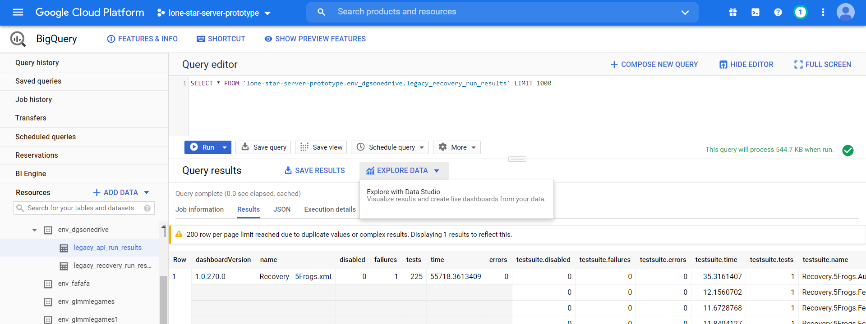

1. It will create a default template, now user can customize same as per the records they want to publish. Once done, click on “Save” option and then “Share”.

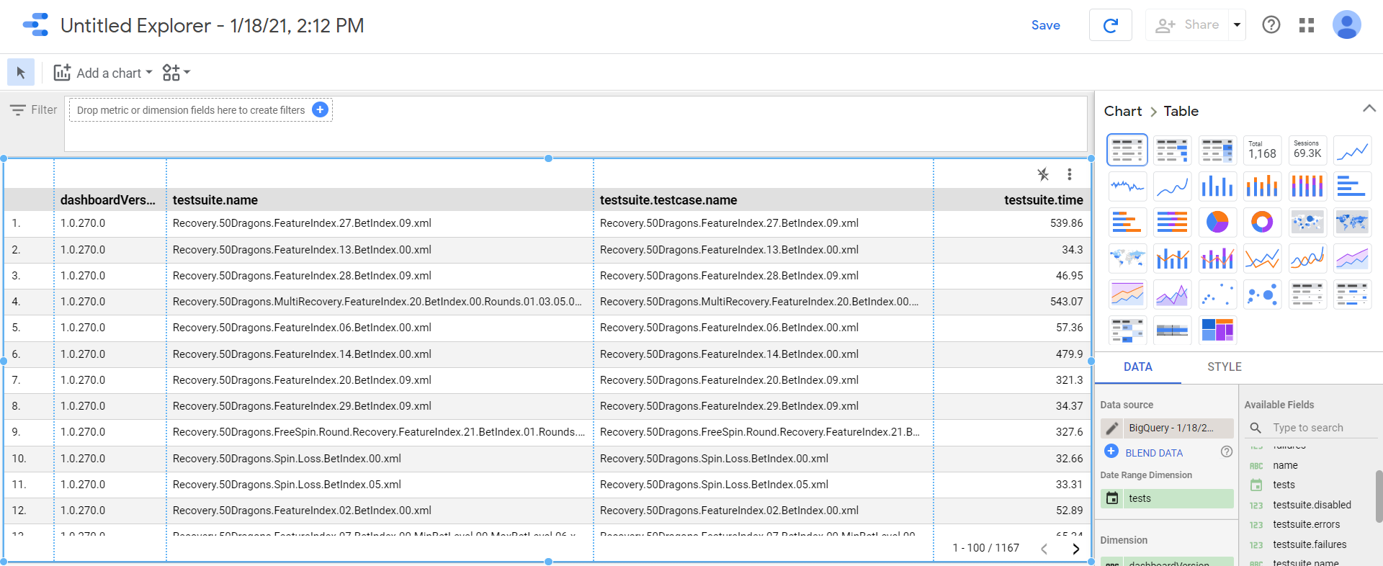

1. Now, user will be directed where templated created can now be published and is ready to be used/viewed in data studio. Under Menu -> File -> Embed report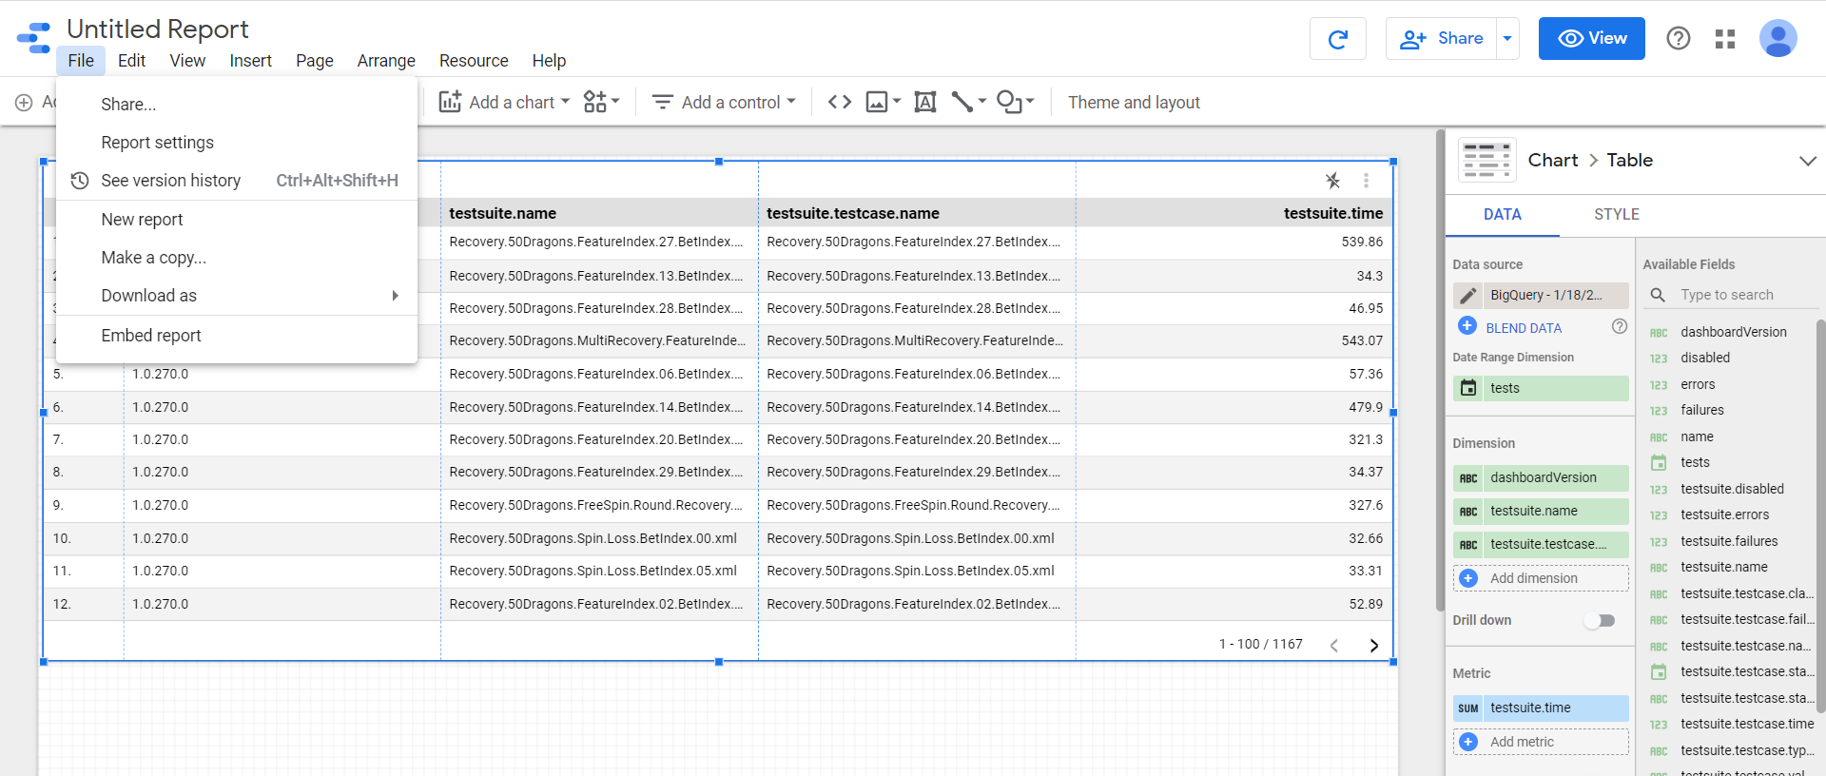

Enable embedding, click on “Done”

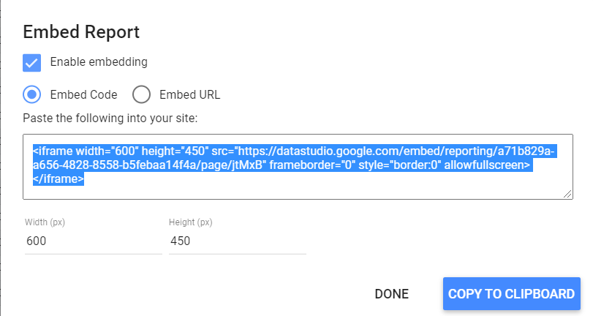

Now, click on “Share” option and under “Manage access” select “Anyone on the Internet can find and view” and click on “Save” button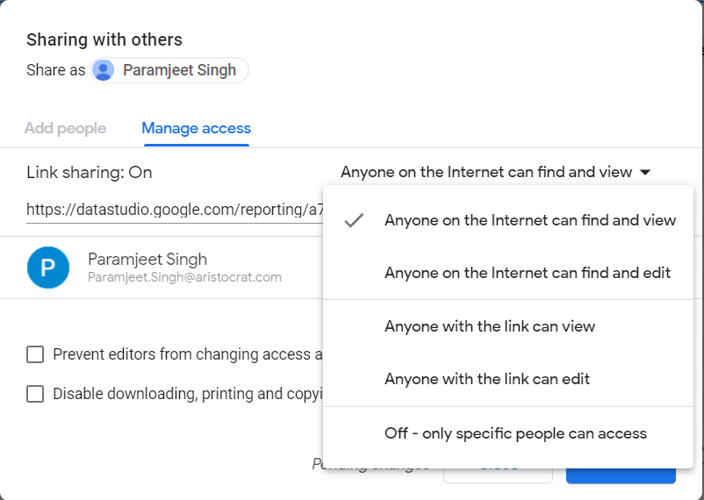

1. Before launching test harness, copy the Template/Report ID from the URL in data studio. Eg : If the data studio URL is <https://datastudio.google.com/u/0/reporting/a71b829a-a656-4828-8558-b5febaa14f4a/page/jtMxB/edit>

Then Template/Report ID is “a71b829a-a656-4828-8558-b5febaa14f4a”

1. Goto test-harness -> Data Studio

<https://portal.internal.aristocrat-platforms.com/env-dgsonedrive/test-studio-reports>

Enter data studio report ID in “DataStudio Report ID” field

Enter the name of the report and click on “Save Report template” button

Report will get created and will become available under “Report Templates”

1. Click on the created template to view the report

