|  |  |
| --- | --- |
|  | **2021** |
|  | .  Phuspinder Singh |

|  |
| --- |
| **[Exam Store]** |
| One Stop Solution for books |

# Details of Client

|  |  |
| --- | --- |
|  |  |
| Client Name | Jonas |
| Email Address | Jonas12@gmail.com |
| Phone | +64 755 5869 55 |
| Developer | Phuspinder |
| Company Name | Exam store |

# Project Requirement:

Exam store Project in which record of books can be added, updated and deleted with login

**Systems Analysis –** This platform was built with ASP.NET. The key feature is adding a record of different things that taking record

The project team assessed the project's scope and devised a timetable and resource allocation strategy based on their findings.

**Systems design** – This is a high-level description of how a computer-based system would satisfy the requirements; it is expected to be a single-user system that does not rely on data connection for the primary facility.

**Systems Specifications**

OS -Windows 10

IDE- Visual Studio

**Programming** – ASP.NET and C# was used for functionality completed as a working system in an MVC model.

Step 2***:*** Produced a project proposal contained that includes home page, add books update books and place order with predefined login system.

Project Goal – Build a platform for record keeping books and placing order for books

Project Objectives – The main objectives of the project was to enable that anyone can add record in it whose ever is admin at that time

Project Scope – A full-fledge website develop 5 page website development

1. Context – A Admin Login Facility
2. ASP.NET language platform
3. Stakeholders of the product: People who want to book a book
4. Backend or API integration

Project Deliverables –

1. Analysis documentation
2. Design documentation
3. Executable program
4. User documentation

|  |  |  |
| --- | --- | --- |
| **Milestone** | **Time taken** | **Finalized** |
| Designing | 1 Days | Yes |
| Programming | 2 Days | Yes |
| Documentation | 2 days | Yes |

Resources

|  |  |
| --- | --- |
| Processor | 1 GHz |
| RAM | 512 MB |
| Disk space (minimum) |  |
| 32-bit | 4.5 GB |
| 64-bit | 4.5 GB |

  

Admin Login

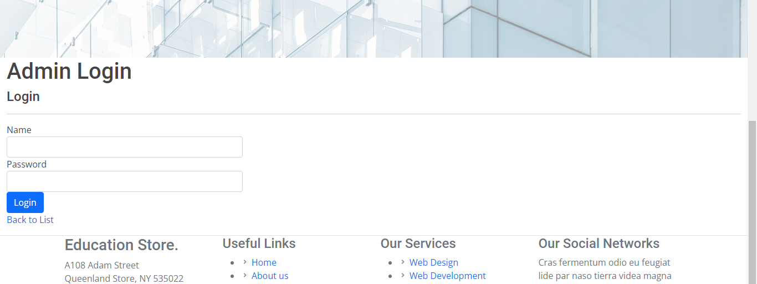

Login Details

Name : [Book@gmail.com](mailto:Book@gmail.com)

Password: Book

After Logging In



Books details can be entered that will be shown to index page

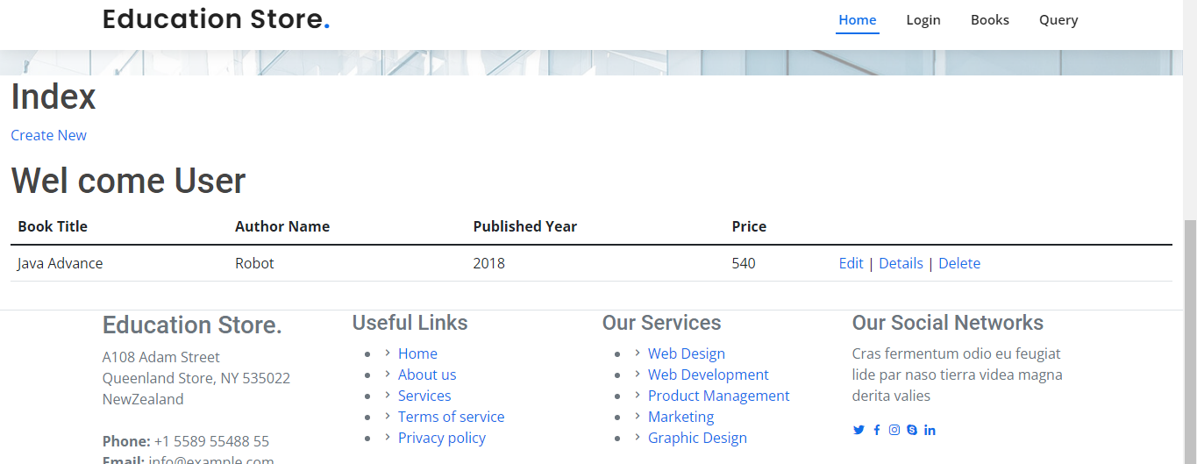

When user click on books



Stock Page

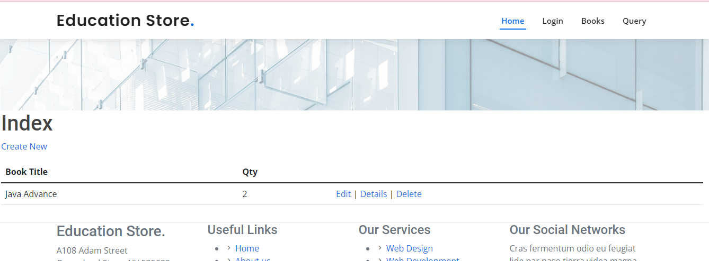

Order Page

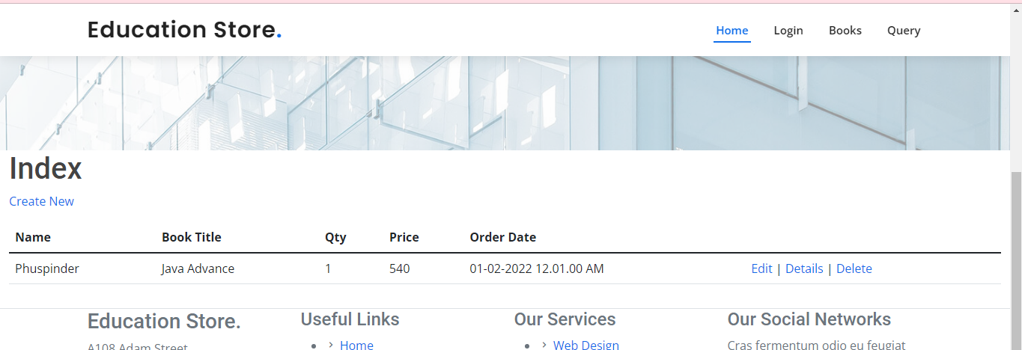

Entered Quires can be viewed

