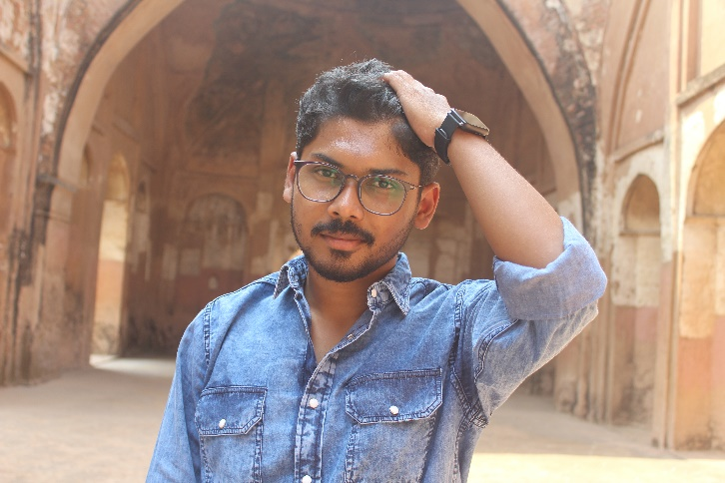

**Name - Saikat Samadder**

**DOB - 07/11/2000**

* **Education :**

Secondary Education – Baugachhi Kashibala Vidyapith(H.S), North 24 P.G.S.

Higher Secondary Education – Rajballavpur High School(H.S), North 24 P.G.S.

Bachelor's degree – Sree Chaitanya College, Habra ,WBSU, North 24 P.G.S.

Master's degree - Visva Bharati University, Santiniketan, Bolpur, Birbhum.

* **Specialization**- Condensed matter physics.
* **Dissertation** - Double perovskite solar cell .
* **Skill** - LateX ,C++, Python.

**I am interested in Experimental physics**