**Test Case Scenario**

**What I do**

1. **Import project in eclipse**
2. **Then show error multiple class (account get set)**
3. **Setup Project Lombox jar library reduce boilerplate code no need to manual create getter setter.**
4. **Start writing logic (given task) add functionality for a transfer of money between accounts**.
5. **Create moneyTransfer method api**
6. **@PostMapping(path = "/{accountFrom},{accountTo},{amount}").**
7. **Write main logic in AccountService class.**
8. **Create two method**

accountFrom.withdraw(amount);/minus amount from account

accountTo.deposit(amount);/plus amount to account

1. **Also create one custome exception for thow won exception message.**
2. **Star application show as below log application start 18080port**

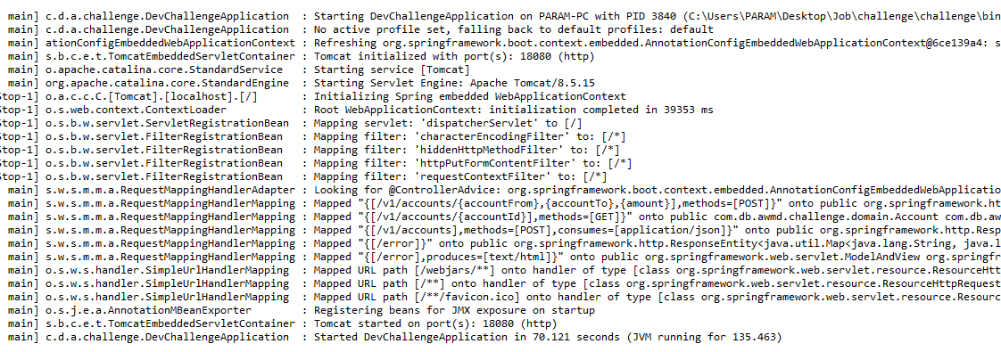

1. **Open browser and type below url for check application is working fine or not**
2. <http://localhost:18080/v1/accounts/1>
3. How ansure application is working fine presh F12 goto network tab
4. **Request URL:**

http://localhost:18080/v1/accounts/1

1. **Request Method:**

GET

1. **Status Code:**

200

1. **Remote Address:**

[::1]:18080

1. **Referrer Policy:**

no-referrer-when-downgrade

**Status code 200 show that means application is running fine also api.**