For Alexa development you will need an amazon development account, register at developer.amazon.com. The regular AWS cloud account will not work.

|  |  |
| --- | --- |
| **Creating Skill** |  |
| *Skill Name* | LuckyNumber |
| *Default Language* | us-en |
| *Choose a model to add to you skill* | Custom |
| *Choose Skill Bankend Resources* | Alexa Hosted Python or Node js |
| *Choose Template to add to your skill* | Start from scratch |
| *Invocation Name(looks like this should be lowercase)* | good ducky |

→ **save and build model**

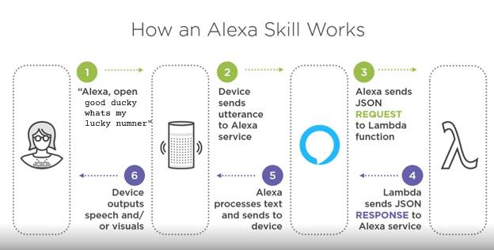

|  |  |
| --- | --- |
| **1** | “good ducky” → is the invocation name for the skill |
|  | In json response make note of the “Should End Session” property  reprompt(speakOut) |

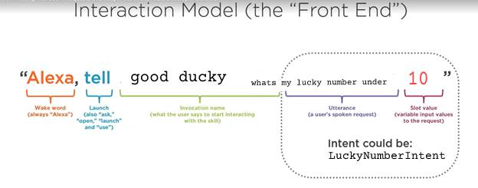

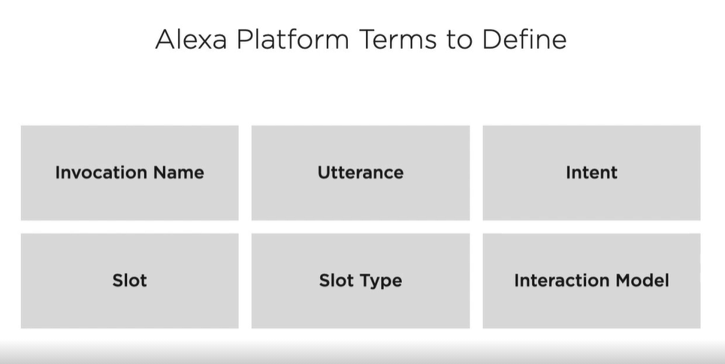

**Interaction model** – is combination of Invocation name, utterance, intent, slot and slot type

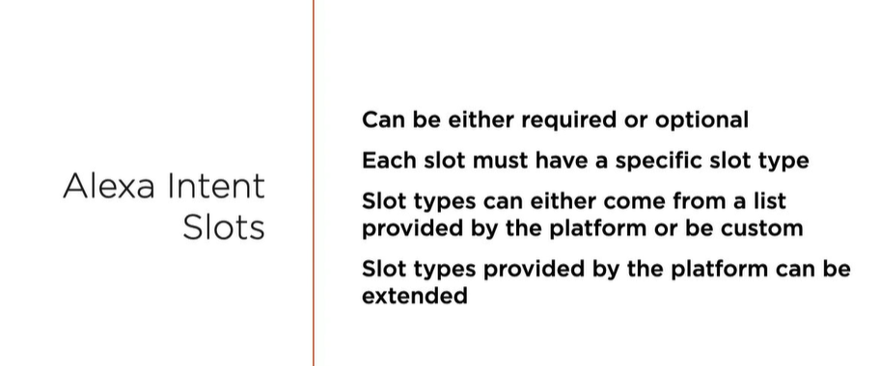

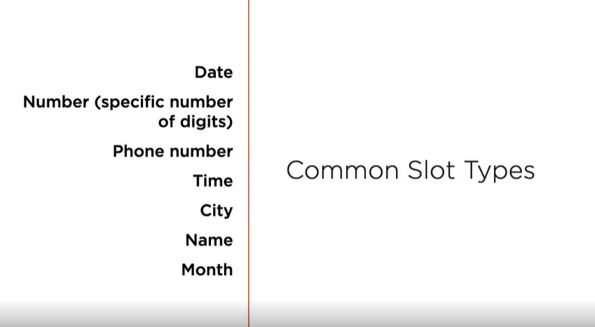

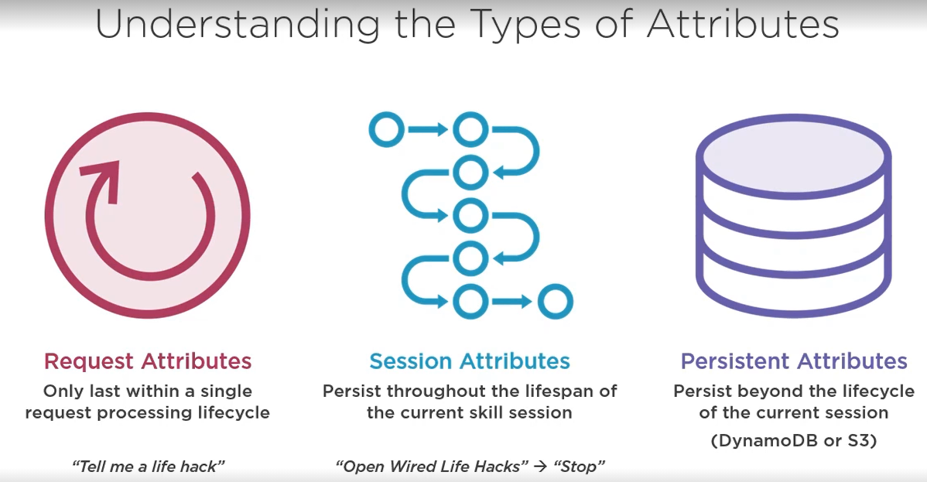

**Persist** to dynamodb or S3 - DynamodbPersistanceAdapter or S3PersistanceAdapter

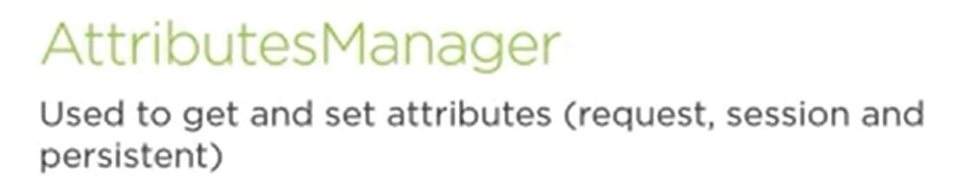

**RequestInterceptor and ResponseInterceptor**

**Alexa Skills kit**