LAB NO: 7
CLASSICAL PROBLEMS OF SYNCHRONIZATION

1. Modify the above Producer-Consumer program so that, a producer can produce at the most 10 items more than what the consumer has consumed.

Program:
#include <stdio.h>
#include <pthread.h>
#include <semaphore.h>
#include <unistd.h>

#define SIZE 5

int buffer[SIZE];
int in = 0, out = 0;
int produced = 0, consumed = 0;

sem_t mutex, empty, full;

void* producer(void* arg) {
int item = 0;
while(item < 20) {

if(produced - consumed >= 10) {
sleep(1);
continue;
}

sem_wait(&empty);
sem_wait(&mutex);

buffer[in] = item;
printf("Produced: %d\n", item);

in = (in + 1) % SIZE;
produced++;
item++;

sem_post(&mutex);
sem_post(&full);
}
return NULL;
}

void* consumer(void* arg) {
while(consumed < 15) {
sem_wait(&full);
sem_wait(&mutex);

int item = buffer[out];
printf("Consumed: %d\n", item);

out = (out + 1) % SIZE;
consumed++;

sem_post(&mutex);
sem_post(&empty);

sleep(1);
}
return NULL;
}

int main() {
pthread_t p, c;

sem_init(&mutex, 0, 1);
sem_init(&empty, 0, SIZE);
sem_init(&full, 0, 0);

pthread_create(&p, NULL, producer, NULL);
pthread_create(&c, NULL, consumer, NULL);

pthread_join(p, NULL);
pthread_join(c, NULL);

sem_destroy(&mutex);
sem_destroy(&empty);
sem_destroy(&full);

return 0;
}

Output:

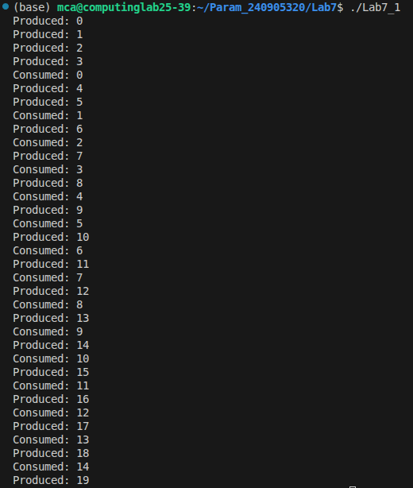

2. Write a C/C++ program for first readers-writers problem using semaphores.

Program:
#include <stdio.h>
#include <pthread.h>
#include <semaphore.h>
#include <unistd.h>

sem_t wrt;
sem_t mutex;
int readcount = 0;

void *reader(void *arg)
{
int id = *((int *)arg);

sem_wait(&mutex);
readcount++;
if (readcount == 1)
sem_wait(&wrt);
sem_post(&mutex);

printf("Reader %d is reading\n", id);
sleep(1);

sem_wait(&mutex);
readcount--;
if (readcount == 0)
sem_post(&wrt);
sem_post(&mutex);

printf("Reader %d finished reading\n", id);
return NULL;
}

void *writer(void *arg)
{
int id = *((int *)arg);

sem_wait(&wrt);
printf("Writer %d is writing\n", id);
sleep(2);
printf("Writer %d finished writing\n", id);
sem_post(&wrt);

return NULL;
}

int main()
{
pthread_t r[3], w[2];
int id[3] = {1, 2, 3};
int wid[2] = {1, 2};

sem_init(&mutex, 0, 1);
sem_init(&wrt, 0, 1);

for (int i = 0; i < 3; i++)
pthread_create(&r[i], NULL, reader, &id[i]);

for (int i = 0; i < 2; i++)
pthread_create(&w[i], NULL, writer, &wid[i]);

for (int i = 0; i < 3; i++)
pthread_join(r[i], NULL);

for (int i = 0; i < 2; i++)
pthread_join(w[i], NULL);

sem_destroy(&mutex);
sem_destroy(&wrt);

return 0;
}

Output:
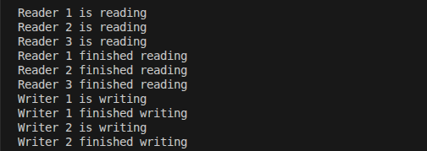
5.Write multithreaded program that generates the Fibonacci series. The program should work as
follows: The user will enter on the command line the number of Fibonacci numbers that the
program is to generate. The program then will create a separate thread that will generate the
Fibonacci numbers, placing the sequence in data that is shared by the threads (an array is probably
the most convenient data structure). When the thread finishes execution the parent will output thesequence generated by the child thread. Because the parent thread cannot begin outputting the
Fibonacci sequence until the child thread finishes, this will require having the parent thread wait for
the child thread to finish.

Program:
#include <stdio.h>
#include <pthread.h>

int fib[50], n;

void generate(void* p) {
fib[0] = 0;
fib[1] = 1;
for (int i = 2; i < n; i++)
fib[i] = fib[i - 1] + fib[i - 2];
}

int main() {
pthread_t t;
printf("Enter Size of Fibonnaci Series:\n");
scanf("%d", &n);

pthread_create(&t, NULL, generate, NULL);
pthread_join(t, NULL);
printf("Fibonacci Sequence\n");
for (int i = 0; i < n; i++) {
printf("%d ", fib[i]);
}
}

Output:
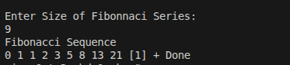
{
printf("Child Process\n");
printf("Child PID: %d\n", getpid());
printf("Child PPID: %d\n", getppid());
}
else
{
wait(&status);
printf("Parent Process\n");
printf("Parent PID: %d\n", getpid());
printf("Parent PPID: %d\n", getppid());
}
return 0;
}

Output:

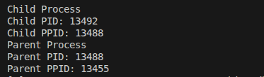

2. Write a C program to load the binary executable of the previous program in a child
process using exec system call.

Program:
#include <stdio.h>
#include <unistd.h>
#include <sys/wait.h>

int main() {
pid_t pid;
pid = fork();
int status;
if (pid == 0) {
execlp("ls", "ls", "-l", NULL);
} else {
wait(&status);
printf("Parent finished\n");
}
return 0;
}

Output:
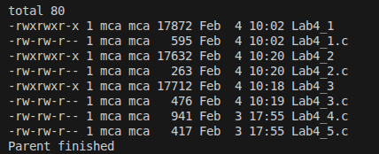

3.Create a zombie (defunct) child process (a child with exit() call, but no corresponding wait() in
the sleeping parent) and allow the init process to adopt it (after parent terminates). Run the process
as background process and run “ps” command.
Program:

#include <stdio.h>
#include <unistd.h>
#include <stdlib.h>
#include <sys/types.h>
#include <sys/wait.h>

int main()
{
pid_t pid = fork();
if (pid == 0) {
printf("Child exiting\n");
sleep(10);
}
else if (pid > 0) {
printf("Parent sleeping\n");
sleep(30);
}
else {
perror("fork failed");
}
}

Output:
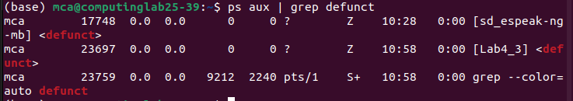
4. Write a multithreaded program that performs different sorting algorithms. The program should
work as follows: the user enters on the command line the number of elements to sort and the
elements themselves. The program then creates separate threads, each using a different sorting
algorithm. Each thread sorts the array using its corresponding algorithm and displays the time taken
to produce the result. The main thread waits for all threads to finish and then displays the final
sorted array.

Program:
#include <stdio.h>
#include <pthread.h>
int a[50], n;
void bubble(void* p) {
int i, j, t;
for (i = 0; i < n - 1; i++){
for (j = 0; j < n - i - 1; j++){
if (a[j] > a[j + 1]) {
t = a[j];
a[j] = a[j + 1];
a[j + 1] = t;
}
}
void selection(void* p) {
int i, j, m, t;
for (i = 0; i < n - 1; i++) {
m = i;
for (j = i + 1; j < n; j++)
if (a[j] < a[m])
m = j;
t = a[i];
a[i] = a[m];
a[m] = t;
}
}
int main() {
pthread_t t1, t2;
printf("Enter Array Size\n");
scanf("%d", &n);
printf("Enter Array Elements\n");
for (int i = 0; i < n; i++){
scanf("%d", &a[i]);
}
pthread_create(&t1, NULL, bubble, NULL);
pthread_create(&t2, NULL, selection, NULL);
pthread_join(t1, NULL);
pthread_join(t2, NULL);
for (int i = 0; i < n; i++)
printf("%d ", a[i]);
return 0;
}

Output:
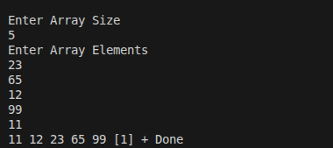

LAB NO: 4
PROCESS AND THREAD MANAGEMENT

1. Write a C program to create a child process. Display different messages in parent
process and child process. Display PID and PPID of both parent and child process.
Block parent process until child completes using wait system call.

Program:
#include <stdio.h>
#include <unistd.h>
#include <sys/wait.h>
#include <sys/types.h>
#include <stdlib.h>
int main()
{
int status;
pid_t pid;
pid = fork();
if (pid == -1)
{
printf("Error Child Not Created\n");
}
else if (pid == 0)
{
printf("Child Process\n");
printf("Child PID: %d\n", getpid());
printf("Child PPID: %d\n", getppid());
}
else
{
wait(&status);
printf("Parent Process\n");
printf("Parent PID: %d\n", getpid());
printf("Parent PPID: %d\n", getppid());
}
return 0;
}

Output:

2. Write a C program to load the binary executable of the previous program in a child
process using exec system call.

Program:
#include <stdio.h>
#include <unistd.h>
#include <sys/wait.h>

int main() {
pid_t pid;
pid = fork();
int status;
if (pid == 0) {
execlp("ls", "ls", "-l", NULL);
} else {
wait(&status);
printf("Parent finished\n");
}
return 0;
}

Output:

3.Create a zombie (defunct) child process (a child with exit() call, but no corresponding wait() in
the sleeping parent) and allow the init process to adopt it (after parent terminates). Run the process
as background process and run “ps” command.
Program:

#include <stdio.h>
#include <unistd.h>
#include <stdlib.h>
#include <sys/types.h>
#include <sys/wait.h>

int main()
{
pid_t pid = fork();
if (pid == 0) {
printf("Child exiting\n");
sleep(10);
}
else if (pid > 0) {
printf("Parent sleeping\n");
sleep(30);
}
else {
perror("fork failed");
}
}

Output:
4. Write a multithreaded program that performs different sorting algorithms. The program should
work as follows: the user enters on the command line the number of elements to sort and the
elements themselves. The program then creates separate threads, each using a different sorting
algorithm. Each thread sorts the array using its corresponding algorithm and displays the time taken
to produce the result. The main thread waits for all threads to finish and then displays the final
sorted array.

Program:
#include <stdio.h>
#include <pthread.h>
int a[50], n;
void bubble(void* p) {
int i, j, t;
for (i = 0; i < n - 1; i++){
for (j = 0; j < n - i - 1; j++){
if (a[j] > a[j + 1]) {
t = a[j];
a[j] = a[j + 1];
a[j + 1] = t;
}
}
void selection(void* p) {
int i, j, m, t;
for (i = 0; i < n - 1; i++) {
m = i;
for (j = i + 1; j < n; j++)
if (a[j] < a[m])
m = j;
t = a[i];
a[i] = a[m];
a[m] = t;
}
}
int main() {
pthread_t t1, t2;
printf("Enter Array Size\n");
scanf("%d", &n);
printf("Enter Array Elements\n");
for (int i = 0; i < n; i++){
scanf("%d", &a[i]);
}
pthread_create(&t1, NULL, bubble, NULL);
pthread_create(&t2, NULL, selection, NULL);
pthread_join(t1, NULL);
pthread_join(t2, NULL);
for (int i = 0; i < n; i++)
printf("%d ", a[i]);
return 0;
}

Output:

5.Write multithreaded program that generates the Fibonacci series. The program should work as
follows: The user will enter on the command line the number of Fibonacci numbers that the
program is to generate. The program then will create a separate thread that will generate the
Fibonacci numbers, placing the sequence in data that is shared by the threads (an array is probably
the most convenient data structure). When the thread finishes execution the parent will output thesequence generated by the child thread. Because the parent thread cannot begin outputting the
Fibonacci sequence until the child thread finishes, this will require having the parent thread wait for
the child thread to finish.

Program:
#include <stdio.h>
#include <pthread.h>

int fib[50], n;

void generate(void* p) {
fib[0] = 0;
fib[1] = 1;
for (int i = 2; i < n; i++)
fib[i] = fib[i - 1] + fib[i - 2];
}

int main() {
pthread_t t;
printf("Enter Size of Fibonnaci Series:\n");
scanf("%d", &n);

pthread_create(&t, NULL, generate, NULL);
pthread_join(t, NULL);
printf("Fibonacci Sequence\n");
for (int i = 0; i < n; i++) {
printf("%d ", fib[i]);
}
}

Output:

5.Write multithreaded program that generates the Fibonacci series. The program should work as
follows: The user will enter on the command line the number of Fibonacci numbers that the
program is to generate. The program then will create a separate thread that will generate the
Fibonacci numbers, placing the sequence in data that is shared by the threads (an array is probably
the most convenient data structure). When the thread finishes execution the parent will output thesequence generated by the child thread. Because the parent thread cannot begin outputting the
Fibonacci sequence until the child thread finishes, this will require having the parent thread wait for
the child thread to finish.

Program:
#include <stdio.h>
#include <pthread.h>

int fib[50], n;

void generate(void* p) {
fib[0] = 0;
fib[1] = 1;
for (int i = 2; i < n; i++)
fib[i] = fib[i - 1] + fib[i - 2];
}

int main() {
pthread_t t;
printf("Enter Size of Fibonnaci Series:\n");
scanf("%d", &n);

pthread_create(&t, NULL, generate, NULL);
pthread_join(t, NULL);
printf("Fibonacci Sequence\n");
for (int i = 0; i < n; i++) {
printf("%d ", fib[i]);
}
}

Output:

