LAB NO: 8
DEADLOCK MANAGEMENT ALGORITHMS

1. Consider the following snapshot of the system. Write C/C++ program to implement Banker’s
algorithm for deadlock avoidance. The program has to accept all inputs from the user. Assume
the total number of instances of A,B and C are 10,5 and 7 respectively.
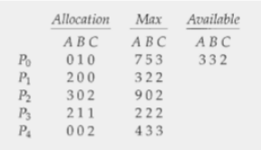

Program:

#include <stdio.h>
#include <stdbool.h>

int main() {
int n;
int total[3] = {10, 5, 7};

printf("Enter number of processes: ");
scanf("%d", &n);

int alloc[n][3], max[n][3], need[n][3];
int available[3];

printf("\nEnter Allocation Matrix:\n");
for(int i = 0; i < n; i++) {
printf("For Process P%d:\n", i);
for(int j = 0; j < 3; j++)
scanf("%d", &alloc[i][j]);
}

printf("\nEnter Max Matrix:\n");
for(int i = 0; i < n; i++) {
printf("For Process P%d:\n", i);
for(int j = 0; j < 3; j++)
scanf("%d", &max[i][j]);
}

for(int i = 0; i < n; i++)
for(int j = 0; j < 3; j++)
need[i][j] = max[i][j] - alloc[i][j];

for(int j = 0; j < 3; j++) {
int sum = 0;
for(int i = 0; i < n; i++)
sum += alloc[i][j];
available[j] = total[j] - sum;
}

printf("\nNeed Matrix:\n");
for(int i = 0; i < n; i++) {
printf("P%d: ", i);
for(int j = 0; j < 3; j++)
printf("%d ", need[i][j]);
printf("\n");
}

printf("\nAvailable Resources: ");
for(int j = 0; j < 3; j++)
printf("%d ", available[j]);
printf("\n");

bool finish[n];
int safeSeq[n];
int work[3];

for(int i = 0; i < n; i++)
finish[i] = false;

for(int j = 0; j < 3; j++)
work[j] = available[j];

int count = 0;

while(count < n) {
bool found = false;

for(int i = 0; i < n; i++) {
if(!finish[i]) {
bool safe = true;

for(int j = 0; j < 3; j++) {
if(need[i][j] > work[j]) {
safe = false;
break;
}
}

if(safe) {
for(int j = 0; j < 3; j++)
work[j] += alloc[i][j];

safeSeq[count++] = i;
finish[i] = true;
found = true;
}
}
}

if(!found) {
printf("\nSystem is NOT SAFE\n");
return 0;
}
}

printf("\nSystem is SAFE.\nSafe Sequence: ");
for(int i = 0; i < n; i++)
printf("P%d ", safeSeq[i]);

printf("\n");

return 0;
}

Output:
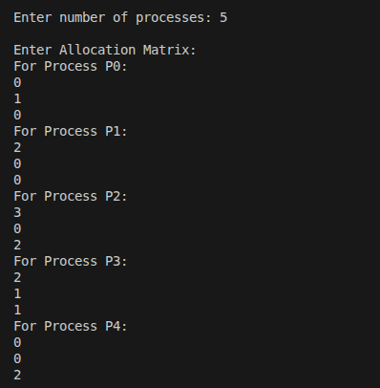

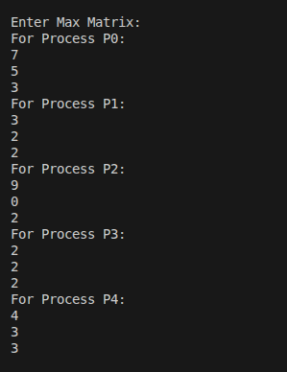

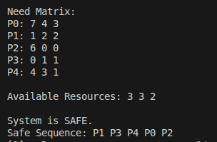

2. Consider the following snapshot of the system. Write C/C++ program to implement deadlock
detection algorithm.

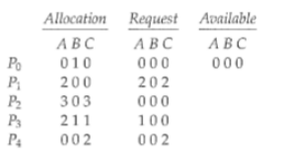

Program:

#include <stdio.h>
#include <stdbool.h>

int main() {
int n, m;

printf("Enter number of processes: ");
scanf("%d", &n);

printf("Enter number of resource types: ");
scanf("%d", &m);

int allocation[n][m];
int request[n][m];
int available[m];

printf("\nEnter Allocation Matrix:\n");
for(int i = 0; i < n; i++) {
printf("For Process P%d:\n", i);
for(int j = 0; j < m; j++)
scanf("%d", &allocation[i][j]);
}

printf("\nEnter Request Matrix:\n");
for(int i = 0; i < n; i++) {
printf("For Process P%d:\n", i);
for(int j = 0; j < m; j++)
scanf("%d", &request[i][j]);
}

printf("\nEnter Available Resources:\n");
for(int j = 0; j < m; j++)
scanf("%d", &available[j]);

bool finish[n];
int work[m];

for(int i = 0; i < n; i++) {
bool zeroAlloc = true;
for(int j = 0; j < m; j++) {
if(allocation[i][j] != 0) {
zeroAlloc = false;
break;
}
}
finish[i] = zeroAlloc;
}

for(int j = 0; j < m; j++)
work[j] = available[j];

bool found;
do {
found = false;

for(int i = 0; i < n; i++) {
if(!finish[i]) {
bool possible = true;

for(int j = 0; j < m; j++) {
if(request[i][j] > work[j]) {
possible = false;
break;
}
}

if(possible) {
for(int j = 0; j < m; j++)
work[j] += allocation[i][j];

finish[i] = true;
found = true;
}
}
}

} while(found);

bool deadlock = false;

for(int i = 0; i < n; i++) {
if(!finish[i]) {
printf("Process P%d is deadlocked\n", i);
deadlock = true;
}
}

if(!deadlock)
printf("System is NOT deadlocked\n");
else
printf("System is in DEADLOCK state\n");

return 0;
}

Output:

