Lab3 : UNIX SHELL PROGRAMMING (SHELL SCRIPTING)

Q1) Write a shell script to find whether a given file is the directory or regular file.

Shell Script:
#!/bin/sh
echo "Enter the file or directory name:"
read name
if [ -d "$name" ]; then
echo "$name is a directory"
elif [ -f "$name" ]; then
echo "$name is a regular file"
else
echo "$name does not exist"
fi
Output:
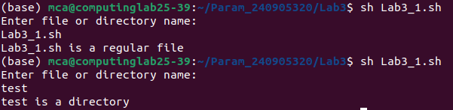
Q2) Write a shell script to list all files (only file names) containing the input pattern (string) in the folder entered by the user.
Shell Script
#!/bin/sh
echo "Enter the folder name:"
read folder
echo "Enter the pattern:"
read pattern
grep -l "$pattern" "$folder"/* | xargs -n 1 basename
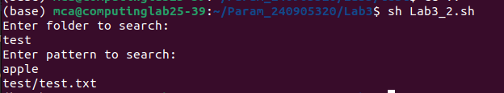
Output

Q3) Write a shell script to replace all files with .txt extension with .text in the current directory recursively.
Shell Script
#!/bin/sh
find . -type f -name "*.txt" | while read file
do
mv "$file" "${file%.txt}.text"
done
Output:
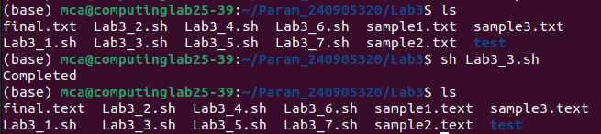

Q4) Write a shell script to calculate the gross salary.
GS = Basics + TA + 10% of Basics.
Shell Script
#!/bin/sh
echo "Enter Basic Salary:"
read basic
echo "Enter TA:"
read ta
gs=$(echo "$basic + $ta + ($basic * 0.10)" | bc)
echo "Gross Salary = $gs"
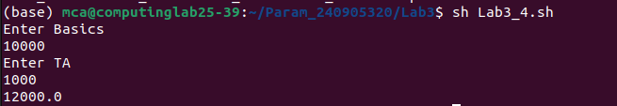
Output

Q5) Write a program to copy all the files (having file extension input by the user) in the current folder to the new folder input by the user (single level only).
Shell Script
#!/bin/sh
echo "Enter file extension:"
read ext
echo "Enter destination folder:"
read folder
mkdir -p "$folder"
cp *"$ext" "$folder"
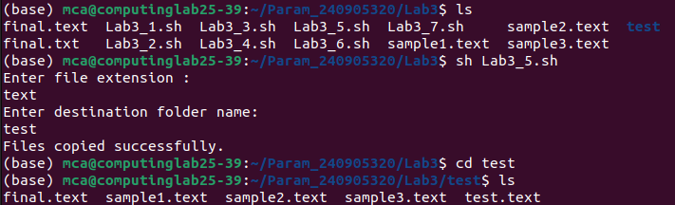
Output

Q6) Write a shell script to modify all occurrences of “ex:” with “Example:” only if it occurs at the start of the line or after a period (.).
Shell Script
#!/bin/sh
for file in *
do
if [ -f "$file" ]; then
sed -i 's/^ex:/Example:/; s/. *ex:/. Example:/g' "$file"
fi
done
Output
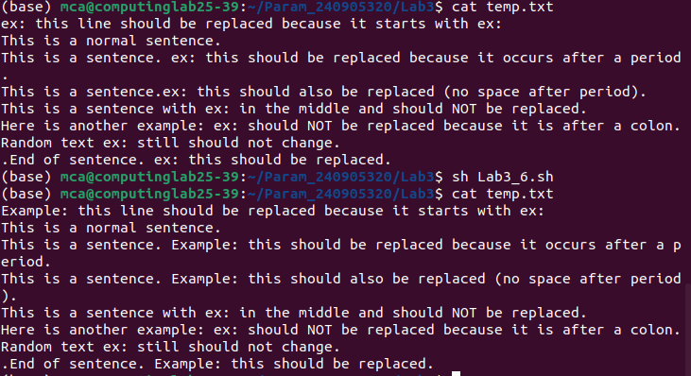

Q7) Write a shell script which deletes all the even numbered lines in a text file.
Shell Script
#!/bin/sh
echo "Enter file name:"
read file
sed -i '2~2d' "$file"
Output
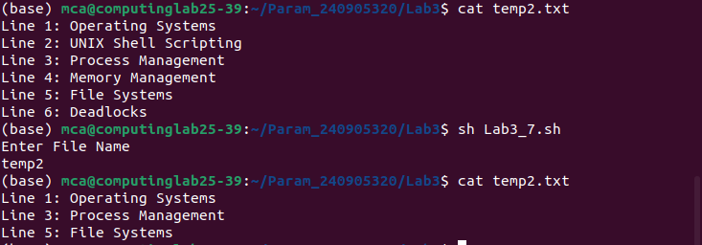

Q2)Write a shell script to list all files (only file names) containing the input pattern
(string) in the folder entered by the user.
Q3)Write a shell script to replace all files with .txt extension with .text in the current di-
rectory. This has to be done recursively i.e if the current folder contains a folder
“OS” with abc.txt then it has to be changed to abc.text
Q4)Write a shell script to calculate the gross salary. GS=Basics + TA + 10% of Basics.
Floating point calculations has to be performed.
Q5)Write a program to copy all the files (having file extension input by the user) in the
current folder to the new folder input by the user. ex: user enter .text TEXT then all
files with .text should be moved to TEXT folder. This should be done only at single
level. i.e if the current folder contains a folder name ABC which has .txt files then
these files should not be copied to TEXT.
Q6)Write a shell script to modify all occurrences of “ex:” with “Example:” in all the filespresent
in current folder only if “ex:” occurs at the start of the line or after a period (.). Example:
if a file contains a line: “ex: this is first occurrence so should be re- placed” and “second
ex: should not be replaced as it occurs in the middle of the sen-tence.”
Q7)Write a shell script which deletes all the even numbered lines in a text file.

