Online Gardening Platform
A Project Report
Submitted in partial fulfilment of the
Requirements for the award of the Degree of
BACHELOR OF SCIENCE (INFORMATION TECHNOLOGY)
BY
Sahil Adak
Seat Number: 01
Adarsh Gupta
Seat Number: 18
Under the esteemed guidance of
Mrs. Vaishali Desai

DEPARTMENT OF INFORMATION TECHNOLOGY
(Affiliated to University of Mumbai)
MUMBAI – MAHARASHTRA – 400104
MAHARASHTRA
2024 - 2025

PROFORMA FOR THE APPROVAL PROJECT PROPOSAL
PNR No.: Roll no: ___________
1. Name of the Student __________________________________________________________________
2. Title of the Project __________________________________________________________________
3. Name of the Guide
__________________________________________________________________
4. Teaching experience of the Guide

5. Is this your first submission? Yes No

Signature of the Student Signature of the Guide
Date: ………………… Date: …………………….

Signature of the Coordinator
Date: …………………

ABSTRACT
The "Online Gardening Platform" project aims to create a comprehensive e-commerce website for gardening enthusiasts, offering a wide range of products, personalized garden planning services, and an online community for knowledge sharing and support. The platform addresses challenges faced by individual gardeners, such as time-consuming searches and lack of resources, while providing a user-friendly experience with secure transactions and expert content. Built using ASP.NET with C# and SQL Server, the system ensures scalability, security, and strong performance. It features user login, product browsing, order management, and personalized recommendations, with a focus on fostering an active gardening community and enhancing customer satisfaction.

ACKNOWLEDGEMENT
I would like to express my deepest gratitude to all those who contributed to the successful completion of this online gardening project. First and foremost, I would like to thank my mentors and instructors for their invaluable guidance, feedback, and encouragement throughout the project. Their expertise and insights greatly enhanced the quality of this work.
I am also grateful to my colleagues and peers, whose constant support and collaboration have been a source of motivation. Their constructive discussions and teamwork were instrumental in overcoming challenges.
Additionally, I would like to extend my appreciation to the online communities and resources that provided me with technical knowledge and tools essential to the project. Finally, I am thankful to my family and friends for their patience, understanding, and encouragement during this endeavour.

DECLARATION
I hereby declare that the project entitled, “Online Gardening Platform” done at Lords Universal College (Goregaon), has not been in any case duplicated to submit to any other university for the award of any degree. To the best of my knowledge other than me, no one has submitted to any other university. The project is done in partial fulfilment of the requirements for the award of degree of BACHELOR OF SCIENCE (INFORMATION TECHNOLOGY) to be submitted as final semester project as part of our curriculum.

Name and Signature of the Student

Project Bifurcation

Module | Adarsh Gupta (50%) | Sahil Adak (50%)
Project Planning & Documentation | Requirement gathering, defining objectives | Writing system requirements, finalizing scope
Frontend Development | Designing UI/UX, HTML, CSS implementation | JavaScript integration, Bootstrap styling
Backend Development | ASP.NET C# coding for user authentication and session management | ASP.NET C# coding for order processing and payment gateway integration
Database Design & Implementation | Creating database schema, user and product tables (MySQL/SQL Server) | Implementing order, cart, and transaction tables (MySQL/SQL Server)
E-commerce Functionality | Product listing, search, and filtering logic | Add to cart, checkout, and order management features
Admin Panel Development | Admin login, dashboard layout, and user management | Inventory control, order tracking, and revenue analytics
Security & Authentication | Implementing encryption, password hashing, and session validation | Implementing role-based access control and security testing
Testing & Debugging | Writing and executing test cases, unit testing | Performance testing, bug fixes, and validation checks
Mobile Responsiveness | Ensuring proper layout on different screen sizes | Fixing mobile UI bugs, optimizing load times

Table of Contents

Chapter 1: Introduction 8
1.1 Background 8
1.2 Objectives 8
1.3 Achievements 9
1.4 Organization of Report 9
Chapter 2: Survey of Technologies 11
Chapter 3: Requirement and Analysis 14
3.1 Problem Definition 14
3.2 Requirements Specification 14
3.3 Planning and Scheduling 15
3.4 Software and Hardware Requirements 16
3.5 Preliminary Product Description 17
3.6 Conceptual Models 18
Chapter 4: System Design 26
4.1 Basic Module 26
4.2 Data Base Design 26
4.3 User Interface design 31
4.4 Test Case Design 33
Chapter 5: Implementation and Testing 35
Chapter 7: Conclusion 60

Chapter 1: Introduction

Background

Creating this website indicates a significant opportunity for improvement, especially in providing personalized guidance, enhancing community engagement, offering expert Support and integrating advanced planning tools
Current System Overview:
- Manual Process: Searching, making contacts, bargaining, lack of knowledge.
- Challenges: The existing system aims to provide services on organisational basis, leaving individual gardening enthusiast alone

Objectives

The purpose of this project is to create a one-stop online destination for gardening enthusiasts. By offering a comprehensive range of products, services, and interactive features, the platform aims to make gardening more accessible, enjoyable, and educational for users of all skill levels.
The scope of this project includes the development and launch of an online gardening platform with the following components:
  - E-commerce website with a diverse range of gardening products.
  - Garden planning and design services for personalized garden setups.
  - Online community for user-generated content and interaction.
  - Loyalty program with rewards and customizable alerts.
  - Educational video tutorials covering various gardening techniques and activities.
The platform will be applicable to:
- Novice gardeners seeking guidance and products to start their gardening journey.
- Experienced gardeners looking for advanced products, services, and a community to share their knowledge.
- Urban dwellers interested in urban gardening and sustainable living.
- Educational institutions offering gardening programs and looking for resources.
- Gardening businesses seeking an online platform to reach a wider audience.

Achievements

Upon successful completion of the project, the following achievements are anticipated:
- The Main Achievement of this Project is to provide a personal basis service to the individual home gardeners at their place which others entities have been lacking currently majoring their focus on organization level isolating individual homeowners with minimum garden space.
- Online reach and service availability.
- An active online community fostering knowledge sharing and support among gardeners.
- A successful loyalty program that increases customer retention and satisfaction.

Organization of Report
The report is organized into the following chapters:
- Survey of Technology: This chapter demonstrates the student's research skills, critical thinking, and ability to justify their choices based on a thorough understanding of the available technological options.

  - System Analysis: In this chapter, we identify the key stakeholders and gather their requirements. It details both functional requirements. This analysis ensures that the system meets the needs of all users.

  - System Design: This chapter outlines the architectural design of the system. It includes diagrams and descriptions of the system architecture, database schema, user interface designs, and workflow processes.

  - Implementation and Testing: This chapter covers the detailed implementation of the system. It explains the testing strategies and methodologies employed to ensure the system's reliability and performance.

Chapter 2: Survey of Technologies

This chapter aims to demonstrate an awareness and understanding of the available technologies necessary to complete an e-commerce website project for gardening enthusiasts. The discussion will cover the various technologies related to website development, payment processing, security, user experience, and content management. A comparative analysis of these technologies will be presented, followed by an explanation of the chosen technology stack for the project.
IDE - Microsoft Visual Studio
Frontend Framework - ASP with C#
Frontend Languages – HTML, CSS, JavaScript
Backend - SQL Server (2008 or higher)
Database - SQL Server

Reasons to Use the Selected Technologies
- Microsoft Visual Studio:
  - Robust Development Environment: Microsoft Visual Studio provides powerful debugging and editing tools, making it a comprehensive IDE for ASP.NET development.
  - Seamless Integration: It integrates perfectly with other Microsoft technologies like SQL Server and ASP.NET, simplifying the development workflow.
  - Extensive Features: Built-in tools for code refactoring, testing, and performance analysis help in building enterprise-grade applications.
- ASP with C#:
  - Mature Framework: ASP.NET is a well-established framework for building scalable, secure, and high-performance web applications.
  - Server-Side Rendering: Provides strong support for server-side rendering, improving performance and SEO.
  - Object-Oriented Language: C# provides type safety and is a robust, versatile language ideal for backend logic.
- HTML, CSS, JavaScript:
  - Universally Accepted: These technologies form the core of web development and are supported by all modern browsers.
  - Rich Interactivity: JavaScript enhances user interactivity on the front end, while HTML and CSS form the structure and design.
  - Flexibility: Easy to combine with ASP.NET for seamless frontend-backend integration.
- SQL Server (2008 or higher):
  - Enterprise-Level Database: SQL Server offers robust security, high performance, and scalability, making it a perfect choice for large-scale applications.
  - Tight Integration with ASP.NET: SQL Server works seamlessly with ASP.NET and Visual Studio, reducing the need for extensive configuration.
  - Advanced Features: Features like stored procedures, triggers, and advanced data management enhance the efficiency of database operations.

Comparison of the Selected Technologies with Alternatives:
Component | Your Choice | Alternative 1 | Alternative 2 | Alternative 3
IDE | Microsoft Visual Studio | IntelliJ IDEA | Atom | Sublime Text
Frontend | ASP.NET with C# | React.js | Angular | Vue.js
Backend | SQL Server (2008 or higher) | MySQL | PostgreSQL | MongoDB
Database | SQL Server | SQLite | PostgreSQL | MongoDB

Comparison with Alternatives:
- Frontend (ASP.NET with C# vs. React.js vs. Angular vs. Vue.js):
  - ASP.NET provides full server-side rendering, which is better for SEO and security. React.js is more flexible with client-side rendering, while Angular offers a comprehensive front-end framework. Vue.js is lightweight and more beginner-friendly but has a smaller ecosystem compared to ASP.NET.
- Backend (SQL Server vs. MySQL vs. PostgreSQL vs. MongoDB):
  - SQL Server is ideal for enterprise applications with its strong security features and performance, while MySQL is widely used in various industries. PostgreSQL is highly scalable and offers advanced features. MongoDB is great for handling unstructured data but may require different data modeling techniques.

Why Choose the Above Stack?
- Enterprise-Level Security & Performance: ASP.NET with C# and SQL Server provide robust security measures, ideal for large-scale applications with sensitive data.
- Strong Integration: The entire Microsoft technology stack integrates seamlessly, simplifying development, debugging, and deployment processes.
- Scalability: This stack is highly scalable, making it suitable for applications that require growth over time, especially for e-commerce platforms.
- Community & Ecosystem: Microsoft has a large support base and community, ensuring access to resources, libraries, and third-party integrations.

Chapter 3: Requirement and Analysis

3.1 Problem Definition

The manual process of searching, making contacts, and bargaining in the current system is inefficient and often results in a lack of knowledge for the users. This process requires significant time and effort, and without a structured approach, individuals may struggle to make informed decisions. Additionally, the existing system is primarily designed to cater to organizations, which leaves individual gardening enthusiasts without the necessary support and resources to pursue their interests effectively. This gap creates challenges for individuals who wish to engage in gardening activities but lack the means or knowledge to do so efficiently.
- Time-consuming search: Individuals spend a lot of time searching for gardening resources.
- Complex bargaining process: Negotiating prices is difficult without proper guidance or knowledge.
- Inadequate support: The current system mainly supports organizations, leaving individual gardening enthusiasts without enough resources.

3.2 Requirements Specification

3.2.1 Functional Requirements
A complete understanding of software requirement we must have to know since it is very essential to the success of web-development project and effort.
- User login and Registration.
- Customer can view products without login
- Customer can add or remove products to cart without login.
- If customer tries to purchase the product must login to the system.
- Integrating payment methods to it for better and secure Transaction.
- The order will be placed if customer process the payment successfully
- OTP notification through mail for email verification
- Automatically bill generation through mail
- Automatically email notification for order cancellation
3.2.2 Non-Functional Requirements
- Usability: The website must have user-friendly interface and simple too for better look.
- Performance: Must be fast and responsive and loads quickly
- Security: The system needs to provide security against any kind of threats and ensures the system to secure it from any unauthorised person.
- Should be scalable to handle any increasing number of users and Transactions.
User Requirements:
Simple and easy-to-use interface for customers
Reliable and secure platform for conducting transactions
System Requirements:
The system must support high availability and handle multiple users concurrently without performance degradation.

3.3 Planning and Scheduling

The project will unfold over a six-month timeline, divided into specific phases shown through the following Gantt chart:
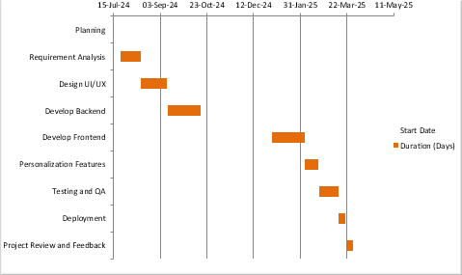

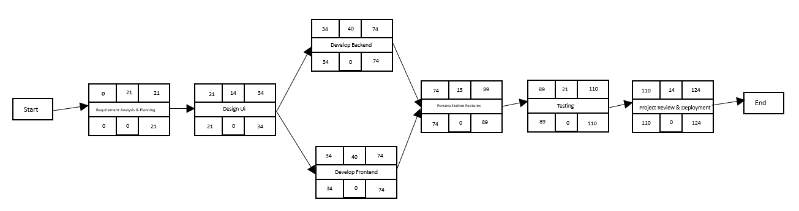
Pert Chart

Allocation of resources:
Dedicated front-end and back-end development, testing and project management teams
Allocation of server resources for management and data documentation
Risk Management:
Identify risks such as development delays, security vulnerabilities and scalability issues
Mitigation strategies include thorough testing, regularly updated testing and contingency plan
Milestones will be established at the end of each phase to evaluate progress and make necessary adjustments.

3.4 Software and Hardware Requirements

3.4.1 Software Requirements
- Web Development Frameworks: Front End in Asp.net with C# , Backend in SQL Server
- Database: SQL Server (2008 or higher).
- Development Tools: Visual Studio, GitHub.
3.4.2 Hardware Requirements
- Hosting Services: hosting solution to ensure scalability and reliability.
- Development Machines: Standard laptops or desktops capable of running development environments.

3.5 Preliminary Product Description

The proposed online gardening platform will serve as a comprehensive resource for gardening enthusiasts, featuring:
Product Listings: An extensive collection of gardening supplies categorized for easy navigation.
Expert Content: Informative articles and video tutorials on gardening practices.
Community Engagement: A forum and social media integration to foster user interaction.
Personalized Services: Custom garden planning and design services tailored to individual user needs.

3.6 Conceptual Models

3.6.1 DFD diagram
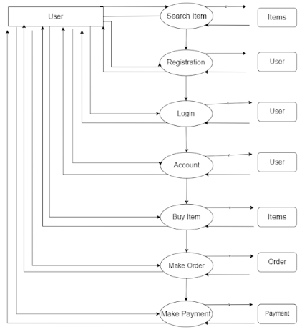

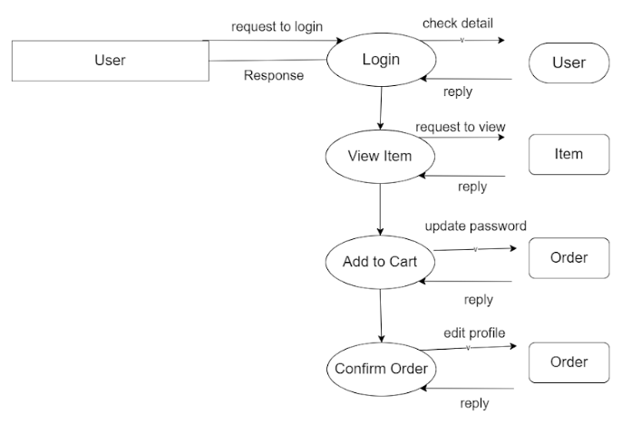

3.6.2 ER diagram

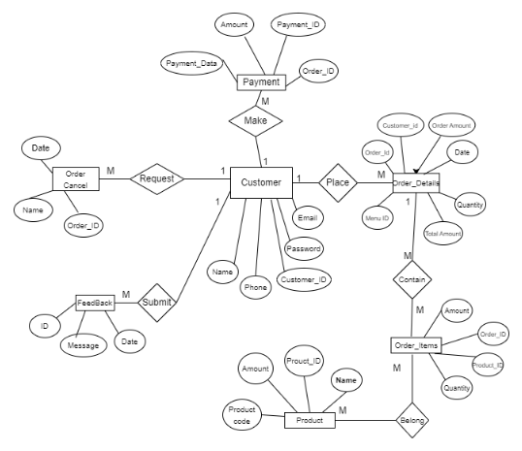

3.6.3 Use Case diagram
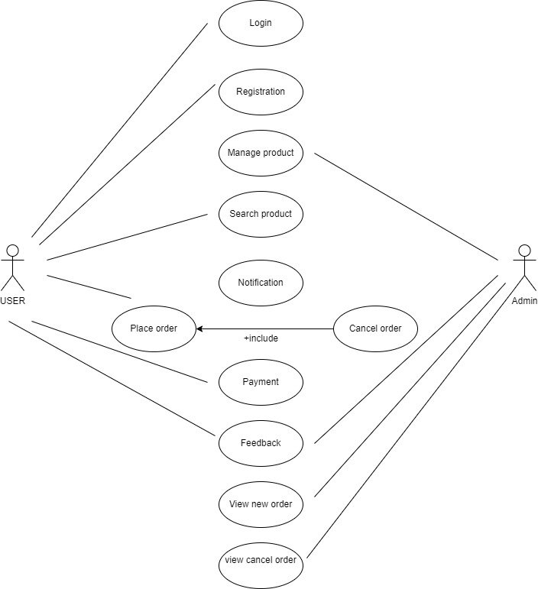

3.6.4 Class diagram
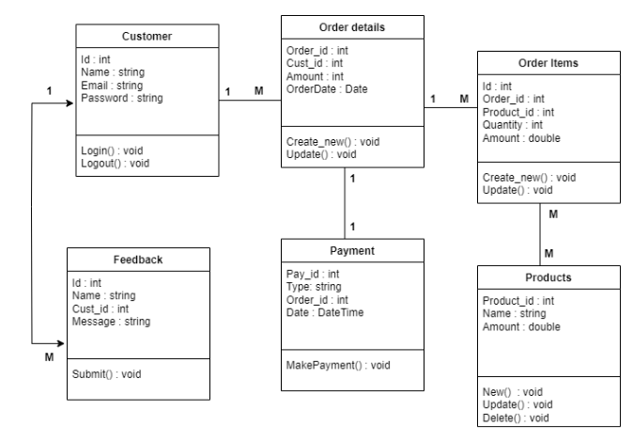

3.6.5 Sequence Diagram

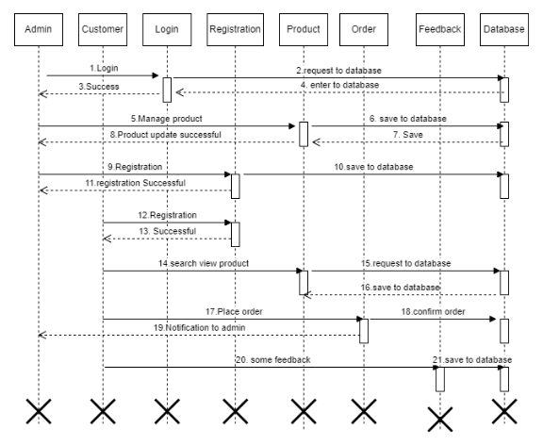

3.6.6 Activity diagram
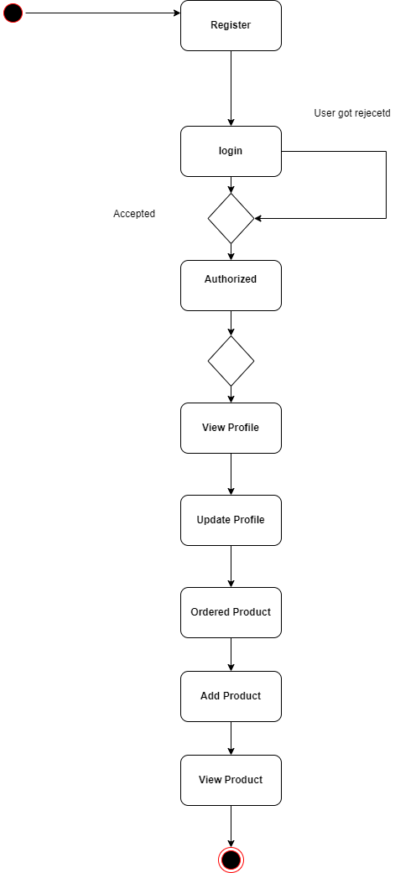

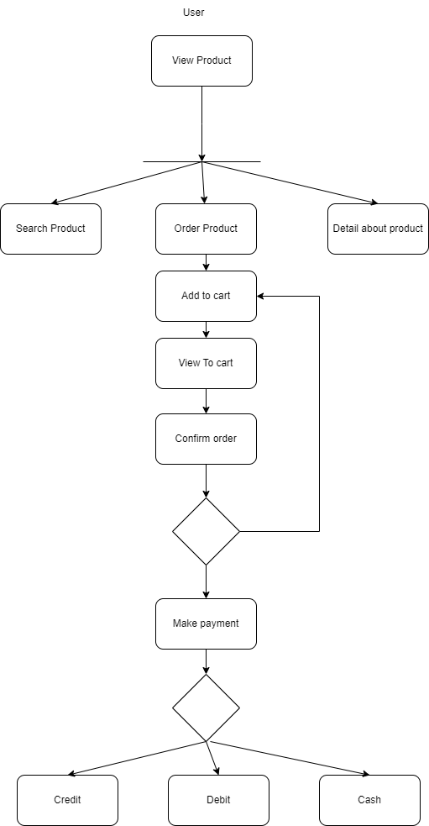

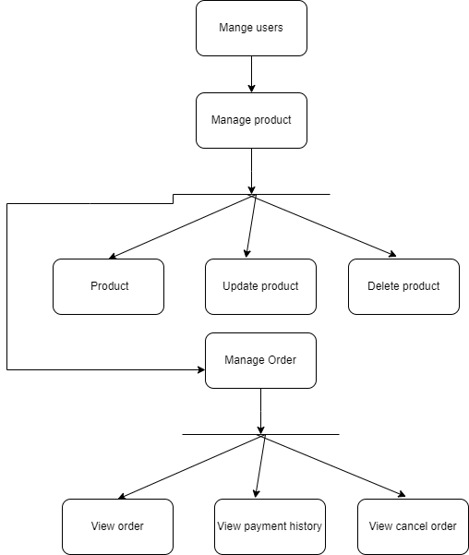

Chapter 4: System Design

4.1 Basic Module

- User Module :-
Administration :- This module will be used by the administrator. It will enable the administrator to update, view, create and delete any data in database. The admin will be to manage customer , can add product catalog and view order of customers.
Customer :- This module will be use by customer. Customer can order new product such as plants and tools and can also view past orders.

- Payment :- Payment can be done online as well as offline.

- Feedback :- Customer can give feedback regarding service . This help admin to provide better service to its customers.

- Inventory/Stock :- Administrator can add/remove products as per the category, quantity, rate etc. This module help admin to maintain inventory and can also track stock re-order level.

- Booking Order :- Customer can search products and add them to cart and confirm order as per need.

4.2 Data Base Design

Schema Design

Customer Table:
Column Name | Data Types | Constrain
Customer_id | INT | Primary Key,Not null
Customer_name | VARCHAR(45) | Not null
Email | VARCHAR(45) | Unique
Password | VARCHAR(45) | Not null
DOB | Date | Not null
Phone_no | VARCHAR(10) | Unique

Admin Table:
Column Name | Data Types | Constrain
i_autoid | INT | Primary Key,Not null
username | VARCHAR(50) | null
password | VARCHAR(50) | null
Createdate | datetime | null

Feedback Table:
Column Name | Data Types | Constrain
ID | INT | Primary Key,Not null
Message | VARCHAR(150) | Not null
Date | Date | Not null
Order Details:
Column Name | Data Types | Constrain
Order_ID | INT | Primary Key,Not null
Orderdate | datetime | null
Order Amount | float | null
Date | Date | Not null
Total Amount | DECIMAL(18,2) | Not null
Menu_ID | INT | Foreign Key
Quantity | INT | Not null

Order_Items:
Column Name | Data Types | Constrain
Order_ID | INT | Foreign Key
Product_ID | INT | Foreign Key
Quantity | INT | Not null
Amount | DECIMAL(18,2) | Not null

Payment:
Column Name | Data Types | Constrain
Payment_ID | INT | Primary Key, Not null
Order_ID | INT | Foreign Key
Amount | DECIMAL(18,2) | Not null
Payment_Date | Date | Not null

Product:-
Column Name | Data Types | Constrain
Name | VARCHAR(45) | Not null
Product Code | VARCHAR(45) | Primary Key,Not null
Amount | DECIMAL(18,2) | Not null
Product_ID | INT | Not null

Order Cancel:
Column Name | Data Types | Constrain
Name | VARCHAR(45) | Not null
Date | Date | Date
Order_ID | INT | Not null

Data Integrity and Constraints
- Primary Key Constraint: Primary key constraint uniquely identifies each record in a database. A Primary Key must contain unique value and it must not contain null value. Usually Primary Key is used to index the data inside the table.

- Not Null Constraint: Not Null Constraint makes sure that a column is not left null. It forces the person to enter some value else it will show an error.

- Unique Constraint: Unique Constraint the name itself suggest that a column will have a unique values. This constraints makes sure that the column don’t have any duplicate value. It can applied to column level or table level.

- Auto Increment: The constraint applied to whichever column will see that it increments itself whenever a new record is inserted, so that the duplication is not generated

Security Issues
- Authorization: Admin provides the facility to provide the registration to the users which can be a customer.

- Authentication: Only the registered users are allowed to login and access the site for using it. For login purpose the user have to give the username and password and from the database they will be authenticated.

- Information Integrity: The information that is being provided by the user are not leaked to any of the outside person. The information about the product or catalog can be changes by the admin only and no user can change it.

- Detection: The passwords of the users and admin are alphanumeric password and there is also an option of changing the password even for the admin so that a single password cannot stay for long

4.3 User Interface design

- Home page
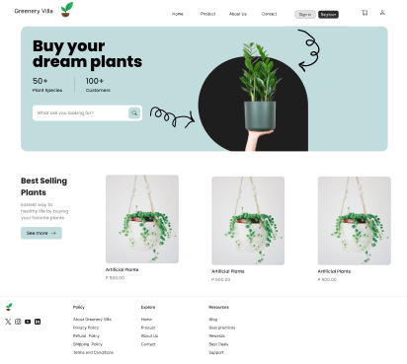

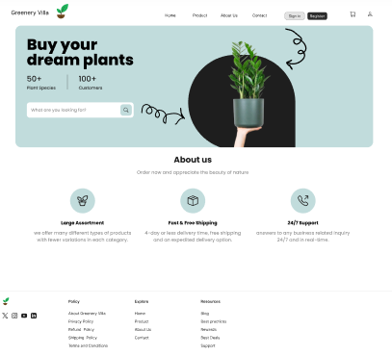
- About us page

- Contact page
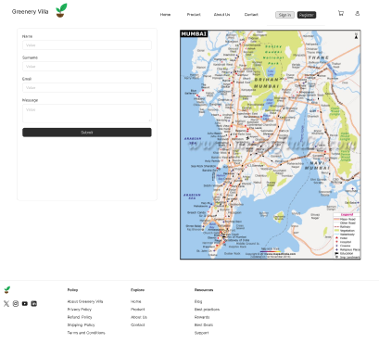

- Product page


This ui is for basic understanding of our website.
The website will not be same as the UI design but it will be similar to the design.

4.4 Test Case Design

Test Case | Test Description | Activity | Expected Output
Test Case 1 | 1. Open the registration page.  2. Enter valid registration details (username, password, email, etc.).  3. Click on the "Submit" button. | Display Registration Confirmation | Registration successful confirmation message is displayed.
Test Case 2 | 1. Open the login page.  2. Enter valid username and password.  3. Click on the "Login" button. | Display User Profile | login successful message shown.
TC-003 | 1. Open the product page.  2. Click on the "Add to Cart" button.  3. Open the cart to view the added product. | Display Cart | Product should appear in the cart with the message "Product Added."
TC-004 | 1. Open the cart.  2. Proceed to check out.  3. Enter payment and shipping details.  4. Click on the "Confirm Order" button. | Display Order Details | Order confirmation message is displayed.
TC-005 | 1. Open the order details page.  2. Click on the "Cancel Order" button. | Cancel Order | Order should be marked as canceled with the message "Order Cancelled."
TC-006 | 1. Admin navigates to the order refund page.  2. Admin processes the refund request. | Refund Confirm | Refund confirmation message should be sent to the user.
TC--007 | 1. Initiate the OTP request on the login/registration page.  2. Enter the correct OTP received on the phone.  3. Click on the "Verify" button. | SMS OTP Sent | OTP verified successfully message is shown.

Chapter 5: Implementation and Testing

5.2 Coding Details and Code Efficiency:
- Userlogin.aspx.cs
using System;
using System.Collections.Generic;
using System.Data;
using System.Data.SqlClient;
using System.Linq;
using System.Web;
using System.Web.UI;
using System.Web.UI.WebControls;

public partial class User_UserLogin : System.Web.UI.Page
{
protected void Page_Load(object sender, EventArgs e)
{

}
protected void Button1_Click(object sender, EventArgs e)
{
string EmailID = txtemail.Text.Trim();
string Password = txtpwd.Text.Trim();

DB d1 = new DB();
DataSet ds = d1.GetDataSet("SELECT User_ID, Mobile_no, Email_ID, Password FROM dbo.User_details WHERE Email_ID = '" + EmailID + "'");

if (ds.Tables[0].Rows.Count > 0) // If email exists
{
string storedPassword = ds.Tables[0].Rows[0]["Password"].ToString();

if (storedPassword == Password) // Correct password
{
Session["UserId"] = ds.Tables[0].Rows[0]["User_ID"].ToString();
Session["MobileNo"] = ds.Tables[0].Rows[0]["Mobile_no"].ToString();
Session["Email"] = ds.Tables[0].Rows[0]["Email_ID"].ToString();
Response.Redirect("Home.aspx");
}
else
{
lblError.Text = "Incorrect password. Please try again.";
}
}
else
{
lblError.Text = "Email not found. Please register or check your email.";
}
}

protected void Button2_Click(object sender, EventArgs e)
{
Response.Redirect("Register.aspx");
}
}

- Register.aspx.cs

using System;
using System.Collections.Generic;
using System.Linq;
using System.Web;
using System.Web.UI;
using System.Web.UI.WebControls;

public partial class User_Register : System.Web.UI.Page
{
protected void Page_Load(object sender, EventArgs e)
{

}
protected void LogBtn_Click(object sender, EventArgs e)
{
string Name = txtname.Text;
string EmailId = txtemail.Text;
string Password = txtpwd.Text;
string Phone = txtnum.Text;
DB d1 = new DB();
int res = 0;

string Query = "Insert Into dbo.User_details(First_Name,Email_ID,Password,Mobile_no) values('"+Name+"','" + EmailId + "','" + Password + "','" + Phone + "')";
res = d1.ExecuteQuery(Query);
if (res > 0)
{
Response.Write("<script>alert('Account is Created Login Now')<script>");
Response.Redirect("UserLogin.aspx");
}

else
{
/*errmsg.InnerText = "Some Error is Occured";*/
}
}

protected void Button1_Click(object sender, EventArgs e)
{

}
}

- Cart.aspx.cs

using iTextSharp.text.pdf;
using iTextSharp.text;
using iTextSharp.text.pdf.qrcode;
using System;
using System.Collections.Generic;
using System.Data;
using System.IO;
using iTextSharp.text;
using iTextSharp.text.pdf;
using System.Linq;
using System.Web;
using System.Web.UI;
using System.Web.UI.WebControls;
using Razorpay.Api;
using System.Net.Mail;
using iTextSharp.text.pdf.parser;

public partial class User_Cart : System.Web.UI.Page
{
DB d1 = new DB();
DataTab Dt1 = new DataTab();
DataTable dt = new DataTable();

public int qty = 0;
int qnt_inc;
double Max_Price = 0;

int product_qty;
double product_prices;
static double total_prices;

protected void Page_Load(object sender, EventArgs e)
{
emptycart.Visible = false;
if (!IsPostBack)
{
BindDataList();

}
}

protected void BindDataList()
{

DataTable dt = new DataTable();

if (Session["CurrentTable2"] == null)
{
dt = Dt1.CreateDataTable();
}
else
{
dt = (DataTable)Session["CurrentTable2"];

}

if (dt.Rows.Count > 0)
{
total_prices = 0.0;
DataList1.DataSource = null;
DataList1.DataSource = dt;
DataList1.DataBind();
DataRow[] result = dt.Select();

if (result.Length > 0)
{

foreach (DataRow row in result)
{

product_qty = Convert.ToInt32(row[3]);
row[3] = product_qty;

product_prices = Convert.ToDouble(row[4]);

/*total_prices += product_qty * product_prices;*/
total_prices += product_qty * product_prices;

Session["FinalPrice"] = total_prices;
totalPrice.InnerText = total_prices.ToString();
/*Response.Write("total price" + Session["FinalPrice"].ToString());*/

}
LastPrice.Text = (total_prices + 100).ToString();
string t = LastPrice.Text;
Session["FinalOrderPay"] = t;
double n = Convert.ToDouble(t);
Session["LastPrice"] = n;
}

}
else
{
DataList1.DataSource = null;
DataList1.DataSource = dt;
DataList1.DataBind();

total_prices = 0;
emptycart.Visible = true;
if (emptycart.Visible == true)
{
BillDiv.Visible = false;
CopDiv.Visible = false;
UserSearcBx.Visible = false;
}

}

}

public void add_tocart(int product_id, String product_name, String product_img, int prodQn, string product_price)
{

if (Session["CurrentTable2"] == null)
{
dt = Dt1.CreateDataTable();
}
else
{
dt = (DataTable)Session["CurrentTable2"];
}

int qty = 1;
int qnt_inc = 0;
double a = Convert.ToDouble(product_price);
Session["a"] = a;
double b = Convert.ToDouble(prodQn);
/*int DelCharge = delCharges;*/
double c;
c = a * b;
double total_price = c;
Session["St"] = c;
DataSet ds = new DataSet();

Session["ProdId"] = product_id;
DataRow[] result = dt.Select("ProdID = '" + product_id + "'");

if (result.Length > 0)
{

foreach (DataRow row in result)
{

product_qty = Convert.ToInt32(row[3]) + 1;
row[3] = product_qty;

product_prices = Convert.ToDouble(row[4]);

total_prices += product_qty * product_prices;
Session["FinalPrice"] = total_prices;
totalPrice.InnerText = total_prices.ToString();

}

LastPrice.Text = (total_prices + 100).ToString();

string t = LastPrice.Text;
double n = Convert.ToDouble(t);
Session["LastPrice"] = LastPrice.Text;
BindDataList();

}

else
{

Dt1.AddRecord(product_id, product_name, product_img, prodQn, product_price, dt);

}
Session["CurrentTable2"] = dt;

}

protected void DataList1_ItemCommand(object source, DataListCommandEventArgs e)
{
if (e.CommandName == "remove_cart")

{
DataTable dab = new DataTable();

dab = (DataTable)Session["CurrentTable2"];

int ID = Convert.ToInt32(e.CommandArgument);

DataRow[] result = dab.Select("ProdId='" + ID + "'");

if (result.Length > 0)
{

foreach (DataRow row in result)
{

row.Delete();

}

}

Session["CurrentTable2"] = dab;
BindDataList();

}
else
{
if (e.CommandName == "Add")
{
int ID = Convert.ToInt32(e.CommandArgument);
string query = "Select * from dbo.ProductDetails where ProductId ='" + ID + "'";
DataSet checkdb = d1.GetDataSet(query);

if (checkdb.Tables[0].Rows.Count > 0)
{
int id = (int)checkdb.Tables[0].Rows[0]["ProductId"];
String name = checkdb.Tables[0].Rows[0]["Prod_Name"].ToString();
String img = checkdb.Tables[0].Rows[0]["Image"].ToString();
string price = checkdb.Tables[0].Rows[0]["Price"].ToString();
int qn = (int)checkdb.Tables[0].Rows[0]["user_id"];
/* int DelChrges = (int)checkdb.Tables[0].Rows[0]["DeliveryCharges"];*/
add_tocart(id, name, img, qn, price);
}

else
{

}

}
else
{
if (e.CommandName == "Sub")
{
DataTable dab = new DataTable();

dab = (DataTable)Session["CurrentTable2"];

int ID = Convert.ToInt32(e.CommandArgument);

DataRow[] result = dab.Select("ProdId='" + ID + "'");

if (result.Length > 0)
{

int qty = 1;

foreach (DataRow row in result)
{

Session["ProdId"] = row[0];

qty = Convert.ToInt32(row[3]) - 1;
if (qty == 0 || qty < 0)
{
row[3] = 1;
}
else
{
row[3] = qty;

}

Label lb = (Label)Page.Master.FindControl("quna");
/* Response.Write(lb.Text);*/

}
if (Session["FinalPrice"] != null)
{
foreach (DataRow row in result)
{

double FinalPriceIs = (double)Session["FinalPrice"];
double ProdPrice = Convert.ToDouble(row[4]);
double FinalPriceN = FinalPriceIs - ProdPrice;
totalPrice.InnerText = FinalPriceN.ToString();
double FinalPrice = FinalPriceIs - ProdPrice + 100;
LastPrice.Text = FinalPrice.ToString();

Session["LastPrice"] = FinalPrice;

}
}

Session["CurrentTable2"] = dab;
BindDataList();
/* Response.Write(Session["ProdId"].ToString());*/
}
}

}

}
}

protected void appBtn_Click(object sender, EventArgs e)
{

UserSearcBx.Style.Add("display", "block");
CopDiv.Style.Add("display", "none");

}

protected void copBtn_Click(object sender, EventArgs e)
{

string Code = TextBox1.Text;

if (Code == "" || Code == null)
{
msg.Text = "Please enter code";
}
else
{
msg.Text = "";
DataSet ds = new DataSet();
DB d1 = new DB();
string Query = "select * from Coupon where CopCode='" + Code.Trim() + "'";
ds = d1.GetDataSet(Query);
if (ds.Tables[0].Rows.Count > 0)
{
int DiscountNumber = (int)ds.Tables[0].Rows[0]["CopDiscount"];

if (Session["LastPrice"] != null)
{

double price = Convert.ToDouble(Session["FinalOrderPay"]);

double DiscountPrice = (Convert.ToDouble(DiscountNumber) / 100) * price;

double NewPriceAfterDiscount = price - DiscountPrice;
LastPrice.Text = NewPriceAfterDiscount.ToString();
CopDiscount.Text = DiscountPrice.ToString();

msg.Style.Add("color", "rgb(0, 179, 0)");
msg.Text = "Coupon applied";

}

}
else
{
msg.Text = "Invalid coupon code";
}
}
}

- Plants.aspx.xs

using System;
using System.Collections.Generic;
using System.Data;
using System.Linq;
using System.Web;
using System.Web.UI;
using System.Web.UI.WebControls;

public partial class User_SelfHelp : System.Web.UI.Page
{
DB d1 = new DB();

DataTab d2 = new DataTab();
DataTable dab = new DataTable();

protected void Page_Load(object sender, EventArgs e)
{

if (!IsPostBack)
{
bind_datalist();

}
}

private void bind_datalist()
{
DataSet ds = new DataSet();
ds = d1.GetDataSet("Select * from dbo.ProductDetails where Categoryid=19");

if (ds.Tables[0].Rows.Count > 0)
{

Repeater1.DataSource = ds.Tables[0];
Repeater1.DataBind();

}

}

public void add_tocart(int product_id, String product_Img, String product_name, int prodQn, string product_price)
{

if (Session["CurrentTable2"] == null)
{
dab = d2.CreateDataTable();
}
else
{

dab = (DataTable)Session["CurrentTable2"];
}

int quantity = 1;
double a = Convert.ToDouble(product_price);
double b = Convert.ToDouble(quantity);
double c;
c = a * b;
String total_price = c.ToString();

DataRow[] result = dab.Select("ProdId = '" + product_id + "'");

if (result.Length > 0)
{

foreach (DataRow row in result)
{

int qty = Convert.ToInt32(row[3].ToString());

row[3] = qty + 1;

Double total = Convert.ToDouble(row[4].ToString());

Session["Total"] = row[4];

}
}
else
{

d2.AddRecord(product_id, product_Img, product_name, prodQn, product_price, dab);

}
Session["CurrentTable2"] = dab;
Session["Qn"] = b;

}
protected void Repeater1_ItemCommand(object source, RepeaterCommandEventArgs e)
{

if (e.CommandName == "add_cart") // check command is cmd_delete
{

int ID = Convert.ToInt32(e.CommandArgument); // value from CommandArgument

string query = "Select * from dbo.ProductDetails where Productid ='" + ID + "'";
DataSet checkdb = d1.GetDataSet(query);

if (checkdb.Tables[0].Rows.Count > 0)
{
int id = (int)checkdb.Tables[0].Rows[0]["Productid"];
String name = checkdb.Tables[0].Rows[0]["Name"].ToString();
string price = checkdb.Tables[0].Rows[0]["Price"].ToString();
String Img = checkdb.Tables[0].Rows[0]["Image"].ToString();
/* int qn = (int)checkdb.Tables[0].Rows[0]["BookQnantity"];*/
int qn = (int)checkdb.Tables[0].Rows[0]["user_id"];
add_tocart(id, Img, name, qn, price);
Response.Write("<script language=javascript>alert('Added to cart');</script>");

}

}

}
}

- AdminLogin.aspx.cs

using System;
using System.Collections.Generic;
using System.Data;
using System.Linq;
using System.Web;
using System.Web.UI;
using System.Web.UI.WebControls;

public partial class Admin_AdminLogin : System.Web.UI.Page
{
DB d1 = new DB();
DataSet ds = new DataSet();
string user_id, user_name;

protected void Page_Load(object sender, EventArgs e)
{

}

private bool IsAdminLogin()
{

{
bool result = true;
ds = d1.GetDataSet("select * from tbl_adminmaster where i_autoid='"+Id.Text+"' and username='" + Email.Text + "' and password='" + Pwd.Text + "'");
if (ds.Tables[0].Rows.Count > 0)
{
user_name = ds.Tables[0].Rows[0]["username"].ToString();
user_id = ds.Tables[0].Rows[0]["i_autoid"].ToString();
return result;

}
else
{
result = false;
return result;

}

}

}

protected void LogBtn_Click(object sender, EventArgs e)
{
try
{
string emailId = Email.Text;
string pass = Pwd.Text;

if (IsAdminLogin())
{
Session["username"] = user_id;
Response.Redirect("Dashboard.aspx", false);
}

else
{
Response.Write("<script>alert('Invalid username and password')</script>");
}
}

catch (Exception ex)
{
throw (ex);
}
}
}

5.3 Testing Approach
Testing is very vital for any system to be successfully implemented. The common view is that it is performed to prove that there are no errors in a program. Therefore the most useful and practical approach is with the explicit intention of finding the errors. The system is tested experimentally to ensure that the software does not fail. The system is run according to its specifications and in the way the user expects. Following testing practices are used. The system will process as normal input preparation of test sample data.

5.3.1 Unit Testing
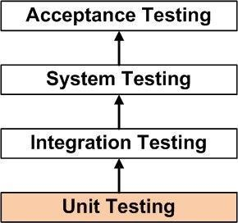
Unit Testing is a level of software testing where individual units/ components of a software are tested. The purpose is to validate that each unit of the software performs as designed. A unit is the smallest testable part of any software. It usually has one or a few inputs and usually a single output. In procedural programming a unit may be an individual program, function, procedure, etc.

5.3.2 Integration Testing
Integration Testing is a level of software testing where individual units are combined and tested as a group. The purpose of this level of testing is to expose faults in the interaction between integrated units. Test drivers and test stubs are used to assist in Integration Testing.
Bottom Up is an approach to Integration Testing where bottom level units are tested first and upper-level units step by step after that. This approach is taken when bottom-up development approach is followed. Test Drivers are needed to simulate higher level units which may not be available during the initial phases.
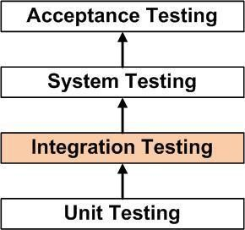
5.3.3 Beta Testing
Beta Testing is one of the Acceptance Testing types, which adds value to the product as the end-user (intended real user) validates the product for functionality, usability, reliability, and compatibility.
Inputs provided by the end-users helps in enhancing the quality of the product further and leads to its success. This also helps in decision making to invest further in the future products or the same product for improvisation.
Since Beta Testing happens at the end user’s side, it cannot be the controlled activity.

5.5 Test Cases
Test case id | Description | Input | Expected Output | Actual Output | Status
Case 1 | Admin login | E-mail ID=“admin@gmail.com” Password =“123456”  Role = “Admin” | Admin should be intended page after login | Directed to the Dashboard page after login | Successful
Case 2 | Admin login | E-mail ID=“@admingmail.com” Password =“41235”  Role = “Admin” | Appropriate message for invalid admin login credentials | Invalid admin login credentials | Successful
Case 3 | User Registration | Mobile no. = “7666238659”  E-mail ID=”abc@gmail.com”  Password = “A12345678”  Role = “User” | User should be directed to credentials  page | Directed to the Login  page | Successful
Case 4 | User Registration | Mobile no. = “ 84531”  E-mail ID=“@USERgmail.com” Password= “53435”  Role= “User” | Appropriate message for invalid user Registration  credentials | Invalid input for  user Registration credentials | Successful
Case 5 | User Login | E-mail ID=“abc@gmail.com”  Password=“A12345678” | User should be directed to the intended page | User should be directed  to Home page | Successful
Case 6 | User Login | E-mail ID=“@admingmail.com”  Password=“534153” | Appropriate message for invalid User Login  credentials | Invalid input for  User login credentials | Successful

Chapter 6: Results and Discussion

6.1 Test Results:

- User Registration:
  - All registration functionalities passed successfully.
  - The registration page displayed as expected, users were able to register using valid email IDs, and error handling for duplicate emails worked correctly.
- Add to Cart & Checkout:
  - Users could add products to the cart and successfully proceed to checkout.
  - The system provided clear error messages when attempting to add unavailable products.
- Payment Processing:
  - Secure payment gateway integration allowed successful transactions.
  - Invalid payment details resulted in appropriate error messages, ensuring security and proper handling of transactions.
- Order Management:
  - Users were able to view their order history.
  - The admin panel displayed order details, including pending,
- Admin Panel:
  - Secure login system prevented unauthorized access.
  - Admins could manage product inventory, view customer orders, and update stock levels efficiently.
- Automated Verification & Security:
  - User data was automatically validated before order processing.
  - The system maintained high-security standards, including data encryption, secure login mechanisms, and session management.

6.2 User Documentation:

Sign up:
Allows new users to create an account by providing necessary details.
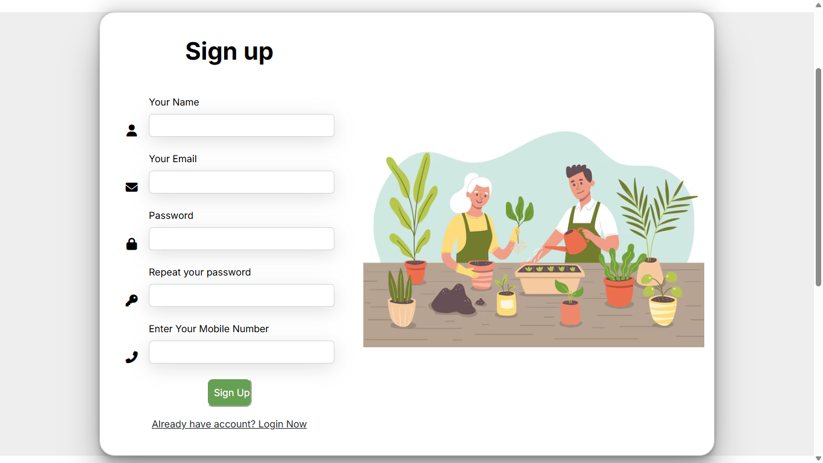

Sign in:
Enables registered users to log in and access their accounts.
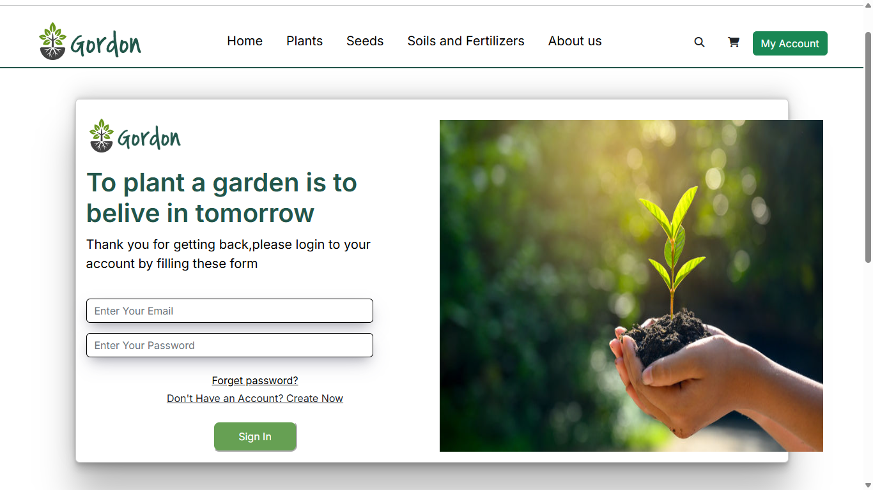

Home page:
Serves as the main landing page with featured products and navigation options.
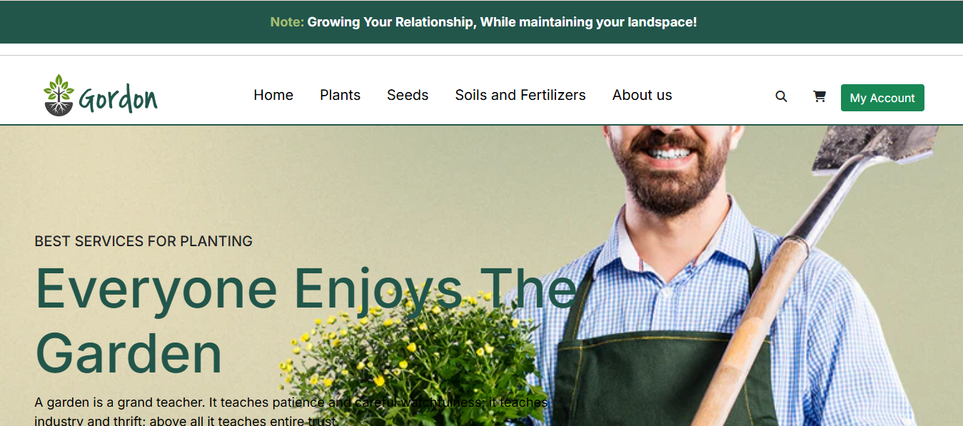

Plants page:
Displays a variety of plants available for purchase with details.
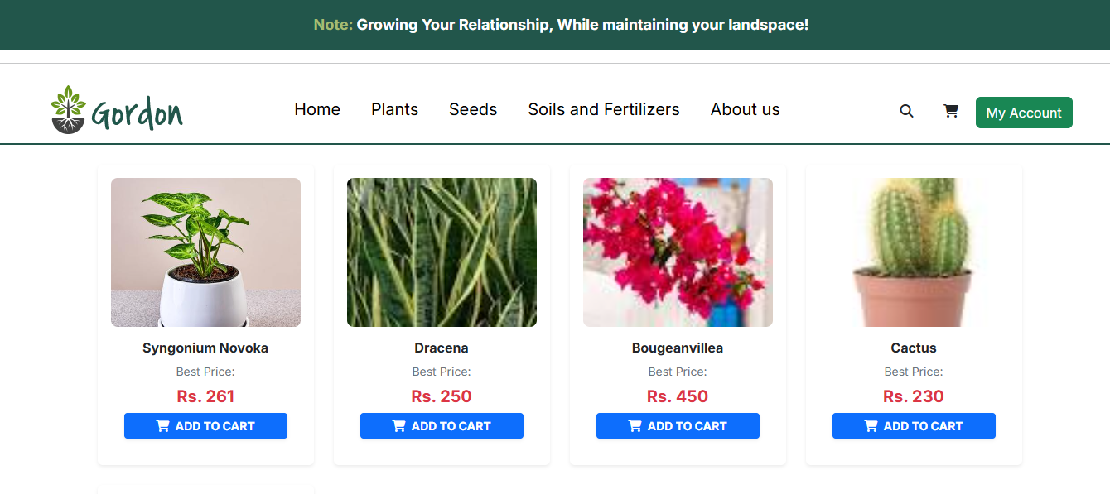

Seeds page:
Lists different types of seeds with descriptions and pricing.
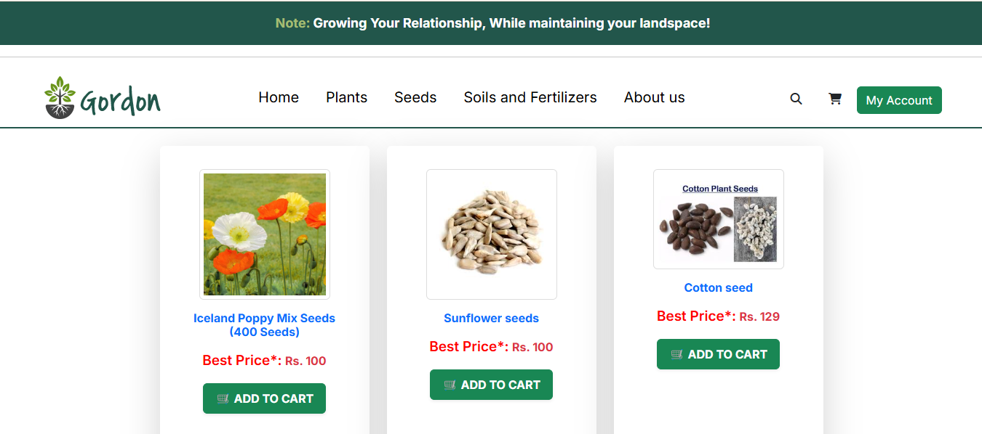

Soils and Fertilizers Page:
Showcases various soil types and fertilizers for gardening needs.
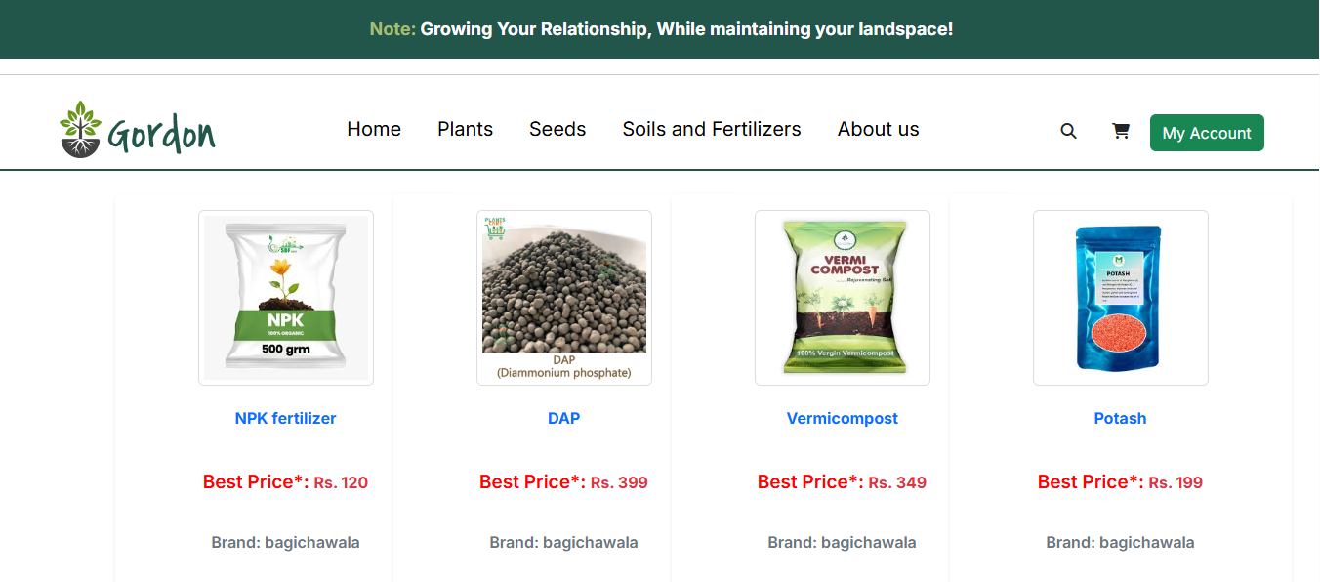

Cart Page:
Allows users to review and manage selected items before checkout.
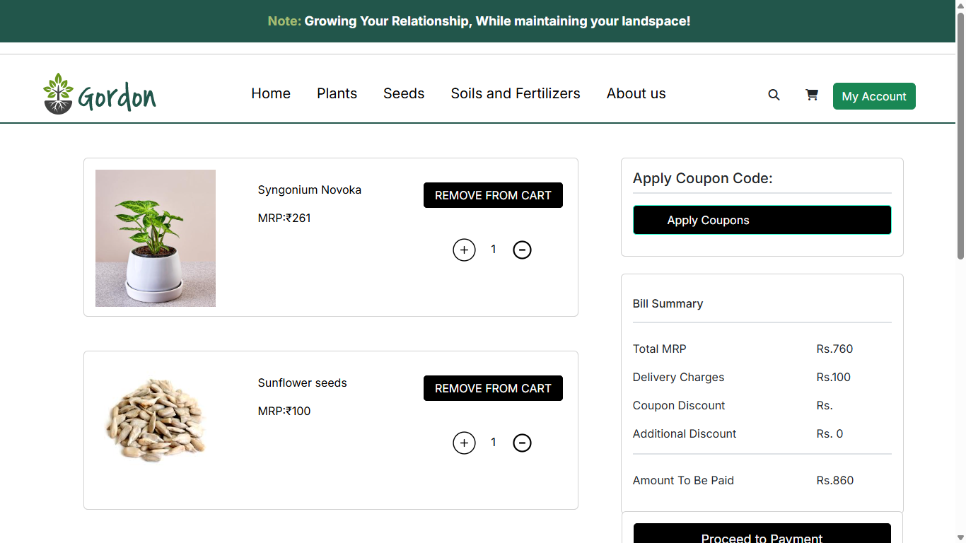

Chapter 7: Conclusion

In conclusion, the development and implementation of the Online Gardening Platform represent a significant step forward in the world of e-commerce and gardening. This project has demonstrated the potential of technology to enhance the gardening experience by providing users with a seamless online marketplace, personalized recommendations, and a community-driven learning environment.
As we move forward, it is crucial to continually refine and expand this platform, taking into account the evolving needs of gardening enthusiasts, advancements in e-commerce technology, and emerging trends in sustainable gardening. By doing so, we can ensure that gardening remains accessible to all, fostering a deeper appreciation for nature and empowering users with the tools and knowledge they need to cultivate thriving gardens.
In summary, this Online Gardening Platform is not just a project; it represents a vision for the future of gardening commerce and education. It harnesses the power of technology to revolutionize the gardening experience, making it more personalized, efficient, and engaging. The possibilities are limitless, and this project is just the beginning of an exciting journey toward a more connected and informed gardening community.

7.1 Significance of the System:
The Online Gardening Platform plays a crucial role in bridging the gap between traditional gardening practices and modern technological advancements. It empowers gardening enthusiasts by providing flexible, accessible, and educational opportunities to enhance their skills. By integrating e-commerce with gardening tools, plants, fertilizers, and an interactive community, this platform fosters a sustainable and knowledge-sharing environment.

7.2 Limitations of the System:
While the Online Gardening Platform offers numerous benefits, it also has certain limitations and challenges, such as:
- Technical Constraints: The integration of AI-based recommendations and a seamless e-commerce experience requires continuous optimization and technical advancements.
- Resource Limitations: Limited availability of specific gardening products or regional restrictions may impact user accessibility.
- Scalability Issues: As the user base grows, ensuring seamless performance and efficient customer support will require enhanced infrastructure.
- User Adoption: Encouraging traditional gardeners to shift to an online platform may take time and require educational efforts.
7.3 Future Scope of the Project:
- AI-based Product Recommendations: Implement AI algorithms to curate personalized gardening product suggestions based on user preferences, seasonal needs, and previous purchases.
- Advanced Admin Dashboard: Enhance the admin dashboard with features such as comprehensive order management, customer analytics, revenue tracking, and customizable reporting tools for better decision-making.
- Virtual Gardening Simulations: Explore the integration of virtual simulations to offer interactive gardening tutorials, helping users visualize plant growth, pest management, and landscaping techniques.
- Personalized Gardening Plans: Develop AI-powered gardening plans based on users' geographical locations, soil types, and climate conditions, offering customized guidance on plant care and maintenance.
- Gamification Elements: Integrate gamification features such as badges, points, leaderboards, and challenges to encourage active participation, gardening achievements, and user engagement.
- Community Forums and Discussion Boards: Implement features that enable users to connect with fellow gardeners, seek advice, share experiences, and collaborate on gardening projects.
- Mobile App Development: Create a mobile version of the Online Gardening Platform, allowing users to access gardening resources, shop for products, and engage with the community on the go.
- Language Localization: Implement multilingual support to make the platform accessible to a diverse global audience, ensuring seamless user experience for gardening enthusiasts from different regions.
.

REFERENCES

Web Development
- MDN Web Docs - Comprehensive documentation for HTML, CSS, and JavaScript:
https://developer.mozilla.org/
- W3Schools - Web development tutorials for HTML, CSS, and JavaScript:
https://www.w3schools.com/
- Tutorialspoint - Web development guides and tutorials:
https://www.tutorialspoint.com/web_development_tutorials.htm
- CSS-Tricks - Advanced CSS techniques and resources:
https://css-tricks.com/
- Bootstrap Documentation - Frontend framework for responsive design:
https://getbootstrap.com/docs/

Backend Development (ASP.NET & C#)
- Microsoft ASP.NET Documentation - Official ASP.NET guides and best practices:
https://learn.microsoft.com/en-us/aspnet/core/
- Microsoft C# Documentation - Language reference and tutorials:
https://learn.microsoft.com/en-us/dotnet/csharp/
- TutorialsPoint ASP.NET - Beginner to advanced ASP.NET learning resources:
https://www.tutorialspoint.com/asp.net/index.htm
- C# Corner - Community-driven ASP.NET and C# tutorials:
https://www.c-sharpcorner.com/

Database (MySQL & SQL Server)
- MySQL Documentation - Official MySQL guides and reference:
https://dev.mysql.com/doc/
- Microsoft SQL Server Documentation - Official SQL Server database reference:
https://learn.microsoft.com/en-us/sql/sql-server
- W3Schools SQL Tutorial - SQL basics and queries:
https://www.w3schools.com/sql/
- TutorialsPoint MySQL Tutorial - MySQL database learning resource:
https://www.tutorialspoint.com/mysql/index.htm
- SQL Server Central - Community-based SQL Server learning platform:
https://www.sqlservercentral.com/

UI/UX & Design Tools
- Figma - Collaborative UI design tool:
https://www.figma.com/
- Adobe XD - UI/UX prototyping software:
https://www.adobe.com/products/xd.html
- Canva - Online graphic design platform:
https://www.canva.com/
- Font Awesome - Free icon library for web development:
https://fontawesome.com/
- Google Fonts - Open-source web typography:
https://fonts.google.com/

Payment Integration
- Razorpay - Secure payment gateway for online transactions:
https://razorpay.com/

GLOSSARY

- ASP.NET: A web application framework developed by Microsoft for building dynamic web applications.
- Backend: The server-side part of the website that handles business logic, database interactions, and processing user requests.
- Bootstrap: A front-end framework used to create responsive and mobile-friendly web applications.
- C# (C-Sharp): A programming language developed by Microsoft, used for building applications in the .NET framework.
- CSS (Cascading Style Sheets): A style sheet language used for designing the appearance of web pages.
- Database: A structured collection of data used to store, manage, and retrieve information efficiently.
- Deployment: The process of making a web application live on a server or cloud platform.
- Domain Name: The unique address used to access a website, such as www.onlinegardening.com.
- E-commerce: The buying and selling of goods and services online.
- Encryption: A method of securing data by converting it into a code that only authorized users can decode.
- Frontend: The part of a website that users interact with, built using HTML, CSS, and JavaScript.
- Framework: A collection of pre-written code that helps developers build applications more efficiently.
- Gardening Tools: Equipment and supplies used for gardening, such as shovels, watering cans, and fertilizers.
- HTML (HyperText Markup Language): The standard language used to create web pages.
- Inventory Management: A system that tracks the stock levels of products available for sale.
- Integration: The process of connecting different software systems to work together.
- JavaScript: A programming language used to create interactive features on websites.
- Localization: The process of adapting a website to different languages and cultural preferences.
- Login System: A security feature that allows users to create accounts and access personalized content.
- Mobile App: A software application designed for mobile devices, allowing users to access the platform on the go.
- MySQL: A popular open-source database management system used for storing and managing data.
- Navigation Bar: A user interface element that allows users to browse different sections of a website.
- Online Payment Gateway: A secure service that processes financial transactions on the website.
- Order Management: The system that handles customer purchases, order tracking, and deliveries.
- Payment Integration: The incorporation of secure online payment methods such as PayPal, Stripe, or Razorpay.
- Product Listing: The display of available gardening products for users to browse and purchase.
- Responsive Design: A web design approach that ensures a website adapts to different screen sizes.
- Scalability: The ability of a system to handle increased traffic and transactions without performance issues.
- SEO (Search Engine Optimization): Techniques used to improve a website’s visibility in search engine results.
- SQL Server: A relational database management system used for storing and retrieving data efficiently.
- Transactions: The process of buying or selling products through the online platform.
- Two-Factor Authentication (2FA): An additional layer of security requiring a second form of verification.
- User Interface (UI): The visual elements of a website that users interact with.
- User Experience (UX): The overall experience a user has while navigating a website.
- Virtual Shopping Cart: A feature allowing users to add multiple items to a cart before completing a purchase.
- Web Application: A software application accessed via a web browser.
- Website Analytics: Tools that track and report user behaviour on a website.

APPENDICES

Appendix A: Project Overview
The Online Gardening Platform is an e-commerce-based web application that provides gardening enthusiasts with a seamless shopping experience for gardening tools, plants, fertilizers, and expert resources. The platform integrates features such as product recommendations, an online community, and personalized gardening plans.

Appendix B: Technology Stack
- Frontend: HTML, CSS, JavaScript, Bootstrap
- Backend: ASP.NET with C#
- Database: MySQL & SQL Server
- Hosting: Microsoft Azure / AWS
- Payment Gateway: Razorpay, PayPal, Stripe
- Development Tools: Microsoft Visual Studio, GitHub

Appendix C: System Modules
- User Management: Registration, login, and authentication.
- Product Management: Adding, updating, and categorizing gardening products.
- Shopping Cart & Checkout: Secure order processing with multiple payment options.
- Admin Dashboard: Tools for managing inventory, users, and orders.
- Order Tracking System: Real-time order tracking and status updates.

Appendix D: Hardware & Software Requirements
- Hardware: Minimum 8GB RAM, Intel i5 processor or equivalent, 256GB SSD storage.
- Software: Windows 10/11, Microsoft SQL Server, Visual Studio 2022, IIS Web Server.
- Browser Compatibility: Google Chrome, Mozilla Firefox, Microsoft Edge.

Appendix E: Database Schema (Simplified)
- Users Table: Stores user details, roles, and authentication data.
- Products Table: Maintains product listings, descriptions, and pricing.
- Orders Table: Records customer purchases and order statuses.
- Payments Table: Logs payment transactions and methods.
- Reviews Table: Captures customer reviews and ratings.

Appendix F: Key Features and Functionalities
- Secure Authentication: Implemented using hashed passwords and 2FA.
- Search and Filter Options: Users can filter products by category, price, and availability.
- Loyalty Rewards System: Users earn points for purchases and community engagement.
- Newsletter Subscription: Regular updates on new products and gardening tips.
- Mobile-Friendly Design: Fully responsive web application for seamless browsing on mobile devices.

Appendix G: Future Enhancements
- Augmented Reality (AR) for Virtual Garden Planning.
- Integration of IoT for Smart Gardening Solutions.
- Mobile App Development for iOS and Android.
- Multi-language Support for Global Reach.
- AI-Powered Plant Diagnosis and Disease Detection.

Appendix H: Testing and Debugging Process
- Unit Testing: Ensures each module functions correctly.
- Integration Testing: Verifies smooth interaction between modules.
- Performance Testing: Evaluates response time and load handling.
- Security Testing: Detects vulnerabilities and ensures data protection.
- User Acceptance Testing: Confirms usability and effectiveness before deployment.

Appendix I: Project Timeline
Phase | Duration | Tasks Covered
Planning | 2 Weeks | Requirement gathering, research
Design | 3 Weeks | UI/UX design, database schema setup
Development | 6 Weeks | Frontend & backend development, integration
Testing | 3 Weeks | Debugging, performance & security testing
Deployment | 2 Weeks | Hosting, final optimizations, live launch

Appendix J: References
Refer to the Reference Page section for a detailed list of resources used in developing this project.

