A Project Report
On
“timetable generator”
Submitted by
Mr. Param
Seat no.: -
in partial fulfillment for the award of the degree of

BACHELOR OF SCIENCE
in

COMPUTER SCIENCE
under the guidance of
Prof. Sonu
Department of Computer Science


VIDYAVARDHINI’S
A. V. COLLEGE OF ARTS, K. M. COLLEGE OF COMMERCE, E. S. A. COLLEGE OF SCIENCE, VASAI(WEST),

PALGHAR-401202,
(Affiliated To University Of Mumbai)

MAHARASHTRA

(SEM-V)
(2025 - 2026)

DECLARATION

I,Param hereby declare that the project entitled “timetable generator” submitted in the partial fulfilment for the award of Bachelor of Science in Computer Science during the academic year 2025 – 2026 is my original work and the project has not formed the basis for the award of any degree, associate ship, fellowship or any other similar titles.

Signature of the Student:

Place:

Date:

ACKNOWLEDGEMENT

I would like to acknowledge my sincere thanks towards our project guide Head of Computer Science Department Prof. rohan for her valuable guidance and suggestions and providing me an opportunity to do the project work in the college lab and which made me complete the project successfully.

I am a very thankful to my project guide Prof. Sonu for providing such nice guidance in form of comments and corrections. I am thankful to and fortunate enough to get constant encouragement, support and guidance from all teaching staff of Computer Science which helped us in successfully completing our project work. Also, I would like to extend our sincere esteems to all staffs in laboratory for their timely support.

-Param
T.Y.BSC (Computer Science)

PLAGARISM REPORT
[[plagarism_report]]

GANTT CHART

INDEX

Sr.no | Contents | Page no | Sign
1. | Introduction and Objective | 7
2. | Scope of Project and Technology stack | 7
3. | Feasibility Study | 8
4. | System Features and Modules | 8
5. | Use case and Advantages | 8
6. | Hardware and Software Requirement | 8
7. | System Design Details  - Event Table  - Entity Relationship Diagram  - Class Diagram  - Activity Diagram  - Use Case Diagram  - Sequence Diagram  - Component Diagram  - Deployment Diagram  - Database Model | 8  9  10  11  12  13  14  15  16
8. | System Implementation (CODE) | 25
9. | User Interface (Screenshots) | 37
10. | References | 41

INTRODUCTION AND OBJECTIVE

Introduction
Manual timetable generation in educational institutions is a notoriously complex and time-consuming process, often leading to inefficiencies, scheduling conflicts, and suboptimal resource utilization. This inherent complexity arises from the multitude of constraints involved, including teacher availability, subject prerequisites, room capacities, student groups, and institutional policies. The traditional approach, heavily reliant on human effort and manual adjustments, is prone to errors and struggles to adapt quickly to changes, frequently resulting in dissatisfaction among staff and students. This project addresses these challenges by proposing the development of an automated Timetable Generator system. The primary aim is to provide an intelligent, efficient, and user-friendly solution that automates the creation of academic timetables, thereby streamlining administrative processes and optimizing the allocation of institutional resources.
Objective
The core objective of this project is to develop a robust and intelligent Timetable Generator system capable of automating the complex process of academic scheduling. Specifically, the system aims to achieve several key objectives: to significantly reduce the time and effort traditionally spent on manual timetable creation, allowing administrative staff to focus on more strategic tasks; to minimize scheduling conflicts such as simultaneous teaching assignments for staff or concurrent classes for students by enforcing predefined constraints; to optimize the utilization of available resources, including classrooms, laboratories, and faculty members, ensuring an equitable and efficient allocation; to provide a flexible platform that allows for easy modification and regeneration of timetables in response to unforeseen changes or specific requests; and ultimately, to enhance operational efficiency and user satisfaction across the institution through a transparent and reliable scheduling process.

SCOPE OF PROJECT AND TECHNOLOGY STACK

Scope
The scope of this Timetable Generator project encompasses the automation of academic scheduling within a typical educational institution, focusing on core functionalities required for generating conflict-free and optimized timetables. This includes the management of entities such as courses, subjects, faculty members, student batches/groups, and available classrooms/laboratories. The system will allow administrators to input and manage all relevant data, define various scheduling constraints (e.g., teacher availability, room capacity, subject sequencing, maximum workload), and generate timetables based on these parameters using an algorithmic approach. Furthermore, it will provide functionalities for visualizing generated timetables, detecting and highlighting potential conflicts, and exporting schedules in common formats. However, the project explicitly excludes features such as student registration, attendance tracking, advanced resource management beyond scheduling (e.g., inventory management), integration with financial systems, or real-time modification of ongoing classes. The focus remains strictly on the automated generation and management of academic schedules.
Technology Stack:
For the development of the Timetable Generator, a modern and robust technology stack will be employed to ensure scalability, maintainability, and efficient performance. The backend logic, responsible for data processing, constraint satisfaction, and the core scheduling algorithms, will primarily be implemented using Python, leveraging frameworks such as Django or Flask for rapid application development and robust API creation. Python's extensive libraries for optimization and data manipulation make it an ideal choice for the complex algorithms involved in timetable generation. For the frontend, a responsive and interactive user interface will be built using a JavaScript framework like React or Angular, ensuring a smooth user experience across various devices. Data persistence will be managed by a relational database system such as PostgreSQL or MySQL, known for their reliability, data integrity, and suitability for complex data models. Version control will be managed via Git, with deployment potentially leveraging containerization technologies like Docker for consistency across environments.

Feasibility Study
The feasibility of developing an automated Timetable Generator system is evaluated across three critical dimensions: technical, operational, and economic. Technically, the project is highly feasible, given the maturity of modern programming languages like Python, advanced algorithmic techniques for constraint satisfaction problems, and readily available frameworks for both backend and frontend development. The existing knowledge base and open-source contributions in optimization algorithms provide a solid foundation. Operationally, the system offers substantial feasibility as it directly addresses a critical administrative pain point. It is anticipated that the automation will significantly improve efficiency, reduce human error, and enhance user satisfaction by providing a transparent and adaptable scheduling tool, thereby ensuring its adoption and continued use within educational institutions. Economically, while initial investment in development resources and time is required, the long-term benefits far outweigh these costs. The system promises to save considerable administrative hours, optimize resource utilization, and eliminate the indirect costs associated with manual errors and inefficiencies, thereby demonstrating strong economic viability and a positive return on investment in terms of enhanced productivity and resource management.

SYSTEM FEATURES AND MODULES

System Features
The Timetable Generator system will encompass a comprehensive suite of features designed to facilitate efficient and error-free academic scheduling. Key functionalities include: User Authentication and Authorization, providing secure access for different user roles such as administrators, faculty, and students; Master Data Management, enabling administrators to input, update, and manage core entities like teachers, subjects, courses, student batches, and available classrooms, along with their respective attributes; Constraint Definition, allowing the precise specification of various scheduling rules, including teacher availability, maximum daily/weekly lectures, room capacities, subject prerequisites, and specific time preferences; Automated Timetable Generation, which employs sophisticated algorithms to construct conflict-free and optimized timetables based on all defined constraints; Conflict Detection and Resolution, providing clear indications of any unresolvable clashes and offering tools or suggestions for manual adjustments; Timetable Visualization and Reporting, presenting generated schedules in intuitive graphical formats (e.g., daily, weekly views) and allowing for export into various document types (e.g., PDF, Excel); and Change Management, facilitating easy modifications to constraints or data and subsequent regeneration of schedules.
Modules
The Timetable Generator system will be architecturally divided into several distinct, interconnected modules to ensure modularity, maintainability, and scalability. The User Management Module will handle user registration, authentication, authorization, and role-based access control. The Data Input & Management Module will provide interfaces for administrators to define, create, update, and delete all fundamental entities such as faculty members, academic subjects, courses, student groups, and physical classrooms, along with their respective properties. The Constraint Management Module is dedicated to defining and maintaining all scheduling rules and preferences, including teacher availability patterns, subject-specific time allocations, room-type requirements, and minimum/maximum lecture loads. The core of the system, the Timetable Generation Engine, will house the complex algorithms responsible for processing all data and constraints to construct conflict-free and optimized timetables. Finally, the Reporting & Visualization Module will enable users to view generated timetables in various formats, detect conflicts, and export schedules for distribution, while a System Configuration Module will allow for global settings adjustments.

USECASE AND ADVANTAGE
Modules
The Timetable Generator system supports various use cases, primarily centered around different user roles within an educational institution. An Administrator initiates the process by logging in and utilizing the Data Input & Management Module to populate the system with all necessary information, including details of teachers, courses, subjects, student groups, and available rooms. Following this, the Administrator accesses the Constraint Management Module to meticulously define all scheduling rules, such as teacher unavailability periods, preferred subject slots, and room capacity limits. Once all data and constraints are in place, the Administrator triggers the Timetable Generation Engine, which processes the inputs to produce an optimized schedule. They then review the generated timetable via the Reporting & Visualization Module, address any highlighted conflicts, and, upon satisfaction, publish or export the final schedule. A Teacher may log in to view their personal timetable, check their assigned courses, and understand their availability for meetings, while a Student can view their class schedule, including subject times, assigned rooms, and instructors, ensuring they are aware of their academic commitments.
Modules
The implementation of an automated Timetable Generator offers numerous significant advantages over traditional manual scheduling methods. Primarily, it leads to a dramatic reduction in time and effort required for timetable creation, freeing administrative staff to concentrate on more critical tasks. The system inherently ensures minimization of scheduling conflicts by rigorously applying predefined constraints, thereby enhancing operational efficiency and reducing confusion among staff and students. It facilitates the optimal utilization of resources, including classrooms, laboratories, and faculty expertise, by intelligently allocating them based on availability and requirements, preventing under or over-utilization. The system provides enhanced flexibility and adaptability, allowing for quick modifications and regeneration of timetables in response to unforeseen circumstances, new enrollments, or policy changes. Furthermore, it promotes transparency and fairness in scheduling, as decisions are based on objective algorithms rather than subjective judgments. Ultimately, these benefits contribute to an overall improvement in institutional productivity, staff and student satisfaction, and a more streamlined academic administration.

HARDWARE AND SOFTWARE REQUIREMENTS

Hardware Requirements
The hardware requirements for the Timetable Generator system are designed to be efficient yet robust enough to handle the computational demands of scheduling algorithms and data management. For the server-side deployment, a minimum configuration would include a multi-core processor (e.g., Intel i5 or equivalent, 4 cores minimum) with at least 8 GB of RAM to support the database, application server, and the potentially memory-intensive scheduling algorithms. Sufficient disk space (e.g., 250 GB SSD) is required for the operating system, database files, application code, and log files, prioritizing SSD for faster I/O operations. Network connectivity with a stable internet connection is crucial for access. Client-side access typically requires standard desktop or laptop computers with modern web browsers, possessing at least 4 GB of RAM and a stable internet connection, as most of the processing occurs on the server. For larger institutions with a significant number of entities (teachers, students, courses) and complex constraints, scaling up processor cores and RAM on the server would be advisable to maintain optimal performance.

Software Requirements
The successful deployment and operation of the Timetable Generator system necessitate a specific set of software components, encompassing both server-side and client-side installations. On the server, a reliable Operating System such as Linux (e.g., Ubuntu Server, CentOS) or Windows Server is required to host the application. A robust Database Management System (DBMS) like PostgreSQL or MySQL will be installed to store all system data, including user credentials, course details, teacher information, and generated timetables. An appropriate Web Server (e.g., Nginx or Apache) will be configured to serve the frontend application and handle client requests, potentially working in conjunction with a WSGI server (e.g., Gunicorn or uWSGI) for Python-based backend applications. For development, a suitable Python Interpreter (version 3.8+) and associated package managers (pip) will be essential. Client-side access primarily requires a modern Web Browser (e.g., Google Chrome, Mozilla Firefox, Microsoft Edge) compatible with the chosen frontend framework, ensuring full functionality and a consistent user experience without the need for additional software installations.

SYSTEM DESIGN

Event Table
[[event_table]]

2. ENTITY-RELATIONSHIP DIAGRAM
[[er_diagram]]

3. CLASS DIAGRAM
[[class_diagram]]

4. ACTIVITY DIAGRAM
[[activity_diagram]]

5. USECASE DIAGRAM
[[usecase_diagram]]

6. SEQUENCE DIAGRAM
[[sequence_diagram]]

7. COMPONENT DIAGRAM
[[component_diagram]]

8. DEPLOYMENT DIAGRAM
[[deployment_diagram]]

9. DATABASE MODEL
[[database_model]]

SYTEM IMPLEMENTATION

1.PY
# This script generates the MindCraft Product Requirements Document (PRD) in the
# specified Google AdMob Challenge format using the 'python-docx' library.
#
# Installation: pip install python-docx
from docx import Document
from docx.shared import Pt, RGBColor
from docx.enum.text import WD_ALIGN_PARAGRAPH
from docx.enum.style import WD_STYLE_TYPE
from docx.shared import Inches
def add_heading_styled(document, text, level):
"""Adds a heading and applies the custom style if it's level 1."""
heading = document.add_heading(text, level=level)
if level == 1:
# Apply the custom style using the style attribute
heading.style = 'Heading 1 Custom'
return heading
def create_mindcraft_prd(filename="MindCraft_PRD_Submission.docx"):
"""Generates the Word document PRD for MindCraft."""
document = Document()
# --- Setup Custom Style for Section Headings ---
styles = document.styles
style = styles.add_style('Heading 1 Custom', WD_STYLE_TYPE.PARAGRAPH)
style.font.size = Pt(18)
style.font.bold = True
# Using a professional blue color for contrast
style.font.color.rgb = RGBColor(0x1E, 0x40, 0xAF)
# --- Document Header ---
document.add_heading('Google AdMob App Development Challenge', level=0).alignment = WD_ALIGN_PARAGRAPH.CENTER
document.add_heading('Product Requirements Document (PRD) Submission', level=0).alignment = WD_ALIGN_PARAGRAPH.CENTER
document.add_paragraph('App Name: MindCraft — The AI Sandbox for Your Thoughts').alignment = WD_ALIGN_PARAGRAPH.CENTER
document.add_paragraph(f'Generated: 2025-11-24').alignment = WD_ALIGN_PARAGRAPH.CENTER
document.add_page_break()
# --- 0. Document & Team Information ---
add_heading_styled(document, '0. Document & Team Information', level=1)
# FIX: Change rows=5 to rows=6 (1 header row + 5 data rows)
table = document.add_table(rows=6, cols=2)
table.style = 'Table Grid'
# Custom data provided by the user
data = {
'App/Game Name': 'MindCraft — The AI Sandbox for Your Thoughts',
'Team Name': 'Nusta Onetap',
'Primary Contact': 'Param Shinde, paramshinde14@gmail.com',
'AdMob Publisher ID': 'pub-6277686976363250',
'App Category': 'Simulation / AI Utility'
}
# Populate the table headers (Row 0)
row_cells = table.rows[0].cells
row_cells[0].text = 'Field'
row_cells[1].text = 'Submission Details'
# Populate the table data (Rows 1-5)
for i, (field, detail) in enumerate(data.items(), 1):
row_cells = table.rows[i].cells
row_cells[0].text = field
row_cells[1].text = detail
document.add_paragraph('\n') # Add some space
# --- 1. Executive Summary & Product Vision (Creativity & Innovation: 30%) ---
add_heading_styled(document, '1. Executive Summary & Product Vision (Creativity & Innovation: 30%)', level=1)
document.add_paragraph('(Total Word Count for Section: 250 - 350 words)')
document.add_heading('1.1. The Pitch (Elevator Pitch) (Max 50 words)', level=2)
p11 = document.add_paragraph(
'MindCraft is the first AI Sandbox that lets users instantly simulate complex life "what-if" scenarios '
'— from career changes to diet outcomes — and experience the results as an interactive, gamified story '
'or visualized outcome. It’s an experiential planning tool for the mind.'
)
document.add_heading('1.2. The Core Problem (Pain Point) (Max 100 words)', level=2)
p12 = document.add_paragraph(
'People constantly face complex, high-stakes decisions (career, finance, health) but lack the tools '
'to visualize personalized outcomes. Existing solutions like self-help apps offer generic advice, while '
'AI chatbots provide static answers. There is a massive gap for an app that merges AI reasoning with '
'interactive life simulation and storytelling based on personal input, making complex future planning engaging and instant.'
)
document.add_heading('1.3. The Innovative Solution (Value Proposition) (Max 200 words)', level=2)
p13 = document.add_paragraph(
'MindCraft’s originality lies in its **AI Simulation Generator**, which takes a simple text prompt and '
'generates a multi-mode output: an Interactive Story Player (branching choices), a Game Mode (levels, challenges), '
'and a Visual Mode (comic snapshots). This is the single, unique function. Users choose MindCraft because '
'it transforms abstract thought into a concrete, personalized, and entertaining experience, enabling '
'risk-free experimentation with life scenarios. The content is infinite, ensuring continuous user engagement.'
)
document.add_paragraph('Key Modes: Story Mode, Game Mode, Outcome Mode, Visual Mode.')
# --- 2. Market and Audience (Potential Market Size: 10%) ---
add_heading_styled(document, '2. Market and Audience (Potential Market Size: 10%)', level=1)
document.add_paragraph('(Total Word Count for Section: 200 - 300 words)')
document.add_heading('2.1. Target Audience Profile (Max 100 words)', level=2)
p21 = document.add_paragraph(
'Primary Users: Age 14–35, globally. This includes students, young professionals, and creators. '
'Psychographics: Users are making major life decisions, are curious about AI, and enjoy simulation or '
'storytelling experiences. Context: They use the app during decision-making periods, commute times, '
'or leisure for both personal planning (finance, fitness) and entertainment (fantasy scenarios).'
)
document.add_heading('2.2. Market Size and Opportunity (Max 100 words)', level=2)
p22 = document.add_paragraph(
'The app targets the intersection of the Productivity, Self-Help, and Simulation Games markets, '
'estimated at a Global TAM of **~1.5 Billion users**. The opportunity is vast, particularly in the Android ecosystem, '
'as there is no direct competitor offering personalized AI-driven simulation as a core feature. We target high-volume '
'markets like India, Southeast Asia, and the US where mobile-first consumption is dominant.'
)
document.add_heading('2.3. Competitive Landscape (Max 100 words)', level=2)
p23 = document.add_paragraph(
'1. **Replika / Character AI (Indirect):** Offers static conversational chat. MindCraft is superior because it generates *interactive, branching experiences* and *visual outcomes*, not just text responses.'
)
document.add_paragraph(
'2. **Life Simulation Games (Indirect):** E.g., The Sims, BitLife. These are fictional and cannot accept personal, real-life data. MindCraft’s sustainable advantage is its **Personalized Data Integration** using AI.'
)
# --- 3. Scope and Minimum Viable Product (MVP) ---
add_heading_styled(document, '3. Scope and Minimum Viable Product (MVP)', level=1)
document.add_paragraph('(Total Word Count for Section: 150 - 250 words)')
document.add_heading('3.1. Required Scope Constraints (MANDATORY CHECKLIST)', level=2)
document.add_paragraph('[X] The app/game is B2C (designed for consumers, not businesses).')
document.add_paragraph('[X] The app/game is self-sustaining and can earn revenue immediately upon publication.')
document.add_paragraph('[X] The app/game does NOT require complex background operational setups or physical logistics (e.g., on-ground fulfillment, partnerships, or supply chains).')
document.add_heading('3.2. MVP Feature List (Max 150 words)', level=2)
p32 = document.add_paragraph(
'The MVP focuses on the core simulation loop and monetization:'
)
document.add_paragraph('1. **Scenario Input Engine:** Plain-text prompt submission.', style='List Bullet')
document.add_paragraph('2. **AI Simulation Generator (Core):** Outputs Interactive Story Mode and Visual Mode (comic snapshots).', style='List Bullet')
document.add_paragraph('3. **Interactive Story Player:** Choice-based branching and outcome display.', style='List Bullet')
document.add_paragraph('4. **User Profile & History:** Save and re-run simulations.', style='List Bullet')
document.add_paragraph('5. **AdMob & IAP Integration:** Functional implementation of both monetization streams (Free/Premium tiers).', style='List Bullet')
document.add_heading('3.3. Out-of-Scope Features (Max 100 words)', level=2)
p33 = document.add_paragraph(
'1. Leaderboards / Community sharing features (planned for V2).'
)
document.add_paragraph(
'2. Advanced Outcome Mode (probability chart generation).'
)
document.add_paragraph(
'3. Complex User Profile data integration (e.g., fitness tracker API links).'
)
# --- 4. Retention Strategy (Retention Strategies Deployed: 10%) ---
add_heading_styled(document, '4. Retention Strategy (Retention Strategies Deployed: 10%)', level=1)
document.add_paragraph('(Total Word Count for Section: 200 - 300 words)')
document.add_heading('4.1. The User Loop & Hook (Max 100 words)', level=2)
p41 = document.add_paragraph(
'The primary loop is **Thought -> Simulation -> Insight -> New Thought**. The user has a "what if" question (Hook), runs a simulation, gains personalized insight, and saves the result. This naturally leads to the next "what if" question, creating an infinite content loop. The Hook is the immediate, personalized visualization of abstract concepts.'
)
document.add_heading('4.2. Specific Retention Tactics (Max 100 words)', level=2)
p42 = document.add_paragraph(
'1. **Simulation History & Re-run:** Users save simulations for tracking and future comparison.'
)
document.add_paragraph(
'2. **Daily/Weekly Scenario Prompts:** Curated AI-generated prompts to inspire new "what-if" explorations and drive DAU.'
)
document.add_paragraph(
'3. **Progress/Leveling:** Gamified progress tracking based on the number and complexity of simulations completed, encouraging continuous use.'
)
document.add_heading('4.3. Future Growth Strategy (Max 100 words)', level=2)
p43 = document.add_paragraph(
'Growth will be driven by **Virality through Shareable Content**. Every generated Visual Mode outcome (comic snapshot) and completed Story Mode can be easily shared to social media (e.g., "See my future as a space entrepreneur!"). The integrated Leaderboards/Community feature (post-MVP) will also incentivize organic sharing and discovery of user-created content.'
)
# --- 5. Monetization Strategy (Business Model: 20%) ---
add_heading_styled(document, '5. Monetization Strategy (Business Model: 20%)', level=1)
document.add_paragraph('(Total Word Count for Section: 250 - 400 words)')
document.add_heading('5.1. Business Model Selection (Max 50 words)', level=2)
p51 = document.add_paragraph(
'We will use a **Hybrid Model**. The core utility (basic simulation runs) will be ad-supported (AdMob), appealing to the mass market. Premium features (advanced visuals, unlimited runs, detailed reports) will be monetized via In-App Purchases (IAP) to capture high-value users.'
)
document.add_heading('5.2. Ad Monetization Strategy (Max 200 words)', level=2)
p52 = document.add_paragraph(
'**Ad Formats:** We will leverage **AdMob Banner Ads**, **Interstitial Ads**, and **Rewarded Video Ads**.'
)
document.add_paragraph(
'**Placement & Frequency:**'
)
document.add_paragraph(
'1. **Banner Ads:** Fixed at the bottom of the main "History" and "Input" screens. Low intrusion, high impressions.'
)
document.add_paragraph(
'2. **Interstitial Ads:** Displayed upon exiting a completed Story/Game Mode simulation or after saving a simulation to history (1 ad every 5 minutes of active use). Optimal timing as the core task is completed.'
)
document.add_paragraph(
'3. **Rewarded Video Ads:** Offered to Free Tier users to unlock a high-quality "Premium Visual" snapshot or an extra interactive choice within the Story Player. This is optimal as it provides real user value in exchange for viewing the ad.'
)
document.add_heading('5.3. In-App Purchase (IAP) Strategy (If Applicable) (Max 150 words)', level=2)
p53 = document.add_paragraph(
'Premium features provide enhanced value and remove friction:'
)
document.add_paragraph(
'1. **MindCraft Pro (Subscription):** Unlimited daily simulation runs, removes all ads, and unlocks **Advanced Semantic Modeling** for higher fidelity outcomes.'
)
document.add_paragraph(
'2. **Virtual Coin Packs:** Used to purchase one-time advanced visuals (e.g., "HD Anime Style Snapshot") or bypass waiting periods for complex simulations.'
)
document.add_paragraph(
'3. **Detailed Report Access:** Pay to unlock the full text/chart-based "Outcome Mode" report, which contains deep data analysis from the simulation (high user value for serious planners).'
)
# --- 6. User Experience & Design (UI/UX: 30%) ---
add_heading_styled(document, '6. User Experience & Design (UI/UX: 30%)', level=1)
document.add_paragraph('(Total Word Count for Section: 150 - 250 words)')
document.add_heading('6.1. Core User Flow (Max 100 words)', level=2)
p61 = document.add_paragraph(
'1. **User Opens App:** Sees the Scenario Input Engine on the homepage.'
)
document.add_paragraph(
'2. **Enters Prompt:** User types: "Simulate if I start a side business selling custom sneakers."'
)
document.add_paragraph(
'3. **App Generates:** A loading screen shows the multi-stage AI generation process (text/story/visuals).'
)
document.add_paragraph(
'4. **User Interacts:** The Story Player opens, presenting the first choice: "Should you invest $500 or $1000?"'
)
document.add_paragraph(
'5. **Outcome:** User completes the simulation, saves it, and is offered a Premium upgrade for the full report.'
)
document.add_heading('6.2. Design Rationale and Experience (Max 150 words)', level=2)
p62 = document.add_paragraph(
'The design will follow a **Dark Mode** theme to reflect the futuristic/AI sandbox concept, utilizing clean, non-distracting interfaces (UX principle: Focus on Content). Navigation will be simple: **Input, History, Profile**. The design will emphasize large, tappable buttons for choices in the Story Player and use modern, highly legible sans-serif fonts. Visual Mode outcomes will be highly engaging, designed to resemble comic book panels or stylized anime snapshots to maximize shareability and user enjoyment.'
)
document.add_heading('6.3. Wireframe/Mockup Link (Visual Component) (Max 10 words)', level=2)
document.add_paragraph('Link: [Insert Public Link to Figma/Miro Mockups Here]')
# --- 7. Technical Requirements and Next Steps ---
add_heading_styled(document, '7. Technical Requirements and Next Steps', level=1)
document.add_paragraph('(Total Word Count for Section: 50 - 100 words)')
document.add_heading('7.1. Technical Stack (Optional) (Max 30 words)', level=2)
p71 = document.add_paragraph(
'Frontend: Flutter (Android-first). Backend: Firebase (Auth, Firestore, Functions) + Gemini API for all LLM calls and content generation.'
)
document.save(filename)
print(f"Product Requirements Document saved as: {filename}")
if __name__ == '__main__':
create_mindcraft_prd()

2.PY
#!/usr/bin/env python3
"""
generate_core_prd.py
Creates a clean PRD document (Word format) with core hackathon-required sections:
- Problem Statement
- Solution Overview
- Target Users
- Key Features
- Technical Approach
- Success Metrics
Usage:
pip install python-docx
python generate_core_prd.py
"""
from docx import Document
from docx.shared import Pt
from docx.enum.text import WD_PARAGRAPH_ALIGNMENT
from datetime import datetime
import os
OUTPUT_FILENAME = "PRD_MindCraft.docx"
# ----------------------------
# PRD Content (Minimal & Clean)
# ----------------------------
PRD = {
"title": "Product Requirements Document (PRD)",
"app_name": "MindCraft — AI Sandbox for Your Thoughts",
"generated": datetime.utcnow().strftime("%Y-%m-%d %H:%M:%SZ") + " (UTC)",
"sections": {
"Problem Statement": [
"People constantly wonder about scenarios such as career changes, starting a business, "
"new habits, fitness plans, or major life decisions. However, no existing digital product "
"allows users to simulate these ideas in an interactive, visual, or game-like experience.",
"Current solutions like self-help apps and AI chat interfaces lack personalization and "
"cannot generate immersive, outcome-based simulations. Users want deeper, more engaging "
"ways to explore 'what-if' scenarios that feel realistic and fun."
],
"Solution Overview": [
"MindCraft is a mobile app that converts any thought or scenario into an AI-generated simulation. "
"Users simply describe an idea (e.g., 'What happens if I start a fitness routine?' or "
"'Simulate me in an alternate universe'), and the app generates:",
"- A story-based simulation",
"- An interactive decision-driven path",
"- Visual snapshots or comic-style scenes",
"- Predicted outcomes based on user choices",
"This creates a unique blend of entertainment, self-discovery, and AI personalization."
],
"Target Users": [
"Primary user groups include:",
"- Students (age 14–25)",
"- Young professionals",
"- Creative individuals exploring ideas",
"- Gamers who enjoy simulations",
"- Anyone exploring personal growth or alternative scenarios",
"The product is B2C, globally scalable, and does not require any physical operations."
],
"Key Features": [
"1. Scenario Input Engine — Users type any idea or thought.",
"2. AI Simulation Generator — Produces interactive stories, outcomes, and visuals.",
"3. Interactive Story Mode — Decision-driven branching paths.",
"4. Outcome Analytics — Probability charts and insights.",
"5. Visual Snapshot Generator — Anime/comic-style frames.",
"6. User Profiles — Save, replay, and share simulations.",
"7. Monetization — Ads and in-app purchases for advanced simulations."
],
"Technical Approach": [
"Frontend: Flutter (Android-first), using Bloc/Riverpod for state management.",
"Backend: Firebase for Auth, Firestore for data, Cloud Functions for AI requests.",
"AI Engine: Uses GPT/Gemini-like models to generate text, decisions, and visuals. "
"Caching and batching reduces cost.",
"Infrastructure: Entirely serverless, auto-scaling, zero physical logistics.",
"Data Storage: Firestore + local caching via Hive.",
"Deployment: Google Play Store, with AdMob + In-App Purchases for monetization."
],
"Success Metrics": [
"Activation:",
"- % of users completing their first simulation within 2 minutes",
"- Time-to-first-output",
"",
"Engagement:",
"- Average sessions per user per week",
"- Simulation completion rate",
"",
"Retention:",
"- Day 1, Day 7 user retention",
"",
"Monetization:",
"- IAP conversion rate",
"- Ad impression eCPM",
"",
"Virality:",
"- Number of shared simulations",
"- Views on community-generated simulations"
]
}
}
# ----------------------------
# Word Document Builder
# ----------------------------
def create_docx(prd, output_path):
doc = Document()
# Default font
style = doc.styles["Normal"]
style.font.name = "Calibri"
style.font.size = Pt(11)
# Title
title = doc.add_paragraph()
run = title.add_run(prd["title"])
run.bold = True
run.font.size = Pt(18)
title.alignment = WD_PARAGRAPH_ALIGNMENT.CENTER
# App name
subtitle = doc.add_paragraph()
sr = subtitle.add_run(prd["app_name"])
sr.bold = True
sr.font.size = Pt(14)
subtitle.alignment = WD_PARAGRAPH_ALIGNMENT.CENTER
# Generated timestamp
date_p = doc.add_paragraph(prd["generated"])
date_p.alignment = WD_PARAGRAPH_ALIGNMENT.CENTER
doc.add_paragraph("") # Blank line
# Sections
for section_title, content_lines in prd["sections"].items():
doc.add_heading(section_title, level=2)
for line in content_lines:
if line.startswith("- ") or line.startswith("1.") or line.startswith("2.") or line.startswith("3."):
doc.add_paragraph(line, style="List Bullet")
else:
doc.add_paragraph(line)
doc.add_paragraph("") # spacing
# Save output
doc.save(output_path)
print(f"\n✔ PRD generated successfully: {output_path}")
def main():
output_path = os.path.join(os.getcwd(), OUTPUT_FILENAME)
create_docx(PRD, output_path)
print("Open the file and review formatting before submission.")
if __name__ == "__main__":
main()

USER INTERFACE


Figure 6: WIN_20250413_21_07_56_Pro.jpg
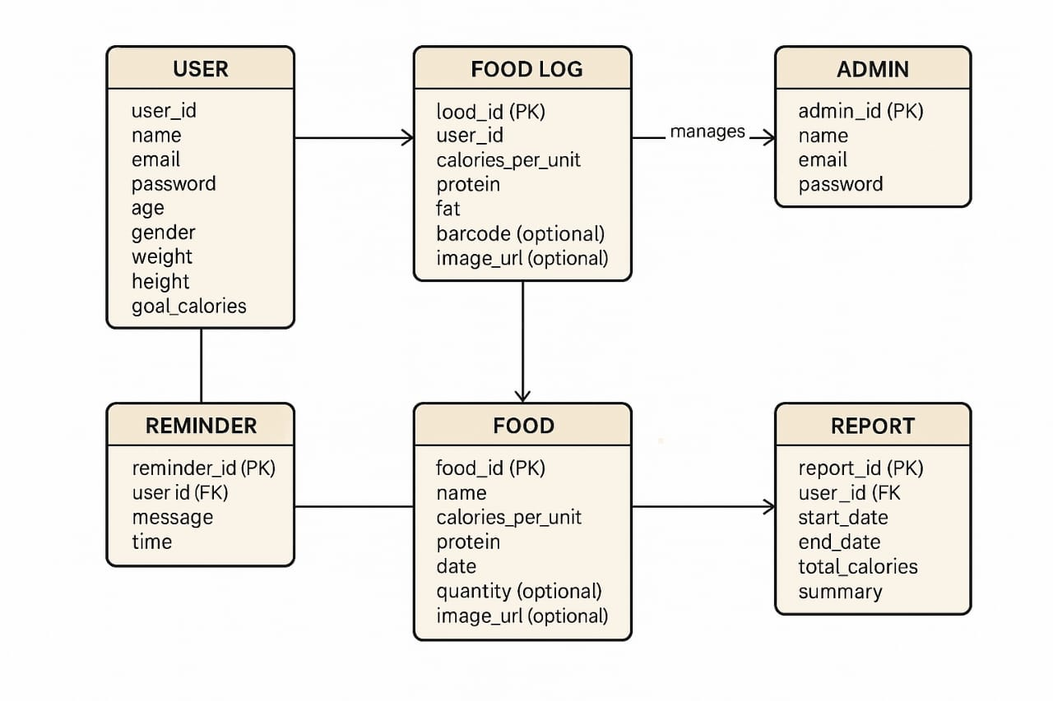
Figure 5: WhatsApp Image 2025-07-03 at 22.28.05_46f22122.jpg
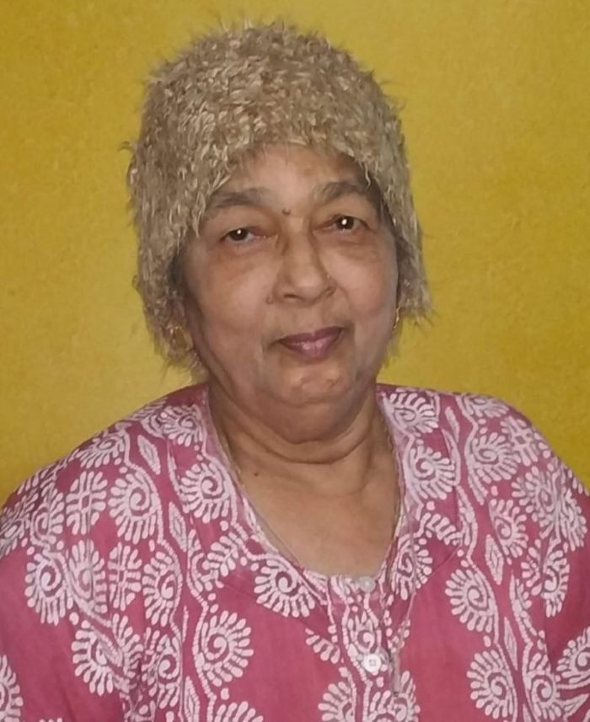
Figure 4: aaji.jpg
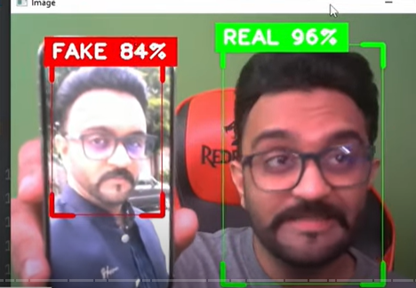
Figure 3: 845c734f-d64f-46b6-92f6-e416701ae817.png
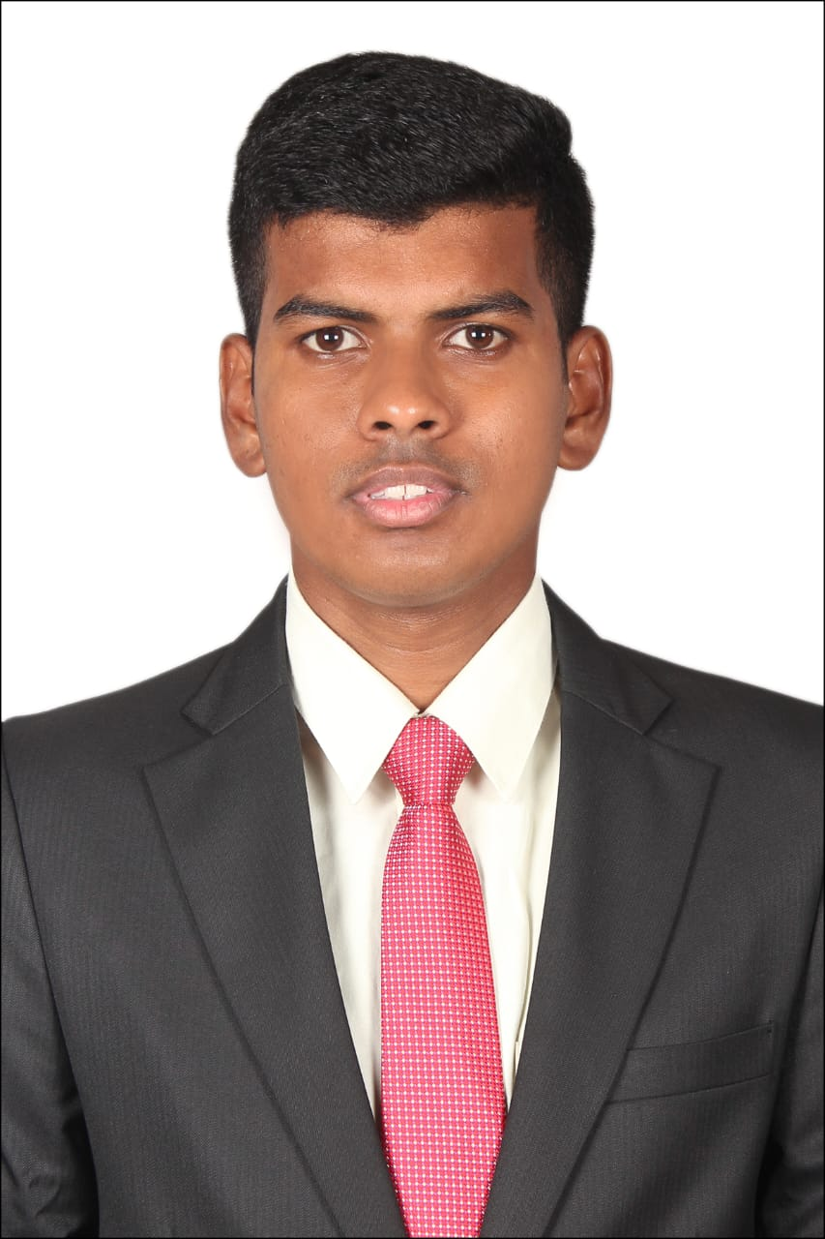
Figure 2: 1.jpeg

Figure 1: target.jpg

REFERENCES

- www.google.com

- https://www.youtube.com

- https://chatgpt.com

Table of Contents
Update field to populate TOC.

