A Project Report
On
“Face Recognition Attendance”
Submitted by
Mr. Param Sachin Shinde
Seat no.: -
in partial fulfillment for the award of the degree of

BACHELOR OF SCIENCE
in

COMPUTER SCIENCE
under the guidance of
Prof. Swetha Iyer
Department of Computer Science


VIDYAVARDHINI’S

A.V. COLLEGE OF ARTS, K. M. COLLEGE OF COMMERCE,

E. S. A. COLLEGE OF SCIENCE, VASAI(WEST), PALGHAR
(Affiliated to University of Mumbai)

MAHARASHTRA

(SEM-V)
(2024-2025)

DECLARATION

​ I, Param Sachin Shinde, hereby declare that the project entitled “Face Recognition Attendance” submitted in the partial fulfillment for the award of bachelor of science in computer science during the academic year 2025-2026 is my original work and the project has not formed the basis for the award of any degree, associateship, fellowship or any other similar titles.

Signature of the Student:

Place:

Date:

ACKNOWLEDGEMENT

I would like to acknowledge my sincere thanks towards our project guide Head of Computer Science Department Prof. Srimathi Narayanan for their valuable guidance and suggestions and providing me an opportunity to do the project work in the college lab and which made me complete the project successfully.

I am very thankful to Prof. Swetha Iyer for providing such nice guidance in form of comments and corrections. I am thankful to and fortunate enough to get constant encouragement, support and guidance from all teaching staff of Computer Science which helped us in Successfully completing our project work. Also, I would like to extend our sincere esteems to all staffs in laboratory for their timely support.

-Param Sachin Shinde
T.Y.BSC (Computer Science)

[[plagarism_report]]

GANTT CHART

INDEX

Sr. no | Contents | Page no | sign
1. | Introduction and Objective | 7
2. | Scope of Project, Technology stack | 8
3. | Feasibility study | 10
4. | System Features and Modules | 11
5. | Use case and Advantages | 12
6. | Hardware and Software Requirement | 14
7. | System Design Details  - Event Table  - Entity Relationship Diagram  - Class Diagram  - Activity Diagram  - Use Case Diagram  - Sequence Diagram  - Component Diagram  - Deployment Diagram  - Database Model | 16  18  19  20  21  22  23  24  25
8. | System Implementation (CODE) | 26 - 41
9. | User Interface (Screenshots) | 43 - 46
10. | References | 47

INTRODUCTION AND OBJECTIVE

Introduction

The Face Recognition Attendance System is a modern and secure platform designed to automate and streamline the process of taking attendance. By leveraging advanced facial recognition technology, this system provides a reliable alternative to traditional methods like manual sign-in sheets or ID card scans. It aims to eliminate common issues such as proxy attendance and human error, providing an accurate and real-time record of presence. The system features a centralized dashboard that gives administrators, teachers, and students access to relevant attendance data. The core of the system is the live video feed, which uses a pre-trained model to detect and recognize faces in real-time. When a face is recognized, the system automatically logs the student's attendance and updates the record in a connected database.

Objective
The main objectives of the Face Recognition Attendance System are to:
- Provide a reliable and automated attendance system. The project aims to eliminate manual attendance tracking and reduce human error by using facial recognition technology to accurately log student presence.
- Enhance security and prevent proxy attendance. By using a live video feed with liveness detection, the system ensures that only real individuals are marked present, preventing spoofing and fraudulent attendance logging.
- Create a centralized and accessible database. The system will store attendance records in an SQLite database, making it easy for administrators, teachers, and students to access and filter data based on their roles and needs.
- Offer comprehensive reporting and analytics. The project includes features to generate daily, weekly, and monthly attendance reports, which can be exported as Excel files for further analysis.
- Streamline administrative tasks. The system automates the process of generating reports and can be configured to send daily attendance data via email, reducing the administrative workload.
- Provide a user-friendly web interface. The project includes a Flask-based web application for managing users, monitoring live attendance, and reviewing unknown faces, making the system easy to operate for different user roles.

SCOPE OF PROJECT AND TECHNOLOGY STACK

Scope
The scope of the Face Recognition Attendance System is to create a comprehensive, automated attendance solution. The project includes the following key areas:
- Core Face Recognition and Liveness Detection: The system will use pre-trained models, specifically FaceNet and a separate liveness detection model, to identify and authenticate individuals in a live video stream. It will perform real-time facial recognition and check for liveness to prevent fraudulent attendance logging using photos or videos.
- Database Management: The system will use a SQLite database to store attendance records, including the student's username, a timestamp, and their attendance status ("Present" or "Already Logged"). It also includes functionality to export this data to an Excel file.
- User Management and Roles: The web application will support different user roles: Admin, Teacher, and Student, each with a specific dashboard and access rights. The admin can manage users by adding, deleting, or updating their credentials and roles.
- Web-based Dashboard and Monitoring: A Flask web application will provide a central dashboard for real-time monitoring of attendance. It will display attendance logs as they are recorded, and an admin can view a live CCTV feed of the recognition process.
- Reporting and Data Export: The system will provide analytics on daily, weekly, and monthly attendance trends. It also allows for exporting attendance data to an Excel file for further analysis. An automated email function is included to send daily attendance reports.
- Attendance Logging Rules: The attendance logging will be governed by a configurable interval (defaulting to 5 minutes), preventing a single user from being marked present multiple times within a short period.

Technology Stack:
The app is built using the following technologies:
- Frontend (User Interface):
  - Flask: The project uses Flask, a Python web framework, to create the web application's front end. It handles user authentication, dashboard displays, and live attendance streams.
  - HTML, CSS, JavaScript: The templates for the dashboards and other web pages are built using standard web technologies.
- Backend:
  - Python: The entire backend logic, including the face recognition process and the web application, is written in Python.
  - Flask: As a web framework, Flask handles routing, HTTP requests, and rendering of web pages. It also manages sessions for user authentication.
  - OpenCV: This library is used for capturing video from the camera, processing image frames, and drawing bounding boxes and labels on the video feed.
- Core Recognition & AI Models:
  - FaceNet: This deep learning model is used to generate 128-D vector embeddings of faces. These embeddings are then used to distinguish between different individuals.
  - MTCNN (Multi-task Cascaded Convolutional Networks): This is used for efficient and accurate face detection in images and video frames. It's used to locate faces before the FaceNet model processes them.
  - Liveness Detection Model: A separate, pre-trained liveness_model.h5 is loaded to determine if a detected face is real or a spoof (e.g., a photo or video).
  - Support Vector Machine (SVM): An SVM classifier, trained on the FaceNet embeddings, is used to classify the faces and identify the correct person.
- API & Communication:
  - Requests: The requests library is used in the 1update.py script to send real-time attendance data to the Flask web application via a POST request.
  - Server-Sent Events (SSE): The app.py uses SSE to stream attendance updates to the live dashboard in real time.
  - SMTP (smtplib): The 1auto_email_report.py script uses this library to send attendance reports via email.
- Database & Storage:
  - SQLite3: A lightweight, file-based database used to store attendance records.
  - Pickle: The trained SVM model and the label encoder are saved and loaded using Python's pickle library, allowing the main script to quickly use them for predictions.
  - Excel (pandas): The pandas library is used to read data from the SQLite database and export it to an Excel spreadsheet for reporting purposes.

Feasibility Study
- Technical Feasibility
- The system leverages proven technologies such as OpenCV, MediaPipe, TensorFlow/Keras, and SQLite, which are robust and widely used for face recognition and real-time processing.
- Development is feasible with Python (for backend logic and recognition in 1update.py) and Flask (for the web interface in app.py), offering a straightforward integration of video processing and web functionalities..
- Economic Feasibility
- The project utilizes open-source tools (e.g., OpenCV, TensorFlow, Flask), significantly reducing development costs with no licensing fees.
- Hardware costs are limited to a standard webcam and a modest computer for processing, making it affordable for small-scale deployment.
- Operational Feasibility
• Users (admins, teachers, students) can interact with the system via a simple web interface, requiring minimal training due to intuitive dashboards (e.g., attendance logs, user management).
• The face recognition process runs automatically with real-time feedback, enhancing user experience by eliminating manual attendance checks.
- Schedule Feasibility
• The use of pre-built libraries (e.g., OpenCV, MediaPipe) and a Flask framework accelerates development, allowing a basic MVP (face recognition and attendance logging) to be completed in 6–10 weeks.
• Advanced features like video streaming (start_cctv), filtered exports, or email reports can be incrementally added in subsequent sprints
- Social Feasibility
• The system benefits educational institutions or organizations by automating attendance, improving efficiency, and reducing human error, fostering a tech-savvy environment.
• It enhances security and trust through liveness checks and face recognition, ensuring accurate attendance records.

SYSTEM FEATURES AND MODULES

System Features
- User Management and Authentication: Provides secure login for Admin, Teacher, and Student roles, with an admin interface to manage users.
- Real-time Attendance Logging: Automatically logs attendance using FaceNet, SVM, and liveness detection models from a live video feed.
- Administrative Dashboard: Provides an admin panel to start/stop the system, register new faces, retrain the model, and review unknown faces.
- Reporting and Analytics: Generates and exports daily, weekly, and monthly attendance reports to Excel.
- Automated Email Reports: Automatically sends daily attendance reports to a specified email address.
- Live Attendance Stream: Displays attendance events in real-time on a web dashboard using a server-sent events stream.
- Configurable Logging: Allows the admin to set a custom attendance logging interval to avoid duplicate entries.

Modules
- Attendance Logging Module: This module uses OpenCV, FaceNet, and an SVM model to recognize faces and log attendance.
- User Management Module: This module handles user authentication and allows admins to manage user accounts and roles.
- Database Module: This module manages all interactions with the SQLite database for storing and retrieving attendance data.
- Reporting & Analytics Module: This module generates daily, weekly, and monthly attendance reports that can be exported to Excel.
- Web Dashboard Module: This Flask module provides the user interface for monitoring and controlling the system.

USECASE AND ADVANTAGE

Use Case for Face Recognition Attendance System
Title: Logging Attendance via Face Recognition
- Actors:
  - Student (User) o Administrator (Admin)
- Preconditions:
  - The student's face has been registered in the system.
  - The face recognition system script (1update.py) has been started by the administrator.
  - The camera is active and properly positioned.
- Main Flow:
  - The student enters the camera's view.
  - The system's detect_faces_mediapipe function detects a face in the live video frame.
  - The liveness detection model verifies that the face is real to prevent spoofing.
  - The SVM classifier compares the embedding to the stored face embeddings to identify the student.
  - If the student's face is recognized with a high confidence score, the system checks the database for their last logged time.
  - If the student has not been logged within the configured interval, the system marks them as "Present" in the SQLite database with a timestamp.
  - A notification is sent to the web application's dashboard, updating the live attendance stream.
  - If the face is not recognized (e.g., an unknown person), the system saves an image of the unknown face for later review by the admin.
- Postconditions:
  - The student's attendance is accurately logged in the database.
  - The attendance log is visible on the web dashboard.
  - An image of any unknown face is saved for admin review.

Advantages of the DIY Making App
- Increased Accuracy and Efficiency: The system automates attendance logging, which eliminates the human error and time consumption associated with manual methods.
- Enhanced Security: By using a liveness detection model, the system prevents attendance fraud by distinguishing between a real person and a photograph or video.
- Real-time Monitoring and Data: The live attendance stream provides administrators and teachers with instant updates on who is present. All data is stored in a centralized SQLite database for easy access and review.
- Simplified Administration: The system reduces the administrative burden by automatically generating daily, weekly, and monthly reports and sending them via email.
- User and Model Management: Admins can easily register new users, retrain the model with updated data, and manage unknown faces from a simple web interface.
- Customizable Settings: The attendance logging interval can be adjusted to prevent a user from being marked present multiple times in a short period.

HARDWARE AND SOFTWARE REQUIREMENTS

Hardware Requirements
- For Development:
- Processor: Intel Core i5-8265U or equivalent.
- RAM: 8 GB installed physical memory (16 GB recommended for smoother performance)
- Storage: Sufficient free space for project files, database, and saving unknown face images.
- Camera: A camera or webcam is required for development and testing.
- Operating System:
  - Windows 10 or higher
  - MacOS 10.14 or higher
  - Linux (any distribution supporting Flutter and Android Studio)
- For Deployment (End-User):
- Computer or Laptop: A computer or laptop is required.

- Camera/Webcam: An attached camera is essential to capture the video stream.

- Network Connection: A stable network connection is needed for the system to connect to the database.

- Storage: Storage space for the database and to save unknown face images is needed.

- Power Supply: A reliable power supply is required for the system to run without interruption.

Software Requirements
- For Development:
  - Programming Language: Python.
  - Framework: Flask is used for the web-based application.
  - Libraries: The project relies on several key Python libraries, including OpenCV to capture video and process images, NumPy for numerical operations, and keras_facenet for face embeddings. Other libraries include sqlite3 for the database, pandas for data analysis and export, subprocess for running other scripts, and smtplib for email.
  - IDE: A Python IDE like PyCharm, VsCode or Spyder is needed.
  - Database: The system uses SQLite for storing attendance records.). o
  - Models: Pre-trained models such as FaceNet and an SVM classifier are required for face recognition. A separate liveness detection model is also used.
  - Git: Version control system to manage the codebase.
- For Deployment (End-User System):
  - Operating System: The system runs on Microsoft Windows 11 Pro.
  - Web Browser: A modern web browser is required to access the Flask-based dashboard.
  - Python Environment: The necessary Python version and all project dependencies must be installed to run the main script and the web server.

SYSTEM DESIGN

Event Table
Event | Trigger | Source | Activity | Destination
Login | User submits credentials | User (Admin/Teacher/Student) | Validate credentials, create session | Redirect to respective Dashboard
Face Detection | Camera captures frame | Camera | Detect face using MTCNN | Face Recognition System
Liveness Check | Detected face | Face Recognition System | Run anti-spoofing (liveness detection) model | Valid/Invalid Result
Face Recognition | Liveness passed | Face Recognition System | Generate embeddings (FaceNet) and classify (SVM) | Attendance Decision
Log Attendance | Recognition result | Flask App | Insert attendance record with status (Present/Absent/FAKE/Unknown | Attendance Database
Store Unknown Face | Face not matched in DB | Flask App | Save face image to unknown_faces folder | Unknown Faces Directory
Review Unknown Faces | Admin action | Admin | Assign/Delete/Delete all unknown faces | Analytics Dashboard
Export Attendance | Teacher request | Teacher | Fetch and display class-wise attendance | Teacher Dashboard
View Personal Attendance | Student request | Student | Fetch student-specific attendance records | Student Dashboard
Spoof Attempt Logged | Fake login attempt detected | Liveness Detection Module | Store spoof attempt details | Security Logs (DB/Admin Dashboard)
Check Attendance Percentage | Student request | Student | Calculate % attendance from records | Student Dashboard
View Analytics | Admin/Teacher Dashboard request | Admin/Teacher | Aggregate data (daily/weekly/monthly) + Pie Chart | Analytics Dashboard
View Class Attendance | Teacher request | Teacher | Fetch and display class-wise attendance | Teacher Dashboard

[[er_diagram]]

[[class_diagram]]

[[activity_diagram]]

[[use_case_diagram]]

[[sequence_diagram]]
[[component_diagram]]

[[deployment_diagram]]

[[database_model]]

STORAGE:
- Database: SQLite (attendance. dB) for attendance records.
- Training Images: E:/Final Year-1/images (subdirectories per user for face registration).
- Unknown Faces: unknown_faces directory (saves unidentified face images).
- Configuration: config.json (e.g., attendance interval).
- Users: users.json (credentials and roles).
- Models and Embeddings: Files like svm_model_160x160.pkl, label_encoder.pkl, faces_embeddings_done_4classes.npz.
- Reports: attendance.xlsx (exported via Pandas).

SYTEM IMPLEMENTATION

email_report.py
import smtplib
from email.mime.multipart import MIMEMultipart
from email.mime.base import MIMEBase
from email import encoders
from datetime import datetime
import os
# Configuration
SENDER_EMAIL = "rohanpandey1234567891011@gmail.com"
SENDER_PASSWORD = "lplfraofzcjkkauh" # Use Gmail App Password
RECEIVER_EMAIL = "paramshinde14@gmail.com"
SMTP_SERVER = "smtp.gmail.com"

SMTP_PORT = 587
# Prepare email
msg = MIMEMultipart()
msg['From'] = SENDER_EMAIL
msg['To'] = RECEIVER_EMAIL
msg['Subject'] = f"Daily Attendance Report - {datetime.now().strftime('%Y-%m-%d')}"
body = "Please find attached today's attendance report."
# Attach Excel file
filename = "attendance.xlsx"
filepath = os.path.abspath(filename)
if not os.path.exists(filepath):
print(f"[ERROR] File {filepath} does not exist.")
exit()

attachment = open(filepath, "rb")
part = MIMEBase('application', 'octet-stream')
part.set_payload(attachment.read())
encoders.encode_base64(part)
part.add_header('Content-Disposition', f'attachment; filename={filename}')
msg.attach(part)
# Send email
try:
server = smtplib.SMTP(SMTP_SERVER, SMTP_PORT)
server.starttls()
server.login(SENDER_EMAIL, SENDER_PASSWORD)
server.send_message(msg)
server.quit()
print("Attendance report sent successfully!")
except Exception as e:
print(f"[ERROR] Failed to send email: {e}")

register_face.py
import cv2 as cv
import os
import sys
import time
from mtcnn import MTCNN
# Config
SAVE_DIR = "E:/Final Year-1/images"

IMG_SIZE = (160, 160)

NUM_IMAGES = 20
detector = MTCNN()
if len(sys.argv) < 2:
print("Usage: python 1register_face.py <name>")
exit(1)
name = sys.argv[1].strip()
save_path = os.path.join(SAVE_DIR, name)
os.makedirs(save_path, exist_ok=True)
cap = cv.VideoCapture(0)
count = 0
print("[INFO] Capturing face images... Press 'q' to quit.")
while cap.isOpened() and count < NUM_IMAGES:
ret, frame = cap.read()
if not ret:
print("[ERROR] Camera failure.")
break
rgb = cv.cvtColor(frame, cv.COLOR_BGR2RGB)
faces = detector.detect_faces(rgb)
if faces:
# Take largest face only
face = max(faces, key=lambda f: f['box'][2] * f['box'][3])
x, y, w, h = face['box']
x, y = abs(x), abs(y)
face_img = frame[y:y+h, x:x+w]
if face_img.size == 0:
continue
face_resized = cv.resize(face_img, IMG_SIZE)
count += 1
img_path = os.path.join(save_path, f"{name}-{count}.jpg")
cv.imwrite(img_path, face_resized)
print(f"[SAVED] {img_path}")
cv.rectangle(frame, (x, y), (x+w, y+h), (0, 255, 0), 2)
cv.putText(frame, f"Captured {count}/{NUM_IMAGES}", (10, 30),
cv.FONT_HERSHEY_SIMPLEX, 0.8, (0, 0, 255), 2)

time.sleep(0.5) # small delay
cv.imshow("Register New Face", frame)
if cv.waitKey(1) & 0xFF == ord('q'):
break
cap.release()
cv.destroyAllWindows()
print(f"[DONE] Collected {count}/{NUM_IMAGES} images for {name}")

export_excel.py
import sqlite3
import pandas as pd
import os
# Connect to the SQLite database
db_path = 'E:/Final Year-1/attendance.db'
conn = sqlite3.connect(db_path)
# Read all records from the attendance table
df = pd.read_sql_query("SELECT * FROM attendance ORDER BY timestamp DESC", conn)
# Debug output
print(f"[DEBUG] Fetched {len(df)} rows from database.")
print(df.head())
# Ensure Excel file is saved to correct location
excel_path = 'E:/Final Year-1/attendance.xlsx'
df.to_excel(excel_path, index=False)
print(f"Attendance exported to '{excel_path}' successfully.")
conn.close()

app.py
from flask import Flask, render_template, request, redirect, session, url_for, flash, Response
from functools import wraps
import subprocess
import psutil
from flask_cors import CORS
import json
import json
import sqlite3
import pandas as pd
import queue
import time
attendance_queue = queue.Queue()
app = Flask(__name__)
app.secret_key = 'your_super_secret_key' # Required for session management
# Dummy user database
import json
USERS_FILE = 'users.json'
def load_users():
with open(USERS_FILE, 'r') as f:
return json.load(f)
def save_users(users):
with open(USERS_FILE, 'w') as f:
json.dump(users, f, indent=4)
# Decorator to protect routes
def login_required(role=None):
def wrapper(f):
@wraps(f)
def decorated_function(*args, **kwargs):
if 'user' not in session:
return redirect(url_for('login'))
if role and session.get('role') != role:
return "Unauthorized", 403
return f(*args, **kwargs)
return decorated_function
return wrapper
@app.route('/')
def index():
return redirect('/login')
@app.route('/analytics')
@login_required(role='admin')
def analytics():
return render_template("analytics.html")
@app.route('/analytics_data')
@login_required(role='admin')
def analytics_data():
import sqlite3
import pandas as pd
conn = sqlite3.connect("attendance.db")
df = pd.read_sql_query("SELECT username, timestamp, status FROM attendance", conn)
conn.close()
if df.empty:
return {"daily": [], "weekly": [], "monthly": [], "pie": {"Present": 0, "Absent": 0}}
# Convert timestamp to datetime
df['timestamp'] = pd.to_datetime(df['timestamp'])
# Daily trend
daily = df.groupby(df['timestamp'].dt.date).size().reset_index(name='count')
# Weekly trend
weekly = df.groupby(df['timestamp'].dt.isocalendar().week).size().reset_index(name='count')
# Monthly trend
monthly = df.groupby(df['timestamp'].dt.to_period("M")).size().reset_index(name='count')
monthly['month'] = monthly['timestamp'].astype(str) # convert Period → string
monthly = monthly[['month', 'count']]
# Pie chart
pie_data = df['status'].value_counts().to_dict()
return {
"daily": daily.to_dict(orient="records"),
"weekly": weekly.to_dict(orient="records"),
"monthly": monthly.to_dict(orient="records"),
"pie": pie_data
}
@app.route('/login', methods=['GET', 'POST'])
def login():
if request.method == 'POST':
username = request.form['username'].strip()
password = request.form['password']
role = request.form['role']
users = load_users()
user = users.get(username)
if user and user['password'] == password and user['role'] == role:
session['user'] = username
session['role'] = role
return redirect(f'/{role}_dashboard')
else:
flash("Invalid credentials or role mismatch")
return redirect('/login')
return render_template('1login.html')
@app.route('/review_unknowns')
@login_required(role='admin')
def review_unknowns():
import os
unknown_dir = "unknown_faces"
images = []
if os.path.exists(unknown_dir):
for img in os.listdir(unknown_dir):
if img.lower().endswith((".jpg", ".png", ".jpeg")):
images.append(img)
return render_template("review_unknowns.html", images=images)
@app.route('/assign_unknown', methods=['POST'])
@login_required(role='admin')
def assign_unknown():
import os, shutil
filename = request.form['filename']
name = request.form['name'].strip()
unknown_dir = "unknown_faces"
images_dir = "E:/Final Year-1/images" # your training images folder
src = os.path.join(unknown_dir, filename)
dst_dir = os.path.join(images_dir, name)
os.makedirs(dst_dir, exist_ok=True)
dst = os.path.join(dst_dir, filename)
shutil.move(src, dst)
flash(f" Unknown face '{filename}' assigned to {name}.")
return redirect('/review_unknowns')
from flask import send_from_directory
@app.route('/unknown_faces/<filename>')
@login_required(role='admin')
def unknown_file(filename):
return send_from_directory('unknown_faces', filename)
@app.route('/log_attendance', methods=['POST'])
def log_attendance():
data = request.json
name = data.get('name')
status = data.get('status')
timestamp = data.get('timestamp')
if name and status and timestamp:
attendance_queue.put({'name': name, 'status': status, 'timestamp': timestamp})
return "Logged successfully", 200
return "Invalid data", 400
def generate_attendance_events():
while True:
if not attendance_queue.empty():
data = attendance_queue.get()
event = f"data: {json.dumps(data)}\n\n"
yield event
time.sleep(1)
@app.route('/attendance_stream')
def attendance_stream():
return Response(generate_attendance_events(), mimetype='text/event-stream')
@app.route('/logout')
def logout():
session.clear()
return redirect('/login')
@app.route('/delete_unknown/<path:filename>', methods=['POST'])
@login_required(role='admin')
def delete_unknown(filename):
import os
filepath = os.path.join("unknown_faces", filename)
if os.path.exists(filepath):
os.remove(filepath)
flash(f" Deleted unknown face: {filename}")
else:
flash(" File not found.")
return redirect('/review_unknowns')
@app.route('/register_face', methods=['GET', 'POST'])
@login_required(role='admin')
def register_face():
if request.method == 'POST':
name = request.form['name'].strip()
try:
subprocess.Popen(['python', '1register_face.py', name])
flash(f"Registering face for: {name}")
except Exception as e:
flash(f"Error starting registration: {e}")
return redirect('/admin_dashboard')
return render_template('register_face.html')
@app.route('/delete_all_unknowns', methods=['POST'])
@login_required(role='admin')
def delete_all_unknowns():
import os, glob
files = glob.glob(os.path.join("unknown_faces", "*"))
for f in files:
try:
os.remove(f)
except:
pass
flash(" All unknown faces deleted successfully.")
return redirect('/review_unknowns')
@app.route('/retrain_model')
@login_required(role='admin')
def retrain_model():
try:
subprocess.run(['python', '1class.py'], check=True)
flash("Model retrained successfully!")
except Exception as e:
flash(f"Error retraining model: {e}")
return redirect('/admin_dashboard')
from flask import send_file
import subprocess

@app.route('/export_attendance')
@login_required(role='admin')
def export_attendance():
try:
# Run export script
subprocess.run(['python', '1export_to_excel.py'], check=True)
flash("Attendance exported successfully!")
except Exception as e:
flash(f"Failed to export attendance: {e}")
return redirect('/admin_dashboard')
# Send the file to download
return send_file("attendance.xlsx", as_attachment=True)
@app.route('/manage_users')
@login_required(role='admin')
def manage_users():
users = load_users()
return render_template('manage_users.html', users=users)
@app.route('/add_user', methods=['POST'])
@login_required(role='admin')
def add_user():
username = request.form['username'].strip()
password = request.form['password'].strip()
role = request.form['role'].strip()
users = load_users()
if username in users:
flash("User already exists.")
else:
users[username] = {"password": password, "role": role}
save_users(users)
flash(f"User '{username}' added successfully.")
return redirect('/manage_users')
@app.route('/delete_user/<username>')
@login_required(role='admin')
def delete_user(username):
users = load_users()
if username in users and username != 'admin':
users.pop(username)
save_users(users)
flash(f"User '{username}' deleted.")
else:
flash("Cannot delete admin or unknown user.")
return redirect('/manage_users')
@app.route('/update_user/<username>', methods=['POST'])
@login_required(role='admin')
def update_user(username):
new_password = request.form['password'].strip()
new_role = request.form['role'].strip()
users = load_users()
if username in users:
users[username]['password'] = new_password
users[username]['role'] = new_role
save_users(users)
flash(f" User '{username}' updated.")
return redirect('/manage_users')
@app.route('/teacher_dashboard')
@login_required(role='teacher')
def teacher_dashboard():
import sqlite3
name_filter = request.args.get('name', '').strip()
date_filter = request.args.get('date', '').strip()
status_filter = request.args.get('status', '').strip()
query = "SELECT username, timestamp, status FROM attendance WHERE 1=1"
params = []
if name_filter:
query += " AND username LIKE ?"
params.append(f"%{name_filter}%")
if date_filter:
query += " AND DATE(timestamp) = ?"
params.append(date_filter)
if status_filter:
query += " AND status = ?"
params.append(status_filter)
conn = sqlite3.connect("attendance.db")
cursor = conn.cursor()
cursor.execute(query, params)
records = cursor.fetchall()
conn.close()
return render_template("teacher_dashboard.html", records=records)
@app.route('/export_filtered')
@login_required(role='teacher')
def export_filtered():
import pandas as pd
import sqlite3
name = request.args.get('name', '')
start = request.args.get('start', '')
end = request.args.get('end', '')
conn = sqlite3.connect("attendance.db")
query = "SELECT * FROM attendance WHERE 1=1"
params = []
if name:
query += " AND username LIKE ?"
params.append(f"%{name}%")
if start and end:
query += " AND DATE(timestamp) BETWEEN ? AND ?"
params.extend([start, end])
df = pd.read_sql_query(query, conn, params=params)
df.to_excel("filtered_attendance.xlsx", index=False)
conn.close()
return send_file("filtered_attendance.xlsx", as_attachment=True)
@app.route('/admin_dashboard')
@login_required(role='admin')
def admin_dashboard():
return render_template('admin_dashboard.html')
@app.route('/student_dashboard')
@login_required(role='student')
def student_dashboard():
import sqlite3
student_name = session['user']
date_filter = request.args.get('date', '').strip()
query = "SELECT * FROM attendance WHERE username = ?"
params = [student_name]
if date_filter:
query += " AND DATE(timestamp) = ?"
params.append(date_filter)
conn = sqlite3.connect("attendance.db")
cursor = conn.cursor()
cursor.execute(query, params)
records = cursor.fetchall()
present_count = len(records)
conn.close()
return render_template("student_dashboard.html", records=records, present_count=present_count)
@app.route('/set_interval', methods=['POST'])
@login_required(role='admin')
def set_interval():
try:
minutes = int(request.form.get("interval"))
if minutes < 1 or minutes > 1440:
flash("Please enter a valid interval between 1 and 1440 minutes.")
return redirect("/admin_dashboard")
with open("config.json", "r") as f:
config = json.load(f)
config["attendance_interval_minutes"] = minutes
with open("config.json", "w") as f:
json.dump(config, f)
flash(f"Attendance logging interval set to {minutes} minutes.")
except Exception as e:
flash(f"Failed to update interval: {e}")
return redirect("/admin_dashboard")
@app.route('/start_cctv')
@login_required(role='admin')
def start_cctv():
return Response(generate_frames(), mimetype='multipart/x-mixed-replace; boundary=frame')
@app.route('/run_cctv')
@login_required(role='admin')
def run_cctv():
# Check if 1update.py is already running
for proc in psutil.process_iter(['pid', 'name', 'cmdline']):
if 'python' in proc.info['name'] and '1update.py' in ' '.join(proc.info['cmdline']):
flash(" Face Recognition is already running.")
return redirect('/admin_dashboard')
try:
subprocess.Popen(['python', '1update.py'])
flash(" Face Recognition started successfully!")
except Exception as e:
flash(f" Failed to start recognition: {e}")
return redirect('/admin_dashboard')
@app.route('/stop_cctv')
@login_required(role='admin')
def stop_cctv():
import psutil
stopped = False
for proc in psutil.process_iter(['pid', 'name', 'cmdline']):
try:
if 'python' in proc.info['name'] and '1update.py' in ' '.join(proc.info['cmdline']):
proc.terminate()
stopped = True
flash(" Face Recognition stopped successfully.")
except (psutil.NoSuchProcess, psutil.AccessDenied):
continue
if not stopped:
flash(" No running Face Recognition process found.")
return redirect('/admin_dashboard')
@app.route('/start_cctv_view')
@login_required(role='admin')
def start_cctv_view():
return render_template('start_cctv.html')
@app.route('/start_and_view_cctv')
@login_required(role='admin')
def start_and_view_cctv():
# Check if 1update.py is already running
for proc in psutil.process_iter(['pid', 'name', 'cmdline']):
if 'python' in proc.info['name'] and '1update.py' in ' '.join(proc.info['cmdline']):
flash(" Face Recognition is already running.")
return render_template('live_attendance.html')
try:
subprocess.Popen(['python', '1update.py'])
flash(" Face Recognition started successfully!")
except Exception as e:
flash(f" Failed to start recognition: {e}")
return render_template('live_attendance.html')
@app.route('/stop_cctv_and_redirect')
@login_required(role='admin')
def stop_cctv_and_redirect():
stopped = False
for proc in psutil.process_iter(['pid', 'name', 'cmdline']):
try:
if 'python' in proc.info['name'] and '1update.py' in ' '.join(proc.info['cmdline']):
proc.terminate()
stopped = True
except (psutil.NoSuchProcess, psutil.AccessDenied):
continue
if stopped:
flash(" Face Recognition stopped successfully.")
else:
flash(" No running Face Recognition process found.")
return redirect(url_for('admin_dashboard'))
import webbrowser
import threading
if __name__ == '__main__':
threading.Timer(1.5, lambda: webbrowser.open("http://127.0.0.1:5000")).start()
app.run(debug=False)

USER INTERFACE

LOGIN SCREEN
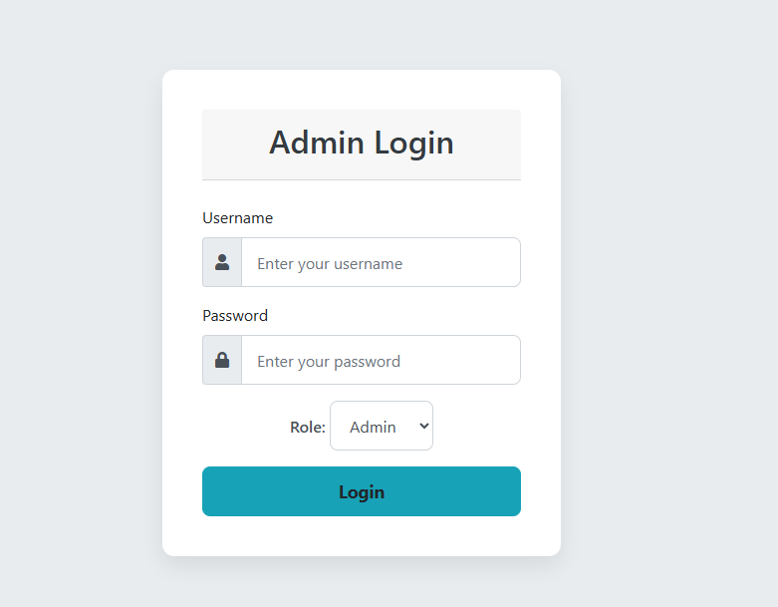

ADMIN DASHBOARD
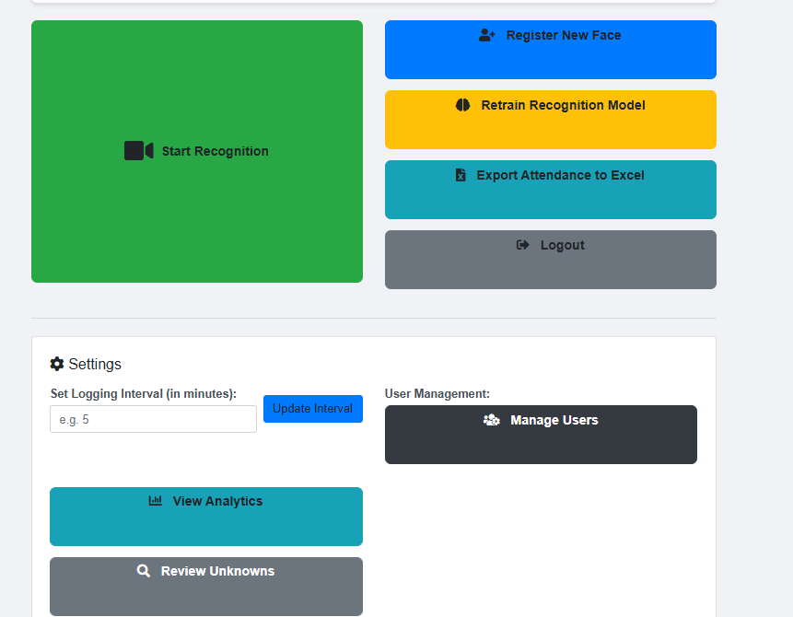

LIVE ATTENDANCE SYSTEM
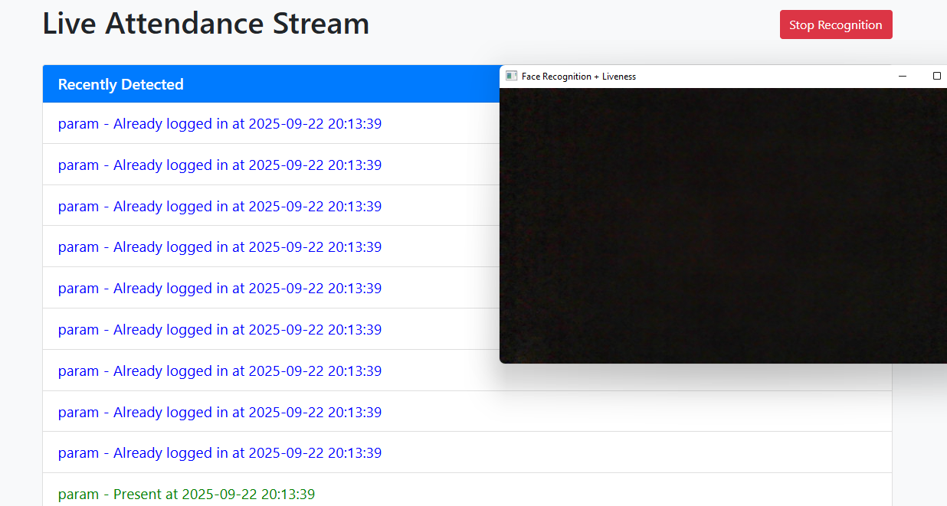

UNKNOWN FACES AND ASSIGN
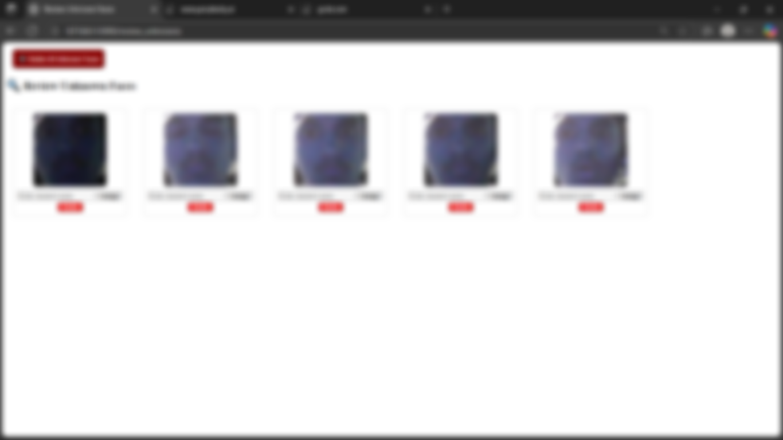

USER MANAGMENT
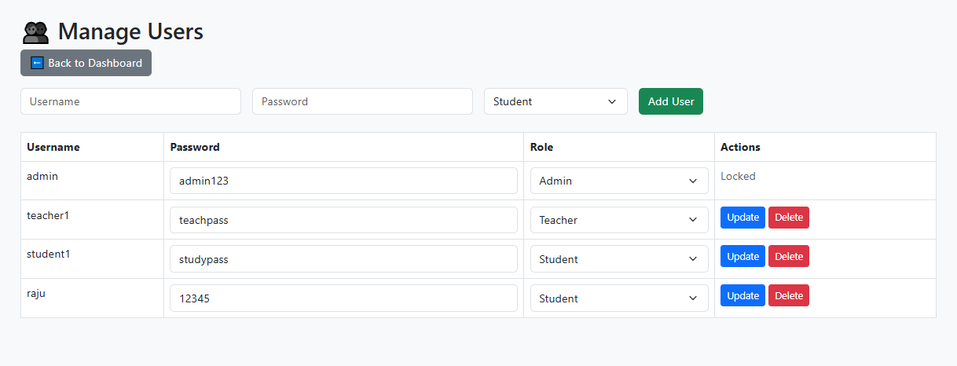

REGISTERING NEW FACE
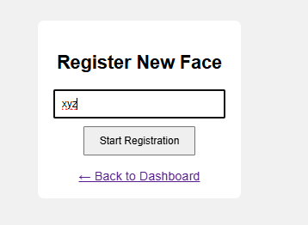

TEACHER DASHBOARD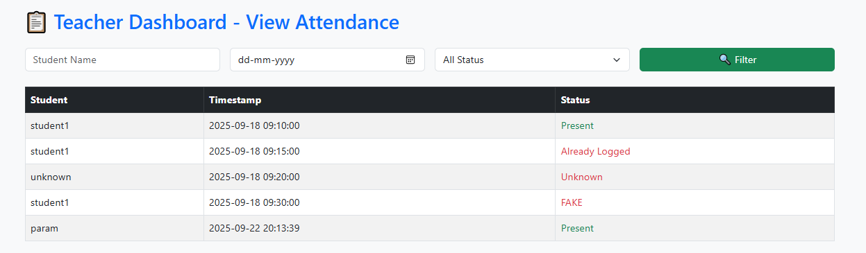

EXCEL SHEET
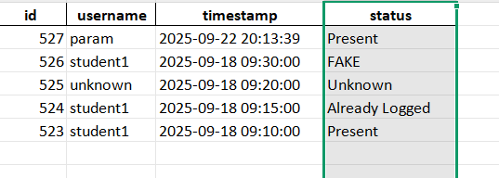

ATTENDANCE DATA
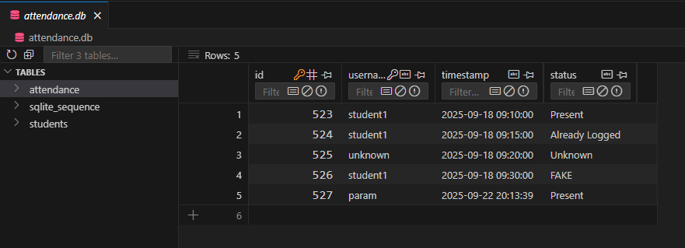

STUDENTS DATA

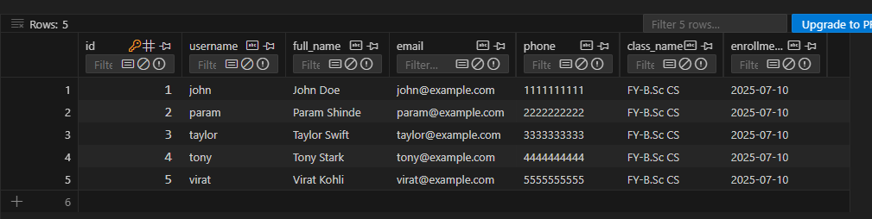

REFERENCES

- https://chatgpt.com/
- https://youtube.com
- https:/.google.com
- https://gemini.google.com/app

Table of Contents
Update field to populate TOC.

