A Project Report
On
“job portal”
Submitted by
Mr. qwert
Seat no.: -
in partial fulfillment for the award of the degree of
BACHELOR OF SCIENCE
in
COMPUTER SCIENCE
under the guidance of
Prof. zzxcv
Department of Computer Science

VIDYAVARDHINI’S
A. V. COLLEGE OF ARTS, K. M. COLLEGE OF COMMERCE, E. S. A. COLLEGE OF SCIENCE, VASAI(WEST),
PALGHAR-401202,
(Affiliated To University Of Mumbai)
MAHARASHTRA
(SEM-V)
(2025 - 2026)

DECLARATION

I,qwert hereby declare that the project entitled “job portal” submitted in the partial fulfilment for the award of Bachelor of Science in Computer Science during the academic year 2025 – 2026 is my original work and the project has not formed the basis for the award of any degree, associate ship, fellowship or any other similar titles.

Signature of the Student:

Place:

Date:

ACKNOWLEDGEMENT

I would like to acknowledge my sincere thanks towards our project guide Head of Computer Science Department Prof. asdfg for her valuable guidance and suggestions and providing me an opportunity to do the project work in the college lab and which made me complete the project successfully.

I am a very thankful to my project guide Prof. zzxcv for providing such nice guidance in form of comments and corrections. I am thankful to and fortunate enough to get constant encouragement, support and guidance from all teaching staff of Computer Science which helped us in successfully completing our project work. Also, I would like to extend our sincere esteems to all staffs in laboratory for their timely support.

-qwert
T.Y.BSC (Computer Science)

PLAGARISM REPORT

GANTT CHART

INDEX

Sr.no | Contents | Page no | Sign
1. | Introduction and Objective | 7
2. | Scope of Project and Technology stack | 7
3. | Feasibility Study | 8
4. | System Features and Modules | 8
5. | Use case and Advantages | 8
6. | Hardware and Software Requirement | 8
7. | System Design Details  - Event Table  - Entity Relationship Diagram  - Class Diagram  - Activity Diagram  - Use Case Diagram  - Sequence Diagram  - Component Diagram  - Deployment Diagram  - Database Model | 8  9  10  11  12  13  14  15  16
8. | System Implementation (CODE) | 25
9. | User Interface (Screenshots) | 37
10. | References | 41

INTRODUCTION AND OBJECTIVE

Introduction
q
Objective
q

SCOPE OF PROJECT AND TECHNOLOGY STACK

Scope
q
Technology Stack:
q

Feasibility Study
q

SYSTEM FEATURES AND MODULES

System Features
q
Modules
q

USECASE AND ADVANTAGE
Modules
q
Modules
q

HARDWARE AND SOFTWARE REQUIREMENTS

Hardware Requirements
q

Software Requirements
q

SYSTEM DESIGN

Event Table

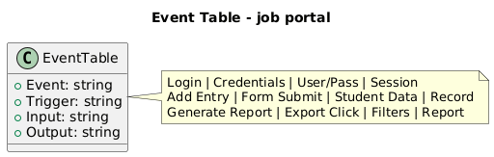
Figure 1: Event Table
Event Table

2. ENTITY-RELATIONSHIP DIAGRAM

3. CLASS DIAGRAM

4. ACTIVITY DIAGRAM

5. USECASE DIAGRAM

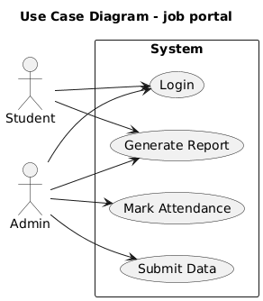
Figure 2: Use Case Diagram
Use Case Diagram

6. SEQUENCE DIAGRAM

7. COMPONENT DIAGRAM

8. DEPLOYMENT DIAGRAM

9. DATABASE MODEL

SYTEM IMPLEMENTATION

SERVER.PY
from wsgiref.simple_server import make_server
from spyne.application import Application
from spyne.decorator import rpc
from spyne.service import ServiceBase
from spyne.protocol.soap import Soap11
from spyne.server.wsgi import WsgiApplication
from spyne.model.primitive import Integer
class CalculatorService(ServiceBase):
@rpc(Integer, Integer, _returns=Integer)
def add_numbers(self, num1, num2):
return num1 + num2
@rpc(Integer, Integer, _returns=Integer)
def sub_numbers(self, num1, num2):
return num1 - num2
@rpc(Integer, Integer, _returns=Integer)
def mul_numbers(self, num1, num2):
return num1 * num2
soap_app = Application([CalculatorService],
tns='example.soap',
in_protocol=Soap11(validator='lxml'),
out_protocol=Soap11())
wsgi_app = WsgiApplication(soap_app)
host = "127.0.0.1"
port = 10000
server = make_server(host, port, wsgi_app)
print(f"Listening on {host}:{port}")
server.serve_forever()

USER INTERFACE


Figure 5: WIN_20250413_21_07_56_Pro.jpg
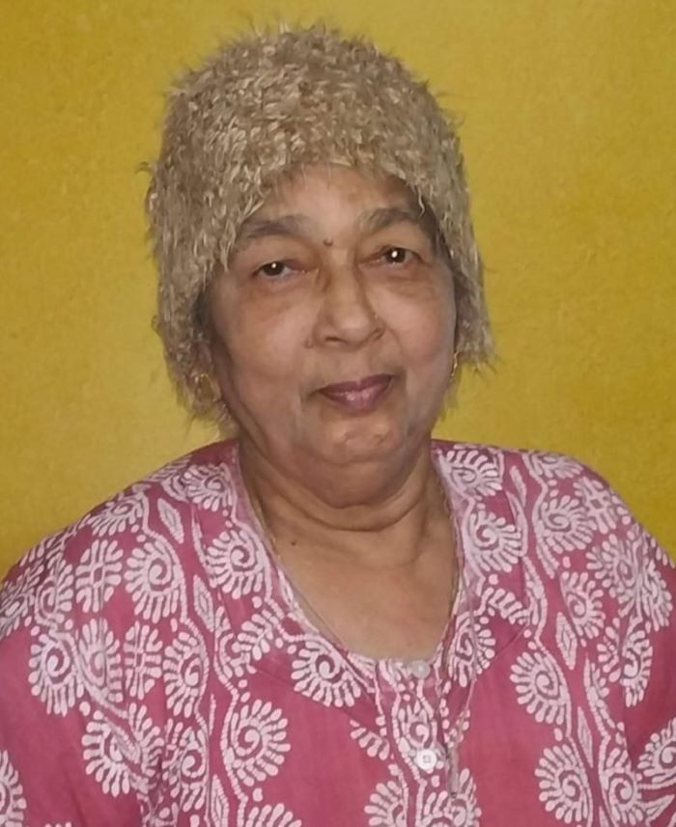
Figure 4: aaji.jpg
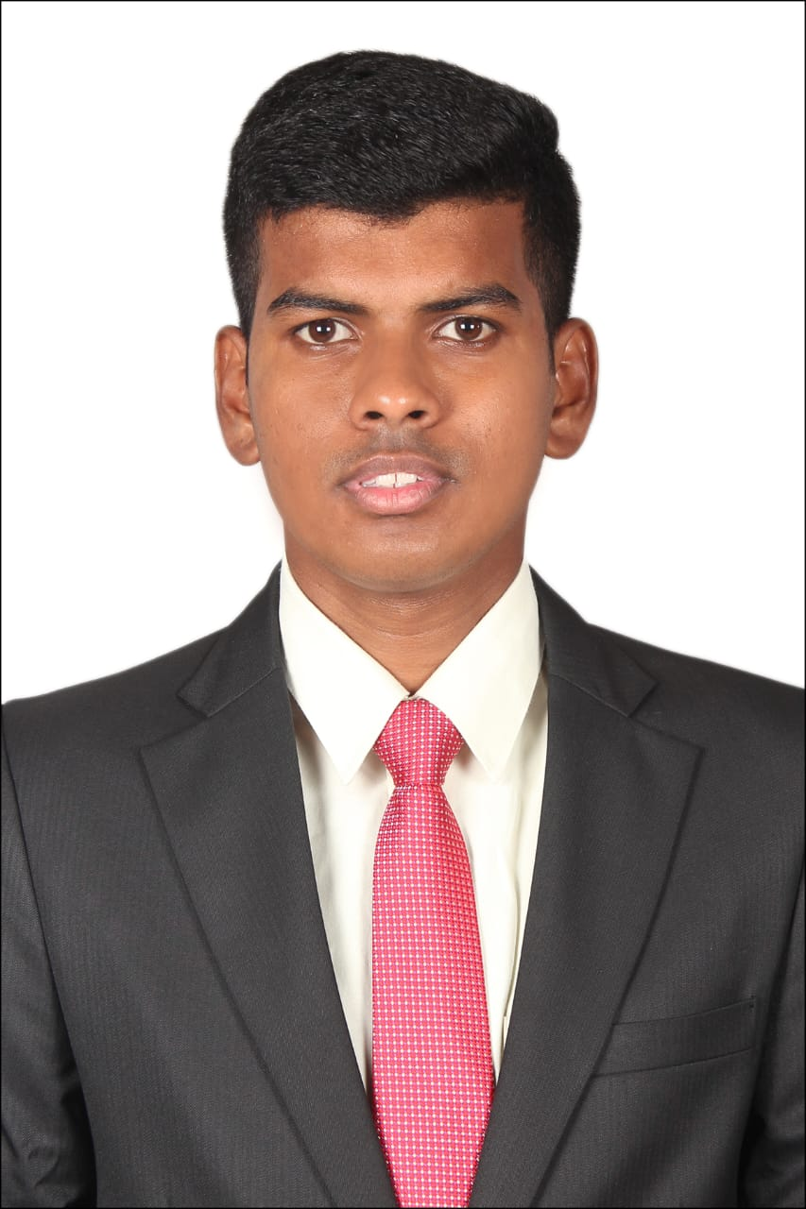
Figure 3: 1.jpeg

REFERENCES

- www.google.com

- https://www.youtube.com

- https://chatgpt.com

Table of Contents
Update field to populate TOC.

