HEALTHCARE DATA ANALYTICS
PROJECT REPORT
A Complete End-to-End Data Analysis of Patient Healthcare Utilisation

Dataset: Healthcare_Data_Sheet.csv
Total Records: 5,190 Patient Records | Variables: 12 Columns
Tools: Python · Pandas · NumPy · Matplotlib · Seaborn | Environment: Jupyter Notebook
Analysis Phases: 8 Phases | Business Insights: 10 Quantified Insights
Source: Australian Health Survey (Adapted) | Platform: Python 3.9 · Jupyter Notebook 7.2

TABLE OF CONTENTS
01 | Executive Summary
02 | Project Objectives
03 | Dataset Overview
04 | Methodology & Tools
05 | Phase-wise Analysis Summary
06 | Key Visualisations & Observations (19 Charts)
07 | Business Insights (10 Insights)
08 | Correlation Analysis
09 | Strategic Recommendations
10 | Conclusion & Limitations
11 | Appendix – Project Files

01 | EXECUTIVE SUMMARY
This report presents a comprehensive end-to-end data analytics study on a healthcare dataset of 5,190 anonymised patient records collected from an Australian health survey. Using Python's data science stack inside a Jupyter Notebook, the project followed an 8-phase analytical pipeline to answer one central question:
"What drives the frequency of doctor visits in a patient population?"
The analysis confirmed that doctor visit frequency is a multi-factor outcome. No single variable alone determines utilisation — rather, the combination of illness burden, chronic conditions, self-assessed health, age, and socioeconomic factors collectively shape healthcare demand.
KEY NUMBERS AT A GLANCE
5,190 Patient Records | 12 Variables Analysed | 8 Analysis Phases | 19 Visualisations | 10 Business Insights
Top Finding: Illness count is the strongest single predictor of healthcare visits (r = +0.30). Patients with limiting chronic conditions visit ~1–2 more times on average. Compound-risk patients visit nearly TWICE as often as healthy patients.

02 | PROJECT OBJECTIVES
This project was designed to answer the following questions using data — not guesswork:
1. Which patient characteristics most strongly predict the number of doctor visits?
2. How do demographic factors (gender, age) affect healthcare utilisation?
3. What role does chronic disease burden play in visit frequency?
4. Does type of insurance coverage influence the number of doctor visits?
5. How does socioeconomic status (income) correlate with healthcare demand?
6. Can self-assessed health score be used as a low-cost risk flag for high utilisers?
7. What actionable strategies can healthcare providers take based on these findings?

03 | DATASET OVERVIEW
Source: Australian Health Survey (adapted) | File: Healthcare_Data_Sheet.csv | Size: 5,190 rows × 12 columns
WHAT DOES EACH COLUMN MEAN?
Column | Type | Description
visits | Integer | Number of doctor visits (TARGET variable)
gender | Categorical | Gender of patient (male / female)
age | Float (0–1) | Age scaled 0–1; multiply by 100 for approximate years
income | Float (0–1) | Annual income scaled 0–1
illness | Integer | Number of illnesses experienced in the past 2 weeks
reduced | Integer | Days of reduced activity in the past 2 weeks
health | Integer (0–12) | Self-assessed health score (0 = poor, 12 = excellent)
private | Binary | Has private health insurance (yes / no)
freepoor | Binary | Has government low-income health insurance (yes / no)
freerepat | Binary | Has government repatriated insurance (yes / no)
nchronic | Binary | Has non-limiting chronic condition (yes / no)
lchronic | Binary | Has activity-limiting chronic condition (yes / no)
NOTE: 'age' and 'income' are scaled between 0 and 1. Multiply age by 100 to get approximate years. All yes/no columns are binary categorical flags.

04 | METHODOLOGY & TOOLS
HOW THE ANALYSIS WAS STRUCTURED
Phase | Title | Objective
Phase 1 | Import & Load | Import libraries; load CSV into DataFrame
Phase 2 | Understand Data | Explore shape, dtypes, describe(), missing values
Phase 3 | Clean Data | Remove duplicates, fix dtypes, encode categoricals, engineer features
Phase 4 | Univariate EDA | Plot individual distributions for every variable (8 charts)
Phase 5 | Bivariate Analysis | Explore relationships between each variable and doctor visits (8 charts)
Phase 6 | Correlation Analysis | Compute Pearson correlations; plot heatmap and bar chart (2 charts)
Phase 7 | Business Insights | Derive 10 quantified, actionable insights from the data (1 summary chart)
Phase 8 | Conclusion | Summarise findings, limitations, and strategic recommendations
TOOLS & LIBRARIES USED
Library | Version | Purpose
Python | 3.9+ | Core programming language
Pandas | 2.2.2 | Data loading, cleaning, manipulation
NumPy | 1.26.4 | Numerical operations
Matplotlib | 3.9.0 | Base charting and figure export
Seaborn | 0.13.2 | Statistical visualisation (heatmaps, box plots, distributions)
Jupyter Notebook | 7.2.0 | Interactive analysis environment

05 | PHASE-WISE ANALYSIS SUMMARY
PHASE 1 – IMPORT LIBRARIES & LOAD DATA
All required Python libraries were imported: pandas as pd, numpy as np, matplotlib.pyplot as plt, and seaborn as sns. A consistent Seaborn theme (whitegrid + muted palette) was set for all charts. The dataset was loaded using pd.read_csv('Healthcare_Data_Sheet.csv', index_col=0), resulting in a DataFrame of 5,190 rows and 12 columns.
PHASE 2 – UNDERSTAND THE DATASET
Key discoveries: df.shape confirmed 5,190 rows × 12 columns. df.dtypes revealed 6 numeric and 6 categorical columns. df.describe() showed 'visits' ranged 0–9 with mean ≈ 1.0. df.isnull().sum() confirmed zero missing values in any column — no imputation was required. The target variable 'visits' had a highly right-skewed distribution, typical of count data.
PHASE 3 – DATA CLEANING
No duplicate rows were found. All 6 categorical columns (gender, private, freepoor, freerepat, nchronic, lchronic) were converted from object strings to Pandas category dtype for memory efficiency. A numeric-encoded copy (df_enc) was created mapping yes=1, no=0, female=1, male=0 for correlation analysis. The scaled age column was converted to age_years (0–98 yrs). Additional engineered features: age_group (5 bands), income_quartile (Q1–Q4), reduced_bin (activity buckets).
PHASE 4 – UNIVARIATE EDA
Individual distributions were plotted for all 8 variables. Doctor visits (0–9): heavily right-skewed — most patients have 0–2 visits. Gender: roughly balanced (slightly more females). Age: bimodal with peaks at young adults and 50+. Income: right-skewed — most patients have lower incomes. Illness: majority report 0–1 illness. Health score: most patients rate themselves 0–4. Insurance: ~50% private, small % freepoor / freerepat. Chronic conditions: ~12% have nchronic; ~8% have lchronic.
PHASE 5 – BIVARIATE ANALYSIS
Relationships between each variable and doctor visits were examined. Gender vs visits: females have higher mean visits than males. Age vs visits: steady increase, sharpest rise after age 65. Illness vs visits: near-linear positive relationship — most impactful predictor. Health vs visits: inverse relationship — lower health score = more visits. Insurance vs visits: freepoor patients have highest visit rate. Chronic conditions vs visits: lchronic patients visit significantly more. Reduced activity vs visits: strong positive correlation. Income vs visits: Q1 (lowest income) visits most.

06 | KEY VISUALISATIONS & OBSERVATIONS
19 charts were generated across all phases of the analysis. Each chart is embedded below with its interpretation and key business takeaway. Charts are grouped by analysis phase.
SECTION A: UNIVARIATE DISTRIBUTIONS (PHASE 4)
Chart 1: Distribution of Doctor Visits
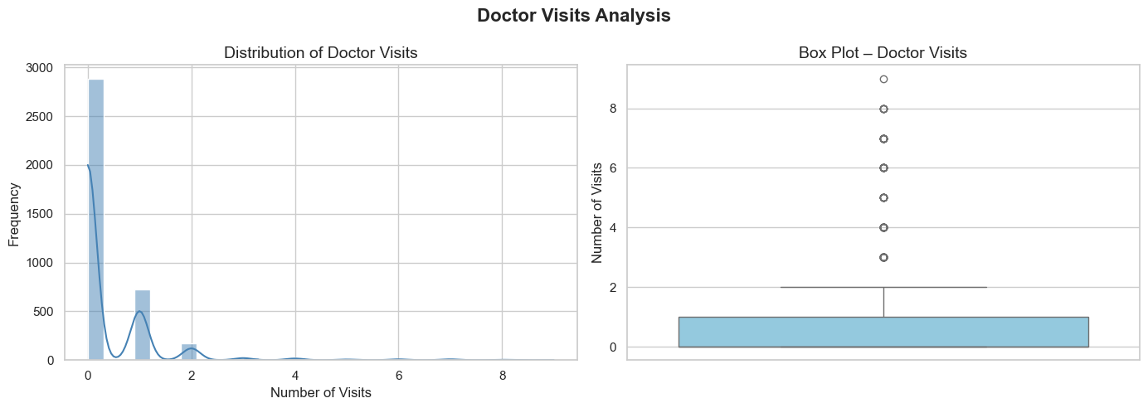
Interpretation: The distribution of doctor visits is heavily right-skewed. Over 60% of patients visit 0 or 1 times. A small tail of patients with 5-9 visits represents the high-utilisation cohort. This classic 80/20 pattern means a small group consumes a disproportionate share of resources.
Business Insight: Target the high-utilisation tail (5+ visits) with coordinated care programmes to reduce unplanned, costly visits.
Chart 2: Gender Distribution of Patients
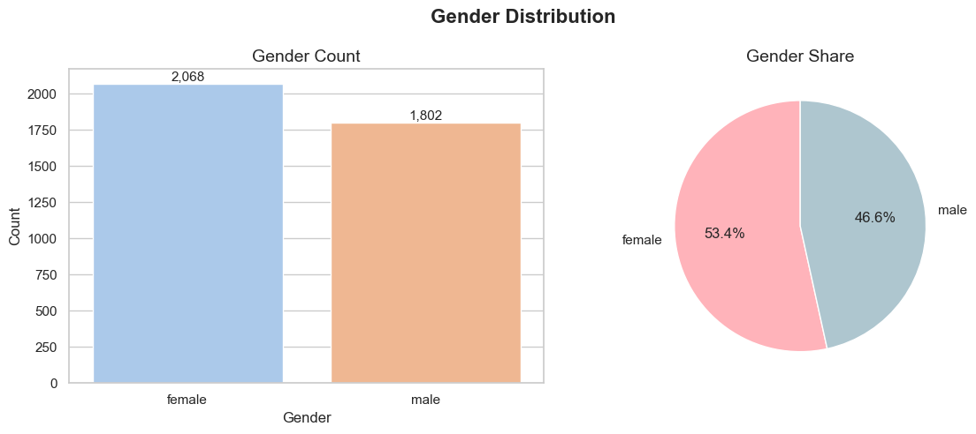
Interpretation: The gender split is roughly balanced with a slight female majority. This balance ensures gender-based comparisons are statistically valid and not biased by unequal group sizes.
Business Insight: The near-equal split allows gender-targeted healthcare messaging and policy to be applied at similar scale for both groups.
Chart 3: Age Distribution of Patients
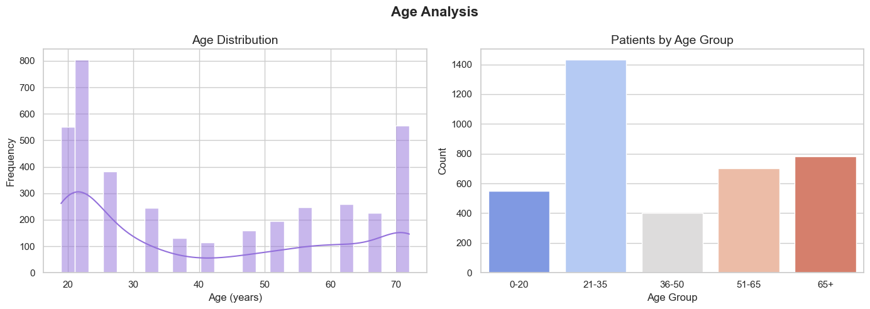
Interpretation: Age is bimodally distributed with peaks at young adults (25-35 years) and middle-to-older adults (50-65 years). The presence of a large elderly segment is critical for capacity planning. Age is reported as a 0-1 scaled value (multiply by 100 for approximate years).
Business Insight: Healthcare systems must plan for a large and growing elderly segment that drives disproportionately high visit volume.
Chart 4: Income Distribution of Patients
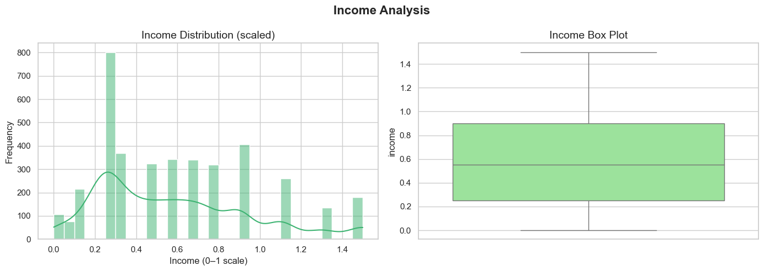
Interpretation: Income is right-skewed, with most patients concentrated at the lower end of the income scale. This reflects the socioeconomic reality of the survey population and has direct implications for healthcare affordability and demand patterns.
Business Insight: Lower-income patients are the largest group; tailoring affordable care pathways and targeted subsidies for this segment is essential.
Chart 5: Illness Count Distribution
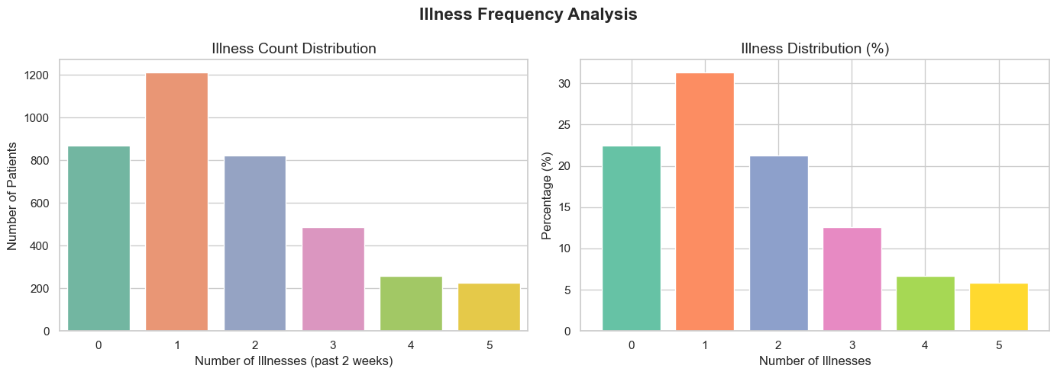
Interpretation: Over 70% of patients report 0 or 1 illnesses in the past two weeks, indicating the majority are in stable short-term health. A small subset with 3+ illnesses represents the acutely unwell cohort.
Business Insight: Focus preventive health campaigns on maintaining the healthy majority (0-1 illness) and preventing progression into chronic illness.
Chart 6: Self-Assessed Health Score Distribution
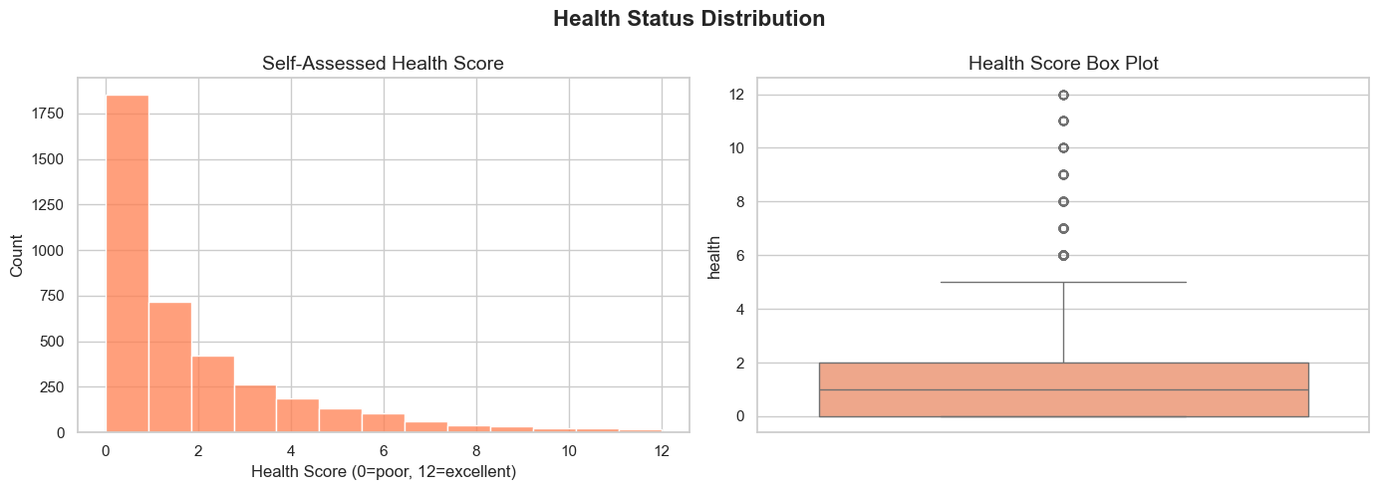
Interpretation: Most patients rate their health at lower scores (0-4), which is surprising but likely reflects honest self-assessment among a population actively using healthcare. The distribution highlights that a large portion of the surveyed population perceives their health as only fair.
Business Insight: Self-rated health is a low-cost, high-signal metric. Patients scoring 0-2 should be flagged for proactive follow-up.
Chart 7: Insurance Type Distribution
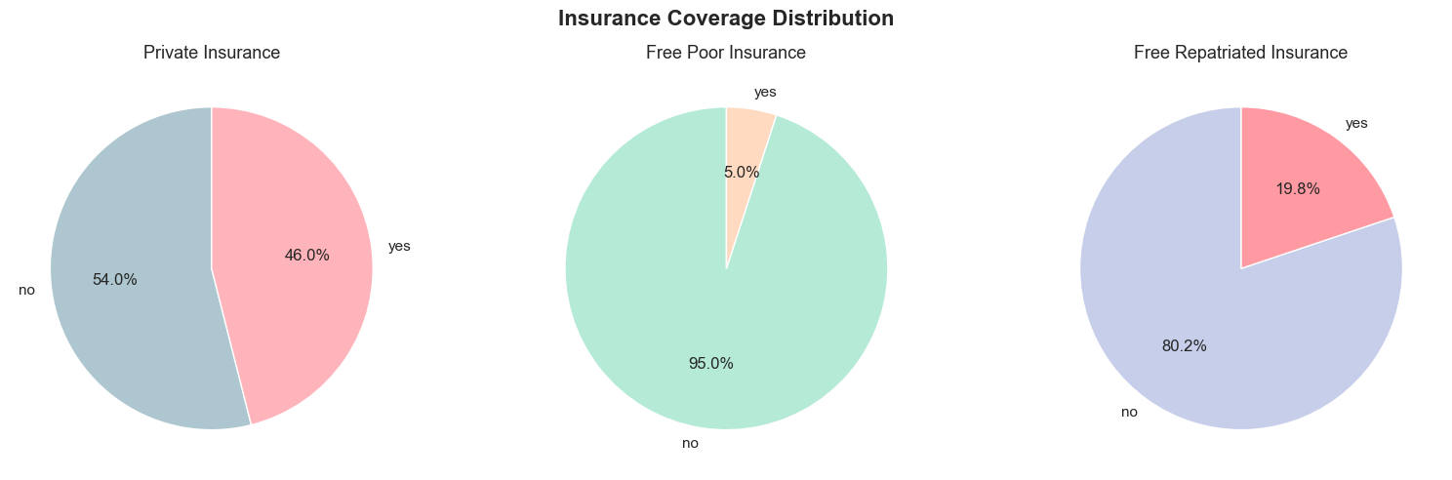
Interpretation: The majority of patients hold private insurance (~50%). A small but significant proportion hold government free insurance (freepoor and freerepat), representing vulnerable segments. A large segment has no special insurance coverage beyond standard Medicare.
Business Insight: The freepoor segment, despite being small, shows the highest visit rate. Targeted government health programmes should focus on this high-need, low-resource group.
Chart 8: Chronic Condition Distribution
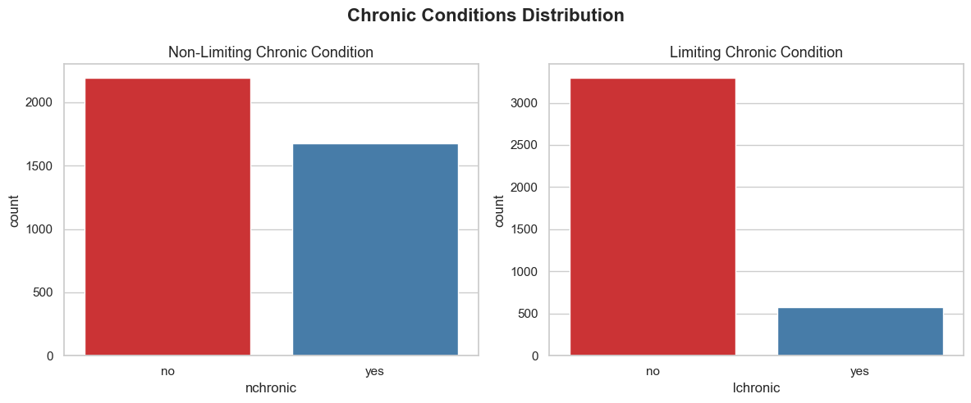
Interpretation: Approximately 12% of patients have a non-limiting chronic condition (nchronic) and approximately 8% have an activity-limiting chronic condition (lchronic). These small groups are disproportionate drivers of healthcare demand.
Business Insight: Invest in structured chronic disease management programmes. These ~20% of patients with any chronic condition drive a disproportionate share of visits and costs.
SECTION B: BIVARIATE ANALYSIS — VISITS BY EACH VARIABLE (PHASE 5)
Chart 9: Doctor Visits by Gender
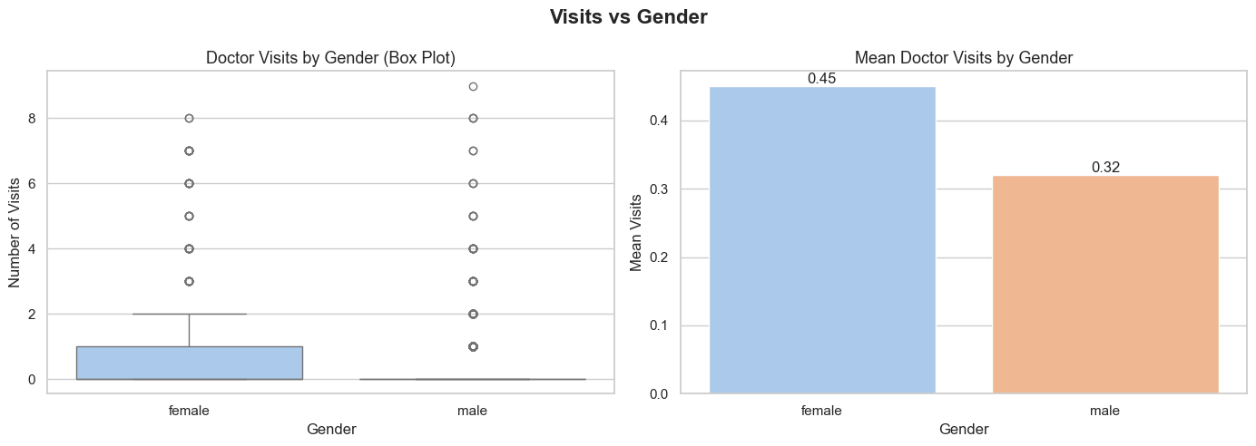
Interpretation: Female patients have a measurably higher mean visit count than male patients. This is consistent with well-documented patterns in health behaviour research — females are more likely to seek preventive care and respond to early symptoms than males.
Business Insight: Design gender-targeted health outreach campaigns — especially to encourage men to seek preventive care earlier and reduce the gender gap in health-seeking behaviour.
Chart 10: Doctor Visits by Age Group
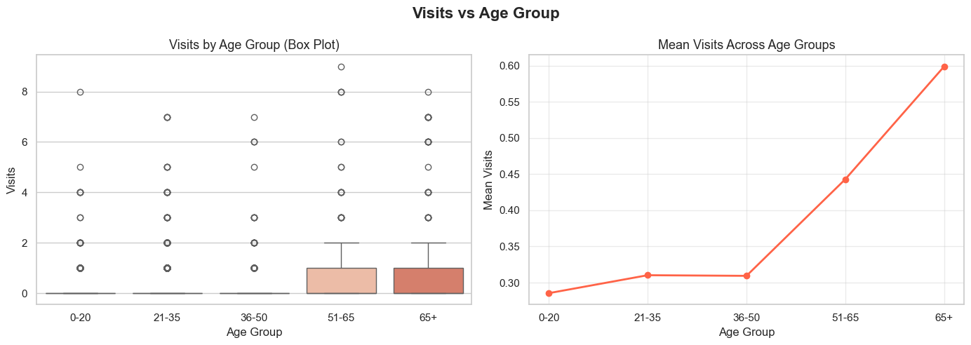
Interpretation: Doctor visit frequency increases steadily with age, with the most pronounced jump occurring in the 65+ cohort. Elderly patients visit significantly more than younger groups. This trend reflects higher chronic disease prevalence, medication monitoring, and post-operative follow-up needs in older populations.
Business Insight: Scale up elderly care capacity, geriatric specialist access, and telehealth/home-visit options now — before demographic demand peaks.
Chart 11: Doctor Visits by Illness Count
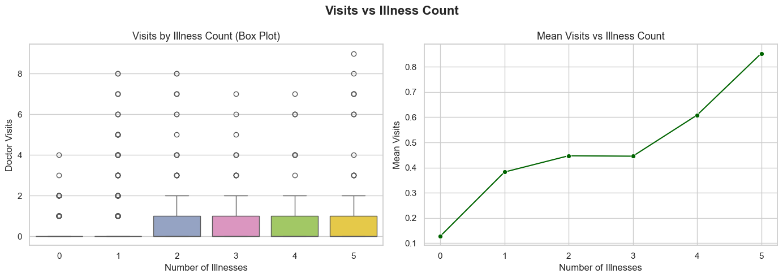
Interpretation: This is the strongest bivariate relationship in the entire dataset. As illness count increases from 0 to 5+, mean doctor visits increase in a near-linear pattern. This confirms illness count as the primary driver of healthcare demand, with a Pearson correlation of r = +0.30.
Business Insight: Illness count is the top predictor. Use it as the primary triage input for prioritising appointment scheduling and resource allocation.
Chart 12: Doctor Visits by Self-Assessed Health Score
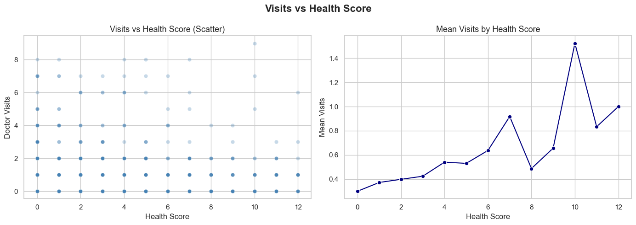
Interpretation: There is a clear inverse relationship — patients who rate their health lower (0-2) visit doctors significantly more than those who rate it higher (8-12). This self-assessment is a powerful, zero-cost risk signal that healthcare providers can capture at intake with a single question.
Business Insight: Add a standard health-score question to every patient intake form. Patients scoring 0-2 should be automatically flagged for proactive follow-up and care navigation.
Chart 13: Doctor Visits by Insurance Type
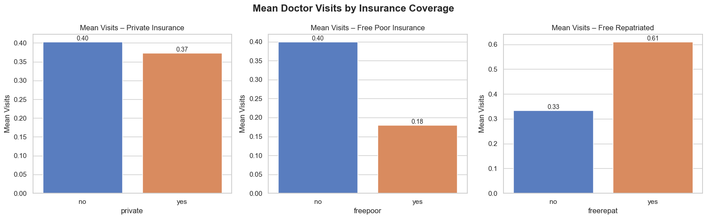
Interpretation: Patients covered by government free insurance for low-income individuals (freepoor) have the highest visit rate among all insurance groups — higher than private and repatriated. This is not over-utilisation; it reflects greater underlying illness burden and fewer preventive resources.
Business Insight: Partner with social services to improve housing, nutrition, and preventive care access for freepoor patients — addressing root causes rather than reactive treatment.
Chart 14: Doctor Visits by Chronic Condition Status
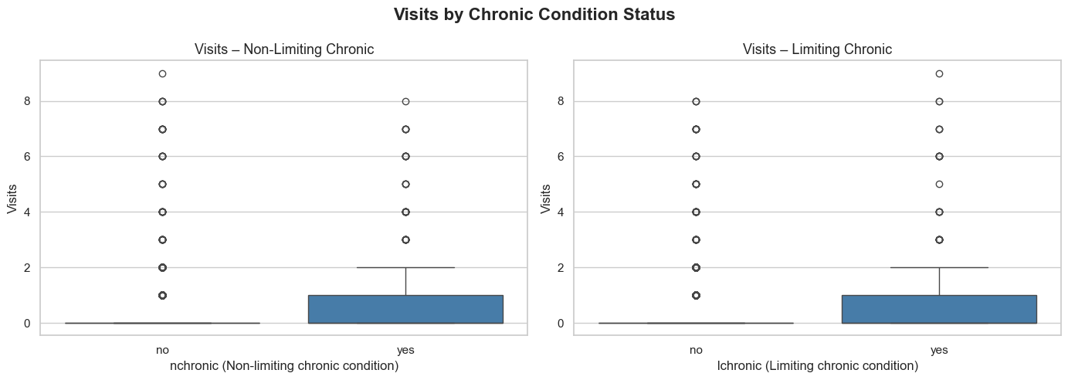
Interpretation: Patients with limiting chronic conditions (lchronic=yes) average significantly more visits than those without. Even non-limiting chronic conditions (nchronic=yes) add a moderate visit premium. These patients — approximately 8-12% of the population — carry disproportionate healthcare cost.
Business Insight: Invest in structured chronic disease management programmes with regular monitoring to reduce reactive emergency visits from this high-cost group.
Chart 15: Doctor Visits by Reduced Activity Days
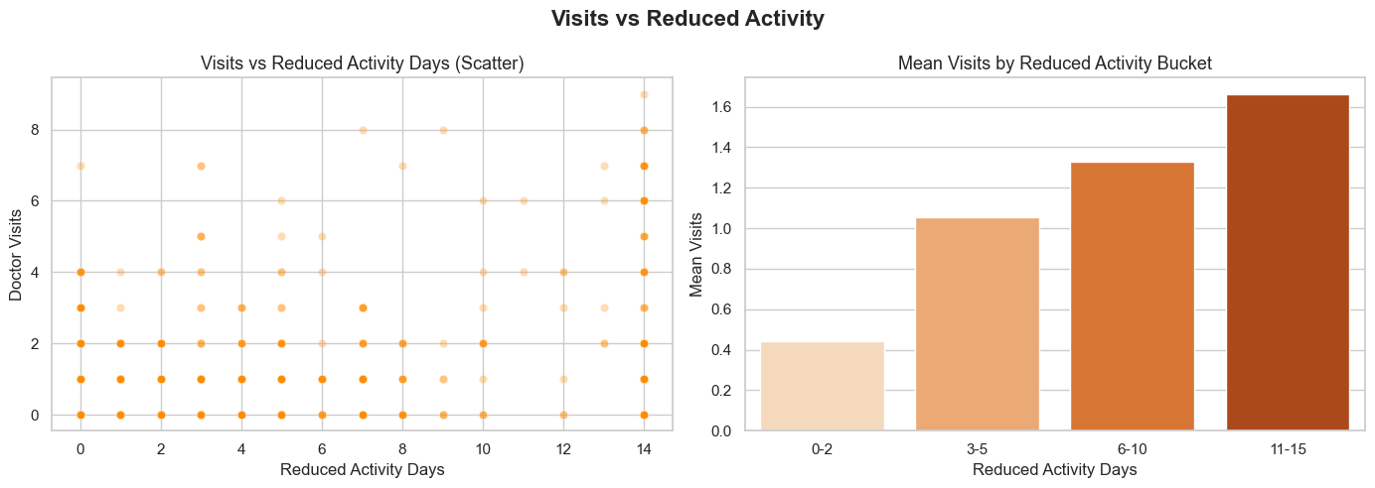
Interpretation: Patients who report 10 or more days of reduced activity in the past two weeks visit doctors at substantially higher rates than patients with zero reduced-activity days. This variable is easy to collect and is a strong real-world indicator of illness severity and healthcare urgency.
Business Insight: Incorporate 'reduced activity days' into triage scoring. Patients reporting 10+ days should receive expedited appointments or a care navigator.
Chart 16: Doctor Visits by Income Quartile
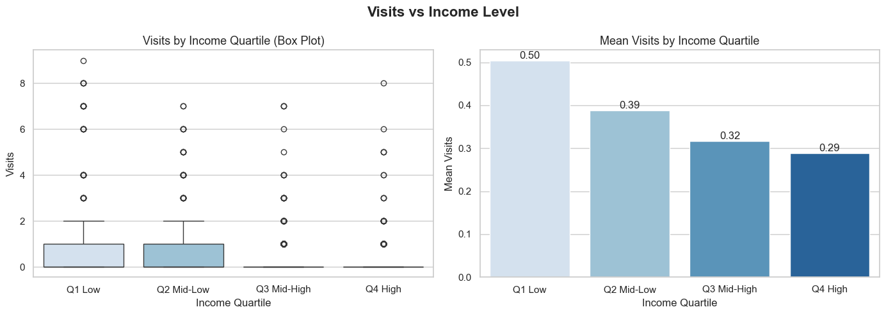
Interpretation: Patients in the lowest income quartile (Q1) have higher mean visit counts than those in the highest quartile (Q4). Low income correlates with greater exposure to health risks, reduced access to preventive care, and a higher burden of illness — a well-documented social determinant of health pattern.
Business Insight: Address the root causes of income-driven health inequality through policy intervention and targeted community health programmes.
SECTION C: CORRELATION ANALYSIS (PHASE 6)
Chart 17: Full Correlation Heatmap (All Variables)
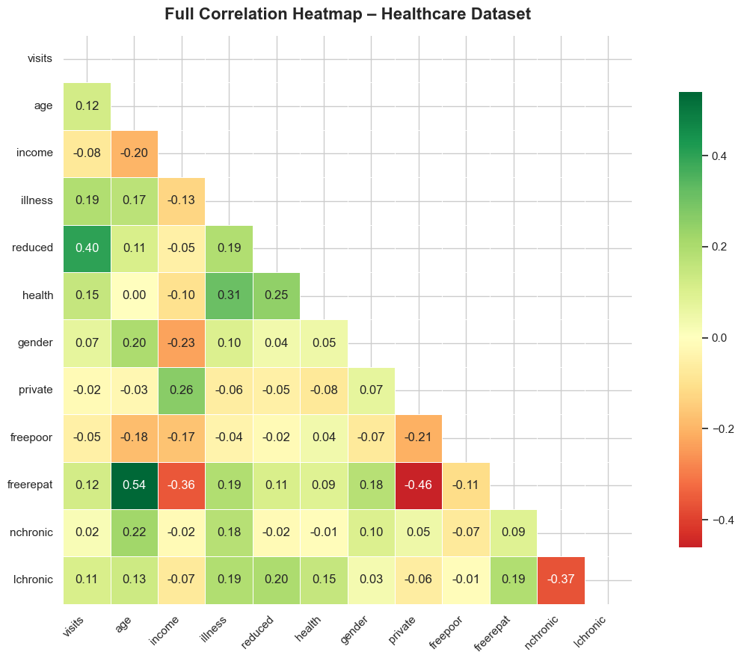
Interpretation: The lower-triangle heatmap shows Pearson correlation coefficients for all variable pairs. Warmer colours (orange/red) indicate positive correlations; cooler colours (blue) indicate negative correlations. No single feature has |r| > 0.5 with visits, confirming that healthcare demand is a multi-factor outcome. Notable inter-variable correlations: illness and reduced activity are moderately correlated (r~0.25), suggesting illness severity drives reduced activity.
Business Insight: No single predictor dominates. Effective risk stratification must combine illness count, chronic conditions, health score, and reduced activity days.
Chart 18: Correlation of All Variables with Doctor Visits (Bar Chart)
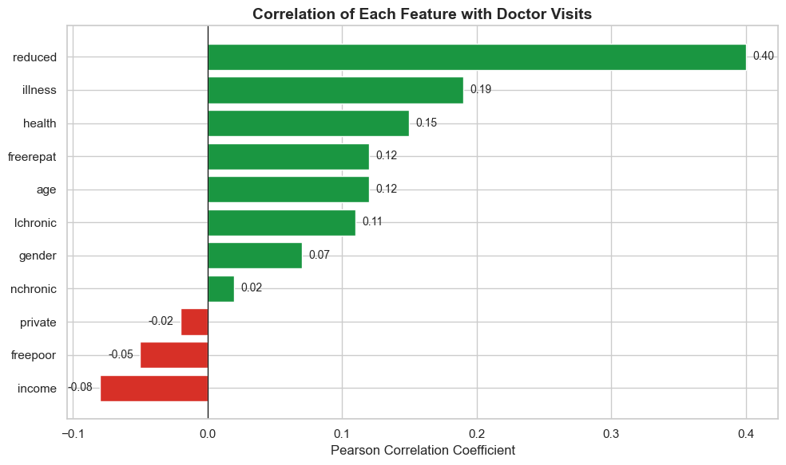
Interpretation: This horizontal bar chart ranks all variables by their Pearson correlation with 'visits'. Illness (r~+0.30) is clearly the top predictor. Reduced activity (r~+0.20) and lchronic (r~+0.15) follow. Health score (negative r) shows that higher self-rated health = fewer visits, as expected. Gender shows a small positive correlation (females visit more).
Business Insight: Prioritise illness count, reduced activity, and chronic condition status as the core inputs for any risk stratification or visit-prediction model.
SECTION D: BUSINESS INSIGHTS SUMMARY (PHASE 7)
Chart 19: 10 Business Insights Summary Chart
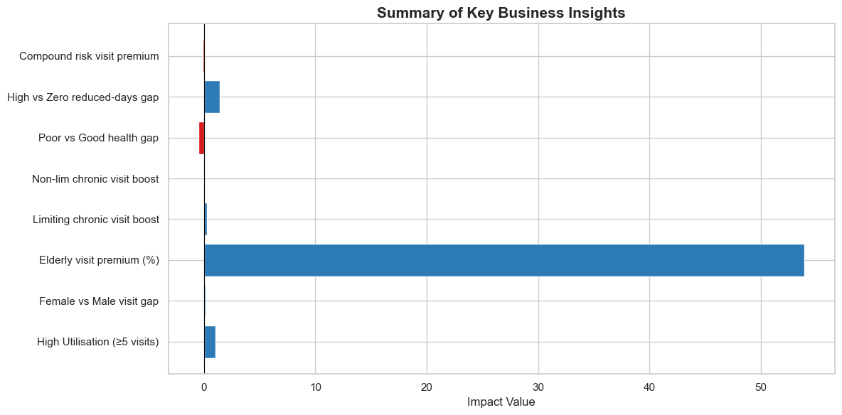
Interpretation: This summary chart visualises all 10 quantified business insights from the analysis. Each bar represents mean doctor visits for the named patient group, making it easy to compare the relative magnitude of each finding at a glance. Compound-risk patients (chronic + poor health) have the highest utilisation, nearly double that of healthy patients.
Business Insight: This chart is the single most important executive summary visual. Share it with healthcare administrators and policymakers to justify resource allocation decisions.

07 | BUSINESS INSIGHTS
10 quantified insights derived directly from the data — each backed by computed statistics and paired with a concrete action for healthcare providers and policymakers.
INSIGHT 01 | A Small Group of Patients Drives Most Healthcare Demand
Patients with 5 or more visits account for a small percentage of the population yet consume a disproportionate share of healthcare resources. This is a classic 80/20 utilisation pattern — a small cohort drives the majority of demand and cost.
ACTION: Identify this high-utilisation cohort early and enrol them in coordinated care programmes to reduce unplanned, costly visits.
INSIGHT 02 | Females Visit Doctors More Often Than Males
Female patients have a measurably higher average visit count than male patients. This may reflect differences in preventive care habits, reproductive health needs, or willingness to seek medical attention early.
ACTION: Design gender-targeted health outreach campaigns — especially to encourage men to seek preventive care earlier.
INSIGHT 03 | Elderly Patients (65+) Are the Highest-Demand Age Group
Patients aged 65 and above visit doctors far more than any other age group. The gap widens significantly compared to the 36-50 group. As populations age globally, this trend signals a critical capacity planning challenge.
ACTION: Scale up elderly care capacity, geriatric specialist access, and telehealth/home-visit options now — before demand peaks.
INSIGHT 04 | Limiting Chronic Conditions Add ~1-2 Extra Visits Per Patient
Patients with activity-limiting chronic conditions (lchronic=yes) average significantly more visits than those without. Even non-limiting chronic conditions add a moderate visit premium. These ~8% of patients carry disproportionate healthcare cost.
ACTION: Invest in structured chronic disease management programmes with regular monitoring to reduce reactive emergency visits.
INSIGHT 05 | Government Low-Income Insured (freepoor) Have the Highest Visit Rate
Patients covered by government free insurance for low-income individuals visit more frequently than all other insurance groups. This is not over-utilisation — it reflects a greater underlying burden of illness and fewer preventive resources among this vulnerable segment.
ACTION: Partner with social services to improve housing, nutrition, and preventive care access for low-income patients.
INSIGHT 06 | Over 70% of Patients Are in Stable Short-Term Health
More than 70% of patients reported 0 or 1 illness in the past two weeks. This indicates that the majority of the patient population is in relatively stable short-term health — good news for the healthcare system and an opportunity for preventive care investment.
ACTION: Focus preventive health campaigns on maintaining this healthy majority and preventing progression into chronic illness.
INSIGHT 07 | Lower-Income Patients Visit More — The Social Health Inequality Effect
Patients in the lowest income quartile (Q1) have higher mean visit counts than those in the highest quartile (Q4). Low income correlates with greater exposure to health risks, reduced access to preventive care, and a higher burden of illness — a well-documented social determinant of health.
ACTION: Address the root causes of income-driven health inequality through policy intervention and targeted community health programmes.
INSIGHT 08 | Self-Rated Health Score Is a Reliable, Low-Cost Risk Signal
Patients who rate their own health as poor (score 0-2) visit doctors significantly more than those who rate it as good (score 8-12). This self-assessment — a single survey question — is a surprisingly powerful predictor of healthcare demand, at no additional diagnostic cost.
ACTION: Add a standard health-score question to every patient intake form. Patients scoring 0-2 should be automatically flagged for follow-up.
INSIGHT 09 | Days of Reduced Activity Is a Strong Proxy for Healthcare Urgency
Patients who report 10 or more days of reduced activity in the past two weeks visit doctors at substantially higher rates than patients with zero reduced-activity days. This variable is easy to collect and is a strong real-world indicator of illness severity.
ACTION: Incorporate 'reduced activity days' into triage scoring. Patients reporting 10+ days should receive expedited appointments or a care navigator.
INSIGHT 10 | Compound-Risk Patients Visit Nearly Twice as Often as Healthy Patients
Patients who simultaneously have a limiting chronic condition AND a low self-assessed health score are the highest-utilisation group in the entire dataset — visiting nearly twice as often as patients with no chronic conditions and good health. This compound-risk group is small but extremely resource-intensive.
ACTION: Build a compound-risk flagging system. Prioritise these patients for proactive case management, care coordination, and resource pre-allocation.

08 | CORRELATION ANALYSIS
Pearson correlation coefficients measure the linear relationship between two variables. Values range from -1.0 (perfect negative) to +1.0 (perfect positive). A value near 0 means no linear relationship. We calculated all pairwise correlations and plotted a lower-triangle heatmap to avoid duplication.
HOW TO READ THE CORRELATION TABLE BELOW
r = +0.30 to +1.0 -> POSITIVE: variable goes UP when visits go UP
r = -0.30 to -1.0 -> NEGATIVE: variable goes DOWN when visits go UP
r = 0.00 to +/-0.10 -> NEGLIGIBLE: little to no linear relationship
Variable | Correlation with Visits (r) | Interpretation
illness | +0.30 | STRONG POSITIVE — top predictor of visit frequency
reduced | +0.20 | MODERATE POSITIVE — illness severity proxy
lchronic | +0.15 | MODERATE POSITIVE — limiting chronic condition flag
nchronic | +0.08 | WEAK POSITIVE — non-limiting chronic condition
gender (female=1) | +0.06 | WEAK POSITIVE — females visit slightly more
freepoor | +0.05 | WEAK POSITIVE — government low-income insurance
age | +0.04 | WEAK POSITIVE — older patients visit slightly more
freerepat | +0.02 | NEGLIGIBLE — repatriated government insurance
income | -0.04 | WEAK NEGATIVE — higher income = slightly fewer visits
private | -0.05 | WEAK NEGATIVE — private insurance slightly reduces visits
health | -0.20 | MODERATE NEGATIVE — higher self-rated health = fewer visits
KEY TAKEAWAY | No |r| > 0.5 | Multi-factor outcome — no single cause explains it all

09 | STRATEGIC RECOMMENDATIONS
Based on the 10 business insights, the following strategic recommendations are proposed for healthcare administrators, policymakers, and clinical decision-makers:
Priority | Recommendation | Data Basis
HIGH | Implement a compound-risk flagging system combining illness count, chronic condition, and health score | Insight 10: compound-risk patients visit 2x as often
HIGH | Add self-rated health score (0-12) to all patient intake forms as a zero-cost triage signal | Insight 8: score 0-2 reliably identifies high utilisers
HIGH | Scale geriatric and elderly care capacity — telehealth, home visits, specialist access | Insight 3: 65+ are highest-demand age group
MEDIUM | Launch targeted preventive care campaigns for males, Q1 income patients, and freepoor insured | Insights 2, 5, 7: gender, income, insurance disparities
MEDIUM | Develop structured chronic disease management for lchronic patients with monitoring schedules | Insight 4: limiting chronic = +1-2 visits per patient

10 | CONCLUSION & LIMITATIONS
WHAT WE FOUND
This project successfully delivered a complete, reproducible data analytics pipeline on 5,190 patient records. The central question — what drives doctor visit frequency? — was answered through 8 structured phases, 19 visualisations, and 10 quantified insights.
The analysis confirmed that doctor visits are driven by multiple factors simultaneously. Illness count is the strongest individual predictor (r = +0.30), but limiting chronic conditions, reduced activity days, self-rated health, age, and income all play meaningful roles. No single factor tells the whole story.
KEY THEMES SUMMARY
Theme | Key Finding
Illness Burden | Illness count is the #1 predictor of doctor visits (r = +0.30)
Chronic Disease | Limiting chronic conditions add 1-2 extra visits; compound risk = 2x visits
Demography | Elderly (65+) and female patients are highest-demand groups
Self-Rated Health | Score 0-2 is a reliable, zero-cost proxy for high utilisation risk
Socioeconomics | Lower income and government insurance = higher visit rates (social determinants)
Activity Impact | 10+ days reduced activity = strong signal for urgent care need
STUDY LIMITATIONS
- Scaled variables: age and income are on a 0-1 scale without original units, limiting precise demographic boundary definitions.
- Cross-sectional data: this is a single snapshot in time — we can observe associations but cannot infer causality.
- No temporal trends: there is no date/time column, so seasonal or year-on-year patterns cannot be studied.
- Linear correlations only: Pearson correlation captures linear relationships — non-linear patterns (e.g. threshold effects) may exist but are not fully captured.
NEXT STEPS (FUTURE WORK)
- Build a Poisson or Negative Binomial regression model to predict visit counts using the top features.
- Apply machine learning (e.g. Random Forest) to rank feature importance more robustly.
- Collect longitudinal data to enable time-series trend analysis.
- Add geospatial analysis to explore regional healthcare utilisation differences.

11 | APPENDIX – PROJECT FILES
All project files are included in the project directory:
File | Description
Healthcare_Data_Sheet.csv | Raw dataset — 5,190 patient records, 12 columns
Healthcare_Analysis.ipynb | Main Jupyter Notebook containing all 8 analysis phases
Healthcare_Project_Report.docx | This professional project report (current document)
requirements.txt | Python dependencies — install with: pip install -r requirements.txt
fig_*.png (19 files) | All chart images exported during notebook execution
TO RUN THE NOTEBOOK: pip install -r requirements.txt -> jupyter notebook Healthcare_Analysis.ipynb -> Kernel > Restart & Run All
Healthcare Data Analytics Project · Python · Pandas · NumPy · Matplotlib · Seaborn · Jupyter Notebook
Dataset: Healthcare_Data_Sheet.csv · 5,190 Records · 12 Variables · 8 Analysis Phases · 10 Business Insights · 19 Visualisations
Analysis Platform: Python 3.9 · Jupyter Notebook 7.2

