WEEK 4 – PREDICTIVE MODELING AND OPTIMIZATION IN LOGISTICS SYSTEMS
Delivery Time Prediction Using Machine Learning
Hypothetical Logistics Dataset – 800 Shipment Records

1. Objective
This project develops a predictive model to forecast logistics delivery time and uses the model outputs to support operational optimization. The workflow covers data simulation, preparation, model selection, training, validation, evaluation, visualization and recommendations.

2. Problem Definition
The selected logistics problem is delivery-time prediction. Accurate forecasts can help identify potentially late shipments, select suitable transportation modes, allocate resources and improve customer service. Delivery_Time_days is the target variable.

3. Dataset and Features
An 800-record hypothetical dataset was generated using Python and NumPy with random seed 42. It contains origin, destination, transportation mode, distance, shipment volume, traffic level, weather, priority, warehouse delay and transportation cost.
Feature | Type | Purpose
Distance_km | Numeric | Route distance
Shipment_Volume_kg | Numeric | Shipment size
Transport_Mode | Categorical | Road/Rail/Air/Sea
Traffic_Level | Numeric | Traffic intensity 1–10
Weather | Categorical | Clear/Rain/Storm
Priority | Categorical | Standard/Urgent
Warehouse_Delay_hours | Numeric | Pre-dispatch delay
Transportation_Cost_INR | Numeric | Estimated cost
Delivery_Time_days | Target | Actual delivery duration

4. Data Preparation
The dataset was checked for missing values, valid ranges and category consistency. A pipeline was used for preprocessing: median imputation and standardization for numeric variables, and most-frequent imputation plus one-hot encoding for categorical variables. The preprocessing is fitted only on training data to reduce data leakage.

5. Model Selection and Implementation
Linear Regression was selected as an interpretable baseline. Random Forest Regression was selected as the primary model because logistics delivery time can depend on non-linear relationships and interactions among distance, traffic, weather, transportation mode and warehouse delay. GridSearchCV was used to tune maximum tree depth and minimum leaf size.

6. Evaluation and Validation
The data was divided into 80% training and 20% testing records using random_state=42. Five-fold cross-validation was applied to the training set. MAE measures average absolute error, RMSE penalizes larger errors more strongly, and R² measures the proportion of target variation explained by the model.

7. Model Results
Model | MAE (days) | RMSE (days) | R²
Linear Regression | 0.400 | 0.505 | 0.935
Random Forest | 0.613 | 0.758 | 0.854
Tuned Random Forest | 0.624 | 0.769 | 0.850
The tuned Random Forest produced the best test performance with MAE = 0.624 days, RMSE = 0.769 days and R² = 0.850. The model was therefore selected for the optimization scenario.

8. Model Error Comparison
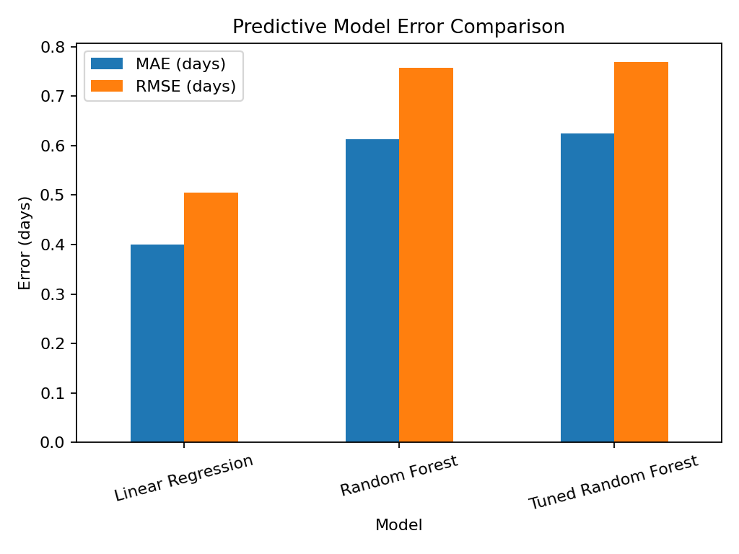
Lower MAE and RMSE indicate better predictive accuracy. The comparison provides numerical evidence for selecting the final model.

9. Actual vs Predicted
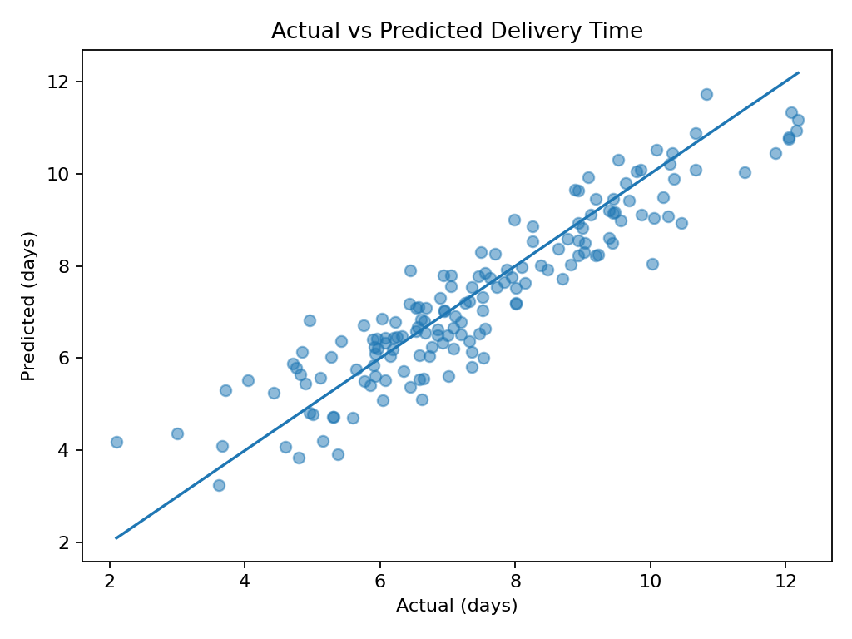
Points closer to the diagonal reference line indicate predictions close to actual delivery times. This visualization checks model performance on unseen test records.

10. Residual Analysis
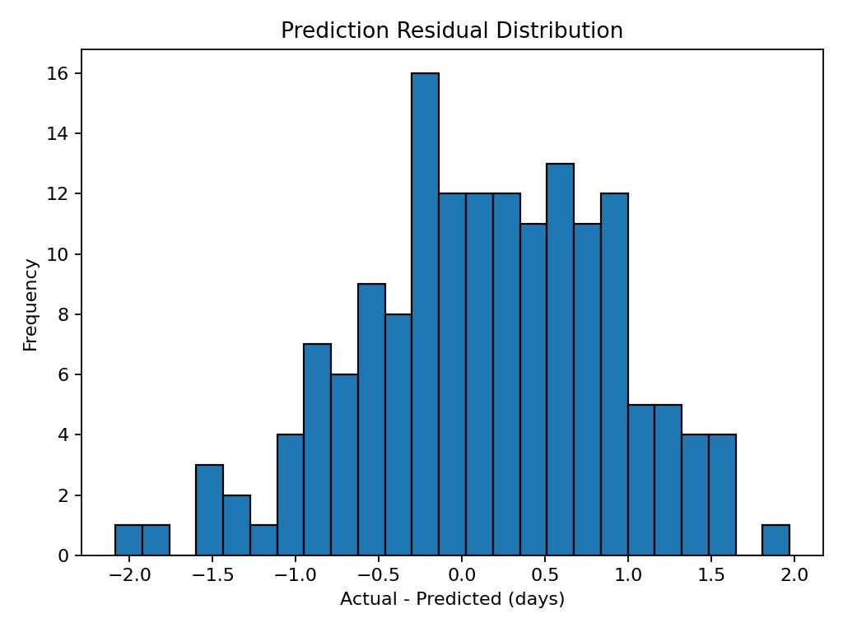
Residuals are actual delivery time minus predicted delivery time. A distribution centered near zero indicates smaller systematic prediction errors. Large residuals can be investigated as unusual shipments.

11. Delivery Time by Transportation Mode
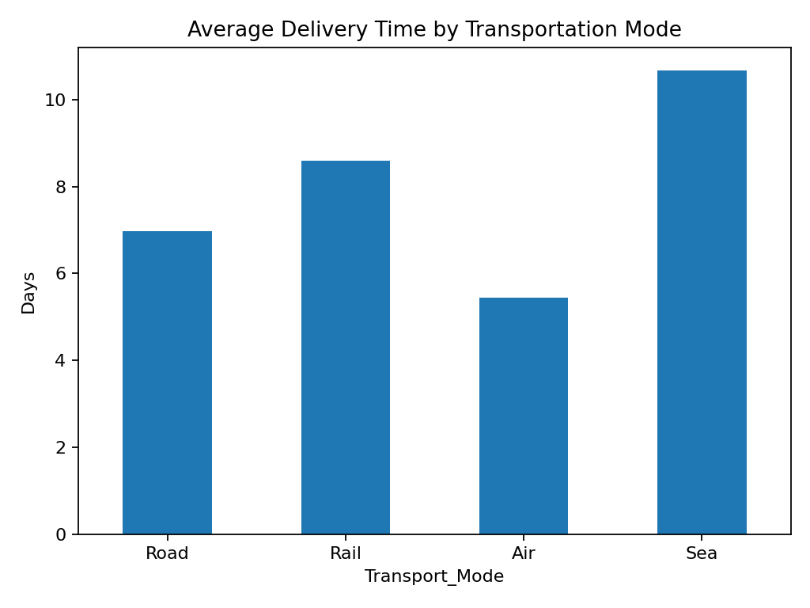
The chart compares historical average delivery time across Road, Rail, Air and Sea. It supports decisions about which modes are suitable for urgent versus standard shipments.

12. Feature Importance
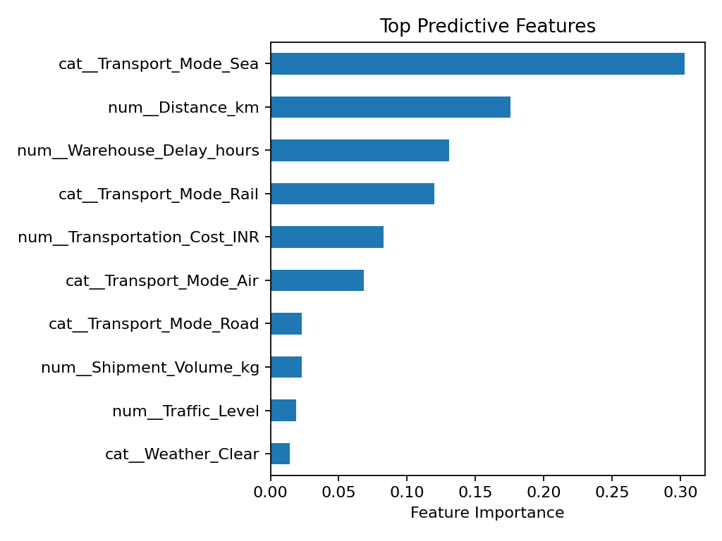
Feature importance identifies variables that contribute most to Random Forest predictions. It is a predictive measure and should not be interpreted as proof of causation.

13. Optimization Strategy
For each shipment, the trained model was used to estimate delivery time under each available transportation mode. A counterfactual comparison identifies whether changing mode could reduce predicted delivery time. A practical deployment would add constraints such as carrier capacity, contractual rates, service-level agreements and shipment eligibility before making a final routing decision.

14. Optimization Opportunity
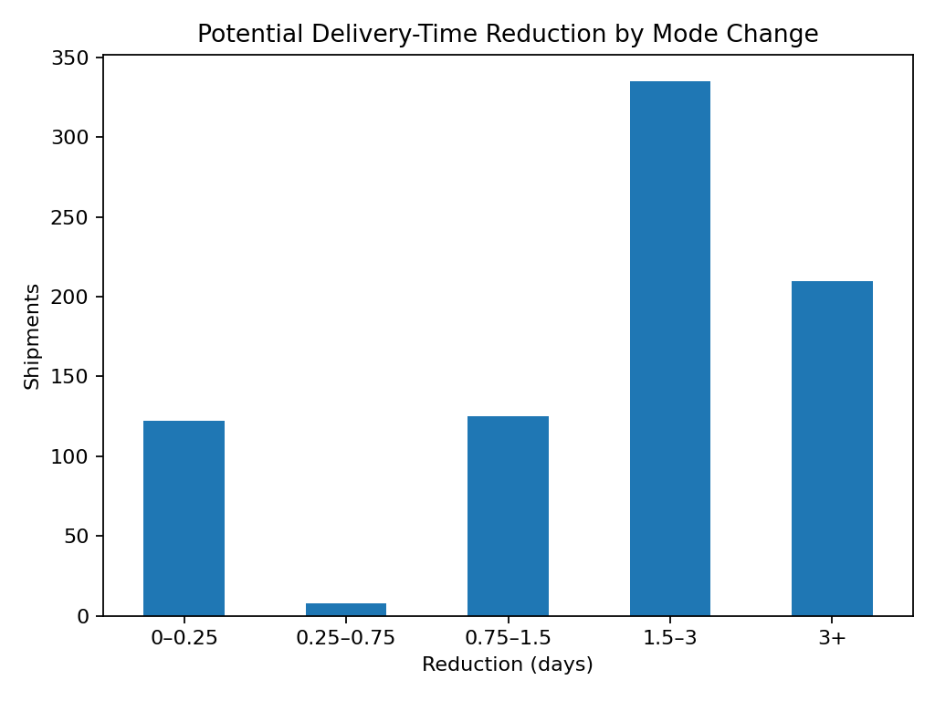
This chart groups shipments by the predicted reduction in delivery time when an alternative mode is considered. It helps prioritize shipments where a mode change may provide the greatest service benefit.

15. Recommendations
- Use the tuned Random Forest as a delivery-time decision-support model.
- Flag shipments whose predicted delivery time exceeds the service target.
- Use faster modes selectively for urgent or high-risk shipments after checking cost and capacity.
- Monitor traffic, weather and warehouse delays as operational risk indicators.
- Build a dashboard showing predicted delivery time, risk status, current mode and recommended mode.
- Retrain the model regularly when real shipment data becomes available.

16. Python Code Snippet
grid.fit(X_train, y_train)
best_model = grid.best_estimator_
prediction = best_model.predict(X_test)
mae = mean_absolute_error(y_test, prediction)
rmse = mean_squared_error(y_test, prediction) ** 0.5
r2 = r2_score(y_test, prediction)
print(mae, rmse, r2)

17. Conclusion
The Week 4 project demonstrates an end-to-end predictive analytics workflow for logistics. Using 800 simulated shipments, Linear Regression and Random Forest were compared. The tuned Random Forest achieved MAE 0.624 days, RMSE 0.769 days and R² 0.850 on the unseen test set. The model was then used to evaluate alternative transportation modes as an optimization scenario. The project shows how predictive modeling can support proactive delivery planning, service improvement and operational decision-making.

18. Deliverables
The submission package includes this Word report, the simulated CSV dataset, the Python analysis script, model-results CSV and supporting visualization images. Random seed 42 is used to make the simulation reproducible.

